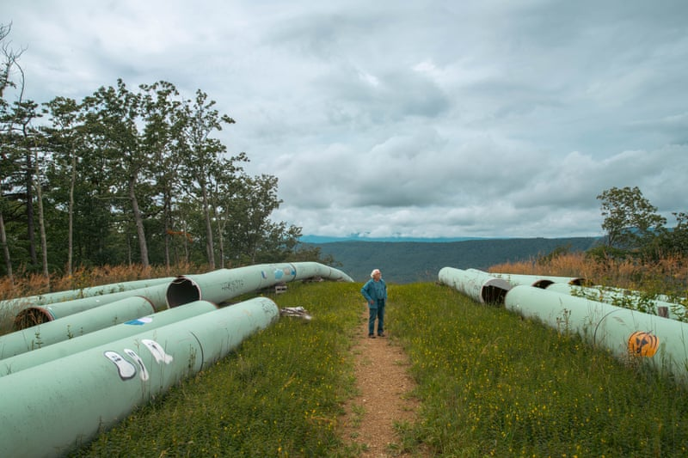

Pipes atop Brush Mountain, across from Sinking Creek Mountain, Jefferson National Forest. Photo, Mark Trent, The Guardian (8/26/2022)

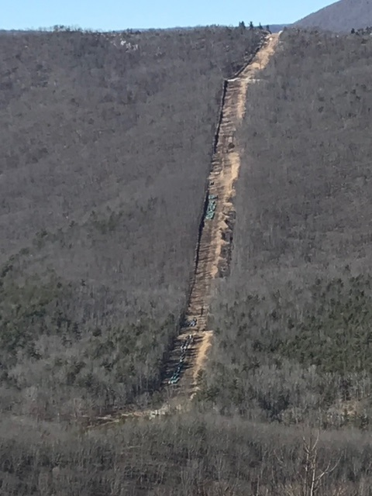MVP pipes,Sinking Creek Mountain, as seen from Brush Mountain, JNF, 2/6/2023. Photo by David Seriff.

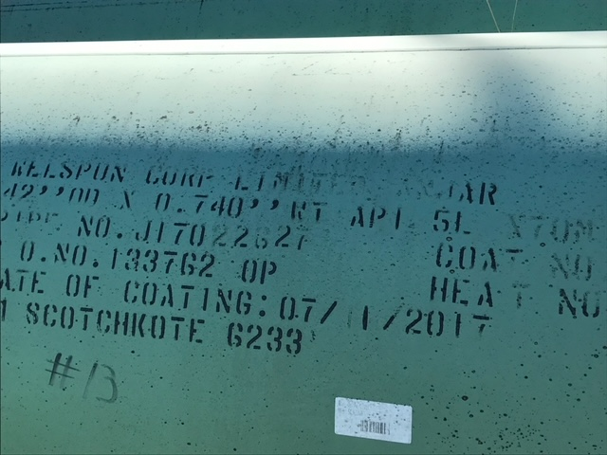

Pipe on Brush Mountain, JNF, coated July 2017. Photo by David Seriff.

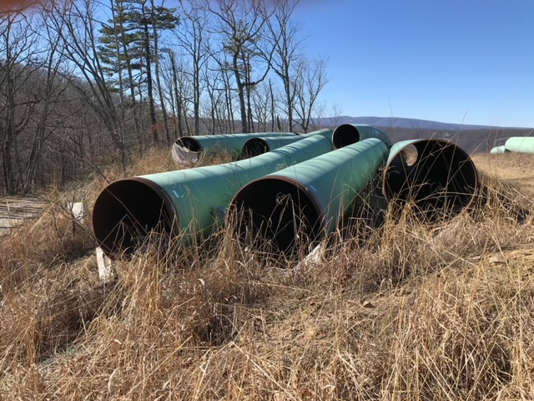

Upon information, this pipe has been exposed to elements on Brush Mountain (JNF) since Summer 2018. Note the absence of endcaps and inner coating leaves the pipe ends and insides vulnerable to corrosion. Photo by David Seriff.

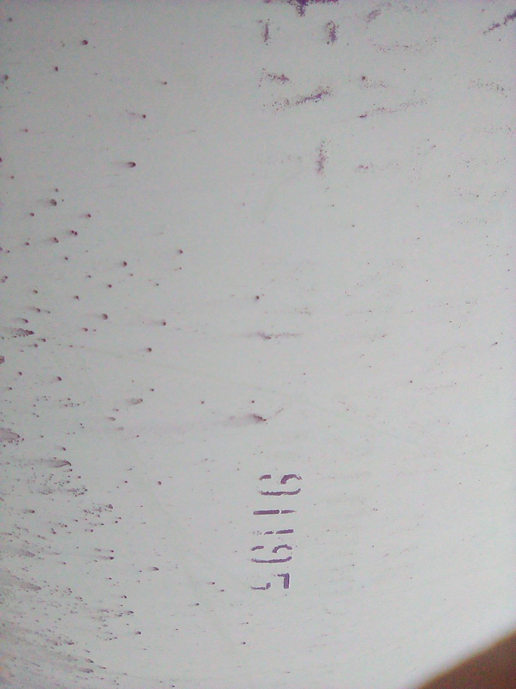

Observers describe stenciling with prior coding date stamps as worn off. Perhaps more significant, the pipe coating appears to have deteriorated and taken on mold, corrosion or both.