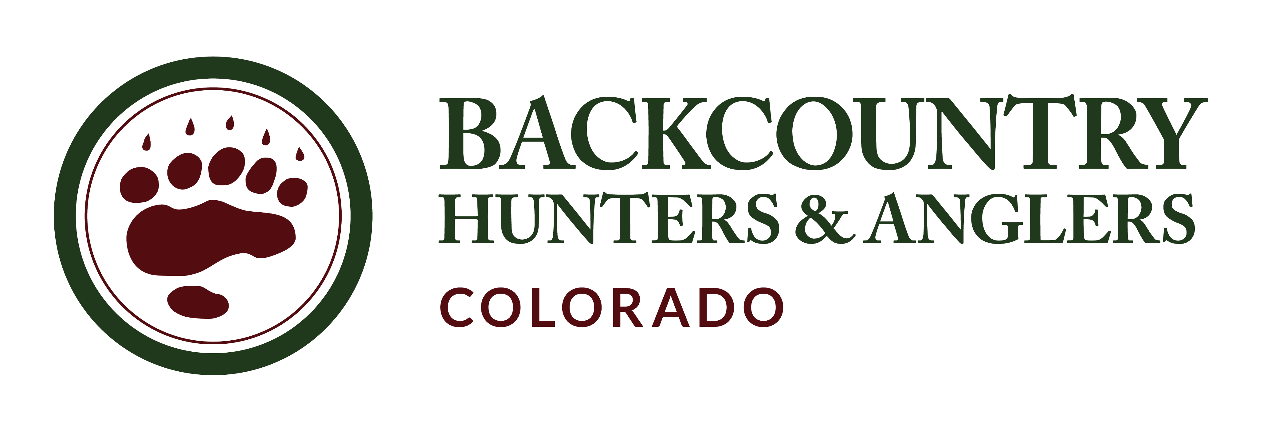

**Re: Thompson Divide Withdrawal**

Anthony Edwards June 8, 2023

Deputy Forest Supervisor

Grand Mesa, Uncompahgre, Gunnison National Forests

Thank you for the opportunity to comment on the proposed Thompson Divide Withdrawal. I am submitting comments on behalf of the Colorado Chapter of Backcountry Hunters & Anglers (CO BHA) where I serve as the Regional Director for the Central West Slope Region of the State.

CO BHA is a grass roots organization of sportsmen and women who strongly believe in the principals of the North American Wildlife Conservation Model and the value of our public lands for fish and wildlife habitat and the traditional fishing and hunting opportunities that are provided. As a group of sportsmen and women, we advocate for the conservation of wild lands and wildlife habitats on our public lands to sustain populations of fish and wildlife and the opportunity for traditional methods of hunting and fishing that challenge us physically and mentally and emphasize the principals of fair chase. The combination of productive habitat and limited human disturbance is essential to the perpetuation of our bighorn sheep, elk, and mule deer populations, and the opportunity for high quality backcountry hunting. Intact stream systems of high quality water are vital to native trout and the remote headwater streams provide outstanding backcountry fishing. Our public lands within the Thompson Divide provide these opportunities to Colorado resident and non-resident hunters and anglers who help support the local and regional economy of our State.

With its bounty of fish and wildlife habitat and rangelands supporting local communities, the Thompson Divide area remains critically important to local ranchers, hunters, and anglers in Colorado. The three primary game management units that span the Thompson Divide are among the most desirable to elk and mule deer hunters in the state. The largely roadless area serves as year-round habitat for those and other wildlife species, but notably supports more than 34,000 acres of elk migration corridors. In 2011, more than 5,000 deer and elk tags were available by draw to hunters within the Thompson Divide. Hunters are also able to purchase over-the-counter bull elk tags that keep public land hunting available to the average person - something increasingly important as access to quality opportunities becomes less available.

The Thompson Divide is a coldwater fisheries stronghold and contains several conservation populations of Colorado River cutthroat trout, considered critical to the recovery and maintenance of the species to its native range. Among the 1,550 miles of stream radiating in all directions off Thompson Divide, about 83 miles qualify as native cutthroat stream habitat along with nearly 12 acres of cutthroat lake habitat. Several of these waters are also designated as “outstanding natural waters” by the state of Colorado for their pristine water quality. The northern boundary of the withdrawal and protection area includes 4.4 miles of Gold Medal fishing water along the Roaring Fork River, and Thompson Divide’s headwater tributaries extend to additional high-quality fisheries in the North Fork of the Gunnison River, the Crystal River and the Colorado River, which sustain surrounding retailers, fishing guides and outfitters that help drive the local recreation economy.

CO BHA has been and will continue to be a strong advocate for the CORE Act which combines and improves four previous Bills, and we hope that eventually Congress will protect all lands within the CORE Act, including the Thompson Divide Withdrawal and Protection Act, through this legislation. We were pleased to see President Biden protect portions of the Continental Divide and Camp Hale through executive action and we now fully support the Forest Service application to withdraw 224,704 acres of the Thompson Divide from all forms of entry, appropriation, and disposal under the public land laws, mining laws and mineral and geothermal leasing laws, subject to valid existing rights for the period of 20 years. We believe this administrative action will provide necessary protection for the outstanding wildlife and backcountry hunting and fishing opportunities the area provides, as well as the cultural, agricultural, and recreational values from further exploration and development until a permanent solution can be achieved legislatively or administratively.

Craig Grother

Craig Grother

Central West Slope Regional Director

Colorado Backcountry Hunters & Anglers