**Review of UN Biodiversity Conference COP15 in Montreal, December 2022**

**Green Energy Times (March 2023) Alan Betts**

One of the most important conferences on the survival of life on Planet Earth was COP15 in Montreal in December, 2022. Representatives from 188 governments gathered in Montreal for two weeks and reached a landmark agreement to guide global action on nature through to 2030.

Chaired by China and hosted by Canada, COP 15 resulted in the adoption of the Kunming-Montreal Global Biodiversity Framework (GBF) on December 19th 2022. The GBF aims to address biodiversity loss, restore ecosystems and protect indigenous rights. The plan includes concrete measures to halt and reverse nature loss, including putting 30 per cent of the planet and 30 per cent of degraded ecosystems under protection by 2030. It also contains proposals to increase finance to developing countries for these purposes.

The broad context here is that there has been a 69% plunge in wildlife populations over the past 48 years. The global rate of species extinction is already at least tens to hundreds of times higher than it has averaged over the past 10 million years.

Much of this accelerated loss has been caused by the destruction of natural habitats by humanity for commercial or agricultural uses; coupled to the increase in climate extremes linked to the relentless burning of the fossil fuels by “business as usual.”

A key agreement is to conserve 30% of the Earth, both terrestrial and marine ecosystems, by 2030 the end of this decade. The expansion of new protected areas will respect indigenous and traditional territories. The language emphasizes the importance of effective conservation management to ensure wetlands, rainforests, grasslands and coral reefs are properly protected, not just on paper. One critical step is the recognition that Indigenous rights are at the heart of conservation. Several scientific studies have shown that Indigenous peoples are the best stewards of nature, representing 5% of humanity but protecting 80% of Earth’s biodiversity. From Brazil to the Philippines, Indigenous peoples are still subjected to human rights abuses, violence and land grabs (after centuries of similar abuse). The language in the text is clear: Indigenous-led conservation models must become the norm **this decade** if we are to take real action on biodiversity.

The meeting addressed the need to reduce environmentally harmful subsidies. The world spends some $1.8 trillion every year on government subsidies driving the annihilation of wildlife and a rise in global heating, according to a study earlier this year. Agreement was reached to phase out or reform subsidies that harm biodiversity by at least $500 billion per year, while scaling up positive incentives for biodiversity conservation and sustainable use.

The final text included watered-down language requiring governments to ensure that large and transnational companies disclose “their risks, dependencies and impacts on biodiversity”. If implemented, this could be the start of a significant change in business practices. This issue is rapidly moving up the agenda of ‘corporate’ risks, as about half of global GDP is dependent on the healthy functioning of the natural world. Several countries are already developing rules for sustainable sourcing. However a widespread change of business strategies this decade will be a challenge.

Key financial discussions at COP15 centered on how much money developed countries will send to developing countries to address biodiversity loss. It was requested that a Special Trust Fund – the GBF Fund – be set up to ensure an adequate, predictable and timely flow of funds. It was recognized that at least $200 billion per year were needed from public and private sources for biodiversity-related funding and international financial flows from developed to developing countries would have to be raised to at least US$ 30 billion per year.

Critical issues of access and benefit-sharing from digital sequence information (DSI) from genetic sources were addressed. Digitized genetic information that we get from nature, which is used frequently to produce new drugs, vaccines and food products come from rainforests, peatlands, coral reefs and other rich ecosystems. Corporations develop, patent products and profit. Products are hard to trace back to their origin country, but many in the developing world are now expecting payment for the use of their resources. COP15 reached the first international agreement to create a multilateral mechanism for benefit-sharing from the use of digital sequence information on genetic resources, including a global fund. This agreement to develop a funding mechanism on sharing DSI benefits in the coming years was hailed as a victory for African states who called for its creation.

COP15 recognized clearly that this coming decade is critical for conserving and protecting natural habitats and biodiversity, and set some clear targets for governments, businesses and society to follow. The tasks will not be easy as we have no global legal structures to enforce the preservation of life on Earth in the face of a capitalist system that presumes it has the right to exploit and if needed destroy life to increase its profits. COP15 did not focus on the parallel issue of accelerating climate change addressed at COP27, and it did not consider Mother Nature’s apparent takeover of the climate system to protect life on Earth, which were both discussed in the December issue of GET. It is worth noting however that Mother Nature is likely to back all COP15’s plans to address biodiversity loss and restore ecosystems.

Figures

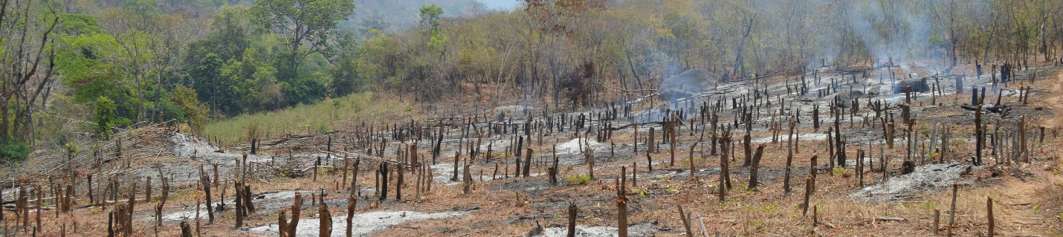

Woodland Clearance in Ribaue foothills, Mozambique @RBG Kew/L.Derbyshire

[Woodland-clearance-Ribaue_1.jpg (3600×800) (kew.org)](https://www.kew.org/sites/default/files/styles/header_style/public/2022-11/Woodland-clearance-Ribaue_1.jpg?itok=_GEhETTQ)