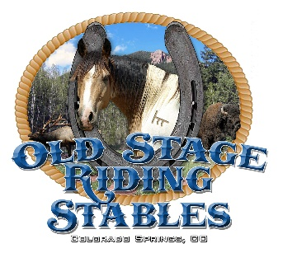

**36 Highland St**

**Colorado Springs, CO 80906**

**719 448-0371**

**February 16, 2020**

**To whom it may concern.**

**As a business owner with animals, I have experienced many close calls with shooters. Having been here for 30 years, conducting trail rides through the Pike National Forest, I have observed many instances of reckless and illegal behavior from shooters. This past year was the worst yet. We had many separate occasions where shooters shot into our stables, and at our horseback rides.**

**I contacted law enforcement each time, however, the USFS officer is spread way to thin to respond in a timely matter. Also, the shooters know they are acting in an illegal manner and take off before we can obtain proof and vehicle descriptions.**

**Having a special use permit with the USFS, and paying for the privilege to use the trails, we would like more to be done to protect us and to keep shooters away from our area as much as possible. We would support an approach of a managed and properly developed shooting range as far away as possible. Right now, the constant sound of rapid and single fire reports takes away much of the ambiance of enjoying the trails by others.**

**Please let me know if you have any questions or what more I can do.**

**Thank you, Laurie Zickefoose**