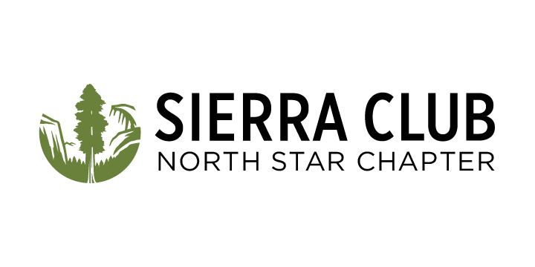 2300 Myrtle Avenue, Suite 260  
 Saint Paul, MN 55114  
 612-659-9124  
 sierraclub.org/minnesota

Thomas Hall, Forest Supervisor

Forest Headquarters

8901 Grand Avenue Place

Duluth, MN 55808

September 17, 2024

RE: School Trust, St. Louis County, and TCF Land Purchase Project

Founded in 1968, The Sierra Club is the nation's oldest and largest grassroots environmental organization, representing over 50,000 members and supporters in Minnesota. The Sierra Club works to safeguard the health of our communities, protect wildlife, and preserve our remaining wild places through grassroots activism, public education, lobbying, and litigation. As a leading grassroots voice working to preserve and protect Minnesota's environment, we empower volunteer leaders to act through environmental advocacy, community organizing, and outdoor exploration. We participate in the administrative process to encourage environmental health and sustainability, long term wildlife and habitat protection, and biodiversity goals.

The Sierra Club North Star Chapter supports the Forest Service in moving forward with the federal purchase of state-owned school trust lands and county tax-forfeited lands inside the Boundary Waters Canoe Area Wilderness (BWCAW). A federal purchase is a much better plan than a land exchange. The land exchange plan is cost prohibitive and not the right choice. The federal purchase of these lands will allow a more efficient administration of the BWCAW. It will also give these parcels the legal wilderness protections that they don’t currently have. This proposal will benefit the BWCAW.

Sincerely,

Sierra Club North Star Chapter

2300 Myrtle Avenue, Suite 260

St. Paul, MN 55114

Bob Graves

Forests and Wildlife Stewards Chair

Sierra Club North Star Chapter

[bob.graves@northstar.sierraclub.org](mailto:bob.graves@northstar.sierraclub.org)

Bill Pollnow

Forests and Wildlife Stewards Vice-Chair

Sierra Club North Star Chapter

[wpollnow@gmail.com](mailto:wpollnow@gmail.com)

Annah Gardner

Forests and Wildlife Stewards member

Sierra Club North Star Chapter

[annahgardner@gmail.com](mailto:ajgardner@stthomas.edu)