Paul Olson, Attorney at Law

September 16, 2019

Carey Case

Project Leader

Central Tongass Project

Petersburg Ranger District

P.O. Box 1328

Petersburg, Alaska 99833

Submitted electronically at: <https://cara.ecosystem->

[management.org/Public//CommentInput?Project=53098](http://management.org/Public//CommentInput?Project=53098)

Dear Ms. Case:

I submit these comments regarding the Central Tongass Project DEIS on behalf of small cruise vessel operators The Boat Company, UnCruise Adventures, and Lindblad Expeditions. Our businesses provide thousands of visitors with hiking, beach combing, wildlife viewing and other remote recreation experiences throughout southeast Alaska, including the Petersburg and Wrangell Ranger Districts. The Boat Company also offers guided freshwater fishing opportunities in the project area. As visitor products providers, we are the largest private sector growth industry in the region. The most important Forest Service resources for our businesses are remote areas that provide protected anchorages, scenic opportunities and some special feature – whether trail access, kayaking or wildlife viewing.

We submitted scoping comments expressing concerns about the Central Tongass Project. We requested that you modify the proposed action in order to prioritize recreation opportunities and infrastructure over the proposed timber sale program and cease planning timber sales in areas now utilized primarily by the guided public. Additionally, we requested an analysis that compares the respective economic contributions – and costs - of recreation and timber sale program management.

Although the DEIS identifies various resources and socio-economic needs, the emphasis of the proposed action is to implement a large timber sale program throughout the project area.1 The Central Tongass Project decision could authorize logging anywhere in nearly 43,000 acres lying within ten “timber analysis areas (TAAs) located on Mitkof, Kupreanof, Kuiu, Wrangell, Zarembo and Etolin islands, and at Thomas Bay and Frosty Bay on the mainland.2

The Forest Service proposes only two action alternatives. Alternative 2 would remove 230 million board feet (MMBF) of timber – nearly two-thirds old-growth forest – from 13,500 acres over the next 15 years.3 Alternative 2 would also entail 200 miles of road construction related work, fragmenting wildlife habitat and degrading fish habitat with 128 new fish stream

 DEIS at 1-5.

2 id at 1-6.

3 id at 2-23; 2-30.

crossing structures.4 Alternative 3 also proposes a massive timber project and would remove 201 MMBF of timber from over 11,700 acres of public land and entail proportionally similar levels of road construction activities.5 The Forest Service would construct 22 miles of new road, 82 miles of temporary road, up to 70 rock quarries, upgrade 71 miles of closed roads and add up to 37 new stream crossing structures.6 The volume is slightly lower in order to retain small amounts of old-growth forest for deer winter habitat and Kuiu Island marten. The Forest Service also proposes to weaken scenic values by placing clearcuts along our cruise routes in scenic waterways such as Wrangell Narrows and Frederick Sound to improve economics for timber sale purchasers.

Our scoping comments explained that these project activities will result in harm to the visitor products industry: displacement by timber operations, loss of scenic values, and harm to fish and wildlife. As explained in the Visitor Products Cluster’s May 2017 letter to Forest Service leaders, our “wild infrastructure” of public lands and waterways that provide scenery, fishing and wildlife resources brings in over a million visitors annually, driving a billion dollar economy that is the largest source of private sector employment in southeast Alaska.7 This wild infrastructure includes places such as north Kuiu Island, Mitkof Island, Kupreanof Island and the mainland that are recovering from timber extraction operations decades ago and now support a healthy, low-impact visitor products industry.

The Central Tongass Project is a project-level decision to authorize logging 230 MMBF and building or rebuild 200 miles of roads over the next 15 years in a geographic area that encompasses almost 3.7 million acres. 8 The DEIS however describes the project as “a large landscape-scale NEPA analysis” that “will result in a decision whether or not to authorize integrated resource management activities on the Petersburg and Wrangell Ranger Districts over the next 15 years.”9 The stated intent of the project “is to contribute to jobs and labor income in local and regional communities in the timber and tourism sectors, while also contributing to improved terrestrial and aquatic conditions ....” 10 The DEIS promises to analyze and describe various project components, but then defers a review of specific locations and projects to a subsequent implementation phase based on the Forest Service’s “condition-based” NEPA framework.11

The “condition-based NEPA” analysis in the DEIS is troubling for our businesses because the proposed action appears to authorize clearcutting any portion of up to 9,500 acres of old-growth forest alone anywhere within 42,779 old-growth forested acres contained in ten different Timber Analysis Areas that provide our businesses with remote recreation and wildlife viewing opportunities and scenic viewsheds.12 We plan itineraries years in advance, and the DEIS fails to disclose when and where large clearcut timber sales will displace our operations.

4id at 2-23.

5 id at 2-23 – 2-25.

6 id at 2-25.

7 <http://www.jedc.org/sites/default/files/Policy_letter%20sign%20on_5_25_2017.pdf> .

8 DEIS at 2-23.

9 id at 1-1.

10 id.

11 id

12 DEIS at 3-60.



NEPA has two fundamental two goals: “(1) to ensure that the agency will have detailed information on significant environmental impacts when it makes decisions; and (2) to guarantee that this information will be available to a larger audience.”13 NEPA’s “‘action-forcing’ procedures . . . require the Forest Service to take a ‘hard look’ at environmental consequences,” *before* the agency approves an action. 14 “By so focusing agency attention, NEPA ensures that the agency will not act on incomplete information, only to regret its decision after it is too late to correct.”15

The analysis in the DEIS fails to meet NEPA requirements to assess the direct, indirect and cumulative impacts of the proposed action and alternatives to it.16 An EIS must provide site-specific information and analysis to ensure informed decisionmaking and meaningful opportunities for public participation.17 The DEIS violates this standard by failing to provide an adequate level of analysis regarding the agency’s plans for timber harvesting throughout a massive project area. The two action alternatives would authorize large timber sales in multiple areas utilized by guided visitors, but the analysis lacks specificity as to when, how much, and specifically where the logging would occur. Visitor products providers plan itineraries and make bookings years in advance and need access to multiple locations across the landscape in order to disperse and provide remote recreation opportunities. The project as proposed in this DEIS would wreak havoc on our field operations and reduce the quality of the experience sought by our clientele in multiple ways.

We support the no-action alternative and wish to provide specific comments addressing several issues of significant concern. First, the DEIS fails to adequately explain why large timber sales are relevant to the socio-economic needs of central southeast communities – particularly because the visitor products and fishery economies are the exclusive private sector economic drivers of any local significance. The Forest Service also failed to analyze or understand the site-specific needs of many tour operators, especially those of us who operate throughout the project area. The proposal to weaken scenic qualities through a Forest Plan amendment that would authorize extensive clearcutting adjacent to designated Visual Priority Routes is unacceptable. The DEIS alternately ignores or vastly underestimates the extent to which reduced scenic values and displacement by timber operations will adversely impact commercial recreation providers. Finally, our operations rely on wildlife viewing and fishing opportunities and the absence of baseline information and site-specific and species-specific analysis of project impacts to bears and salmon is a major flaw with the DEIS. The Forest Service should cease planning on this misguided project.

13 *Envtl. Prot. Info. Ctr. v. Blackwell*, 389 F. Supp. 2d 1174, 1184 (N.D. Cal. 2004) (quoting *Neighbors of Cuddy Mt. v. Alexander*, 303 F.3d 1059, 1063 (9th Cir. 2002)); *see also Earth Island*, 351 F.3d at 1300 (“NEPA requires that a federal agency ‘consider every significant aspect of the environmental impact of a proposed action ... [and] inform the public that it has indeed considered environmental concerns in its decision-making process.’”).

14 *Metcalf v. Daley*, 214 F.3d 1135, 1141 (9th Cir. 2000) (quoting *Robertson v. Methow Valley Citizens Council*, 490 U.S. 332, 348 (1989)).

15 *Id*. (citation omitted).

16 42 U.S.C. § 4332; 40 C.F.R. §§ 1502.16, 1508.8.

17 *WildEarth Guardians v. Mont. Snowmobile Ass’n,* 790 F.3d 920, 922-25 (9th Cir. 2015).



**The DEIS arbitrarily fails to show how large timber sales are relevant to project**

**area socio-economic purposes**

NEPA requires federal agencies to disclose sufficient information to ensure “informed decisionmaking and informed public participation.”18 A DEIS cannot serve this second

essential function if it reflects misleading economic assumptions “by skewing the public’s evaluation of a project.”19 NEPA thus requires that “[a]gencies shall insure the professional integrity ... of the discussions and analyses.”20 9th Circuit case law makes clear that

“inaccurate economic information may defeat the purpose of an EIS by ‘impairing the agency’s consideration of the adverse environmental effects” and by “skewing the public’s evaluation’ of the proposed agency action.21

The failure of the DEIS to accurately analyze relevant information by comparing the respective socio-economic contributions of timber sale purchasers and visitor products providers subverted NEPA’s purpose of ensuring the availability of an “accurate assessment of the information” necessary to evaluate project impacts.22 Further, the Administrative Procedure Act (APA) requires that an agency “examine the relevant data and articulate a satisfactory explanation for its action, including a “rational connection between the facts found and the choice made.”23 An agency action is “arbitrary and capricious if the agency ... entirely failed to consider an important aspect of the problem, offered an explanation for its decision that runs counter to the evidence before the agency, or is so implausible that it could not be ascribed to a difference in view or the product of agency expertise.”24

The DEIS fails these standards because it assumes that clearcutting nearly a quarter billion board feet of timber will provide socio-economic benefits in the project area without analyzing the number of actual Alaskans employed by federal timber – or worse, the number of seafood products and visitor products providers who will suffer harm from further ecological degradation.

The DEIS recognizes that “*a need exists to maintain quality recreation opportunities for the public and to support the recreation and tourism industry*.”25 But then it also imagines a need “to provide ... old- and young-growth timber to support jobs and income in timber and supporting industries” – particularly for the communities of Kake, Petersburg and Wrangell selected as the focus of the socio-economic analysis.26 The description of natural resource-based industries in the socio-economic analysis states that:

Direct employment in natural resource-based industries in Southeast Alaska -

timber, visitor, seafood and mining – together accounted for an estimated 12,808 jobs in 2017, more than one-quarter (28%) of total employment in Southeast

18 40 C.F.R. § 1502.1

19 *Hughes River Watershed Conservancy v. Glickman,* 81 F.3d, 437, 446 (4th Cir. 1996).

20 40 C.F.R. § 1502.24.

21 *Natural Resources Defense Council v. U.S. Forest Service,* 421 F.3d at 811 (quoting *Hughes River Watershed Conservancy Council v. Glickman,* 81 F.3d 437, 446 (4th Cir. 1996).

22 *Natural Resources Defense Council,* 421 F.3d at 812.

23 *Motor Vehicle Manufacturers Ass’n v. State Farm Mutual Automobile Ins. Co.,* 463 U.S. 29, 43 (1983)

24 *Id.*

25 DEIS at 1-5.

26 *Id.* at 1-5, 3-68, 3-297.



Alaska. The visitor industry accounted for more than half (60 percent) of this total, followed by the seafood sector, which accounted for almost one-third (30 percent). *Mining accounted for 7 percent and wood products made up 3 percent in Southeast Alaska but does not contribute to jobs and labor income in the project area .... Therefore mining is not considered further in this analysis*.27

The italicized sentences from the above paragraph raise serious questions about why the Forest Service is planning large timber sales in the project area. Large timber sales, like mining, do not contribute to jobs and labor income in the project area. Why proceed with this project? The Forest Service recognizes that timber sales provide very few jobs in Southeast Alaska but imagines that the distribution of these jobs in rural communities provides for economic stability, local employment and income.28 Our scoping comments explained that our experience working in central southeast Alaska communities over the past decade is that there are no local businesses involved even peripherally in the large timber sale program. We requested that the DEIS update assumptions about timber operators in the project area and then reconsider the purported need for large timber sales.

The Forest Service’s own 2016 Tongass Land Management Plan FEIS shows that large timber sale purchasers have no role in central southeast Alaska communities. Only two of the 24 smaller rural communities in southeast Alaska have any timber activity at all, while the rest depend primarily on fishing and tourism.29 For example, the Forest Service’s 2016 survey of mill production showed that nearly 98% of the 2016 log processing in Southeast Alaska – 17.9 MMBF - occurred on Prince of Wales Island.30 Reported production from mills in Petersburg, Ketchikan and Wrangell was 38 MBF, or .002% of the total production.31 The 2013 survey total mill production in the communities of Ketchikan, Petersburg and Wrangell at 80 MBF out of a total regional sawmill production of 17,593 MBF.32

The proposed action ignores this actual socio-economic data and the DEIS instead insists that a supply of 230 MMBF from the project area is necessary to support a variety of mill sizes and operators, provide employment and incomes in central southeast Alaska communities and contribute to regional economic stability.33 For example, the DEIS states that “Petersburg’s economy is primarily based on the commercial fishing and timber industries” and insists the project may provide as many as 582 Alaska manufacturing jobs.34 It is absurd to imply that timber has similar role to Petersburg’s fishing industry. Petersburg is the 29th ranked port in the entire country by fishery value, with over 300 active fishing permit holders, 386 crew, 630 commercial vessels, 11 processing facilities, and 200 local and over 600 non-

27 *Id.* at 3-306.

28 *Id.* at 3-55, 3-299-3-200.

29 U.S. Forest Service. 2016. Tongass Land and Resource Management Plan Final Environmental Impact Statement at 3-547-3-689. R10-MB-769e (hereinafter 2016 TLMP FEIS).

30 <https://www.fs.usda.gov/detail/r10/landmanagement/resourcemanagement/?cid=fsbdev2_038785>

31 *Id.*

32 *Id.*

33 DEIS at 3-55, 3-296.

34 *Id.* at 2-31, 3-303.



resident processing workers.35 Wrangell’s fishery economy similarly support over 500 resident fishing vessel owners and permit holders, crew, and processing workers.36

In contrast, the Forest Service’s 2017 annual mill survey identifies only two small operations in Petersburg which are the smallest in southeast Alaska and combined have an estimated production of 34 MBF.37 According to the Forest Service’s annual mill survey in the project record, these two mills account for **0.2** full-time equivalent jobs.38 The survey does not identify any other mill operators in central southeast Alaska, although there is another small community mill in Wrangell, which has enough federal timber already available to meet its modest needs for years.39 Despite these facts, the DEIS claims that 230 MMBF of project area timber is necessary to maintain most sawmills in the project area.40 Tongass timber (2017) supports a total of 24 loggers of unknown residency in Alaska (15 MMBF).41

Current economic data show that the visitor products industry is southeast Alaska’s strongest and growing economic sector, with consistent annual increases in industry employment and earnings.42 The Southeast Conference’s 2018 annual economic report identifies the visitor products industry as the region’s top private sector industry in terms of both jobs and wages.43 The vitality of visitor products businesses reflects the growing popularity of Alaska and particularly southeast Alaska which hosts two-thirds of all state visitors, making it the most visited region of the state.44 Forest Service data identify the outfitter/guide industry as a significant part of this growth trend. The total number of guided clients on the Tongass National Forest is increasing at a high rate - from 533,388 clients during the recession in 2011 to 624,667 clients in 2015 - a 15 percent increase.45 The primary activities sought by the guided public are remote outdoor hiking and wildlife viewing opportunities such as the experiences provided by our companies.

Our companies are part of the small cruise vessel fleet - a diverse group of overnight commercial passenger vessels including yachts and smaller motor vessels that carry between 6 and 250 passengers. Passenger capacity in southeast Alaska alone increased to over 16,200 passengers in 2015, up from a statewide passenger capacity of 8,800 passengers in 2011.46 Twenty-four small cruise vessels carrying more than 20 passengers each operated in

35 <http://www.ufafish.org/wp-content/uploads/2018/09/Petersburg-2016-v7.0.pdf>

36 <http://www.ufafish.org/wp-content/uploads/2018/09/Wrangell-2016-v7.0.pdf>

37 DEIS at 3-310.

38 Parrent, D. & N. Grewe. 2018. Report to Ecosystem Planning and Budget USDA Forest Service, Alaska Region, Tongass National Forest: 2017 Sawmill Capacity and Production Report at 4, Table 4.

39 DEIS at 3-57, 3-70-71, 3-304.

40 *Id.* at 3-70.

41 PR 832_0614.

42 Raincoast Data 2018 at 3. *Available at*

<http://raincoastdata.com/sites/default/files/Southeast%20Alaska%20by%20the%20numbers%2020> 18%20updated%20Sept%2025.pdf

43 *Id.* at 1.

44 *Id.* at 1, 5.

*45* Shoreline II FEIS at 3-12, Table 3-5.

46 *See* Alaska Division of Economic Development. 2016. Trends and opportunities in Alaska’s small cruise vessel market (hereinafter Alaska 2016 Small Cruise Market). *Available at:* <https://www.fs.usda.gov/Internet/FSE_DOCUMENTS/fseprd530432.pdf> .

6

southeast Alaska in 2015.47 Since then, three companies have added four more vessels and considerable additional passenger capacity to the southeast Alaska fleet.48 Almost all of these vessels operate along central southeast Alaska marine travel routes.49 Many of the small cruise companies have Forest Service special use permits and provide visitors with unique wildlife viewing, hiking and other recreational opportunities.

Small cruise vessel operators are working to build on recent growth through initiatives to increase the number of multi-day visitors to the region and bring visitors to wider range of communities, including Kake, Petersburg and Wrangell.50 The Forest Service has recognized that small cruise vessels “ha[ve] the potential to yield significant benefit because small ships visit communities of all sizes.”51 Un-Cruise Adventures’ “Alaska Yacht, Bears, Bergs and Bushwhacking” tour operates exclusively out of Kake and Petersburg.52 In 2015, 10 small cruise operators offered 28 itineraries that included a minimum of 136 cumulative visits to the central southeast Alaska communities of Kake, Petersburg and Wrangell.53 The three communities have developed targeted marketing strategies accompanied by additional infrastructure and new local economies, including small business development.54 For example, the Kake and other partners are investing in reconstruction of the historic cannery so that it will provide space for artisans, vendors and other activities.55 These local investments in the visitor products economy reflect market demand trends for rural Alaska community experiences and an economic development model proven to be successful over the past decade in terms of increasing local jobs, municipal revenues and visitor spending.56

The DEIS to some extent acknowledges this growth, identifying 75 small cruise vessel port calls to Wrangell annually with over 7,350 visitors and an overall 26 percent growth in tourism from 2011-2014.57 Visitors spent $4 million during the summer of 2014, including $2.0

47 *Id.*

48 *See* <http://uncruise-alaska.com/ships/s-s-legacy/> ; <https://www.expeditions.com/why-us/our-fleet/national-geographic-quest/overview/> ; [https://www.alaskandreamcruises.com/fleet/chichagof-dream](https://www.alaskandreamcruises.com/fleet/chichagof-dream.).

49 Alaska 2016 Small Cruise Market; *see also* <https://www.uncruise.com/destinations/alaska-cruises/alaska-experience-guide> (showing representative cruise routes and destinations ).

50 Exh. 12 at 116 (Juneau Economic Development Council. 2011. Southeast Alaska action initiatives for key economic clusters – Southeast Alaska Visitor Products).

51 Shoreline II FEIS at 3-11.

52 Exh. 5 (this is the most expensive tour on the basis of daily rate).

53 Exh. 2, Appx. A.

54 Goodrich, B. 2015. Rebuilding Alaska: Breathing new life into Kake’s historic cannery, Reconstruction Project to incubate business and stimulate rural Alaska economy. In: Alaska Business Monthly, December 10, 2015. *Available at:* [www.bethany-goodrich.com/blog/2015/12/breathing-new-life-into-kakes-historic-cannery-reconstruction-project-to-stimulate-rural-alaskan-economy](http://www.bethany-goodrich.com/blog/2015/12/breathing-new-life-into-kakes-historic-cannery-reconstruction-project-to-stimulate-rural-alaskan-economy;); *see also* <http://www.wrangell.com/sites/default/files/fileattachments/economic_development/page/3360/2016_profile.pdf> ; [http://kaketribalcorporation.com/tourism.html](http://kaketribalcorporation.com/tourism.html;);

<https://www.petersburgak.org/vertical/sites/%7B4767CF81-336B-467E-95E0->   
0AA7DA2030AC%7D/uploads/small_cruise(1).pdf .

55 Goodrich, B. 2015.

56 D’Oro, R. 2011. Alaska natives gain foothold in tourism. *Available at:*

<http://www.nbcnews.com/id/42414829/ns/travel-destination_travel/t/alaska-natives-gain-foothold-tourism/#.Wq6ilpch3IV>

57 DEIS at 3-275.



million on excursions and $1.5 million on lodging and restaurants.58 Interestingly, more recent data in the project record indicates an even more significant growth trend, with 13,604 visitors arriving in Wrangell via small cruise vessel in 2017 with an expected increase to 22,000 visitors in 2019. 59 There was a 40 percent increase in summer visitor spending from 2014 – 2017.60 There are 37 visitor industry businesses in Wrangell. 61 Small cruise vessels with 50 – 150 passenger capacities, make roughly 150 port calls to Petersburg.62

The socio-economic analysis in the DEIS, which purports to focus on Central Tongass Project area communities, failed to recognize that because of visitor products industry growth, tourism has become an “economic priority” for Kake.63 The Kake Tribal Corporation’s current website identifies tourism as “the growth area in terms of jobs and businesses.”64 The effort to increase the community’s attraction to the visitor industry recognizes that it is “ideally located” to take advantage of easy marine access and natural surroundings that are “conducive to developing a versatile variety of tourist attractions.”65 The community and other partners are investing in reconstruction of Kake’s cannery so that it will provide space for artisans, vendors and other activities.66

Kake’s effort to integrate tourism into the local economy reflects market demand trends for rural Alaska community experiences and a business model proven to be successful over the past decade.67 In 2004, the Huna Totem Corporation developed Icy Strait Point, a tourism complex near Hoonah.68 This development now provides 130 seasonal and permanent jobs each year, mostly to Hoonah residents.69 In 2010, wages, taxes and visitor spending injected $3.6 million into the Hoonah economy.70

The small cruise vessel economy provides significant returns on these private and municipal investments in tourism businesses and infrastructure. Cruise companies market tours to a specific type of clientele that seek unique cultural and environmental experiences and are willing to pay premium prices.71 Conservative estimates show that one small cruise vessel operating from May to September with a seasonal total of 700 passengers can generate

58 Rain Coast Data 2015 (PR 0535); p 6 – Ana supporst ten busineses alone; $1,050 in spending per Anan traveler).

59 *See* PR 832-0566. It is unclear why the Forest Service used the older data in the DEIS.

60 *Id.*

61 *Id.*

62 DEIS at 3-275.

63 Exh. 8 (Kake Tribal Corporation 2018).

64 *Id.;* Exh. 10 (Goodrich, B. 2015. Rebuilding Alaska: Breathing new life into Kake’s historic cannery, Reconstruction Project to incubate business and stimulate rural Alaska economy. In: Alaska Business Monthly, December 10, 2015.

65 Exh. 8.

66 Exh. 10.

67 Exh. 11 (D’Oro, R. 2011. Alaska natives gain foothold in tourism. *Available at:* <http://www.nbcnews.com/id/42414829/ns/travel-destination_travel/t/alaska-natives-gain-foothold-tourism/#.Wq6ilpch3IV> (last accessed March 18, 2018).

68 *Id.*

69 *Id.*

70 *Id.*

71 Exh. 2 at 8 – 10 (Alaska 2016).



$1.3 million in combined company spending on fuel, moorage, supplies, services and taxes and client spending on shopping, lodging, meals, transportation and activities.72 The $1,857 value per passenger estimate is conservative; actual spending data for small cruise passengers is not available so the estimate reflects data based on per person spending from all Alaska cruise passengers and is likely lower than per visitor spending by small cruise vessel clientele.73 The 20,000 passenger volume estimated for 2019 would thus generate over $37 million in direct spending dispersed between larger ports and more rural communities such as Kake, Petersburg, Wrangell and Hoonah. This economic output rises to $60 million in total economic impact when using economic models that include multiplier effects.74

Moreover, visitor spending directly contributes to the development of another important regional economic driver – the arts economy.75 There are over 2,340 artists residing in southeast Alaska who earn $29.9 million and have a total economic impact of $57.8 million through retail sales and events that rely to a substantial extent on visitor spending.76 Indeed, the regional arts sector is nearly twice the size of the timber industry.

Finally, it is hard to see how the Forest Service will implement Central Tongass Project activities related to recreation infrastructure due to funding constraints. At an average taxpayer cost of $771,000 per million board feet, public losses accruing from the timber sales fully implemented by this project will likely exceed $150 million.77 The Forest Service spends in excess of $20 million per year administering the timber sale program yet revenue returns average less than $2 million.78 In contrast, recreation fee receipts average over $3 million annually – or three quarters of the total allocated budget for recreation, heritage and wilderness resources.79 This leaves at best a $1 million recreation budget per ranger district. How can the agency meet the project’s stated needs for recreational uses?

In sum, a robust new market-based economic sector has replaced a heavily subsidized, declining and mostly absent timber economy in central southeast Alaska communities. The growth in small cruise vessel passenger capacity and corresponding increase in guided public use of the project area warrants a recreation priority because it provides substantial economic benefits for project area communities such as Kake, Petersburg and Wrangell. These economic impacts extend to communities outside the project area such as Sitka and Juneau which function as home ports for the small cruise vessels that depend on Petersburg and Wrangell Ranger District beaches, uplands, old-growth forests and recovering second-growth forests. The action alternatives in the DEIS failed to respond to actual socio-economic data and analyze whether a shift in Forest Service budget and staffing resources toward recreation management and away from the timber sale program would better meet socio-economic needs in project area communities.

72 *Id.*

73 *Id.*

74 *See* Exh. 20 (McDowell Group 2016)(using a visitor direct spending multiplier of 1.62).

75 Exh. 30 (RainCoast Data 2014); Exh. 31 (SitNews 2014).

76 *Id.*

77 *See* <https://headwaterseconomics.org/wp-content/uploads/Tongass_Report.pdf>

78 *Id.*

79 *Id.*



**Central Tongass Project timber sales will have adverse impacts on small cruise vessel tours, outfitter/guides and local economies**

The DEIS offers little more than bare conclusions with no supporting data regarding the Central Project’s impacts on visitor products providers and other recreational users over the next 15 years. The direct, indirect and cumulative impacts conclusions are inconsistent or plainly wrong. On one hand, the DEIS concludes that action alternatives “may result in minor to moderate impacts” on recreational uses as clearcuts impact visual quality and remoteness over an extended period of time.80 But then, the DEIS makes the bizarre claim that clearcutting in or adjacent to remote recreation hotspots such as Thomas Bay or Saginaw and Security Bay or waiving scenery standards along cruise routes would be benign:

Tourism associated with ... small and medium cruise boat opportunities will not likely be substantially affected by the proposed activities. It is possible that harvest activities may be seen when access these remote sites. Small- and medium-sized cruise boat tours are likely to continue at current levels, therefore, nonresident use will not likely be affected by the activities proposed in Alternatives 2 and 3. ... Sites within TAAs may experience temporary decreases in use during harvest activities, but would resume after timber harvest activities are completed (1 to 3 years).

... The proposed activities are not anticipated to directly affect outfitter and guide activities in the project area. Outfitter and guide use would continue at current levels. Based on tourism trends and continued demand for Alaska tours, outfitter and guide requests for use in the project area are likely to increase.81

The one consistency in the analysis of impacts to recreation is an approach which fails to provide an adequate level of site-specific analysis or consider readily available information on guided visitor use in specific areas – particularly with regard to the adverse impacts of timber sales. This analytical approach deprives visitor products providers and other recreational users of the opportunity for meaningful information and input and makes it impossible to understand the adverse impacts on specific recreation users and locations. In particular, the DEIS fails to recognize the significant overlap between commercial recreation uses and proposed Timber Analysis Areas. As a result, the analysis fails to disclose that timber sale activities will displace commercial recreation activities for decades. The DEIS thus violates NEPA by providing misleading and incomplete information regarding the Project’s adverse impacts on commercial and non-commercial recreation users and resources.

The DEIS measures recreation impacts based on three metrics: (1) acres of affected Recreation Opportunity Spectrum (ROS) class; (2) recreation assets, and (3) quantitative determinations of visitor use.82 These measurements do not provide an adequate level of site-specific information, particularly with regard to actual use patterns and the need to assess impacts to remote recreation activities that overlap with Timber Analysis Areas, such as Thomas Bay and north Kuiu Island.

The ROS class change metric that focuses on the availability of Primitive and Semi-Primitive recreation opportunities is not a meaningful way to evaluate adverse impacts to larger

80 DEIS at 3-263.

81 id at 3-287-3-288.

82 id at 3-264.



commercial recreation businesses because they operate extensively in areas with more developed classifications due to accessibility, group size limits, and other restrictions. The DEIS states that the majority of guided visitor use occurs outside of timber development areas but provides no data to support that conclusion.83 Even though the Central Tongass Project area is vast, there is a limited supply of recreation places that combine desirable tourism resources (scenery, wildlife, accessible terrain) with safe anchorages and landing beaches.84 Many cruise operators already face access limitations that allow for guided public use in just a handful of permitted access points along their routes – including Central Tongass Project Timber Analysis Areas.85 There are locations within the Timber Analysis areas that are particularly critical to small cruise vessels because of specific ROS settings that allow for higher levels of guided public use.86 Allowable levels of guided public access are much lower in adjacent Congressionally designated Wilderness Areas and other areas zoned for Primitive and Semi-Primitive remote recreation opportunities.

For example, the DEIS insists changes such as the conversion of nearly 7,000 acres on Kuiu and Mitkof Islands from “Roaded Natural” to “Roaded Modified” would be insignificant for guided visitors due to past timber harvests. 87 This conclusion is wrong. The critical missing piece from the DEIS is site-specific information showing whether guided visitors are now using areas classified as “Roaded Natural” and whether timber sale activities would displace them. The Forest Service could have easily consulted its outfitter/guide database to determine levels of guided visitor use in Timber Analysis Areas, but the DEIS instead relied on incorrect assumptions. Indeed, almost half of existing recreation assets that the agency inventoried are within Timber Analysis Areas.88

The recreation asset metric also does not adequately measure adverse impacts to guided visitor use but instead primarily inventories Forest Service cabins, trails and facilities. while arbitrarily omitting critical recreation assets such as remote recreation hotspots utilized by guided visitors. The DEIS anticipates “low to moderate” indirect effects on recreation infrastructure and users such as temporary displacement.89 This conclusion is wrong; displacement of guided visitors will be long-term rather than temporary. Further, the DEIS fails to recognize that proposed timber sales will have *direct* adverse impacts on guided visitors and visitor products providers because remote recreation experiences extend well beyond inventoried recreation assets such as specific trails and cabins and instead encompasses entire bays and landscapes.

The project record shows that the Forest Service quantified the total number of guided clients using the project area.90 The DEIS identifies outfitter and guide use as a major component of project area visitation, with 20,000 service days utilized annually for hunting,

83 DEIS at 3-287-3-288.

84 Exh. 22. Southeast Alaska Cluster Initiative. 2017. An Open Letter to Congress and Forest Service Leadership about the Tongass National Forest Recreation Program from Tourism Businesses and Industry Supporters at 4. May 25, 2017.

85 *Id.* at 4.

86 Kuiu Timber Sale FEIS at 3-207.

87 *Id.* at 3-279-281.

88 *Id.* at 3-282.

89 DEIS at 3-282-283.

90 PR 833-0993.



freshwater fishing, hiking and sightseeing.91 But in order to understand the impacts of timber sales on visitor products providers, NEPA required the Forest Service to take the simple, additional step of reviewing the Forest Service’s outfitter/guide actual use database and assess particular locations where timber sale activities would displace guided visitors. Instead of investigating guided uses of specific locations within the project area, the DEIS measures recreation visitation and use by the number of visitors to the communities of Wrangell and Petersburg and broadly quantifying the total number of visitor service days without any site-specific reference to remote locations on the forest used by those visitors.92

Increased guided public use of North Kuiu Island exemplifies how the DEIS relies on unsupported assumptions about the spatial distribution of guided recreational use that in turn resulted in a failure to identify adverse socio-economic impacts. Timber operations on North Kuiu Island ceased in 2000.93 The small cruise vessel industry restructured following the 2009-2010 recession to meet increased market demand for quality remote recreation experiences.94 The Kuiu Timber Analysis Area has since become a recreational hotspot. Because of proximity to north Kuiu Island and other sightseeing opportunities in Frederick Sound, small cruise vessels now make more frequent visits to the communities of Kake and Petersburg. These port calls further disperse tourism-based economic benefits provided to southeast Alaska communities.

Small cruise vessels now market access to Kake, Saginaw Bay and Security Bay.95 Scheduled cruises provide the guided public with the opportunity to “[e]njoy kayak and DIB (shallow water expedition craft) exploration in northern Kuiu’s Saginaw Bay” where clients “beachcomb or hike along the beautiful secluded coastline of the area.”96 Visitors then arrive in Kake to “[v]iew the world’s tallest totem pole, a carving demonstration, and experience the intriguing culture of the Tlingit in the Native village of Kake.”97 Un-Cruise Adventures also offers multiple itineraries with north Kuiu and Kake visits that feature morning tours in Kake experiencing local cultural events and totem pole viewing prior to kayaking Saginaw Bay for black bear and eagle viewing and forest hikes.98 The Boat Company’s clients kayak among marine mammals amidst the “beautiful scenery” of Security Bay prior to hiking logging roads or sport fishing interior lakes.99 Lindblad Expeditions accesses Kuiu Island’s interior forests via Security Bay for hiking opportunities and perhaps an occasional glimpse of a black bear.100

Forest Service records from the 2007 Kuiu Timber Sale project show that guided public use of Central Tongass Project area recreation places Saginaw Bay and Security Bay

91 DEIS at 3-277.

92 *Id.* at 3-275; PR 833-0535, 566.

93 Kuiu Island Timber Sale Planning Record Document # (PR#) 00000516 (Catalog of Events).

94 Exh. 2, Alaska Division of Economic Development. 2016. Trends and opportunities in Alaska’s small cruise vessel market.

95 *See, e.g.* Exh. 3 (Alaska Dream Island Adventure tour itinerary); Exh. 4 (Alaska Dream Wilderness and Wildlife Safari Adventure); Exh. 5 (Un-Cruise Adventures’ Alaska tour packages); Exh. 6 (Un-Cruise Adventures Glaciers and Whales Tour); Exh. 7 (The Boat Company, M/V Mist Cove Captain’s Trip Log, July 2017).

96 Exh. 3; Exh. 4.

97 Exh. 3.

98 Exh. 5, 6.

99 Exh. 7.

100 <https://www.expeditions.com/daily-expedition-reports/190767/>



averaged 169 visitors per year from 1994 - 2004.101 Updated Forest Service actual use data show that average guided public use from 2008 through 2016 tripled to 558 visitors per year. 102 Guided public use is even higher now - the number of guided visitors increased to Saginaw Bay and Security Bay increased to 696 visitors in 2014, 808 visitors in 2015 and then to 1,225 visitors in 2016.103 There is an even more compelling upward trend in actual guided public use of an adjacent recreation place, Rowan Bay. The Kuiu Timber Sale FEIS planning record showed average guided public use of 35 visitors per year.104 Annual average guided public use was 217 visitors per year from 2008 through 2011.105 After the recession and industry restructuring, guided public use has increased to an average of 634 visitors per year from 2012 through 2016.106 Even during the recession, guided public use of North Kuiu Island had ballooned relative to data from the previous decade when recent clearcuts characterized the landscape. Guided public use averaged 735 visitors annually to the Petersburg Ranger District’s recreation Study Areas 12A (Security Bay and Saginaw Bay) and 11 (Rowan Bay/Bay of Pillars) from 2008 – 2011.107

Access to North Kuiu bays is essential in large part because they provide high quality recreation experiences at the intersection of Chatham Straits and Frederick Sound, which is a critical location in terms small cruise vessel marine travel routes. Also, there are more stringent guided public access restrictions in surrounding areas along cruise routes – only vessels with small passenger capacities can access adjacent locations such as Admiralty Island, the Tebenkof Bay and Kuiu Island Wilderness and southeastern Baranof Island. These restrictions make access to North Kuiu Island even more critical to the operational feasibility of small cruise vessel operators.

Timber sale activities such as log transfer operations at the Rowan Bay and Saginaw Bay Log Transfer Facilities and upland timber extraction will destroy the currently remote, non­industrial character of the area and displace successful businesses, causing significant adverse economic impacts to southeast Alaska communities. But the DEIS arbitrarily failed to consider the significant growth in guided public recreational use of North Kuiu Island or similar site-specific trends for other previously developed areas now proposed for clearcutting. The Forest Service’s own data from the outfitter/guide use database show massive recent increases in guided public use. The failure of the DEIS to identify and analyze significant changes in project area resource values missed widely available data demonstrating the growth of the small cruise vessel economic sector and ignored the agency’s own data. The positive economic impact from small cruise vessel and visitor spending in Kake, Petersburg and Wrangell flows from their proximity to small cruise vessel travel routes and the industry’s ability to provide specific types of visitors with quality experiences in environments where there are not overlapping timber extraction operations.

**101 Kuiu Timber Sale FEIS PR# 00000011; PR#00000545 at 8.**

**102 Exh. 1. Beers, R. 2017. Outfitter/Guide Use (service days*) within study areas 11, 12A, 12B on the Petersburg Ranger District, Tongass National Forest. Security Bay and Saginaw Bay are now one single recreation use area, Study Area 12A.**

**103 Exh. 1 (Beers 2017).**

**104 Kuiu Timber Sale FEIS PR# 00000011; PR# 00000545 at 8.**

**105 Exh. 1.**

**106** id.

**107** id.



For the above reasons, the Forest Service at a minimum needs to redo the DEIS and carefully consider whether the decision to proceed with the timber sale will displace recreationists in the project area and cause economic losses to Kake, Petersburg, Wrangell and other southeast Alaska communities that serve as ports of call for small cruise vessels. The State of Alaska’s small cruise report explains that:

[t]he number one challenge that operators indicated was lack of sufficient access to public land. These operators require increased and more flexible access to landing sites, including new and maintained trails to provide sufficient space between clients traveling on different vessels. The branding that is associated with [small cruise tours] is one of uncrowded experiences away from masses of people and the companies that depend heavily on access to U.S. Forest Service land along the cruise routes, any action that limits access ... threatens business stability and reduces opportunities for growth.108

In sum, the DEIS arbitrarily ignored the adverse impacts of the timber sales on the recreation industry. Central Tongass Project timber sales will function as the equivalent of an agency regulatory action that reduces allocated guided public access by displacing

recreational users. Small cruise vessel companies depend on the ability to market and provide unique recreation experiences.109 This effort requires guided public access not just to lands in general but rather to areas that offer higher quality recreation experiences in environments that free from industrial activities.110 The resurrection of intensive timber sale activities will displace successful businesses from the limited available areas that provide permitted access points and features such as relatively sheltered waterways, protected anchorages, unique scenic views such as fjords and glaciers, trails, wildlife viewing opportunities and large bays.

**The Forest Service should cease planning on a Forest Plan Amendment to**

**weaken scenery standards**

Our scoping comments requested that you cease planning on the proposal to weaken scenery standards that would significantly diminish important scenic values along cruise routes such as Wrangell Narrows, Frederick Sound and Sumner Strait. The Forest Plan FEIS recognizes that:

...demand for scenic quality can best be represented by the increase in tourist-related travel to the Tongass, as well as a heightened awareness and sensitivity of Alaskan residents to scenic resource values. These facts result in a strong indirect connection between scenic resource values and the economy of

Southeast Alaska. For example, Southeast Alaska’s Inside Passage is advertised and promoted by the Division of Tourism, cruise ship operators, and the Southeast Alaska Tourism Council. Their marketing strategy focuses on the scenery of the Tongass National Forest as a major attraction. The visitors to Southeast Alaska would, therefore, arrive with expectations and an image of the environment and scenery awaiting them. If current trends continue, demand for viewing scenic landscapes will increase.

108 Alaska 2016 Small Cruise Market.

109 *See* 2016 TLMP FEIS at 3-357.

110 Juneau Economic Development Council. 2011. Southeast Alaska Visitor Products. *Available at:* <http://www.jedc.org/forms/5.%20Visitor%20Products%20Cluster%20Initiatives.pdf>



...Lands adjacent to the Alaska Marine Highway, cruise ship routes, flight-

seeing routes, high-use recreation areas, and other marine and land-based travel routes will be seen by more people, more frequently, and for greater duration.111

The Forest Plan FEIS anticipated rising visitor numbers due to increased demand for viewing scenic landscapes - a finding consistent with research showing that landscape quality generates real economic value.112 During the 1996 Forest Plan revision process, the Forest Service identified a negative public perception of clearcuts - “[a]lmost all of those who commented on harvest methods were opposed to the continuation of clearcutting in the Tongass National Forest .... Commenters found clearcuts unappealing and unsightly.”113

But now the Forest Service proposes to analyze a project specific Forest Plan amendment would lower adopted Scenic Integrity Objectives in order to allow for increased volume through clearcutting on scenic viewsheds adjacent to Frederick Sound, Wrangell Narrows, Sumner Straits and on all sides of Wrangell Island.114 The amendment could result in additional 12,084 acres of clearcuts visible from Forest Plan Visual Priority Routes and Use Areas that provide scenery to our clients affected by the proposed Forest Plan Amendment: Wrangell Narrows, Frederick Sound from Petersburg to Kake and Sumner Strait between Wrangell and Cape Decision.115 Both action alternatives would reduce existing scenic integrity well below Forest Plan Scenic Integrity Objectives.116 Indeed, “changes to scenic integrity will last for longer than the implementation of the project, up to approximately 60 to 100 years” and project impacts could reduce scenic integrity to an “Unacceptably Low” rating.117 Instead of photographing and watching whales and wildlife with a scenic forested background, visitors would instead view a background characterized by clearcuts such as the “view” from the Petersburg Ranger District’s recent Tonka project:

111 TLMP FEIS at 3-389-3-390.

112 Exh. 37 (Ahtikoski et al 2011).

113 Exh. 38 (USDA 2000).

114 DEIS at 1-7, 3-69-3-70.

115 DEIS at 3-69-70; USDA Forest Service. 2016. Land and Resource Management Plan, Appx. F. Alaska Region, Tongass National Forest. R-10-MB-769j. December 2016.

116 DEIS at 3-293-3-295.

117 id



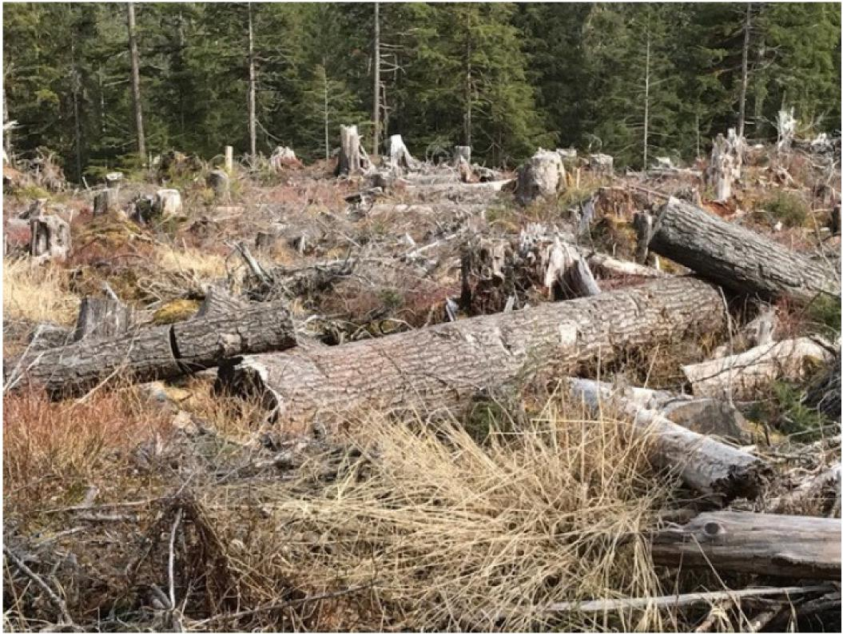

According to Pacific Northwest forester John Bliss:

Social research focused on public aesthetic judgments of forest practices has overwhelmingly concluding that Americans find clearcutting aesthetically offensive. Most research on scenic beauty assessment finds that forest scenes rated high in aesthetic quality contain large trees, low to moderate stand densities, grass and herb cover, color variation, and multiple species. Scenic beauty is reduced by small trunks, dense shrugs, bare ground, woody debris, and evidence of fire or other disturbance.118

Bliss’ findings are consistent with academic studies that consider the growth of nature-based tourism in areas formerly dominated by timber development:

Forest preference studies conclude that people appreciate mature forests with good visibility, some undergrowth and a green field layer with no signs of soil preparation. Forests are thought to be in their natural state, or that look natural and bear no visible traces of human activity are usually preferred. Correspondingly, the view after clearcuts is the least preferred environment. In particular, the large size of the regeneration area and direct traces of cutting,

118 Exh. 35. Bliss, J.C. 2000. Public perceptions of clearcutting.



such as signs of soil preparation and logging residues, have a negative impact. Furthermore, on average, people do not prefer dead or fallen trees.119

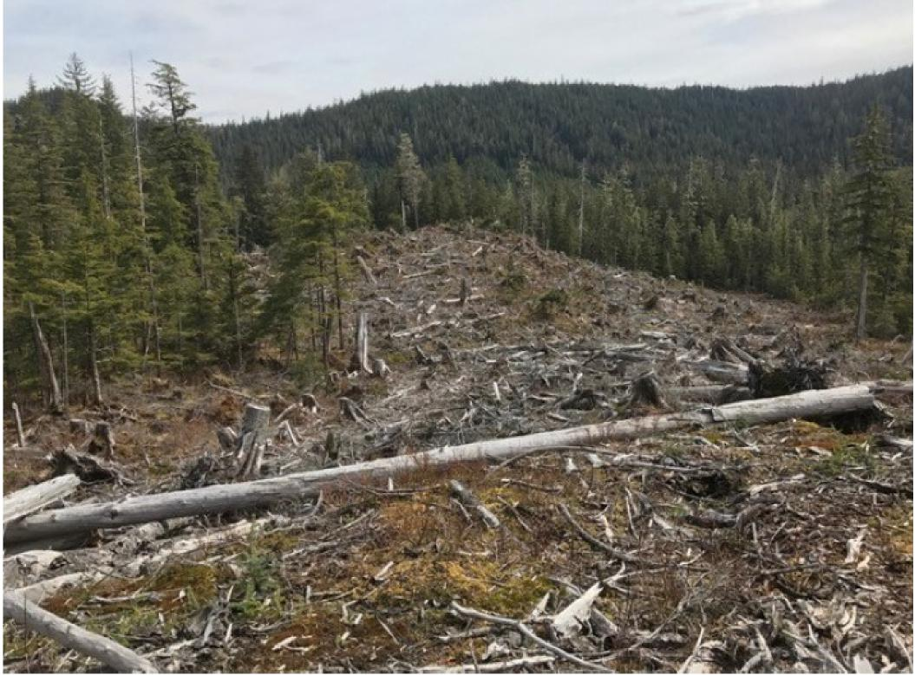

The proposal to weaken scenery standards through a Forest Plan amendment is inconsistent with the agency’s own planning rule. Plan amendments require “a preliminary identification of the need to change the plan” that may be based on a new assessment, a monitoring report; or other documentation of new information, changed conditions, or changed circumstances.”120 The sole reason for compromising Scenic Integrity objectives is to make potentially thousands of additional acres available for clearcutting in order to reduce the potential for deficit appraised timber sales.121 Deficit appraisals are not a changed condition.

The Forest Service’s planning rule also requires that plan components make “contributions to social and economic sustainability considering social, cultural and economic conditions, sustainable recreation, including recreation settings, opportunities, access and

119 Exh. 36. Tyrvainen, L, H Silvennoinen & Ville Halliakainen. 2016. Effect of the season and forest management on the visual quality of the nature-based tourism environment: a case from Finnish Lapland. In: Scandinavian Journal of Forest Research 2017. Vol 32, No. 4, 349-359

120 36 C.F.R. 219.3(b).

121 DEIS at 3-69-70, 3-295; PR 0832_0965.



scenic character, multiple uses and opportunities to connect people with nature.”122 Indeed, planning rule provisions provide multiple instructions to account for aesthetic values and scenic character.123 Appendix F of the Forest Plan identifies Visual Priority Routes – plan

components - where each Ranger District must emphasize scenery, such as routes utilized by cruise ships, ferries and private boaters. The weakening of Scenic Integrity Objectives appears to be a back door approach to removing the Visual Priority Routes.

The Forest Service has provided no assessment, new information, changed conditions or changed circumstances to justify clearcutting adjacent to Visual Priority Routes. The Forest Plan desired condition for Visual Priority Travel Routes is that forest visitors, recreationists and others “will view a natural-appearing landscape.”124 The DEIS does not provide any information showing that use patterns along these routes have changed in a way that warrants a plan amendment. Indeed, as explained in the preceding sections and anticipated by the Forest Service, use of Visual Priority Routes for scenic values is increasing. There is no data supporting the change from a scenery analysis perspective – indeed, the Forest Service’s approach “would eliminate a basic component of the agency’s Scenery Management System – the viewer – from the analysis.”125

Finally, the analysis of scenery in the DEIS is inadequate. For a much smaller project occurring near Ketchikan, the Forest Service recognized that impacts to scenery and recreational opportunities warranted analysis as a significant issue.126 A primary purpose of NEPA is to “assure for all Americans ... esthetically and culturally pleasing surroundings” and agencies must incorporate “the environmental design arts in planning and in decisionmaking.”127 Also, the Forest Plan requires the agency to “[p]erform landscape/viewshed analysis, using as much of the available tools and technology as possible, when planning projects within viewsheds seen from Visual Priority Travel Routes and Use Areas.”128 The Forest Service recognizes that it is a challenge to quantify the scenery resource.129 Indeed, the tables provided in the DEIS simply quantify acreage and fail to illustrate the visual impacts of Forest Service projects. The Forest Service needs to redo the DEIS and make scenic impacts a significant issue, and complete a full and site-specific scenery analysis that discloses to the public the full visual impact of clearcuts in Visual Priority Routes:

122 36 C.F.R. 219.8 (b(2).

123 219.10(a)(1); 219.10(b)(1)(i).

124 2016 Forest Plan at 3-103.

125 Exh.

126 USDA Forest Service. 2015. Saddle Lakes Timber Sale Final Environmental Impact Statement.R10-MB-740a at 180. Ketchikan-Misty Fiords Ranger District, Tongass National Forest, Ketchikan, Alaska. September 2015.

127 42 U.S.C. § 4331(b)(2); § 4332(a).

128 USDA Forest Service. 2016. Land and Resource Management Plan at 4-54. Alaska Region, Tongass National Forest. R-10-MB-769j. December 2016.

129 USDA Forest Service. 2015. Saddle Lakes Timber Sale Final Environmental Impact Statement.



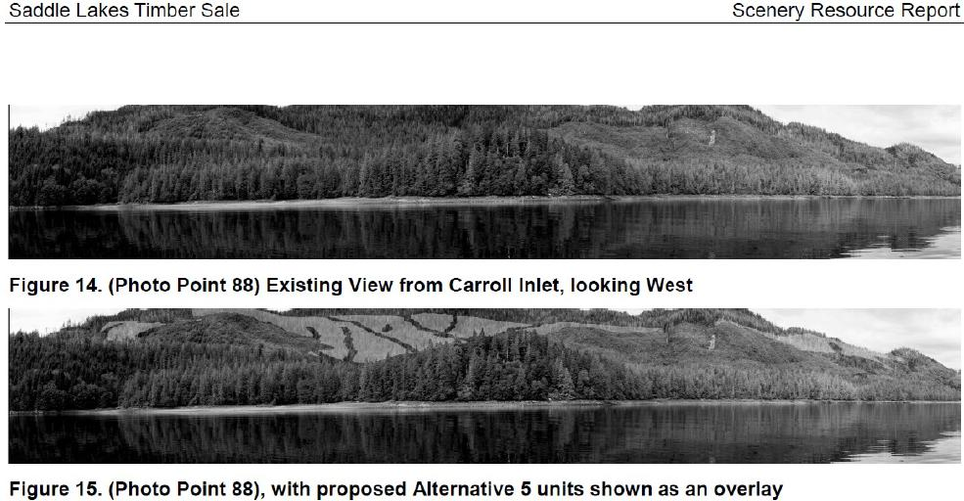



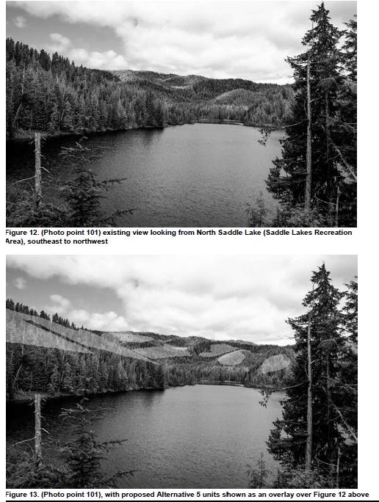



**The DEIS needs to provide more site-specific analysis of impacts to wildlife**

Our businesses provide clients with scientific and ecological information about southeast Alaska’s black and brown bears and bear viewing opportunities throughout the Central Tongass Project area.130 The Forest Service’s responsibility to maintain foraging, denning and other habitat needs for bear populations in the project area is of considerable socio-economic significance. The DEIS identifies bear viewing opportunities at Anan as a recreation asset, but arbitrarily fails to disclose timber sale impacts to bears and to bear viewing opportunities throughout the project area.131

The agency has previously provided analysis of impacts to black and brown bears because of their economic value for hunting and wildlife viewing.132 Bears are a top species for wildlife viewing visitors in Alaska and generate millions of dollars in regional economic impacts. In 2011, wildlife hunting and viewing in general generated 2,463 jobs in southeast Alaska, $138 million in labor income and $360 million in total economic output.133 More recent studies specific to bears show that bear viewing generates massive economic impacts in southcentral Alaska and British Columbia’s Great Bear Rainforest.134 Visitors to Alaska and coastal rainforests in British Columbia identify bear viewing opportunities as a primary reason for their visits.135

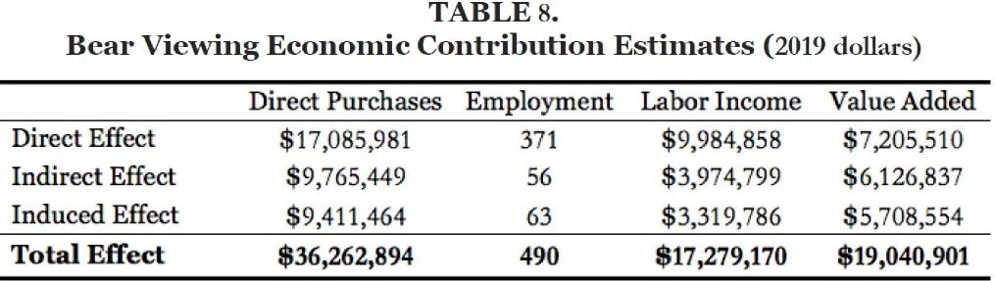

130 [https://www.theboatcompany.org/resources-forms/frequently-asked-questions/](https://www.theboatcompany.org/resources-forms/frequently-asked-questions/;);

[https://www.uncruise.com/destinations/alaska-cruises/wildlife](https://www.uncruise.com/destinations/alaska-cruises/wildlife;); <https://www.lindbladalaska.com/cruises/wild-alaska-escape/>

131 DEIS at 3-277; *see also* PR# 566 (Rain Coast Data 2018) showing an annual economic impact to Wrangell of $1.9 million based on spending by visitors to Anan alone).

132 *See, e.g.* Wrangell Island Project Draft Environmental Impact Statement. 2016 at 76. U.S. Forest Service, Alaska Region. Tongass National Forest, Wrangell Ranger District. R10-MB-634. May 2016.

133 PR #832-0560 (EcoNorthwest 2014).

134 Table 8: Exh. 28. Young, T.B. & J.M. Little. 2019. The economic contribution of bear viewing in south central Alaska. University of Alaska Fairbanks. Table 1.5: Exh. 24. Center for Responsible Travel. 2014. Economic impact of bear viewing and bear hunting in the Great Bear Rainforest of British Columbia. Washington, D.C.

135 *Id.;* PR #832-0560 (EcoNorthwest 2014)



**Table 1.5 Bear Viewing: Economic Impacts ($000)**

|  |
| --- |
|  |
| **Visitor Spending'** |
| **Company Revenues2** |
| **Material purchases3** |
| **GDP4 --- of which** |
| **Labor costs** |
| *Wages and Salaries5* |
| *Mixed Income6* |
| *Benefits (Supplementary Labor Income or SLI)* |
| **Employment** |
| **Employment (FTE)7** |

|  |  |  |  |
| --- | --- | --- | --- |
| **Direct** | **Indirect** | **Induced** | **TOTAL** |

|  |  |  |  |
| --- | --- | --- | --- |
| $15,109.0 |  |  |  |
| $14,114.9 | $1,884.0 | $1,700.8 | **$17,699.8** |
| $6,805.6 | $756.2 | $596.3 | **$8,158.1** |
| $7,309.3 | $1,127.9 | $1,104.6 | **$9,541.7** |
| $4,889.6 | $722.2 | $646.3 | **$6,258.1** |
| *$4,486.9* | *$584.1* | *$434.4* | ***$5,505.4*** |
| *$0.0* | *$57.9* | *$157.6* | ***$215.5*** |
| *$402.6* | *$80.3* | *$54.2* | ***$537.1*** |
| 510 | 13 | 12 | **535** |
| 111 | 11 | 10 | **133** |

**Figure 1.9: Reasons for Visiting British Columbia (N=71)**

90% -

**79%**

Bear Viewing Wildlife Viewing Cultural Tourism Other

**Reason for visiting the GBRF**

80% -

70% -

60% -

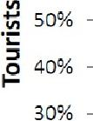

30% -

20% -



**45%**

**21%**

**13%**



10% -

0%

**Indeed, bear viewing opportunities best meet stated project purposes in terms of business stability and growth:136**

**136 Exh. 24.**



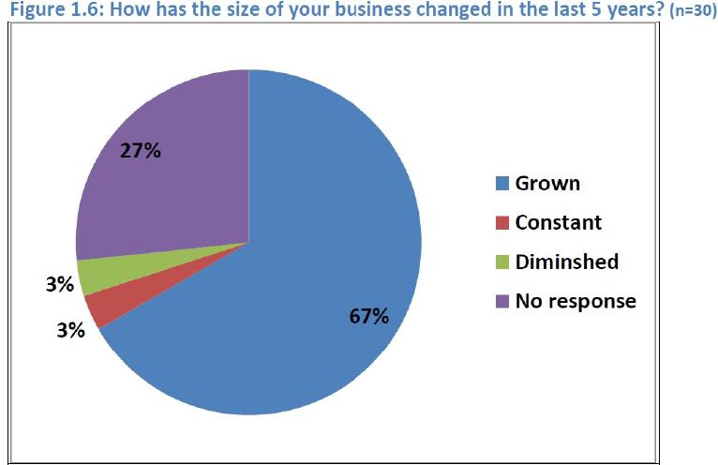

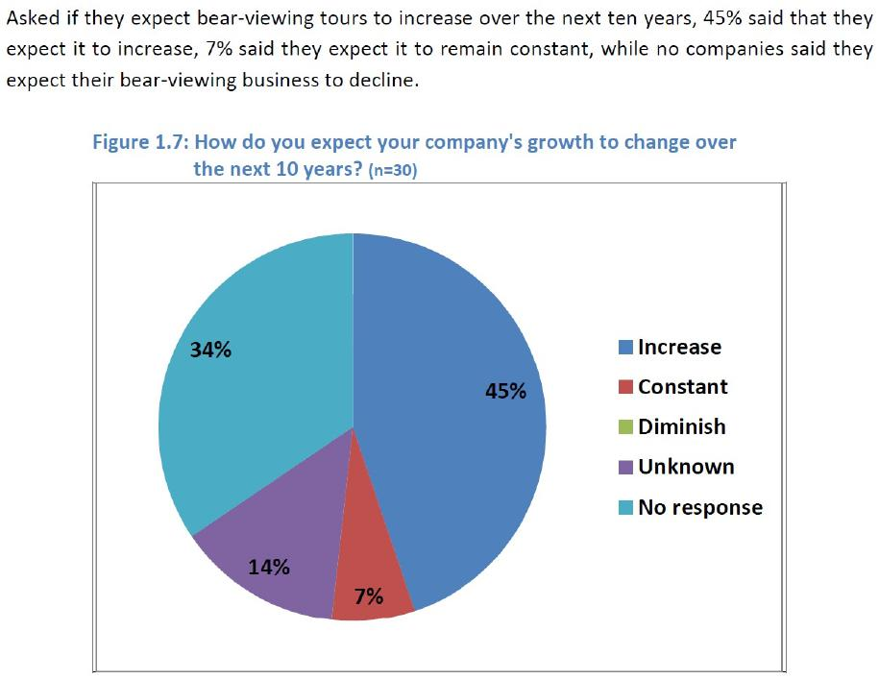



Additionally, bears are an umbrella species with large area requirements and varied habitat uses, including riparian areas, estuaries and old-growth forests. The health of black bear populations is an indicator of overall ecosystem integrity. The Forest Service needs to produce a revised DEIS that evaluates black and brown bear population status and trends and identifies project impacts to specific ecological needs and other risks. The DEIS fails in particular to provide a meaningful discussion of abundance trends, disclose the cumulative effects of future losses of black bear summer habitat during times of reduced pink salmon abundance, and explain how the Forest Service will maintain adequate denning habitat and address other impacts of human caused disturbances to bears.

The Forest Service regulations implementing the National Forest Management Act require the agency to manage fish and wildlife habitat “to maintain viable populations of existing native and desired non-native vertebrate species in the planning area.”137 A viable population “has the estimated numbers and distribution of reproductive individuals to insure its continued existence is well distributed in the planning area.”138 This means the Forest Service must “insure that viable populations will be maintained, habitat must be provided to support, at least, a minimum number of reproductive individuals and that habitat must be well distributed so that those individuals can interact with others in the planning area.”139 The 2016 Amended Forest Plan incorporates these viability obligations: “Provide the abundance and distribution of habitat necessary to maintain viable populations of existing native and desirable non-native species well-distributed in the planning area (*i.e.*, the Tongass National Forest).”140

Further, NEPA’s purpose is to “help public officials make decisions that are based on understanding of environmental consequences, and take actions that protect, restore and enhance the environment.”141 High quality information and accurate scientific analysis are essential to implementing NEPA.142 An EIS must explain baseline conditions as part of the agency responsibility to “succinctly describe the environment of the area(s) to be affected ... by the alternatives under consideration” and “insure that environmental information is available to public officials and citizens before decisions are made and before actions are taken.”143 Thus agencies must “consider every significant aspect of the environmental impact of a proposed action” and to “inform the public that it has indeed considered environmental concerns in its decisionmaking process.”144

The DEIS fails to conduct both the requisite project-specific, species-specific impacts analysis needed to ensure compliance with NFMA and the 2016 Amended Forest Plan. The agency’s use of condition-based analysis does not ensure the level of habitat protection required by NFMA or the 2016 Amended Forest Plan.145 The DEIS identifies moderate effects

137 36 C.F.R. § 219.19 (2000).

138 *Id*.

139 *Id*.

140 *See* 2016 Amended Forest Plan at 4-85.

141 40 C.F.R. § 1508.1(c).

142 *Id.* § 1508.1(b).

143 40 C.F.R. § 1502.15; 1500.1(b); *N. Plains Res. Council v. Surface Transp. Bd.,* 668 F.3d 1067, 1084 (9th Cir. 2011); *Oregon Natural Desert Ass’n v. Jewell,* (9th Cir. 2016)

144 *Baltimore Gas & Elec. Co. v. Natural Res. Def. Council, Inc.,* 462 U.S. 87, 97 (1983).

145 *See, e.g.,* 2016 Amended Forest Plan at 4-92.



to several management indicator species, including wolves, marten, brown creeper, hairy woodpecker and deer.146 Moderate impacts could entail long-term consequences for individuals or habitat, or disturbances that affect vulnerable life stages such as foraging or reproduction.147

But then it states that impacts to black and brown bears would be “minor” – meaning that there would be no long-term impacts to the species as a whole but merely occasional disturbances to individual bears.148 There is no meaningful analysis to support this conclusion. The DEIS merely provides a tabular “summary of effects” that notes potential reductions in foraging habitat (within 500 feet of Class I streams) and denning habitat across large areas without ever disclosing or considering the distribution of project impacts in specific timber analysis areas where the agency proposes landscape scale clearcutting.149

The effects conclusion is a reversal of more detailed agency analyses determining that smaller timber sales in the project area would have “moderate” effects to black bears because of broad reductions in old-growth forest habitat, reductions in denning habitat, reductions in foraging habitat and disturbances during summer, and increased vulnerability to human harvest.150 In other proposed Timber Analysis areas such as Wrangell Island, the agency has identified serious concerns with long-term decreases in habitat suitability, loss of denning habitat and susceptibility to over-harvest due to high road densities.151 These effects led the Forest Service to identify significant cumulative effects and conclude that the species would at best, “persist.”152

The effects conclusions in the DEIS are arbitrary. The main threat to brown bear populations in the project area is clearcut logging.153 Average male skull size of black bears is declining for unknown reasons, and state biologists have identified a likely declining trend in black bear populations caused by carrying capacity reductions caused by clearcut logging. The Alaska Department of Fish and Game explains that:

We remain concerned about the extensive habitat changes occurring throughout [Central Southeast Alaska] due to logging. ... More than 129,000 acres of forested habitat in Unit 3 have been logged to date. As a result, timber harvest poses the most serious threat to black bear habitat in the unit over the long term. Black bears are able to exploit increases in forage in early-successional plant communities immediately after logging and may temporarily benefit from clearcutting. However, this food source is lost approximately 2-25

146 DEIS at 3-104.

147 *Id.* at 3-105.

148 *Id.* at 3-104.

149 *Id.* at 3-151.

150 USDA Forest Service. 2012. Tonka Timber Sale Final Environmental Impact Statement at 3-70-3-72. R10-MB-705c. Tongass National Forest, Petersburg, Alaska. March 2012; *see also* Dungan, J. 2014. Wildlife Resource Report, Mitkof Island EA. Petersburg Ranger District, Tongass National Forest, Alaska (an 843 acre project, includes harvest of POG within 500 ft of class 1 streams, resulting in reduction to foraging habitat).

151 Wrangell Island Project Draft Environmental Impact Statement. 2016 at 98. U.S. Forest Service, Alaska Region. Tongass National Forest, Wrangell Ranger District. R10-MB-634. May 2016.

152 *Id.* at 100.

153 Lowell, R. 2011. Unit 3 brown bear management report. Pages 19-27 in P. Harper, editor. Brown bear management report of survey and inventory activities. 1 July 2008-30 June 2010. Alaska Department of Fish and Game. Juneau, Alaska.



years postlogging with canopy closure, and second-growth forest provide little bear habitat. ...Large clearcuts on Mitkof, Wrangell, and Kupreanof Islands will diminish in value as bear habitat over the next few decades.154

The project record also indicates that a reduction in *suitable* den sites can lead to decreased black bear populations making consideration of an adequate number of den sites across the landscape a critical factor.155

Our companies provide bear viewing opportunities in project area Timber Analysis Areas and submit that a revised DEIS must provide a meaningful, informed discussion of timber sale impacts on bears. Two sentences in a table describing broad habitat measurements across the project area are inadequate.

**The DEIS needs to provide baseline information about project area salmon**

**populations**

A related problem is that the DEIS fails to disclose or analyze trends in salmon abundance in the project area - a significant factor for project area bears. Will disturbances caused by logging have a greater impact now with reduced foraging opportunities? Salmon also support project area sport, commercial and subsistence fisheries. Our scoping comments requested that the DEIS review historical harvest data, provide a detailed description of current stock status in project area watersheds, and disclose the cumulative impacts of additional clearcutting and road construction on this important southeast Alaska resource.

The omission of any current harvest data or information about project area salmon populations is a major oversight in the DEIS. NEPA requires an analysis of impacts to fish species prior to authorizing large logging and road construction activities in salmon habitat.156 An EIS must explain baseline conditions as part of the agency responsibility to “succinctly describe the environment of the area(s) to be affected ... by the alternatives under consideration” and “insure that environmental information is available to public officials and citizens before decisions are made and before actions are taken.”157 Thus agencies must “consider every significant aspect of the environmental impact of a proposed action” and to “inform the public that it has indeed considered environmental concerns in its decisionmaking process.”158 The omission of such an analysis also violates NFMA by ignoring Forest Plan requirements to use management indicators to evaluate potential project activities affecting fish habitat.159

Our scoping comments noted that, as a tour operator that provides guided sport fishing opportunities, The Boat Company’s fishing guides have decades of experience fishing project area watersheds and have observed that salmon returns for several species, particularly in

154 Lowell, R. 201r. Unit 3 black bear management report. Chapter 6, Pages 6-1 through 6-26 in P. Harper and L.A. McCarthy, editors. Black bear management report of survey and inventory activities. 1 July 2010-30 June 2013. Alaska Department of Fish and Game. Juneau, Alaska.

155 Davis, H, A.N. Hamilton, A.S. Harestead & R.D. Weir. 2012. Longevity and Reuse of Black Bear Dens in Managed Forests of Coastal British Columbia. In: Journal of Wildlife Management 76(3):523-527.

156 *Pacific Rivers Council v. U.S. Forest Serv.,* 689 F.3d 1012, 1025-1030 (9th Cir. 2012).

157 40 C.F.R. § 1502.15; 1500.1(b); *N. Plains Res. Council v. Surface Transp. Bd.,* 668 F.3d 1067, 1084 (9th Cir. 2011); *Oregon Natural Desert Ass’n v. Jewell,* (9th Cir. 2016)

158 *Baltimore Gas & Elec. Co. v. Natural Res. Def. Council, Inc.,* 462 U.S. 87, 97 (1983).

159 Forest Plan at 4-12.



Frederick Sound and Chatham Strait were exceptionally poor in 2018. In addition, ongoing drought conditions are affecting salmon distribution, run timing and potentially abundance throughout the state. 160

ADF&G harvest data show a declining abundance trend:

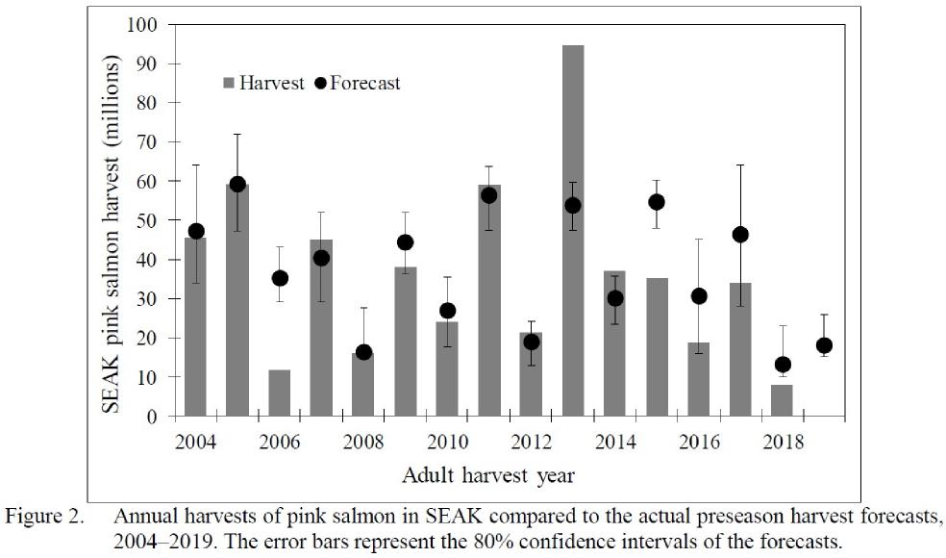

A review of ADF&G management reports indicates that the declining abundance trend is most severe in fishing regulatory districts encompassed within the Petersburg Ranger District’s portion of the project area.161 Indeed, 2019 test fisheries conducted at Kingsmill Point on Kuiu Island and Pt. Gardner on Admiralty Island were exceptionally poor for pink salmon returning to Frederick Sound:

160 [https://www.krbd.org/2019/08/12/ketchikan-wildlife-affected-by-drought/](https://www.krbd.org/2019/08/12/ketchikan-wildlife-affected-by-drought/;); <https://www.juneauempire.com/news/southeast-pink-salmon-forecast-cause-for-concern/> <https://www.alaskajournal.com/2019-08-20/drought-and-dry-conditions-impacting-salmon-across-state>

161 *See, e.g.* Exh. 26 (ADF&G 2018).



2019 Point Gardner Test Fishery Results

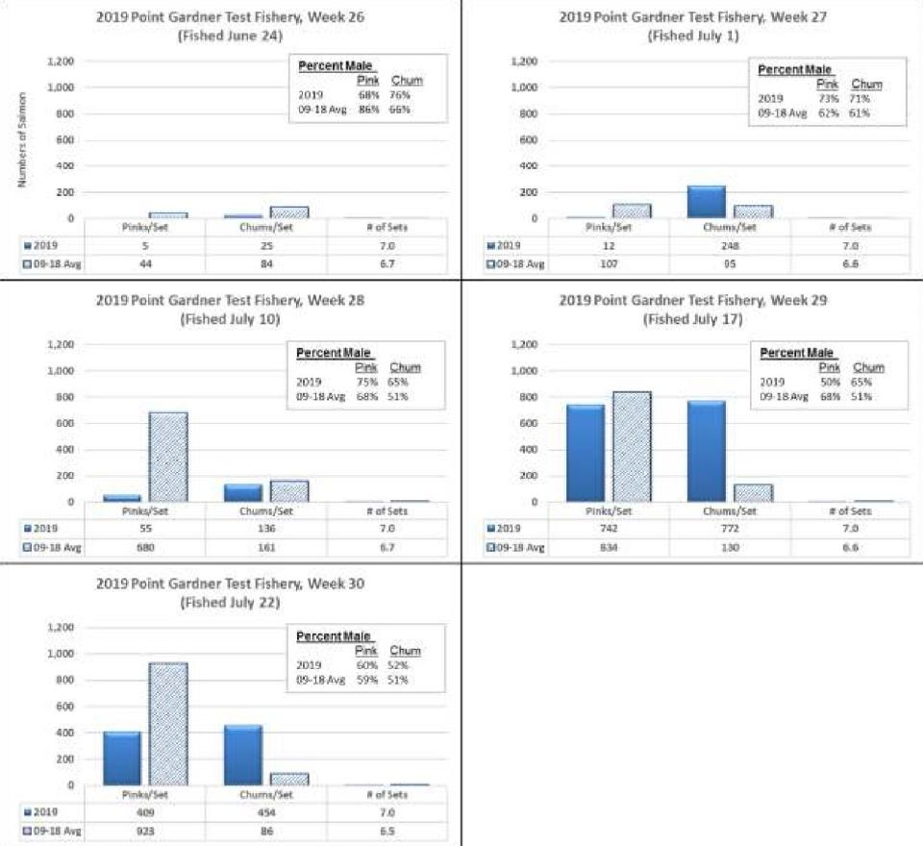

**1.200 1,1130 800 GOO**

400

**II 1019**

**009-1.11**

**742**

**834**

**It of Seca**

**70**

**percantilele**

**Prig Churn**

019 **73% 71%**

**09-18596 62% 61%**

**2019 Point Gardner Test Eisner'', Week 26 (Fished June 24)**

**Percent Mate**

**Eisk chain**

**2019 68% 76%**

**09 ZBAYs 86% fib%**

600

400

**200**

**0**

**Chi/ion/Sig RorS.t.**

**17019 S 2S 7.0**

**DOB- 113 Aery 44 BO** 6.7

**1.200**

**1,000**

**000**

**2019 Point Gardner** Test **_thery, Week 27 (tithed July 1)**

***200***

**0** 1771 **li ,...::..,:,--7,**

**Chunnyloo • of Soo.**

* **74119 12** iiii 7_0

an- **LEI Avg 107 OS 6_6**

**/019 Point Gardner Test Fishery, Week 28 (Fished July 10)**

1=1

**55**

**580**

**1,200**

**1.000**

800

**600 on(i**

**200**

**12010**

**0 09- 111 A.,(5**

**PerceatMale**

Est **gcb.km**

**2039 25% 65%**

**09 18 Avg 68% 51%**

Chi i,'SeC **it of Sett**

**136 7.0**

**161 117**

**7019 Point Gardner Test Fishery, Week 29 (Fished July 17)**

|  |  |  |  |  |  |
| --- | --- | --- | --- | --- | --- |
| **1.200**  **1-400** | | | **Percent Male** | |  |
|  |  |
|  |  |  | **2039** | **50%** | **65%** |
| **800**  **600** |  | **173,I8Avg** | **68%** | **51%** |
|  |
| **400** |  |  |  |  |  |
| **260** |  |  |  |  |  |
| **0** |  |  |  |  |  |

**2019 Point Gardner Test Fishery, Week 30 (Fished July 22)**

■

**Pink\***

**400**

**1,2011**

**1,003**

**(n)(1**

600

**400**

**200**

**a**

**12010 09-18 Oag**

**Percentklele**

**Pris Churn**

1019 60% Si%

**09-16/ivg 59% 51%**

**I htirrie,e$Pt I c454t.**

**454 7.0**

**H6** 65

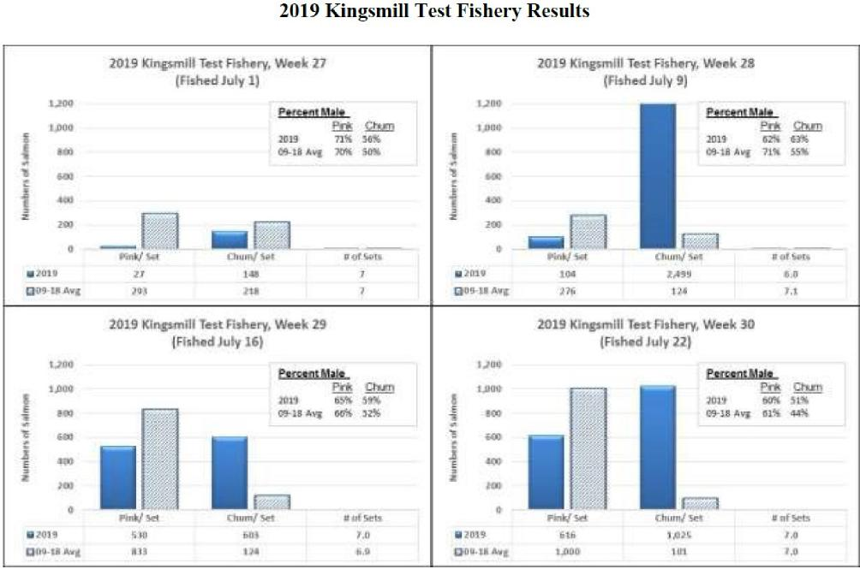

The description of fisheries in the DEIS ignored the current status of fish populations, and only vaguely noted the existence of “thirteen fish species.”162 The fish habitat assessment identified 3,178 miles of Class I and 1,936 miles of Class II streams in the project area, and explains that the project generally could result in changes to water yield, peak flow volume, and timing of flow delivery, sediment delivery, altered riparian vegetation and herbicide treatments and road stream crossing channel disturbance.163 There are 452 failed culverts in the project area blocking access to upstream spawning habitat. 164 But nowhere does the Forest Service acknowledge or even consider whether these activities could increase cumulative risks given drought conditions, poor marine productivity, and declining abundance trends – because the DEIS ignores baseline conditions and entirely omits a description of project area salmon species. The level of analysis is inadequate under NEPA, and the Forest Service must produce a revised DEIS.

162 DEIS at 3-169.

163 id at 3-187.

164id at 3-160-161



**Conclusion**

For the above reasons, we request that you cease planning on this project. If you do proceed, we request that you prepare a revised DEIS that: (1) includes action alternatives that respond to project area socio-economic needs with specific funded recreation infrastructure improvements and diminished timber volumes; (2) provides site-specific information about visitor use in areas proposed for large timber sales and discloses adverse impacts to tour operators; (3) abandons the proposal to weaken scenic values through a Forest Plan amendment and (4) provide a more detailed discussion of project area wildlife and fish species, including baseline information, population trends, and site-specific risks.

Sincerely,



Paul Olson, Attorney at Law

Hunter McIntosh

President

The Boat Company

Washington, D.C. 20036

Captain Dan Blanchard   
CEO/Owner

UnCruise Adventures

Juneau, AK 99802

Craig Moylan

Lindblad Expeditions

Director of Expedition Development – North and Central America

Seattle, WA 98121

