August 30, 2022

Jamie Barbour
Assistant Director for Adaptive Management
USDA Forest Service
Washington Office, Ecosystem Management Coordination Staff
1220 SW 3rd Avenue, Suite 1400
Portland, OR 927204
roy.barbour@usda.gov

Re: Request for information (RFI) on Federal Old-growth and Mature Forests
https://cara.fs2c.usda.gov/Public/CommentInput?project=NP-3239

Dear Mr. Barbour,

Standing Trees submits the following comments regarding the U.S. Forest Service’s July 15, 2022, Request for Information (RFI) on Federal Old-growth and Mature Forests. In addition to the comments below, Standing Trees supports and incorporates herein by reference the August 30, 2022 comments of the Climate Forests Coordinating Group, of which Standing Trees is a member, submitted via CARA online portal and email. Thank you in advance for your careful consideration of our comments.

Standing Trees is an incorporated nonprofit dedicated to advancing policy and legal solutions that protect and restore New England’s native forests. Standing Trees seeks to hold state and federal agencies accountable for their actions that affect forests, and to ensure that land-managers and policymakers follow the latest climate and biodiversity science. We offer the following input on definitions and context for mature and old-growth forests, and the conservation of mature and old-growth forests as required by EO 14072, “Strengthening the Nation's Forests, Communities, and Local Economies,” issued April 22, 2022.

I – Introduction:
On the global scale, forest protection could facilitate approximately half or more of the climate change mitigation needed to hold temperature rise to 1.5 degrees Celsius. However, as noted by Executive Order 14072, “only a small fraction of the world’s mature and old-growth forests remains.” To address this opportunity, EO 14072 directs the USDA and USDOI to “manage forests on Federal lands, which include many mature and old-growth forests, to promote their continued health and resilience; retain and enhance carbon storage; conserve biodiversity; mitigate the risk of wildfires; [and] enhance climate resilience,” among other goals.

The recently-released USDA Forest Service Climate Adaptation Plan notes that mature and old-growth forests are “often viewed as ideal candidates for increased conservation efforts, and are frequently found within areas designated as wilderness or roadless or other management areas where timber harvest is precluded.” The USDA Forest Service Climate Adaptation Plan is wise to highlight the inverse relationship between timber harvest levels and amounts mature and old-growth forests. As implied by the USDA Forest Service Climate Adaptation Plan, there is no greater threat to the extent of mature and old-growth forests on federal public lands than logging.

The following comments, coupled with those of the Climate Forests Coalition, make a clear case for rulemaking to permanently prohibit logging of stands and trees over age 80 on federal public lands.

II – Mature and Old-growth Forests in Context:
Due primarily to human-driven forest conversion (i.e. development, agriculture) and degradation (i.e. logging, fragmentation), mature and old-growth forests, once common in the forested regions of the US, are today underrepresented compared to historical levels. Prior to European settlement, old-growth forests were the dominant land cover of northern New England, including the locations of the White and Green Mountain National Forests.

Today, old forests, which once dominated the region, are functionally absent from northern New England. Elk, caribou, wolverine, wolves, cougars, pine marten, and salmon, once common in New England, have been entirely eliminated or – in the case of salmon – significantly diminished. By any objective measure of ecosystem health, northern New England’s ecosystems remain on life support.

According to the definitive paper on disturbance frequency and intensity in New England, Lorimer and White 2003, “the estimated proportion of the landscape in old-growth forest (>150 years old) [was] 70–89%” before European settlement in regions dominated by northern hardwoods, including much of what is now the White and Green Mountain National Forests. “The proportion of the presettlement landscape in seedling–sapling forest habitat (1–15 years old) ranged from 1 to 3% in northern hardwood forests (Fagus–Betula–Acer–Tsuga) of the interior uplands.” “The current estimates of 9-25% [seedling-sapling habitat] for the northern New England states are probably several times higher than presettlement levels.” Gap size in Hemlock-Northern Hardwood forests averaged less than .75 acres. Beech was the dominant species among Northern Hardwoods, comprising perhaps 30% of the forest. Stand-replacing events occurred, on average, only every 1,000 to 7,500 years.

A 2008 paper builds on these themes: “Although humans have a long history (about 12,000 years) on the North American continent, the magnitude of change wrought by European settlement has no parallel since the last glaciation... In New England, rates of landscape change have been far greater in the past 300 years than in the previous 1000 years as a result of forest cutting, agricultural conversion, urban development, altered fire regimes and herbivore populations, nonnative species introductions, and atmospheric pollution… There has been no return to presettlement conditions because of continuing low-level disturbance and…insufficient recovery time.”

We can measure New England’s progress towards forest ecosystem restoration against several large landscape conservation visions that have gained traction in the past fifteen years. In 2006, Wildlands and Woodlands, a program of Harvard Forest and Highstead Foundation, produced a widely supported vision for New England that included a goal for 10% of all regional forestlands to be conserved as wildlands. Fifteen years later, only 3% of New England is in wildlands, and relatively little progress has been made toward the 10% goal, despite excellent progress towards conserving forests for extraction of wood products.

More recently, based on the rapid decline of wildlife populations and the rapid degradation of the climate, scientists have suggested that much more aggressive measures must be taken to stave off climate and extinction catastrophe. The 2019 Global Deal for Nature (the inspiration for “30x30”) calls for 30% of lands and waters to be permanently protected in GAP 1 and 2 protected areas by 2030 to maintain and restore biodiversity, with an additional 20% percent conserved to stabilize the climate. This vision was partially endorsed by the Biden Administration in Executive Order 14008, “Tackling the Climate Crisis at Home and Abroad.”

Large blocks of intact forest minimize harmful vectors for the spread of invasive species and allow natural disturbances to play out across a sufficiently large landscape to ensure that there is a mix of early and late successional habitats required by the full spectrum of New England’s forest-dependent species. Although passive management is most often all that’s required to restore old forest conditions, it takes centuries to develop forest complexity, requiring permanent protection from timber harvest if restoration is to be successful.,,,,

III – Threats to mature and old-growth forests:
Logging is the single greatest influence on the amount and extent of mature forests across the US, and is easily the most preventable threat to mature forests when compared to fire, insects, disease, and other disturbances. A 2013 study found that "Logging is a larger cause of adult tree mortality in northeastern U.S. forests than all other causes of mortality combined." This finding was reinforced in another study from 2018: "[Logging] comprises more than half of all mortality (on a volume basis), making logging the predominant disturbance—natural or anthropogenic— affecting forest ecosystems in the region."

This level of timber harvest has a significant impact on forest carbon – far greater than any other factor. Timber harvest drives 92% of annual forest carbon losses in the US South, 86% in the North, and 66% in the West. For comparison, the second greatest impacts on forest carbon in each region are as follows: West: fire (15%); North: insect damage (9%; South: wind damage (5%).

Forthcoming research led by Dr. Dominick DellaSala provides the first nationwide assessment of present levels of mature forests in the US. Today, mature and old-growth forests represent ~36% of all forest age classes across the nation, with the greatest amount in a single ownership (35%) located on federal lands. Of the mature forests on federal lands, 92% are managed by the US Forest Service, 9% by the Bureau of Land Management, and 3% by the National Park Service. These forests simultaneously support the highest concentrations of drinking water source areas, at-risk ecosystems, and aboveground living biomass. Despite their exceptional value, the vast majority of mature forests on federal lands (76%), storing approximately 10.64 Gt of CO₂, are unprotected from logging.

Of the mature forests identified by Dr. Dellasala’s study, old-growth represents a tiny fraction in each region of the United States outside of Alaska, demonstrating the need for policies that put a greater percentage of forests on a path to recover late successional forests. In the Eastern US, old-growth comprises just 1.6% of South-Central US forests, 1.1% of the Upper Midwest forests, .5% of Southeast US forests, and .4% of forests in the Northeast.

As evidenced above, the Northeast US has lost a greater percentage of its old-growth forests than perhaps any other region of the US. Private lands across New England are managed more intensively for timber harvest compared with federal public lands. This is especially pronounced in the northern New England states of Maine, New Hampshire and Vermont, where the vast majority of forests are privately owned (~94% of Maine). Recent modeling suggests that logging, not forest conversion, will continue to be the greatest factor in regional aboveground forest carbon over at least the next 50 years.

Although there is a large amount of maturing forest (80-100) across the landscape, future harvests will target these forests where they occur on private lands. Despite widespread forest maturation, rates of timber harvest in New England are such that trends in regional amounts of late successional forest structure are static, and the amount of large diameter standing snags is declining. “Even though forests of the Northeast are aging, changes in silviculture and forest policy are necessary to accelerate restoration of old-growth structure.” A strong, new rule protecting stands and trees on federal forests over the age of 80 is exactly the sort of policy that will allow mature and old-growth forests to return to New England’s landscape at meaningful scales.

IV – The exceptional values of mature and old-growth forests

- Forest Carbon
There is a common misconception that young forests are better than old when it comes to removing carbon in the atmosphere. First of all, old forests store much more carbon than young forests, and they continue to accumulate carbon over time.,, What’s more, the rate of carbon sequestration also increases as trees age. It can take up to 30 years after a regeneration cut for a young forest to become a carbon sink instead of a carbon source.

Today, despite tree cover across the vast majority of the northern New-England landscape, the region’s forests do not produce high levels of ecosystem services due to current management practices, including harvest frequency and intensity, and are still recovering from extensive clearing in the eighteenth and nineteenth centuries. A 2019 paper by Harvard Forest researchers found that:
“Among land uses, timber harvesting [has] a larger effect on [aboveground carbon] storage and changes in tree composition than did forest conversion to non-forest uses… Our results demonstrate a large difference between the landscape’s potential to store carbon and the landscape’s current trajectory.”

Northeast secondary forests have the potential to increase biological carbon sequestration 2.3–4.2-fold. A 2011 paper by UVM Professor Bill Keeton found that:
“…There is a significant potential to increase total carbon storage in the Northeast’s northern hardwood-conifer forests. Young to mature secondary forests in the northeastern United States today have aboveground biomass (live and dead) levels of 107 Mg/ha on average (Turner et al. 1995, Birdsey and Lewis 2003). Thus, assuming a maximum potential aboveground biomass range for old-growth of approximately 250–450 Mg/ha, a range consistent with upper thresholds in our data set and the lower threshold observed at Hubbard Brook, our results suggest a potential to increase in situ forest carbon storage by a factor of 2.3–4.2, depending on site-specific variability. This would sequester an additional 72–172 Mg/ha of carbon.”

Forests in temperate zones such as in the Eastern U.S. have a particularly high untapped capacity for carbon storage and sequestration because of high growth and low decay rates, along with exceptionally long periods between stand replacing disturbance events, similar to the moist coastal forests of the Pacific Northwest. Further, because of recent recovery from an extensive history of timber harvesting and land conversion for agriculture in the 18th, 19th, and early 20th centuries, median forest age is about 75 years, which is only about 25–35% of the lifespan of many of the common tree species in these forests. Because of our remarkable forest ecosystems here in Northeastern North America, several global studies have highlighted the unique potential of our temperate deciduous forests to contribute on the global stage to climate stabilization and resilience.,

A 2013 study provides proof that protecting forests from logging is as close to a guarantee as there is for securing long-term carbon sequestration and storage. Strict protected areas prohibiting logging (i.e. GAP 1, IUCN Category 1, or equivalent classification) cover just 5% of the total land area of the mid-Atlantic and Northeast US (VA, PA, DE, NJ, NY, CT, RI, MA, VT, NH, ME). However, these protected areas account for “30% of the carbon stored in all forests in the region.”

- Climate Resilience and Water Quality
Old forests are also the most resilient to changes in the climate, producing the highest outputs of ecosystem services like clean water, and reducing the impacts of droughts and floods. These ecosystem services protect downstream communities from flooding, purify drinking water at low cost, and maintain base flows and low temperatures in rivers during hot summers for the benefit of fish and wildlife.

In New England, frequent flooding and nutrient-driven water quality degradation are two of our most costly environmental crises, and both are compounded by climate change. Mature and old forests naturally mitigate against flooding and drought by slowing, sinking, and storing water that would otherwise rapidly flow into our streams, rivers, and lakes. Scientists have also shown that old forests are exceptional at removing nutrients that drive harmful algae blooms, like phosphorus.

After Tropical Storm Irene ravaged New England in 2011, Vermont’s Department of Forests, Parks, and Recreation commissioned a report entitled “Enhancing Flood Resiliency of Vermont State Lands.” According to the report:
“There may be a tendency to assume that lands in forest cover are resilient to the effects of flooding simply by virtue of their forested status. However, forest cover does not necessarily equate to forest health and forest flood resilience. Headwater forests of Vermont include a legacy of human modifications that have left certain land areas with a heightened propensity to generate runoff, accelerate soil erosion, and sediment streams. These legacy impacts affect forest lands across the state... The quality of [today’s] forests is not the same as the pre-Settlement old growth forests. The legacy of early landscape development and a history of channel and floodplain modifications continue to impact water and sediment routing from the land.”

A 2019 study led by the University of Vermont looked into the climate resilience of older compared to younger forests. The research found that:
“[Older forests] simultaneously support high levels of carbon storage, timber growth, and species richness. Older forests also exhibit low climate sensitivity…compared to younger forests… Strategies aimed at enhancing the representation of older forest conditions at landscape scales will help sustain [ecosystem services and biodiversity] in a changing world… Although our analysis suggests that old forests exhibit the highest combined [ecosystem services and biodiversity (ESB)] performance, less than 0.2% of the investigated sites are currently occupied by forests older than 200 years. This suggests a large potential to improve joint ESB outcomes in temperate and boreal forests of eastern North America by enhancing the representation of late‐successional and older forest stand structures…”

Because of the overwhelming science in support of recovering America’s old-growth forests, a recent peer-reviewed paper calls for the establishment of Strategic Carbon Reserves, with an emphasis on roadless, maturing forests. The paper finds that:
- “Many of the current and proposed forest management actions in the United States are not consistent with climate goals... [P]reserving 30 to 50% of lands for their carbon, biodiversity and water is feasible, effective, and necessary for achieving them.”
- “Instead of regularly harvesting on all of the 70% of US forest land designated as ‘timberlands’ by the US Forest Service, setting aside sufficient areas as Strategic Reserves would significantly increase the amount of carbon accumulated between now, 2050 and 2100, and reestablish greater ecosystem integrity, helping to slow climate change and restore biodiversity.”
- “Preserving and protecting mature and old forests would not only increase carbon stocks and growing carbon accumulation, they would slow and potentially reverse accelerating species loss and ecosystem deterioration, and provide greater resilience to increasingly severe weather events such as intense precipitation and flooding.”

- Biodiversity
Many of New England’s native fish and wildlife species, including those that are often most imperiled, such as the Northern Long-eared Bat, pine marten, brook trout, Blackburnian and Cerulean Warblers, Scarlet Tanagers, and Wood Thrush, depend on large, unfragmented landscapes and structurally-complex old forests for suitable habitat., Mature, unfragmented, interior forests are rare in New England overall, making the Green and White Mountain National Forests important concentrations of such habitat within New England. When this habitat is fragmented or degraded, such as through road construction and logging projects, these species experience increased threats from interactions with humans, predation, changes in microclimates, the spread of invasive species, and other fragmentation and edge effects.

Pine marten are on the State of Vermont Endangered Species List, and one of only two viable populations in the state is located within the Green Mountain National Forest. A 2022 study analyzing marten populations in Maine found that “even partial harvest activities can diminish the canopy cover, structural complexity and overall basal area [that marten] require[.]” The same study found that “Marten…showed lower initial occupancy probability in areas of increasingly disturbed forest and had both higher extinction rates and lower colonization rates in these areas.”

Northern long-eared bats are federally listed as threatened and the US Fish and Wildlife Service has proposed to uplist the bat to endangered, with a decision due in the fall of 2023. The Northern long-eared bat depends on mature and old forests for roosting and foraging. Its preferred roosting habitat is large-diameter live or dead trees of a variety of species, with exfoliating bark, cavities, or crevices. And its preferred foraging habitat is old forest with complex vertical structure on hillsides and ridges.

V – America needs a straightforward rule to protect mature and old-growth forests
The Forest Service and Bureau of Land Management should promulgate a rule that establishes an objective, field-ready, easily-implementable, publicly verifiable metric to ensure compliance with EO 14072 and the protection of mature and old-growth forests to safeguard forest carbon, biodiversity, and a range of essential ecosystem services. Mature and old-growth forests are complex ecosystems. However, defining, inventorying, and conserving mature and old-growth forests, to meet the intent of EO 14072, need not and should not be a complex, subjective, or onerous process.

The Climate Forests Coalition’s comment letter provides a greater level of justification for setting a clear age threshold at age 80 for forest protection. Below we summarize this justification and provide additional rationale and context for New England.

Across the US, no matter the geographic location or forest type, forests begin to show characteristics of maturity no later than age 80. By this age, trees have typically reached or exceeded measures such as Culmination of Mean Annual Increment, Net Primary Productivity, and other metrics for growth and carbon sequestration that correlate with maturity. After age 80, most forest types will begin to show characteristics of old forests such as standing dead and downed wood, canopy gaps, and a mix of tree ages and sizes.

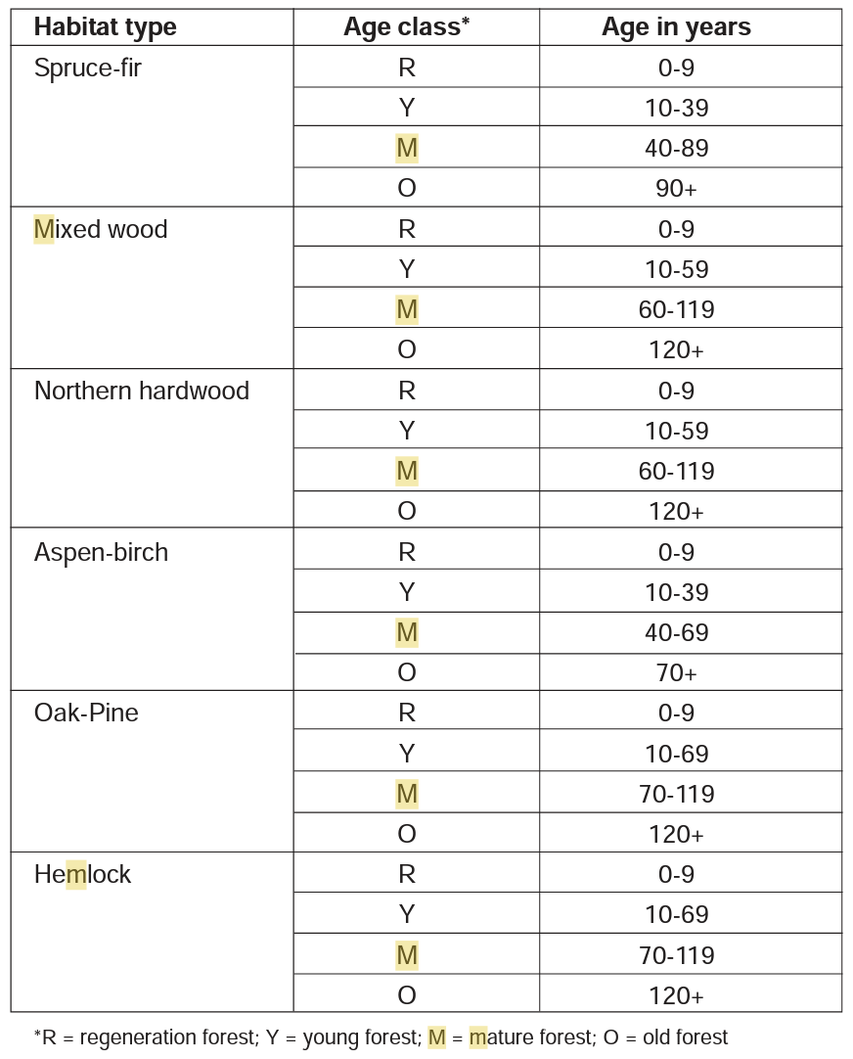
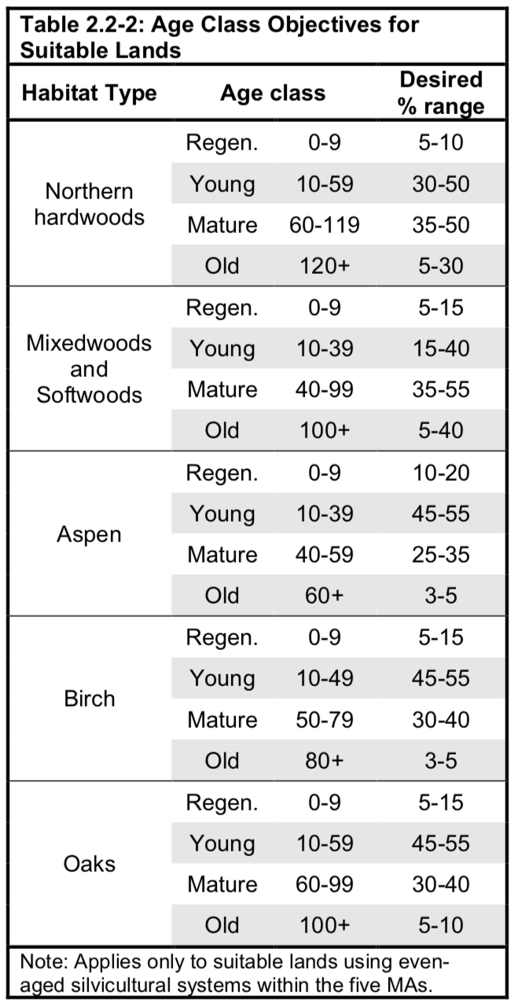
The White and Green Mountain National Forests both define mature forests in their Forest Plans based on age thresholds. The charts below show that all forest types reach maturity prior to age 80.
Figure 2 - 2005 Forest Plan Age Classes,
White Mountain National Forest.
Source document available for download here.
Figure 1 - 2006 Forest Plan Age Classes,
Green Mountain National Forest.
Source document available for download here.

Setting an age threshold through rulemaking to protect federal forests is reasonable, prudent, and efficient for meeting the goals of EO 14072. Other examples of similarly-structured rules or regulations are common and instructive. The 2001 Roadless Area Conservation Rule uses a 5,000-acre threshold, with exceptions for smaller areas, to protect intact forests across more than fifty million acres of lands managed by the US Forest Service. To use another example, we have established thresholds for human maturation at ages 18, 21, and 65. We do not suggest that all humans are identical, but these ages serve as prudent benchmarks for stages of growth and maturity.

VI – Conclusion
Executive Order 14072, “Strengthening the Nation's Forests, Communities, and Local Economies,” commands the USDA Forest Service and USDOI Bureau of Land Management “to conserve America’s mature and old-growth forests on Federal lands.” To meet the intent of this EO, the Forest Service and Bureau of Land Management should immediately commence a rulemaking process that protects mature and old-growth forests from their single greatest threat: logging.

By using a scientifically-valid threshold to define mature stands and trees beginning at age 80, land managers can effectively honor the purpose and intent of EO 14072, refocusing federal land management to accumulate and store carbon, enhance water quality and storage, and support native biodiversity.

Thank you for your careful consideration of these comments. We look forward to future opportunities to help implement EO 14072.

Sincerely,
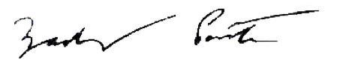

Zack Porter
Executive Director, Standing Trees
Montpelier, VT
zporter@standingtrees.org
(802) 552-0160

Erb et al., Unexpectedly Large Impact of Forest Management and Grazing on Global Vegetation Biomass (2018)
Zaino et al., Vermont Conservation Design – Natural Community and Habitat Technical Report (2018)
Lorimer and White (2003). Scale and frequency of natural disturbances in the northeastern US: implications for early successional forest habitats and regional age distributions.
Nowacki and Abrams, The Demise of Fire and “Mesophication” of Forests in the Eastern United States (2008)
Ceballos et al., Vertebrates on the brink as indicates of biological annihilation and the sixth mass extinction (2020)
“Climate Change 2021: The Physical Science Basis” (Working Group I contribution to the Sixth Assessment Report of the Intergovernmental Panel on Climate Change)
The US Geological Survey maintains the nation’s protected area database and has created a “GAP Status Code Assignment” to categorize types of conservation across all land ownerships, public and private.
Dreiss and Malcom, getting to 30x30: Guidelines for Decision-Makers (2020)
Dinerstein et al., A Global Deal for Nature: Guiding principles, milestones, and targets (2019)
Zaino et al. (2018)
Watson et al., The exceptional value of intact forest ecosystems (2019)
DiMarco et al., wilderness areas halve the extinction risk of terrestrial biodiversity (2019)
Dinerstein et al. (2020)
Miller et al., Eastern national parks protect greater tree species diversity than unprotected matrix forests (2018)
Miller et al., National parks in the eastern United States harbor important older forest structure compared with matrix forests (2016)
Canham et al 2013 - Regional variation in forest harvest regimes in the northeastern United States
Harris et al 2016. Attribution of net carbon change by disturbance type across forest lands of the conterminous United States. Carbon Balance and Management.
Dellasala et al 2022 (forthcoming). Mature and Old-Growth Forest Contributions to Large-Scale Conservation Targets in the Conterminous USA. Frontiers in Science.
Davis, M.B. (ed.). (1996). Eastern old-growth forests. Prospects for rediscovery and recovery. Island Press: Washington, D.C.
Gunn et al 2013. Late-successional and old-growth forest carbon temporal dynamics in the Northern Forest (Northeastern USA). Forest Ecology and Management.
Duveneck and Thompson 2019. Social and biophysical determinants of future forest conditions in New England: Effects of a modern land-use regime. Global Environmental Change.
Ibid.
Ducey et al 2013. Late-Successional and Old-Growth Forests in the Northeastern United States: Structure, Dynamics, and Prospects for Restoration.
Ibid.
Keith et al., Re-evaluation of forest biomass carbon stocks and lessons from the world’s most carbon-dense forests (2009).
Luyssaert et al., Old-growth forests as global carbon sinks (2008).
Masino et al., Older eastern white pine trees and stands sequester carbon for many decades and maximize cumulative carbon (2021).
Stephenson et al., Rate of tree carbon accumulation increases continuously with tree size (2014).
Law et al, Changes in carbon storage and fluxes in a chronosequence of ponderosa pine (2003)
Duveneck and Thompson (2019)
Keeton et al., Late-successional Biomass Development in Northern Hardwood-Conifer Forests of the Northeastern United States (2011)
Id.
Moomaw et al (2019). Intact Forests in the United States: Proforestation Mitigates Climate Change and Serves the Greatest Good.
Id.
Dinerstein et al., A Global Safety Net to reverse biodiversity loss (2020).
Jung et al., Areas of global importance for terrestrial biodiversity, carbon, and water (2020).
Lu et al 2013 - A Contemporary Carbon Balance for the Northeast Region of the United States
Underwood and Brynn, Enhancing Flood Resiliency of Vermont State Lands (2015)
Warren et al., Forest Stream Interactions in Eastern Old-Growth Forests (2018).
Underwood and Brynn (2015)
Thom et al., The climate sensitivity of carbon, timber, and species richness covaries with forest age in boreal-temperate North America (2019)
Law et al., Creating Strategic Reserves to Protect Forest Carbon and Reduce Biodiversity Losses in the United States (2022)
Zaino et al 2018
“The Critical Importance of Large Expanses of Continuous Forest for Bird Conservation” (Askins 2015)
Evans, B. E. and A. Mortelliti, “Effects of forest disturbance, snow depth, and intraguild dynamics on American marten and fisher occupancy in Maine, USA.” Ecosphere (2022) Vol. 13, Iss. 4.
Id.
Burkhart, J. et al. “Species Status Assessment Report for the Northern long-eared bat (Myotis septentrionalis),” U.S. Fish and Wildlife Service. (2022) Version 1.1.
Id.

