31 Dec 2024

TO: Clackamas Ranger District, Mt Hood National Forest

ATTN: Caila Campbell, [caila.campbell@usda.gov](mailto:caila.campbell@usda.gov)

VIA: <https://cara.fs2c.usda.gov/Public//CommentInput?Project=65780>

**Subject: Stone Creek Vegetation Management Project — scoping comments**

Please accept the following scoping comments from Oregon Wild concerning the Stone Creek Vegetation Management Project, <https://www.fs.usda.gov/project/mthood/?project=65780>. Oregon Wild represents 20,000 members and supporters who share our mission to protect and restore Oregon’s wildlands, wildlife, and water as an enduring legacy. Our goal is to protect areas that remain intact while striving to restore areas that have been degraded. This can be accomplished by moving over-represented ecosystem elements (such as logged and roaded areas) toward characteristics that are currently under-represented (such as roadless areas and complex old forest).

This proposal involves:

* 850 acres of commercial thinning in stands less than 80 years old
* 930 acres of timber stand improvement, e.g., non-commercial thinning trees <10” dbh
* 91 acres of sanitation harvest targeting susceptible off-site lodgepole pine
* 1,190 acres would be treated with understory burning
* [unquantified] temporary road construction and road reconstruction
* 660 acres roadside fuel reduction along primary roads (National Forest System Roads 42 and 57) and selected secondary roadways (4270, 5730, 5750, and 4200-230) near popular dispersed recreation sites, roadside fuels reduction treatments would target removing trees less than or equal to 10-inch diameter at breast height and <150 feet from roads
* 17 acre clearcut of the 45 year-old Monticola seed orchard that contains white pine not resistant to blister rust
* approximately 20 miles of road are proposed to change from a ML 2 to ML 1 within the planning area. These 20 miles of roads would be storm-proofed
* Approximately 2 miles of road are proposed for passive decommissioning, continuing an ongoing process of renaturalization

We support the non-commercial thinning for stand improvement, and the use of prescribed fire, but please implement these treatments with an ecological intent, such as enhancing existing diversity of trees and understory vegetation, and leaving a highly variable spatial pattern.

The Forest Service should definitely avoid more regen harvest, which has left this landscape severely degraded over the last 70+ years. Many of the old clearcuts remain noticeable decades later. See this animation on Bark’s website: <https://bark-out.org/wp-content/uploads/2024/12/Stone-Aerials-no-date.gif>

We appreciate this project’s focus on thinning young stands. This can help add complexity and diversity to stands recovering after past clearcutting, and provide some economic benefits. We have a few concerns and suggestions to optimize ecological benefits of thinning, and we request that these issues be addressed in the NEPA effects analysis and incorporated into the alternatives:

* Given the proximity to the Warm Springs Reservation, we encourage the Forest Service to engage in meaningful coordination with the Confederated Tribes of Warm Springs and incorporation of indigenous knowledge and management strategies where appropriate;
* The scoping letter says that the logging occurs in matrix areas, but the scoping maps show commercial thinning in riparian reserves, e.g., Rock Springs Creek. This raises concerns because removing trees from riparian reserves retards attainment of desired abundance of dead wood for both aquatic and terrestrial wildlife. Buffer streams from the effects of heavy equipment and loss of bank trees and trees that shade streams. Mitigate for the loss of LWD input by retaining extra snags and wood (and green trees for recruitment) in riparian areas. Recognize that thinning “captures mortality” and results in a long-term reduction in recruitment of functional down wood, and that effect is not mitigated by future growth;
* Minimize and mitigate carbon emissions from logging by retaining more trees. This project area is moist, productive, and has an infrequent fire return, so it’s a great place to store carbon. In fact, carbon storage should be made part of the purpose and need, because the Forest Service cannot meet all of its legal mandates and LRMP requirements unless climate change is moderated by reduced emissions;
* Minimize and mitigate long-term adverse effects on snag recruitment by retaining more trees in unthinned “skips.” Also consider leaving 10-20 trees per acre in the seed orchard for future snag habitat;
* Thinning has adverse effects on a variety of spotted owl prey, including flying squirrels, red tree vole, red-backed voles, chipmunks, etc. Minimize and mitigate adverse effects on spotted owl prey by retaining more trees, more down wood, shrub cover, and “mid-canopy occlusion” that flying squirrels use for cover when gliding. The agency should design matrix thins to support abundant and diverse populations of owl prey species.
* Mimic natural patterns as much as possible. Strive for a high degree of spatial variability in the leave trees. Be sure to retain clumps of 2-5 trees which are common in natural forests, and leave some 1/4 acre unthinned skips embedded within thinned areas. Small structure-rich “gaps” are also recommended, 1/4 - 1/2 acre areas that are very heavily thinned with a few trees and snags retained within them;
* Retain existing elements of diversity, including wetlands, meadows, rocky outcrops, large trees, large snags, tall deciduous shrubs, hardwoods, and other minor tree species. Retain and protect under-represented conifer and non-conifer trees. Protect shrubs as much as possible, especially deciduous and tall shrubs, and those that produce insects, berries and mast. "Although usually classified as a shrub and not considered in discussions of forest composition or structure, *A. circinatum* [vine maple] dominated the angiosperm component, and although comprising only 0.9% of the basal area, it was the most abundant woody species in terms of stem count. This is important because *A. circinatum* makes a disproportionate contribution to biodiversity in this evergreen conifer forest, for example by providing food for folivore geometrid larvae that feed Neotropical migrant birds [26] and by providing substrate for epiphytic lichens and bryophytes [27]." Lutz JA, Larson AJ, Freund JA, Swanson ME, Bible KJ (2013) The Importance of Large-Diameter Trees to Forest Structural Heterogeneity. PLoS ONE 8(12): e82784. doi:10.1371/journal.pone.0082784. <http://ctfs.arnarb.harvard.edu/Public/pdfs/LutzEtAl_PLoS2013.pdf>
* All yew trees should be excluded from the harvest contract and retained as much as possible within the stand. Yew trees are unique and under-represented. They provide a valuable ecological benefits, such as mid-canopy perches the help spotted owls tolerate weather extremes;
* Retain abundant snags and course wood both distributed and in clumps so that thinning mimics natural disturbance. Retention of dead wood should generally be proportional to the intensity of the thinning, e.g., heavy thinning should leave behind more snags not less. Retain wildlife trees such as hollows, forked tops, broken tops, leaning trees, etc. Keep in mind that the matrix is also expected to provide some late successional habitat values.[1] Thinning does not always accelerate development of late successional forests, in particular commercial thinning has an adverse effect on snags and dead wood that are defining characteristics of late successional habitat. Thinning might produce the first large trees, but those trees would be vigorous and less likely to experience mortality, so developing large snags is not a direct and immediate result of growing large trees. Thinning also dramatically reduces the pool from which future mortality can be recruited so thinning actually retards development of some attributes of late successional forest and spotted owl habitat including snags and down wood. NEPA analyses often assert that "As a result of thinning, growth of retained live trees would be accelerated, so larger trees would be available sooner for recruitment as snags and CWD than without thinning." This is only half the story and it is very misleading. The agency is not being fully honest about the effects of logging unless statements like this are followed by a loud and clear acknowledgement that accelerating development of a few larger *live trees* (that *might* become snags if a few of them happen to die) *comes at the cost* of a significant reduction in the number of medium and large snags over time. From an ecological perspective, the net result of commercial logging is undeniably adverse to snag habitat. The agency cannot present logging as a benefit to snag habitat when it is really a cost that needs to be mitigated.
* Avoid using heavy equipment on wet soils and wet weather log hauling that poses too great a risk of soil damage and water pollution;
* If used correctly, roadside fuel treatments can be a useful tool for fire management. Done incorrectly they can make the situation worse, and cause a lot of unintended adverse trade-offs. Shaded fuel breaks implemented non-commercially with significant canopy retention may be an effective fuel treatment, IF they are maintained over time. Maintaining a reasonably dense canopy will mitigate habitat fragmentation effects, as well as lower maintenance costs by suppressing growth of surface and ladder fuels. If fuel breaks remove too much canopy and are accomplished with heavy equipment that disturbs too much soil, fuel breaks can stimulate the growth of hazardous fuels and weeds, making fire hazard worse instead of better, while making long-term maintenance more difficult and more expensive. Fuel breaks also have significant trade-offs that need to be avoided, minimized, and mitigated, including spreading weeds, habitat fragmentation, exacerbating barriers to wildlife, impaired wildlife connectivity, loss of wildlife cover, loss of snag habitat, facilitating unauthorized OHVs, carbon emissions, etc. NEPA analysis is needed to carefully address these issues. Weeds are definitely a potential big problem with fuel breaks, especially the combination of frequent disturbance caused by recurring maintenance, and road use as a vector for weeds;
* Young stands do not exist in isolation, so be sure to consider the effects of thinning on adjacent mature and old-growth habitat which may provide habitat for spotted owls, marbled murrelets, and other species. Spotted owls may use young stands for dispersal, foraging, and security from predators. It may be helpful to create a “risk map” that identifies areas that are more or less suitable for thinning based on criteria such as: existing habitat characteristics, proximity to occupied habitat or activity centers, proximity to suitable habitat, and proximity to recently thinned areas, non-habitat, and roads. The agency should also consider adjusting both the location and timing of thinning to minimize the cumulative effects of widespread thinning on the sensitive and listed species;
* The Forest Service should develop a preferred alternative that focuses on thinning areas near existing roads, and avoids temporary road construction, which in spite of its name, actually has long-term adverse effects on soil and vegetation;
* Agencies have a duty to consider habitat connectivity in their NEPA analyses. CEQ issued guidance saying “… agencies should consider and be transparent about the positive or negative impacts of proposed actions and alternatives on connectivity and corridors. Through the NEPA review process, Federal agencies can consider measures to advance corridors and connectivity as components of proposed actions, alternatives to proposed actions, or mitigation for proposed actions’ effects.” Mallory, B. 2023. CEQ Guidance for Federal Departments and Agencies on Ecological Connectivity and Wildlife Corridors. March 21, 2023. <https://www.whitehouse.gov/wp-content/uploads/2023/03/230318-Corridors-connectivity-guidance-memo-final-draft-formatted.pdf>.
* Focus the analysis on “trade-offs” related to logging. All logging, including thinning stands of any age, include some adverse impacts and trade-offs. Some impacts of logging are unavoidable, so there is no such thing as a logging operation that is 100% beneficial. Depending on how thinning is done, it can have adverse impacts such as soil disturbance; habitat disturbance; damage to the shrub layer; carbon removal; spreading weeds; reduced populations of prey for carnivorous species; reduced recruitment of snags; road-related impacts on soil, water, site productivity, and habitat; moving fuels from the canopy to the ground, hotter-drier-windier microclimate that is favorable to greater flame lengths and rate of fire spread, etc. Some of these negative effects are fundamentally unavoidable, therefore all thinning has negative effects that must be compensated by beneficial effects such as reducing competition between trees so that some can grow larger faster, increased resistance drought stress and insects, possible increasing species and structural diversity, possible fire hazard reduction, etc. It is generally accepted that when thinning very young stands, the benefits outweigh the adverse impacts and net benefits are likely. It is also widely understood that thinning older stands tends to have greater impacts on soil, water, weeds, carbon, dead wood recruitment so the impacts very often outweigh the benefits, resulting in net negative outcome on the balance sheet. Thus, as we move from young forest to older forests, the net benefits turn into net negative impacts. See Klaus J. Puettmann, Adrian Ares, and Erich Dodson. 2011. Over- and understory vegetation responses to thinning treatments: Can we accelerate late successional stand structures? Symposium: Density Management In The 21st Century: West Side Story. <http://oregonstate.edu/conferences/event/densitymanagement2011/agenda.pdf> (“growth of large trees was less responsive to thinning and low mortality rates for larger trees resulted in little recruitment of large snags or coarse woody debris (down wood). In general, thinning increased abundance and diversity of early-seral understory species, with little effect on late-seral species. On sites where shrub cover was already high harvesting initially reduced the cover, but shrubs recovered over time. Exotic species slightly increased in response to treatment …”); and Erich K. Dodson, Adrian Ares, and Klaus J. Puettmann. 2011. Thinning effects on tree mortality and snag recruitment. Symposium: Density Management In The 21st Century: West Side Story. <http://oregonstate.edu/conferences/event/densitymanagement2011/agenda.pdf> (“…thinning did little to accelerate the development of large snags and coarse downed wood that provide critical wildlife habitat…”) These are some of the trade-offs that must be disclosed and weighed in the NEPA document.
* The sanitation of lodgepole should be done with a light touch, if at all. Since off-site lodgepole is clearly not thriving, it sounds like nature is sorting things out on its own, and at the same time creating valuable dead wood habitat, structural complexity, and stimulating the understory. The Forest Service should mimic natural processes with this treatment and retain abundant dead wood, and avoid setting back the natural regeneration that is already occurring in these stands.

**Thinning in the Matrix must be Restorative and Variable**

The NWFP conservation scheme has its origins in the 1990 report of the Interagency Scientific Committee (ISC Report) which explained that matrix lands are intended for several conservation purposes:

* To provide connectivity for dispersal and interaction of owls among HCAs. ….
* To maintain options for returning owls to the forest matrix by retaining older forest structures in the managed landscape.
* To develop and apply experimental silvicultural treatments that may support a viable owl population in the forest matrix.
* To contribute toward a short-term viable population (less than 50 years).

1990 ISC Report, p 318. (Thomas, J.W.; Forsman, E.D.; Lint, J.B. et al. 1990. A conservation strategy for the northern spotted owl: a report of the Interagency Scientific Committee to address the conservation of the northern spotted owl. Portland, OR. <https://www.fws.gov/sites/default/files/documents/ConservationStrategyForTheNorthernSpottedOw_May1990.pdf>).

The quality of matrix lands for meeting these objectives is directly related to the extent that it resembles nesting, roosting, and foraging habitat. If structurally simple stands in the matrix can be modified to be more complex in terms of species diversity, niche diversity, and dead wood abundance, they will support better foraging opportunities which will greatly improve the quality of dispersal habitat.

The agency should not rely on outdated science suggesting that 40% canopy cover represents owl dispersal habitat. New information indicates that spotted owl dispersal habitat should be managed for “at least 80%” canopy cover. See Stan G. Sovern, Eric D. Forsman, Katie M. Dugger, Margaret Taylor. 2015. Roosting Habitat Use and Selection By Northern Spotted Owls During Natal Dispersal. The Journal of Wildlife Management 79(2):254–262; 2015; DOI: 10.1002/jwmg.834. <https://osu-wams-blogs-uploads.s3.amazonaws.com/blogs.dir/2742/files/2016/09/Sovern-et-al.-2015.pdf> (“**Roost Site Selection**. In contrast to the assumption that stands with relatively open canopies provide suitable dispersal habitat for spotted owls, our results suggest that dispersing juveniles selected stands for roosting that had relatively high canopy closure (x = 66 + 2%). … Two hypotheses could explain why dispersing owls selected closed-canopy stands. First, several researchers (Barrows 1981, Forsman et al. 1984, Weathers et al. 2001) have shown that temperature and precipitation appear to influence selection for roost trees and attributes within a roost tree, such as perch height and percent overhead cover. … Second, juvenile northern spotted owls may have selected for closed-canopy forest because their preferred prey were most abundant … **Landscape Scale Selection**. … [O]ur mean estimate of canopy closure from plots at roosts (66%), which was likely an underestimate of canopy cover, was considerably higher than the minimum values recommended by Thomas et al. (1990) [i.e. 50-11-40]. … **Management Implications**. … Based on our study, we recommend that managers should pursue a strategy that exceeds the canopy cover guidelines recommended by Thomas et al. (1990) when managing dispersal habitat for spotted owls. Based on our estimate of mean canopy closure (66%), and our estimate of mean canopy cover from overlaying a dot grid on the same areas (approx. 14% larger), we recommend that the target for canopy cover in stands managed for dispersing spotted owls should be at least 80%.”)

Owl habitat is characterized by large trees, high canopy closure, abundant dead wood, well-developed understories. A few of these qualities can be attained with traditional uniform thinning (large trees and canopy closure), but all of them are more likely to be attained with variable density thinning and managing for decadence. In particular, canopy closure and well-developed understories are best achieved with variable density thinning.

The agency should design matrix thins to support abundant and diverse populations of owl prey species. “[H]abitat elements that support prey [include] (mistletoe, snags, down wood, forage lichens, truffles abundance)” NSO FRP p 114. Where owl prey base is diverse and abundant spotted owl home ranges tend to be smaller which is energetically advantageous and enhances owl survival rates. Carey, A. 2004 Relationship of Prey and Forest Management. Appendix 5 pp 3-24, 3-25 *in* Courtney, SP; J A Blakesley. 2004. Scientific evaluation of the status of the Northern Spotted Owl. <http://www.sei.org/owl/finalreport/finalreport.htm>. “Numerous patches of low foraging quality can have negative impacts on owl demography and behavior (Carey et al 1992).” id. and this is precisely what uniform thinning that “captures mortality” will do to current and future spotted owl home ranges. A large number of owl prey species have some association with snags and down wood either as sites for denning or as a source of fungal food supplies. Traditional thinning will reduce the recruitment of dead trees and down wood and further simplify the forest structure for many decades. Establishing diverse micro-habitats and creating and retaining large numbers of snags and down wood will help the spotted owl through the habitat bottleneck that it is now going through.

Small mammal populations also appear to increase with understory cover which can follow some forms of thinning. Waldien and Hayes. 2006. Influence of Alternative Silviculture on Small Mammals. USGS/CFER Fact Sheet. July 2006. <http://www.fsl.orst.edu/cfer/pdfs/CFERFS05.pdf>.

North et al. (1999) noted in a study of foraging habitat selection by northern spotted owls, “In our study area, stands with high use by owls typically included many ‘legacies’ (large trees and snags) that survived a fire or windstorm that destroyed much of the previous stand. They found that “stands with 142 m3/ha of intact snags and a high diversity of tree heights had medium or high foraging use by spotted owls. In these old-growth stands, biological legacies (e.g., large trees and snags) produced by past disturbance provide important forest structures associated with spotted owl foraging.” North, Franklin, Carey, Forsman, Hamer. 1999. Forest Stand Structure of the Northern Spotted Owl’s Foraging Habitat. For. Sci. 45(4):520-527. <https://andrewsforest.oregonstate.edu/sites/default/files/lter/pubs/pdf/pub3549.pdf>.

Some have concluded that light, uniform thinnings in young stands are unlikely to attain biodiversity conservation objectives. See Duncan S. Wilson, and Klaus J. Puettmann. Density management and biodiversity in young Douglas-fir forests: challenges of managing across scales. DRAFT submitted to Forest Ecology and Management. August 2006.

Given all the new information on the risks and uncertainties faced by spotted owls, thinning projects in the Matrix should apply variable density thinning techniques because variable density thinning and managing for decadence will help increase the complexity of the forest (structural complexity and plant species diversity) thereby increasing populations of owl prey species and enhancing owl foraging opportunities within owl dispersal/foraging habitat.  
  
VDT will not conflict with matrix objectives. Matrix objectives include timber production as well as habitat and species diversity. Variable thinning will produce potentially more wood products in the short-term as well as significant wood products in the long-term. There is absolutely no requirement that the agencies MAXIMIZE timber production. The ecological benefits of variable density thinning are significant and should not be forgone. There are operational challenges with implementing effective variable thinning prescriptions but the agencies must embrace the challenges and instead of retreating from the ecological objectives of the matrix, the agencies must apply their best thinking and creativity to the objective of creating species-diverse and structurally rich and complex mid-seral forest habitat.

The matrix is supposed to provide wildlife habitat and connectivity and VDT will help the matrix achieve these objectives while also improving the growth of favored commercial tree species. Matrix is not a tree farm. It still has a role to play in providing diverse habitats, so don’t just grow trees, grow forests.

The matrix is an integral part of the management direction included in these standards and guidelines. Production of timber and other commodities is an important objective for the matrix. However, forests in the matrix function as connectivity between Late-Successional Reserves and provide habitat for a variety of organisms associated with both late-successional and younger forests. Standards and guidelines for the matrix are designed to provide for important ecological functions such as dispersal of organisms, carryover of some species from one stand to the next, and maintenance of ecologically valuable structural components such as down logs, snags, and large trees. The matrix will also add ecological diversity by providing early-successional habitat.

…

Matrix objectives for silviculture should include: (1) production of commercial yields of wood, including those species such as Pacific yew and western red cedar that require extended rotations, (2) retention of moderate levels of ecologically valuable old-growth components such as snags, logs, and relatively large green trees, and (3) increasing ecological diversity by providing early-successional habitat.

…

Stands in the matrix can be managed for timber and other commodity production, and to perform an important role in maintaining biodiversity. Silvicultural treatments of forest stands in the matrix can provide for retention of old-growth ecosystem components such as large green trees, snags and down logs, and depending on site and forest type, can provide for a diversity of species. Retention of green trees following timber harvest in the matrix provides a legacy that bridges past and future forests. Retaining green trees serves several important functions including snag recruitment, promoting multistoried canopies, and providing shade and suitable habitat for many organisms in the matrix.

1994 NWFP ROD pp B-1 to B-6 (emphasis added) <https://web.archive.org/web/20170214000554/https://www.blm.gov/or/plans/nwfpnepa/FSEIS-2000/ROD-SandG.pdf>. Clearly VDT, will meet matrix objectives by providing wood products, and by promoting multistoried canopies, providing diversity of species, creating and maintaining structural features such as snags, logs, and large trees, and providing opportunities for early-seral species to persist in mid-seral stands.

According to the 2003 Draft SEIS for survey and manage, “Matrix was also expected to provide for ecologically diverse early-successional conditions and planned timber harvest.” (DSEIS page 68). Variable density thinning is appropriate in the matrix because VDT expands future options for multiple-use/sustained yield in its fullest dimension and VDT does not foreclose any matrix objectives.

Variable Density prescriptions will also improve connectivity by enhancing foraging opportunities for dispersing predators such as spotted owls (and other raptors), marten, fisher, etc. Young and mid-seral forest may not provide ideal nesting/denning conditions but they often do provide for important dispersal functions. If these young and mid-seral forests are species-diverse and structural complex, they are more likely to have healthy populations of small mammals, birds, and other prey species relied upon by predator species of concern.

Variable density thinning can create a variety of micro-habitats that may be suitable for different species. Andy Carey found that VDT could establish patchy habitat patterns that could lead to the development of small mammal populations that are not only more dense but more diverse compared to uniformly thinned stands.

Our results support hypotheses that: (1) biocomplexity resulting from interactions of decadence, understory development, and overstory composition provides pre-interactive niche diversification with predictable, diverse, small mammal communities; (2) these communities incorporate numerous species and multiple trophic pathways, and thus, their integrity measures resiliency and sustainability.

Thus, increasing complexity of the environment through increasing horizontal and vertical heterogeneity in vegetation structure, species diversity in vascular plant composition, and forest-floor structure with coarse woody debris may simultaneously (1) increase multidimensional habitat space (Carey et al., 1999a), (2) reduce frequencies and intensities of interspecies interactions (Grant, 1972; Carey et al., 1980), (3) increase or maintain the already high abundance and diversity of seed fall, fungal fruiting bodies, and invertebrates characteristic of mesic, temperate coniferous forests (Church field, 1990), and (4) allow not only coexistence, but abundance of potentially competing species within communities (Carey and Johnson, 1995, this study). As a result of this complexity, Pacific Northwest forests support the greatest diversity of shrews in North America (Rose, 1994) …

…

These studies do suggest that management can homogenize and simplify (reduce decadence, amounts of coarse woody debris, variety of tree species, diversity and abundance of understory vegetation, and spatial heterogeneity) forest ecosystems. We found local extirpations of a number of species and particularly absence of *G. sabrinus* and *T. townsendii* in multiple plots. These absences raise questions about long-term viability of these species in managed landscapes. Management-induced homogeneity and simplification (1) is a real danger to diversity, resiliency, and susceptibility to invasions of exotic plants (Carey, 1998; Carey et al., 2000; Halpern et al., 1999; Heckman, 1999; Thysell and Carey, 2000), (2) may result in small-mammal communities non-supportive of predators populations (Carey et al., 1992; Carey and Peeler, 1995), …

Andrew B. Carey, Constance A. Harrington; Small mammals in young forests: implications for management for sustainability; Forest Ecology and Management (2001) 154(1-2): 289-309; <http://www.fs.fed.us/pnw/pubs/journals/pnw_2001_carey003.pdf>.

High density and diversity of prey species is clearly advantageous for spotted owls. Dense populations of prey allow for smaller home ranges which is energetically advantageous, while diverse populations reduces the risk that any one species population will decline and leave the owl vulnerable. “[E]xperiments in both terrestrial and aquatic microcosms have tended to find that increasing the number of prey items enhances stability.” Kevin Shear Mccann, The diversity–stability debate. Nature 405, 228 - 233 (11 May 2000). <http://www.iterations.com/protected/dwnload_files/diversity_stability_debate.pdf>. Thinning variably will enhance the habitat for more than one prey species. If one species declines, the owl has other options so diverse prey base tends to have a stabilizing effect on owl populations. The agency can have all these ecological benefits from restoration silviculture and still support some jobs and produce some wood products.

**Weigh the trade-offs associated with logging in riparian reserves.**

Monitoring of the Aquatic Conservation Strategy shows that the natural abundance of large wood (>24” dbh) is still declining. This is because too many large and old trees were removed before the Northwest Forest Plan, large wood has a finite residence time, and tress grow slowly, so it will take a very long time to restore the conditions necessary to recruit natural levels of large wood necessary to support riparian and aquatic biodiversity.

Across the sampled sites in the AREMP area, overall survey results indicate that the density of wood pieces per length of stream consistently declined for the large size category, but they remained relatively constant for the intermediate and in some cases increased for the small size Across the AREMP area, the overall trend in wood piece density was -24.9 percent per decade (95-percent credibility intervals from -32.6 to -16.4 percent), and 83 percent of subwatershed-level trends were negative (95-percent credibility intervals from 71 to 95 percent) for the largest size class D. … All aquatic provinces experienced declines in density of the largest pieces of wood (class D) … Declines in density of larger sizes of wood (class D) were consistent across LUAs, with a 24-percent per decade decrease in LSRs, a 27-percent decrease in matrix, and a 29-percent decrease in congressional reserves. … Overall, trends indicating losses of larger instream wood are consistent with the concept of slow attrition of pieces derived from older, larger trees recruited to streams prior to widespread forest harvest in the region and subsequent protections imposed in accordance with the NWFP.

… For instream wood, we also observed declines in the quantity of the largest size class, presumably as recruitment of these largest pieces mainly occurred prior to the extensive removal of old-growth forests preceding the NWFP. Recovery of larger wood recruitment from older trees occurs on time scales that far exceed the 25-year period of this report.

Dunham, Jason; Hirsch, Christine; Gordon, Sean; Flitcroft, Rebecca; Chelgren, Nathan; Snyder, Marcia; Hockman-Wert, David; Reeves, Gordon; Andersen, Heidi; Anderson, Scott; Battaglin, William; Black, Tom; Brown, Jason; Claeson, Shannon; Hay, Lauren; Heaston, Emily; Luce, Charles; Nelson, Nathan; Penn, Colin; Raggon, Mark. 2023. Northwest Forest Plan the first 25 years (1994 2018): watershed condition status and trends. Gen. Tech. Rep. PNW-GTR-1010. Portland, OR: U.S. Department of Agriculture, Forest Service, Pacific Northwest Research Station. 163 p. <https://doi.org/10.2737/PNW-GTR-1010>. [Notably, the data also show a decline in wood 18-24” dbh in the Western Cascades Provinces]. The long-lasting adverse effect of past mismanagement can be mitigated or made worse depending on how riparian forests are managed going forward. More riparian logging will remove trees that would othersie grow and be recruited as riparian wood, thus making a bad situation worse. While strict conservation of riparian forests will allow those trees to grow and be recruited. Keep in mind that where there is a shortage of large wood, the presence of abundant small wood can partially mitigate that shortage.

Logging is a subtractive endeavor that is adverse to recruitment of dead wood. So, the agency often claims that logging in riparian reserves is necessary to improve attributes other than large wood. However, these benefits are often minor and transitory, and do not outweigh the significant long-term adverse effect of logging on recruitment of dead wood. The agency must focus on the most significant contributions of vegetation toward ACS objectives and the most significant effects of logging on the ACS objectives.

If the agency intends to log in riparian reserves to increase some nebulous goal like “vegetation diversity and complexity,” then please explain why the biophysical indicators for the ACS objectives (set forth below) do not include any mention of vegetation diversity or complexity. See the Jazz Thinning Preliminary Analysis, 2011. <http://bark-out.org/sites/default/files/bark-docs/Jazz_PA_0.pdf>.

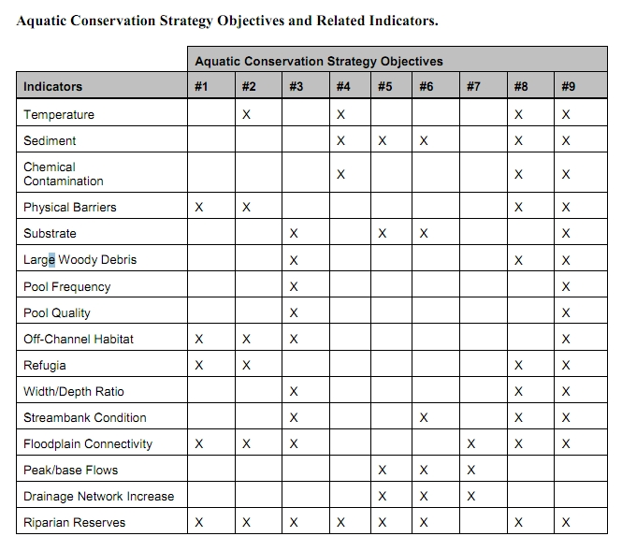

These ACS objectives and biophysical indicators are consistent throughout the Pacific Northwest and are not unique to the Mt Hood NF.

The Northwest Forest Plan and its supporting documentation make clear that the primary value of riparian vegetation is as a source of large wood and shade, not vegetation diversity and canopy layering, as often asserted by the agency to justify logging in riparian reserves. BLM admits “The primary function of Riparian Reserves is to provide shade and a source of large wood inputs to stream channels.” Medford BLM 2013. Pilot Thompson EA, p 3-76. <http://www.blm.gov/or/districts/medford/plans/files/PT_EA_ForWeb.pdf>

NEPA requires consideration of trade-offs. *California v. Block*, 690 F.2d 753, 771 (9th Cir. 1982) (NEPA was designed to “ensure that an agency is cognizant of all the environmental trade-offs that areimplicit in a decision”). Stan Gregory notes the following trade-offs associated with logging riparian reserves to enhance early seral vegetation:

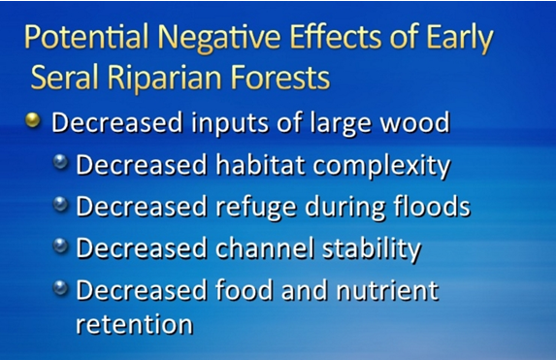

Gregory, Stan 2010. What About Riparian Systems: Who Benefits From an Early Seral Forest Condition. Workshop - Early Seral Forest - We know we need it -- How do we get it? Presentation sponsored by the Central Cascades Adaptive Management Partnership and NW Oregon Ecology Group <http://ecoshare.info/2010/07/06/what-about-riparian-systems-who-benefits-from-an-early-seral-forest-condition-gregory/>

The Northwest Forest Plan Aquatic Conservation Strategy Objectives (1994 ROD p B-11) enumerates specific purposes for “Maintain[ing] and restor[ing] the species composition and structural diversity of plant communities in riparian areas and wetlands” that is -

“to provide adequate summer and winter thermal regulation, nutrient filtering, appropriate rates of surface erosion, bank erosion, and channel migration and to supply amounts and distributions of coarse woody debris sufficient to sustain physical complexity and stability.”

All these values are provided as well or better by unthinned riparian stands.

The effects of logging on dead wood are significant and long term, adversely affecting a core function of the reserves, while the purported benefits to vegetation diversity are minor and transitory, and affect secondary purposes of the reserves.

**Large Wood**

Large quantities of downed trees are a functionally important component of many streams (Swanson et al. 1976; Sedell and Luchessa, 1982; Sedell and Froggat, 1984; Harmon et al. 1986; Bisson et al. 1987; Maser et al. 1988; Naiman et al. 1992). Large woody debris influences channel morphology by affecting longitudinal profile, pool formation, channel pattern and position, and channel geometry (Bisson et al. 1987). Downstream transport rates of sediment and organic matter are controlled in part by storage of this material behind large wood (Betscha 1979). Large wood affects the formation and distribution of habitat units, provides cover and complexity, and acts as a substrate for biological activity (Swanson et al. 1982; Bisson et al. 1987). Wood enters streams inhabited by fish either directly from the adjacent riparian zone from tributaries that may not be inhabited by fish, or hillslopes (Naiman et al. 1992).

Large wood in streams has been reduced due to a variety of past and present timber harvesting practices and associated activities. Many riparian management areas on federal lands are inadequate as long term sources of wood.

…

**Riparian Ecosystem Components**

…

Riparian vegetation regulates the exchange of nutrients and material from upland forests to streams (Swanson et al. 1982; Gregory et al. 1991). Fully functional riparian ecosystems have a suite of characteristics which are summarized below. Large conifers or a mixture of large conifers and hardwoods are found in riparian zones along all streams in the watershed, including those not inhabited by fish (Naiman et al. 1992). Riparian zone-stream interactions are a major determinant of large woody debris loading (House and Boehne 1987; Bisson et al. 1987; Sullivan et al. 1987). Stream temperatures and light levels that influence ecological processes are moderated by riparian vegetation (Agee 1988; Gregory et al. 1991). Streambanks are vegetated with shrubs and other low-growing woody vegetation. Root systems in streambanks of the active channel stabilize banks, allow development and maintenance of undercut banks, and protect banks during large storm flows (Sedell and Beschta 1991). Riparian vegetation contributes leaves, twigs, and other forms of fine litter that are an important component of the aquatic ecosystem food base (Vannote et al. 1980).

1993 FEMAT Report, pp V-13, V-25.

The effects of thinning on crown development are not very significant.

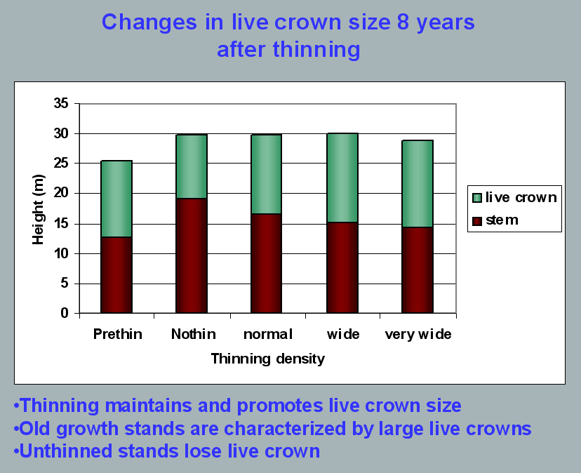

Aquatic/Riparian Ecosystem Dynamics and Associated Management Implications - Recent Findings. Powerpoint, 32.6M. This topic was presented at the Regional Interagency Executive Committee meeting on January 7, 2003. <https://web.archive.org/web/20161221100307/http://www.reo.gov/library/presentations/Szaro_present_Aquatic_Rip_Final.ppt>.

Stimulating the development of a diverse understory is often used as a justification for thinning, but this may not be justified in stands older than about 40 years. A systematic review of 917 Forest Inventory and Analysis (FIA) plots in western Oregon (mostly on non-federal lands) found,

Contrary to expectations of canopy closure, mean canopy cover by age class rarely exceeded 85 percent, even in unthinned productive young conifer forests. Possibly as a result, effects of stand age on understory vegetation were minimal, except for low levels of forbs found in 20- to 40-year-old wet conifer stands. … Although heavily thinned stands had lower total cover, canopy structure did not differ dramatically between thinned and unthinned stands. Our findings suggest potential limitations of simple stand succession models that may not account for the range of forest types, site conditions, and developmental mechanisms found across western Oregon.

McIntosh, Anne C.S.; Gray, Andrew N.; Garman, Steven L. 2009. Canopy structure on forest lands in western Oregon: differences among forest types and stand ages. Gen. Tech. Rep. PNW-GTR-794. Portland, OR: U.S. Department of Agriculture, Forest Service, Pacific Northwest Research Station. 35 p. <http://www.fs.fed.us/pnw/pubs/pnw_gtr794.pdf>. This seems to indicate that the benefits of thinning may be best realized in dense stands younger than 40 years old. This study also showed that in wet conifer stands the mean Canopy Height Diversity Index and the mean Simpson’s Diversity Index of tree heights leveled off at about age 65. This study also looked at canopy conditions after three levels of thinning intensities (heavy, light, and none). “Mean cover of the lower canopy layer was nominal for all three thinning intensities. … There were no evident trends between understory cover and thinning history; both shrub and forb cover were fairly similar among the three thinning intensities. … The lack of a strong effect of crown closure on understory cover may be related to our finding that mean crown cover did not exceed 85 percent. … We expected greater cover of understory vegetation in thinned than in unthinned stands but did not detect significant differences in this analysis.”

While one can generalize that vegetation diversity is more likely to flourish when conifer density is lower, there are data showing a wide range of conifer density can support a wide range of deciduous shrub cover. Thinning is not always necessary. The NEPA analysis should carefully document the site-specific “need” for thinning.

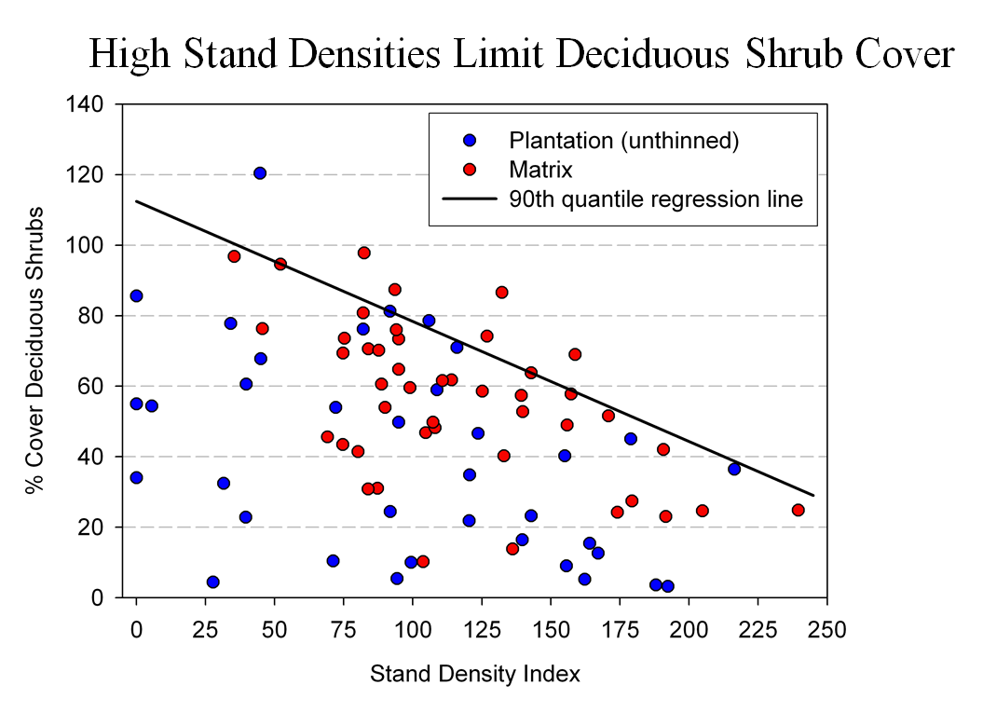

Spies, T. 2008. Powerpoint: Assumptions behind thinning young stands to create late successional riparian habitat. Presented at Riparian Thinning: Logic Paths for Silvicultural Prescriptions -- March 20, 2008. <https://ecoshare.info/projects/central-cascade-adaptive-management-partnership/workshops/riparian-thinning-logic-paths/>

It is also worth noting that where understories are well-stocked, midstory development can be enhanced by focusing on treating the understory itself rather than killing canopy trees.

[R]esults show that individual understory trees can be selectively favored for increased growth into the midstory by being released from competing saplings in the understory cohort. …Our results suggest that understory release treatments can be used to target individual saplings for increased growth, thereby recruiting a shade tolerant midstory cohort and accelerating the development of vertical foliar connectivity and a multi-layered stand structure. Abundance of non-coniferous understory vegetation is also augmented by this treatment. … [Note] The extent to which released understory trees collectively form a cohesive midstory canopy stratum is dependent on the density and horizontal arrangement of those released individuals. … . Inducing spatial variability within the midstory tree cohort would emulate the finescale disturbances of natural stands that create gaps and patches.

Taylor, Andrew 2016. Understory Vegetation Dynamics and Midstory Development Following Understory Release Treatments in Northwest Oregon Thinned Douglas-fir Stands. OSU MS Professional Paper.

Anderson (2007) looked at the effects of thinning in young Douglas fir forests and found –

[T]hinning treatments … had little impact on the abundance, size, or diversity of understory vegetation. Disturbance resulted in short-term decreases in understory vegetation cover, particularly tall shrubs. However, within five years of treatment, understory vegetation abundance returned to approximate pretreatment condition. … The general lack of understory vegetation response to the thinning treatments was likely due to the inherent resistance and resilience of the plant communities to disturbance, as well as the low intensity of disturbance attributable to the treatments.

/ / /

/ / /

/ / /

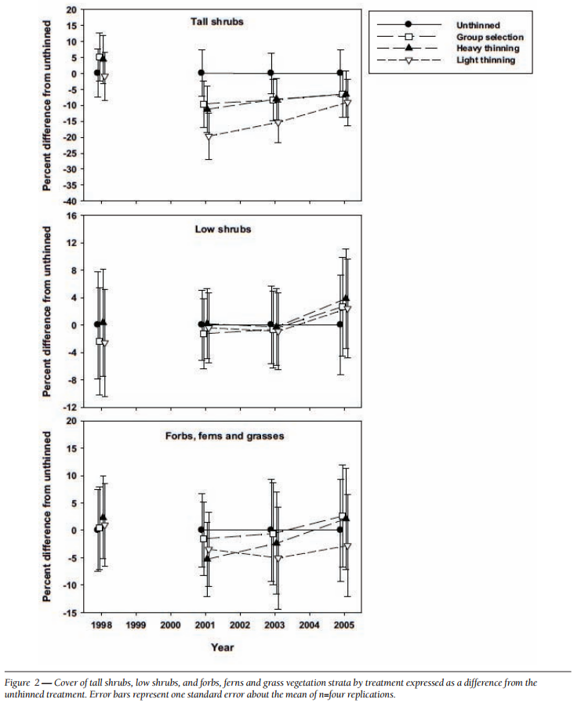

[Four years after thinning] tall shrub cover that was approximately four to nine percent less than the unthinned treatment … [C]over by low shrub species was unchanged by the harvest activity … Forbs, ferns, and grasses [experienced] little difference in cover between thinned and unthinned stands. … [F]ollowing treatment, the mean number of species declined somewhat, [then] return[ed] to pretreatment levels… [T]he evenness component of diversity did not differ among treatments or vary over time …. [T]here was little evidence of substantial alterations of understory shrub and herbaceous vegetation. This lack of strong understory vegetation response in terms of composition, abundance, or size is consistent with several studies of thinning in Douglas-fir. In a recent review of seven operational-scale silviculture experiments, Wilson and Puettmann (2007) report that percent cover by shrubs and percent cover by herbs, one to seven years following thinning showed little difference across a wide range of residual basal area.

Paul D. Anderson 2007. Understory Vegetation Responses to Initial Thinning of Douglas-fir Plantations Undergoing Conversion to Uneven-Age Management. Proceedings of the 2007 National Silviculture Workshop. <http://www.fs.fed.us/pnw/publications/gtr733/PNW_GTR_733_4.pdf> This paper was published in: Deal, R.L., tech. ed. 2008. Integrated restoration of forested ecosystems to achieve multi-resource benefits: proceedings of the 2007 national silviculture workshop. Gen. Tech. Rep. PNW-GTR-733. Portland, OR: U.S. Department of Agriculture, Forest Service, Pacific Northwest Research Station. 306 p.

[W]hile specific structural attributes of forest ecosystems have been correlated with certain species, it is uncertain how such species will respond to treatments designed to recreate these features. There is always the possibility that in our attempt to create a structural attribute we think is important, we eliminate another attribute that is equally important, but unrecognized. One example is that attempts to restore spotted owl habitat by heavily thinning to accelerate the development of large diameter nesting trees could actually delay spotted owl recovery by reducing production of the large down wood utilized by the species it preys upon (Forsman et al., 1984; Carey, 1995; North et al., 1999). Similarly, heavily thinning stands to accelerate the development of marbled murrelet nesting trees also create open stands with a dense understory that is ideal habitat for a number of corvid species that prey on marbled murrelet nest eggs (USFWS, 2010). Riparian thinning efforts to create long-term supplies of very large diameter instream wood that can initiate complex wood jam formation (e.g., key pieces) are also likely to reduce the supply of large diameter wood that will create pools (Beechie and Sibley, 1997; Beechie et al., 2000; Fox and Bolton, 2007). Thus, we suggest that any efforts to actively restore riparian forests for the benefit of certain species should be treated as scientific experiments and proceed cautiously, skeptically, and with robust pre- and post-treatment data collection efforts. Hypothesized effects of thinning on riparian forest structure and the use of that structure by targeted species should be tested against empirical data.

Pollock, Michael M. and Timothy J. Beechie, 2014. Does Riparian Forest Restoration Thinning Enhance Biodiversity? The Ecological Importance of Large Wood. Journal of the American Water Resources Association (JAWRA) 50(3): 543-559. DOI: 10.1111/jawr.12206. <http://oregon-stream-protection-coalition.com/wp-content/uploads/2014/07/Pollock-and-Beechie.-2014.-Riparian-thinning-and-biodiversity.pdf>.

Climate change highlights an additional trade-off related to logging riparian buffers. New science shows that more frequent drought makes upland habitats less suitable, so increasing numbers of upland birds flock to riparian corridors, which become more crowded, with negative effects on riparian-dependent species. The agency should do more to increase space for wildlife that need moist streamside habitat during droughts. Gabrielsen, Paul 2021. In dry years, rivers become birds’ crowded corridors. University of Utah @THEU. <https://attheu.utah.edu/uncategorized/in-dry-years-rivers-become-birds-crowded-corridors/> (“New research from the University of Utah and the Utah Division of Wildlife Resources (UDWR) finds that in dry years, birds funnel into the relative greenness of riparian (adjacent to river) environments. That increased diversity is accompanied by overcrowding that may cause increased competition for habitat and resources, the study finds, and an overall decrease in populations of birds who call the river home. … Neate-Clegg and his colleagues noticed that during particularly dry years they were finding more birds than usual in the mist nets near rivers. … The multi-year data showed that total bird captures and total species were higher in hotter and drier years, El Niño years, and less green years. The effect was strongest for non-riparian species, suggesting that in harsh conditions, birds from all over the landscape found their way to the rivers. “This suggests that the wider landscape is unable to support migrants and so they are forced to use greener areas,” Neate-Clegg says. But just as an influx of tourists can crowd out locals, the uptick in birds may have taken its toll on typically riparian species, especially those that breed on river banks…. In warmer years, population growth rates slowed for 47% of riparian bird species. The slowing, the researchers found, wasn’t due to more birds deaths, but rather to fewer new birds joining the population. There could be several reasons that bird breeding goes down in hotter years, but the authors suspect that more species in riparian habitats can mean more competition and fewer resources to go around. ‘This study shows how native bird populations utilize these habitats,’ Norvell says. ‘As droughts intensify, this becomes increasingly the refuge that everything’s relying on. And I don’t think humans are all that different in this case. We’re all increasingly relying on these very same areas.’ Neate-Clegg says that rivers provide connections for birds across the landscape, enabling them to transport nutrients or disperse seeds. A hotter, drier climate could affect those important functions that birds provide, called ‘ecosystem services.’”)

**Do not rely on the flawed boilerplate climate analyses**

As explained below, the Forest Service’s standardized NEPA language handed down from the regional office regarding carbon and climate change fails to take a hard look that NEPA requires. The analysis makes several highly misleading statements about managing forests for carbon storage, climate resilience, and the effects on climate change. The analysis inappropriately mischaracterizes the role of individual logging projects in the cumulative problem of global GHG emissions. The analysis misstates the effects of logging related carbon emissions that are not related to “deforestation.” The analysis grossly misstates the climate effects of logging intended to reduce disturbance. The analysis misleadingly implies that logging benefits the climate by increasing forest productivity.

The NEPA analysis should consider the adverse climate consequences of GHG emissions caused directly and indirectly by logging. The NEPA analysis should estimate the quantity of GHG emitted by logging and associated activities throughout the wood products supply chain, and describe the contribution of this project to cumulative impacts of excess GHG in the atmosphere. The NEPA analysis should use a proxy such as the social cost of carbon dioxide emissions to describe effects.

The Forest Service should not rely on the boilerplate NEPA language from the regional office which is flawed in many ways. Instead the Forest Service:

* Must recognize the cumulative nature of the GHG emissions and climate problems. It does not matter that this project is small in the global scheme because all emissions matter when the causation (and effects) of climate change are global and cumulative;
* Cannot credibly assert that this project is harmless because it’s not causing deforestation. This is immaterial. All GHG emissions, regardless of the source or how it is labelled, are part of the problem and cause the same climate impacts.
* Cannot credibly assert that thinning for forest health justifies or mitigates emissions from logging. Logging does not increase the capacity for growing trees. To the contrary, logging harms soil and reduces site productivity. Storing carbon in wood products is not preferable to storing carbon in forests. Evidence shows that forests are a more secure way of storing carbon. If this forest is not logged, or if more green tree are retained *in situ*, the agency cannot conclude that natural mortality will be greater than logging mortality. In fact, it is quite easy to predict that logging causes significantly more mortality than natural processes.
* Must not compare carbon *before and after* logging. That is an improper framework for NEPA analysis. The proper NEPA framework is to compare the effects of different alternatives (over time), so the agency must describe the carbon emissions and carbon storage in the forest over time *with* logging and *without* logging.
* Logging to reduce fire effects does not result in a net increase in forest carbon storage. The agency cannot predict the location, timing, or severity of future wildfires, so most fuel treatments will cause carbon emissions without any offsetting benefits from modified fire behavior. Studies clearly show that the total carbon emissions from logging (plus unavoidable wildfire) are greater than carbon emissions from wildfire alone.
* Cannot credibly assert that carbon storage in wood products is a useful climate strategy. Logging kills trees, stops photosynthesis, and initiates decay and combustion, with the end result being a significant transfer of carbon from the forest to the atmosphere. In stark contrast, an unlogged forest continues to grow and transfer more carbon from the atmosphere to the forest. Carbon emissions caused by logging far exceed the small fraction of carbon transferred to wood products. Carbon accounting methods that attempt to account for *substitution* of wood for other high-carbon building materials are fraught with uncertainty and too often represent maximum potential substitution effects rather than lower realistic estimates.

The FS [website](https://www.fs.usda.gov/emc/nepa/climate_change/index.shtml) links to a 2009 [document](https://www.fs.usda.gov/emc/nepa/climate_change/includes/cc_nepa_guidance.pdf) explaining how to incorporate “Climate Change Considerations in Project Level NEPA Analysis.” Since then the agency has regressed to a misleading and incomplete non-quantitative analysis of how carbon emissions from logging contribute to global climate change. The FS should now be following the latest 2023 CEQ guidance on fulfilling NEPA requirements for projects that affect the carbon cycle and emit GHG.

**CEQ Guidance: Take a Hard Look at the Effects of, and Alternatives to, GHG Emissions from Logging.**

The agency should follow the latest (2023) CEQ guidance for analysis of global climate change in federal NEPA analyses, including quantification of GHG emissions, quantification of the social cost of GHG emissions, disclosure whether the project makes progress toward or away from climate goals, comparison of effects with-and-without the project, and development of alternatives that avoid, minimize, and mitigate effects of emissions.

**Quantifying, Disclosing, and Contextualizing Climate Impacts, and**

**Addressing the Potential Climate Change Effects of Proposed Federal**

**Actions**

Consistent with section 102(2)(C) of NEPA, Federal agencies must disclose and consider the reasonably foreseeable effects of their proposed actions including the extent to which a proposed action and its reasonable alternatives (including the no action alternative) would result in reasonably foreseeable GHG emissions that contribute to climate change. Federal agencies also should consider the ways in which a changing climate may impact the proposed action and its reasonable alternatives, and change the action’s environmental effects over the lifetime of those effects.…

Some resource management activities, such as a prescribed burn or certain non-commercial thinning of forests or grasslands conducted to reduce wildfire risk or insect infestations, might result in short-term GHG emissions or loss of stored carbon but greater long-term ecosystem health, including an overall net increase in carbon sequestration and storage. However, other types of land-use changes, such as permanent deforestation, can adversely alter ecosystem long-term carbon dynamics, resulting in net emissions. Agencies can use relevant tools to analyze the anticipated long-term GHG emissions implications from proposed ecosystem restoration actions.

This guidance is intended to assist agencies in disclosing and considering the effects of GHG emissions and climate change. This guidance does not establish any particular quantity of GHG emissions as “significantly” affecting the quality of the human environment. However, quantifying a proposed action’s reasonably foreseeable GHG emissions whenever possible, and placing those emissions in appropriate context are important components of analyzing a proposed action’s reasonably foreseeable climate change effects.

This section of the guidance identifies and explains the following steps agencies should take when analyzing a proposed action’s climate change effects under NEPA:

1) Quantify the reasonably foreseeable GHG emissions (including direct and indirect emissions) of a proposed action, the no action alternative, and any reasonable alternatives as discussed in Section IV(A) below.

2) Disclose and provide context for the GHG emissions and climate impacts associated with a proposed action and alternatives, including by, as relevant, monetizing climate damages using estimates of the SC-GHG, placing emissions in the context of relevant climate action goals and commitments, and providing common equivalents, as described below in Section IV(B).

3) Analyze reasonable alternatives, including those that would reduce GHG emissions relative to baseline conditions, and identify available mitigation measures to avoid, minimize, or compensate for climate effects.

…

NEPA requires more than a statement that emissions from a proposed Federal action or its alternatives represent only a small fraction of global or domestic emissions. Such a statement merely notes the nature of the climate change challenge, and is not a useful basis for deciding whether or to what extent to consider climate change effects under NEPA. Moreover, such comparisons and fractions also are not an appropriate method for characterizing the extent of a proposed action’s and its alternatives’ contributions to climate change because this approach does not reveal anything beyond the nature of the climate change challenge itself—the fact that diverse individual sources of emissions each make a relatively small addition to global atmospheric GHG concentrations that collectively have a large effect.

Therefore, when considering GHG emissions and their significance, agencies should use appropriate tools and methodologies to quantify GHG emissions, compare GHG emission quantities across alternative scenarios (including the no action alternative), and place emissions in relevant context, including how they relate to climate action commitments and goals. This approach allows an agency to present the environmental and public health effects of a proposed action in clear terms and with sufficient information to make a reasoned choice between no action and other alternatives and appropriate mitigation measures. This approach will also ensure the professional and scientific integrity of the NEPA review.48

As part of the NEPA documents they prepare, agencies should quantify the reasonably foreseeable gross GHG emissions increases and gross GHG emission reductions49 for the proposed action, no action alternative, and any reasonable alternatives over their projected lifetime, using reasonably available information and data.50

…

Quantification and assessment tools are widely available and are already in broad use in the Federal Government and private sector, by state and local governments, and globally. CEQ maintains a GHG Accounting Tools website listing many such tools.56 …

…

[A]gencies should use the following best practices, as relevant: (1) In most circumstances, once agencies have quantified GHG emissions, they should apply the best available estimates of the SC-GHG [Social Cost of Greenhouse Gases] 61 to the incremental metric tons of each individual type of GHG emissions62 expected from a proposed action and its alternatives. 63 SC-GHG estimates allow monetization (presented in U.S. dollars) of the climate change effects from the marginal or incremental emission of GHG emissions, …

…

SC-GHG estimates can help describe the net social costs of increasing GHG emissions as well as the net social benefits of reducing such emissions. Given NEPA’s mandates to consider worldwide and long-range environmental problems,68 it is most appropriate for agencies to focus on SCGHG estimates that capture global climate damages and, consistent with the best available science, reflect a timespan covering the vast majority of effects and discount future effects at rates that consider future generations. It is often also worth affirming that SC-GHG estimates, including those available at the publication of this guidance, may be conservative underestimates because various damage categories (like ocean acidification) are not currently included.

… [A]gencies should explain how the proposed action and alternatives would help meet or detract from achieving relevant climate action goals and commitments, including Federal goals, international agreements, state or regional goals, Tribal goals, agency-specific goals, or others as appropriate.69 However, as explained above, NEPA requires more than a statement that emissions from a proposed Federal action or its alternatives represent only a small fraction of global or domestic emissions.

…

**Reasonable Alternatives**

Considering reasonable alternatives, including alternatives that avoid or mitigate GHG emissions, is fundamental to the NEPA process and accords with Sections 102(2)(C) and 102(2)(E) of NEPA, which independently require the consideration of alternatives in environmental documents.74 NEPA calls upon agencies to use the NEPA process to identify and assess the reasonable alternatives to proposed actions that will avoid or minimize adverse effects on the human environment.75

Consideration of alternatives provides an agency decision maker the information needed to examine other possible approaches to a particular proposed action (including the no action alternative) that could alter environmental effects or the balance of factors considered in making the decision. Agencies make better informed decisions by comparing relevant GHG emissions, GHG emission reductions, and carbon sequestration potential across reasonable alternatives, assessing trade-offs with other environmental values, and evaluating the risks from or resilience to climate change inherent in a proposed action and its design.

Agencies must consider a range of reasonable alternatives, as well as reasonable mitigation measures if not already included in the proposed action or alternatives, consistent with the level of NEPA review (e.g., EA or EIS) and the purpose and need for the proposed action.76

…

**Mitigation**

Identifying and analyzing potential mitigation measures is an important component of the NEPA process.105 Evaluating potential mitigation measures generally involves first determining whether impacts from a proposed action or alternatives can be avoided, then considering whether adverse impacts can be minimized, then, when impacts are unavoidable, rectifying them and, if appropriate, requiring compensation for residual impacts.106 Mitigation plays a particularly important role in how agencies should assess the potential climate change effects of proposed actions and reasonable alternatives. Agencies should consider mitigation measures that will avoid or reduce GHG emissions. Given the urgency of the climate crisis, CEQ encourages agencies to mitigate GHG emissions to the greatest extent possible.

…

**Special Considerations for Biological GHG Sources and Sinks**

…

In NEPA reviews, for actions involving potential changes to biological GHG sources and sinks, agencies should include a comparison of net GHG emissions and carbon stock117 changes that are anticipated to occur, with and without implementation of the proposed action and reasonable alternatives. The analysis should consider the estimated GHG emissions (from biogenic and fossil-fuel sources), carbon sequestration potential, and the net change in relevant carbon stocks in light of the proposed actions and timeframes under consideration, and explain the basis for the analysis.

Some actions that involve ecosystem restoration118 can generate short-term biogenic emissions while resulting in overall long-term net reductions of atmospheric GHG concentrations through increases in carbon stocks or reduced risks of future emissions. One example is certain vegetation management practices that affect the risk of wildfire, insect and disease outbreak, or other disturbance. Some resource management activities, such as a prescribed burn or certain non-commercial thinning of forests or grasslands conducted to reduce wildfire risk or insect infestations, might result in short-term GHG emissions or loss of stored carbon but greater long-term ecosystem health, including an overall net increase in carbon sequestration and storage. However, other types of land-use changes, such as permanent deforestation, can adversely alter ecosystem long-term carbon dynamics, resulting in net emissions. Agencies can use relevant tools to analyze the anticipated long-term GHG emissions implications from proposed ecosystem restoration actions.

Federal land and resource management agencies should consider developing and maintaining agency-specific principles and guidance for considering biological carbon in management and planning decisions. fn/119. Such guidance can help address the importance of considering biogenic carbon fluxes and storage within the context of other management objectives and ecosystem service goals, …

Council on Environmental Quality 2023. National Environmental Policy Act Guidance on Consideration of Greenhouse Gas Emissions and Climate Change <https://www.federalregister.gov/documents/2023/01/09/2023-00158/national-environmental-policy-act-guidance-on-consideration-of-greenhouse-gas-emissions-and-climate>. fn/119: See, e.g., USDA Forest Service, Considering Forest and Grassland Carbon in Land Management (2017), <https://www.fs.usda.gov/research/treesearch/54316>... (aka, Janowiak, et al 2017. Considering Forest and Grassland Carbon in Land Management. Gen. Tech. Rep. WO-95. Washington, D.C.: United States Department of Agriculture, Forest Service. 68 p. <https://www.fs.usda.gov/research/publications/gtr/gtr_wo95.pdf>.)

The Jan. 9, 2023 Federal Register notice says “This interim guidance is effective immediately. … This interim [15] GHG guidance, effective upon publication, builds upon and updates CEQ's [2016 Final Guidance](https://obamawhitehouse.archives.gov/sites/whitehouse.gov/files/documents/nepa_final_ghg_guidance.pdf) for Federal Departments and Agencies on Consideration of Greenhouse Gas Emissions and the Effects of Climate Change in National Environmental Policy Act Reviews … This guidance applies longstanding NEPA principles to the analysis of climate change effects, which are a well-recognized category of effects on the human environment requiring consideration under NEPA … Agencies should use this guidance to inform the NEPA review for all new proposed actions. Agencies should exercise judgment when considering whether to apply this guidance to the extent practicable to an on-going NEPA process …” <https://www.federalregister.gov/documents/2023/01/09/2023-00158/national-environmental-policy-act-guidance-on-consideration-of-greenhouse-gas-emissions-and-climate>.

==

Each substantive issue discussed in these comments should be (i) incorporated into the purpose and need for the project, (ii) used to develop NEPA alternatives that balance tradeoffs in different ways, (iii) carefully analyzed and documented as part of the effects analysis, and (iv) considered for mitigation.

Please post to the project website, links to all relevant ESA and EFH consultation documents, RMPs, watershed analyses, and other supporting documents relied on in the NEPA analysis.

Please post to the project website before the public comment period, georeferenced maps of the proposed activity units that can be used to navigate in the field using apps such as Avenza.

Please provide Oregon Wild with timely notice of any forthcoming comment opportunities, and any draft and final decisions on this project. If the agency discovers new information or changed circumstance or modifies the project or the analysis after the decision, Oregon Wild requests to be notified and provided an opportunity to comment.

Note: If any of these web links in this document are dead, they may be resurrected using the Wayback Machine at Archive.org. <http://wayback.archive.org/web/>

Sincerely,



Doug Heiken (he/him)

[dh@oregonwild.org](mailto:dh@oregonwild.org)

1. The NWFP conservation scheme has its origins in the 1990 report of the Interagency Scientific Committee (ISC Report) which explained that matrix lands are intended for several conservation purposes:

   * To provide connectivity for dispersal and interaction of owls among HCAs. ….
   * To maintain options for returning owls to the forest matrix by retaining older forest structures in the managed landscape.
   * To develop and apply experimental silvicultural treatments that may support a viable owl population in the forest matrix.
   * To contribute toward a short-term viable population (less than 50 years).

   1990 ISC Report, p 318. (Thomas, J.W.; Forsman, E.D.; Lint, J.B. et al. 1990. A conservation strategy for the northern spotted owl: a report of the Interagency Scientific Committee to address the conservation of the northern spotted owl. Portland, OR. <https://www.fws.gov/sites/default/files/documents/ConservationStrategyForTheNorthernSpottedOw_May1990.pdf>. The quality of matrix lands for meeting these objectives is directly related to the extent that it resembles nesting, roosting, and foraging habitat. If structurally simple stands in the matrix can be modified to be more complex in terms of species diversity, niche diversity, and dead wood abundance, they will support better foraging opportunities which will greatly improve the quality of dispersal habitat.