June 8, 2023

To whom it may concern,

Thank you again for the notice of the public comment period for the POW LLA Spring 2023 Long-term Plan. Thank you for including the Activity: Explore allowing e-bikes on trails; Determine mandates and policy related to allowing e-bikes on trails. If allowed and feasible, follow through with process.

I am advocating for the usage of Class 1 e-bikes as defined in FSM 7705 on trails currently not open to motorized vehicles such as Indian, Cutthroat, and Honker trails. I ask that you stipulate that Class 1 e-bikes, of not more than 750 watts, equipped with a motor that provides assistance only when the rider is pedaling and that ceases to provide assistance when the e-bike reaches the speed of 20 miles per hour, be allowed to operate on these trails.

Please begin the appropriate environmental analysis and public engagement to determine if e-bike usage on these roads is appropriate.

Thank you.

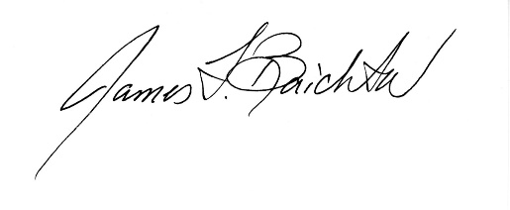

James F. Baichtal, Sc.D. (Hon.)

P.O. Box 19515

Thorne Bay, Alaska 99919 (907)-209-6690 baichtal557@gmail.com