CTLLA Kake Public Meeting, 3/5/2018

Mike Jackson – Mike notes several locations of purported naturally occurring radioactive material that is affecting customary food gathering locations. Cites a high occurrence of cancer in clan members whose traditional territory and food gathering locations are in Kadake Bay, Kuiu Island. Other locations include the Goose Lake area the Hamilton Bay timber sale area, Unit 9. Mike would like to have a soil scientist take samples from these locations mineral analysis.

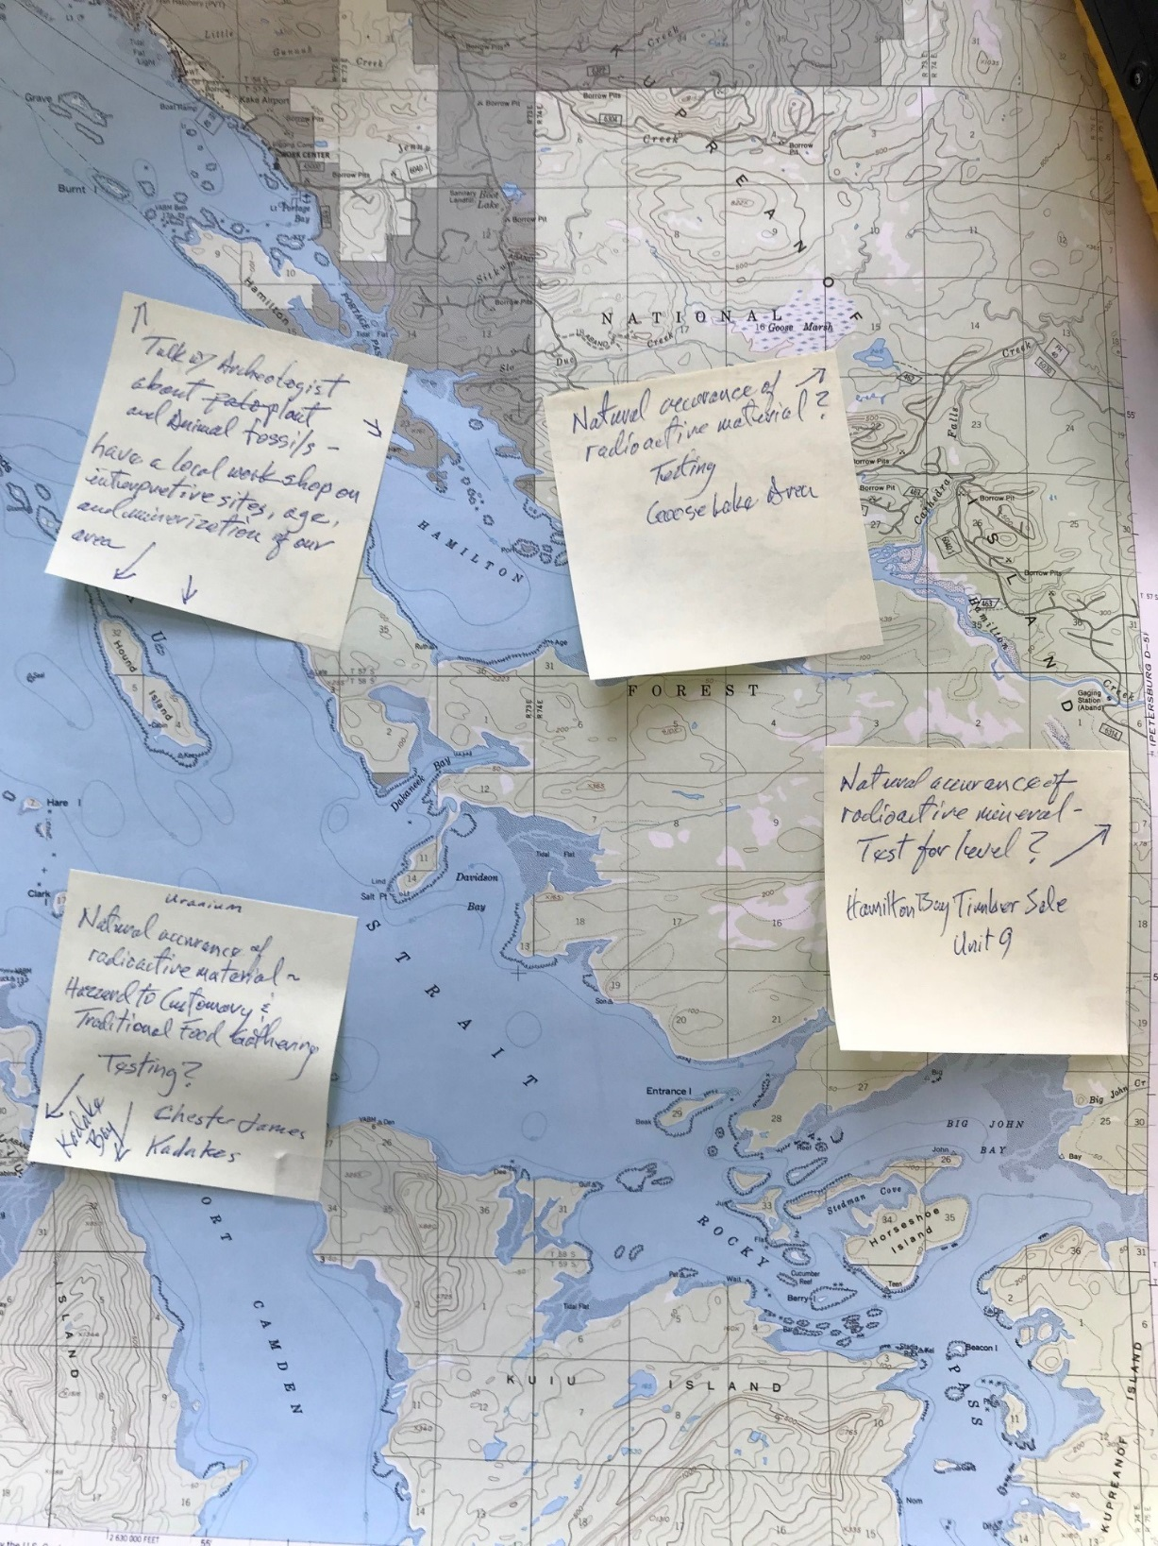

Mike Jackson – Would like to see geologists and paleontologists host a workshop to investigate the possibility of plant and animal fossil interpretive sites in the Kake area. Noted Hound Island and Hamilton Bay fossil locations.

Robbie Garrets – Robbie would like specific firewood cutting areas defined along the Kake road system. Open roads to old clearcuts that have dead trees along fringes.

Robbie Garrets – Horticultural experiment to prune clearcuts grooming them for longer periods of berry production.

Robbie Garrets – Believe we need to get ahead of the curve on allowing O/G to enter and fish out small streams that do not support large quantities of sport fish. Has witnessed guides overfish small streams in the Kake area.