23 April 2021

TO: Robert Sanchez, Siuslaw NF Supervisor; Steve Lydick, Coos Bay BLM District Manager

VIA: <https://cara.ecosystem-management.org/Public//CommentInput?Project=59324>

**Subject: Franklin and Wasson Wild and Scenic Rivers Comprehensive River Management Plan — scoping comments**

Please accept the following scoping comments from Oregon Wild concerning the Franklin and Wasson Wild and Scenic Rivers Comprehensive River Management Plan, <https://www.fs.usda.gov/project/?project=59324>. Oregon Wild represents 20,000 members and supporters who share our mission to protect and restore Oregon’s wildlands, wildlife, and water as an enduring legacy.

**WSR Proposed Boundaries**

The NEPA analysis should consider alternative boundaries that may better protect outstandingly remarkable values by extending to nearby ridgetops and encompassing small tributaries and headwalls.

The Wild and Scenic River Act provides that boundaries should encompass an average of not more than “320 acres of land per mile.” The Wasson Creek boundary falls far short of that due in part to the meandering path of the lower sections of the creek. To compensate for the low number of corridor acres per stream mile, we propose that the boundaries of the corridor be widened to encompass the entire drainage of the small tributaries and headwalls that flow into Wasson Creek. See rough outline in red line on the map below.

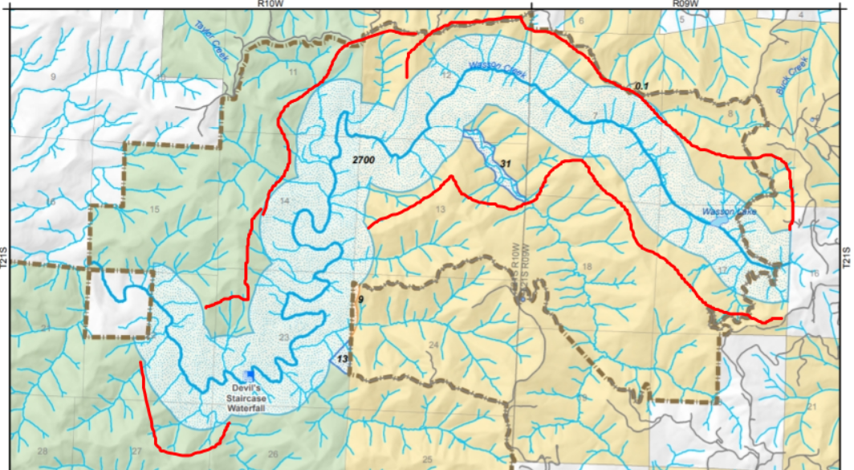

Making this adjustment may be most important in the far eastern portions of the corridors that are outside the wilderness.

Franklin Creek’s WSR boundaries could also be slightly expanded to encompass the drainage and headwalls of small tributaries.

Capturing the full drainage and headwalls will help protect and restore outstandingly remarkable values related to water quality, fish and wildlife habitat, natural fluvial and geomorphic processes, scenery, recreation, etc.

The small addition labelled “31” on the map above should either be included in the expanded corridor as drawn above or at least widened to 2 site potential tree heights to capture more of the natural riparian processes.

**Recommendations**

We have a strong preference for conservation and restoration of outstandingly remarkable values via natural processes such as photosynthesis, biomass accumulation, natural disturbance and mortality, fire, floods, wind, etc. These forces created the natural features that we now identify as outstandingly remarkable values.

The NEPA analysis should develop alternatives that harmonize conservation of the outstandingly remarkable values with other important conservation goals including: the objectives of the Wilderness Act, critical habitat designated under the Endangered Species Act, climate goals including mitigation and adaptation, and the USFS and BLM Riparian and Aquatic Conservation Strategies that also apply to these lands.

We would like to reiterate the management recommendations we made I our March 5th, 2021 pre-scoping letter:

We have some *recommendations* for the management of the area:

* + Overall, we urge you to manage the area for values other than human use. This unique wild place is best managed for wildlife habitat, ecosystem integrity, biodiversity, carbon storage capacity, and clean water. Encouraging more human use could mean damage to sensitive areas, disturbance and other impacts to wildlife who find refuge here, and degradation of WSR ORVs.
  + We recommend allowing certain closed roads, such as FS Road 4100, to become de facto trails and maintained accordingly. The rugged terrain, shallow soils, and dense vegetation does not lend itself to trail building or maintenance, and additional trails (off of roads) may lead to degradation of WSR ORVs or important Wilderness qualities.
  + We encourage you to manage the portion of the Wasson Wild & Scenic River that is outside the designated Wilderness as close to the same way as the portion within the Wilderness as possible.
  + We urge the agencies to coordinate or focus nearby restoration efforts on enhancing the ORVs for which the Wasson and Franklin Creek WSRs are designated. This can mean acquiring private parcels of land (and stream) to better protect or restore fish and wildlife habitat, water quality, and scenery.
  + In addition to closures that have already occurred, consider decommissioning roads on the edge of the DSW to further reduce the possibility of illegal trespass.
  + Invest in education, information, and signage that will deter illegal use and help the public understand and respect the important and unique nature of the DSW.
    - Given its location on the edge of the Wilderness, location near a main road, and being an attraction in and of itself, Wasson Lake might be a good location to place an information kiosk for people visiting the area that includes education about Leave No Trace principles, Wilderness regulations, and the nature of the area’s unique ecology. (However, we do not recommend posting a detailed topo map that might encourage rogue trails.)
  + Invest in monitoring of human use and illegal trespass so these impacts can be addressed and mitigated.

Our *concerns* for the management of the area may come if increased human use is encouraged

and leads to abuse or trespass, or if disturbance of wildlife, pollution of streams, or the spread of invasive weeds increases.

Each substantive issue discussed in these comments should be (i) incorporated into the purpose and need for the project, (ii) used to develop NEPA alternatives that balance tradeoffs in different ways, (iii) carefully analyzed and documented as part of the effects analysis, and (iv) considered for mitigation.

Sincerely,

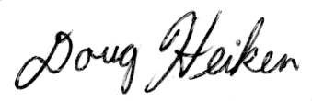

Doug Heiken

[dh@oregonwild.org](mailto:dh@oregonwild.org)