Re: Taos Ski Valley Gondola and Other Improvements Projects Draft Enviornmental Assessment.

Mr. Duran,

Thank you and the Forest Service for reading this reply.

I recognize that hundreds of hours have gone into the creation of this proposal, and I thank all those who put forth their time and best efforts. The focus of this plan is improving the guest experience at Taos Ski Valley. In it's current form, this plan requires costs be beared by the public, communities and people surrounding Taos Ski Valley. I believe we can do better. There is, somewhere, a plan that is a win for the public, the Ski Valley and the Forest Service. However, as written, this Draft EA, is not a win-win for all parties.

I have many happy memories of growing up skiing at TSV. I currently also live along the river and an acequia. I see the life that they bring to the valley. With one leg on the slopes and one in the river, I’m seeking a win-win solution.

The opening cover image is enticing and looks like it was put forward by the perparor. I ask that this report uses neutral and relevant imagery in order to maintain objectivity and public trust.

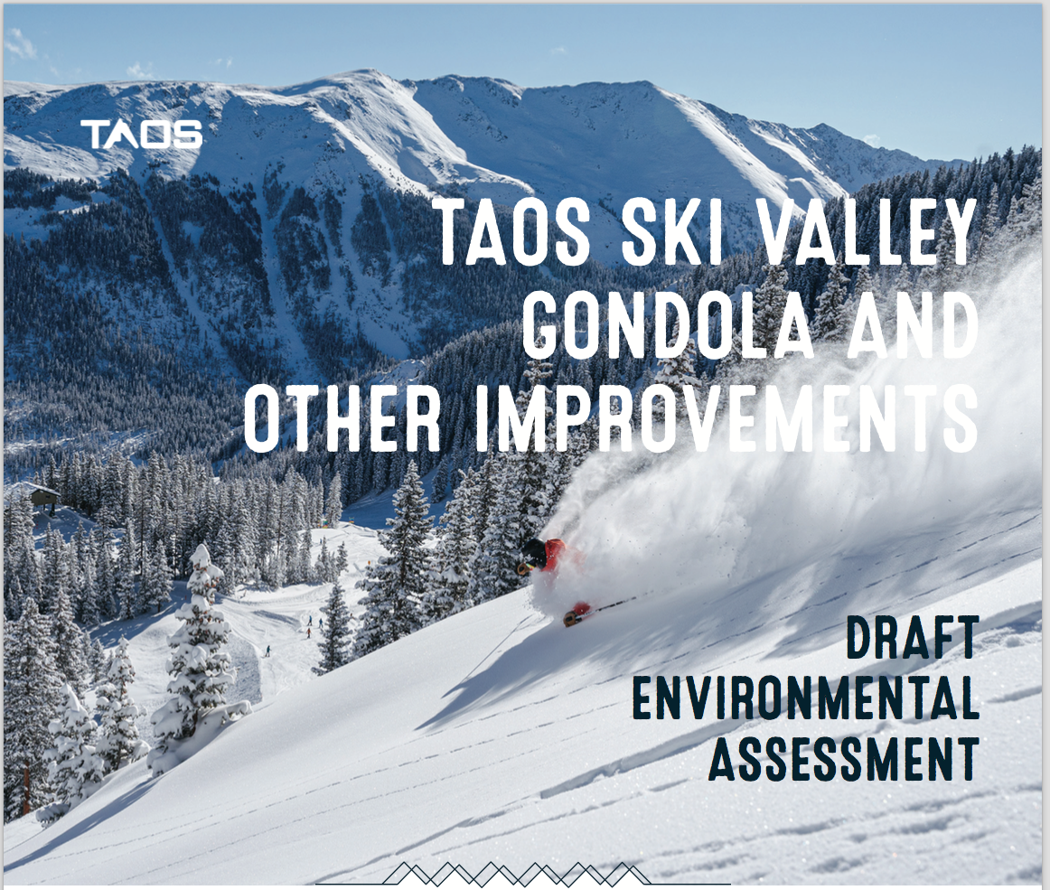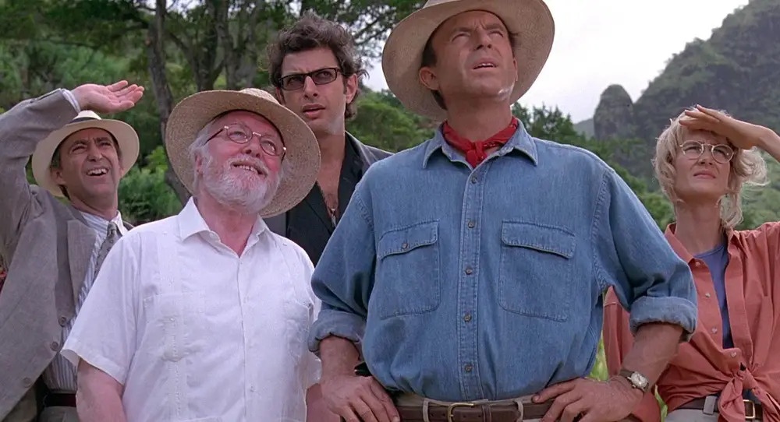

“Wow, it is big alright.”

As young students, we would often spend extra time and money at Kinko’s working on our binding and our covers. We hoped to impress our professor from the minute one. Sometimes this was done on top of a thoroughly well written paper, but more often, it was done to make up for our lack of preparation and skill.

Using graphics for the sake of influence is well known and done often these days. Here we see Cambridge Analytics using images to influence elections in Nigeria.  
(<https://www.theguardian.com/uk-news/2018/apr/04/cambridge-analytica-used-violent-video-to-try-to-influence-nigerian-election>)

To offset the bias that may be induced by seeing beautiful mountain imagery and elegant graphics, I submit the following:

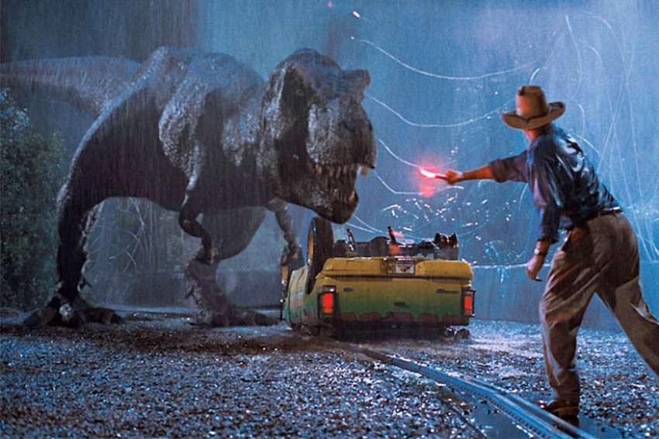

The movie, Jurassic Park, is a tale about a theme park built upon a great vision, but who's the lack of adequate planning results in unintended consequences for its guests.

This is what we wish to avoid. We seek to improve Taos Ski Valley’s (TSV) draft EA so that it better meets the needs of their future guests, the Forest Service, and the needs of Taos residents and nearby communities.

An appropriate use of leading images would have been a map of the Ski Valley and the proposed changes.

Such maps, are essential to understanding the Draft EA but are only found at the back of the report, pages 58 and 59.

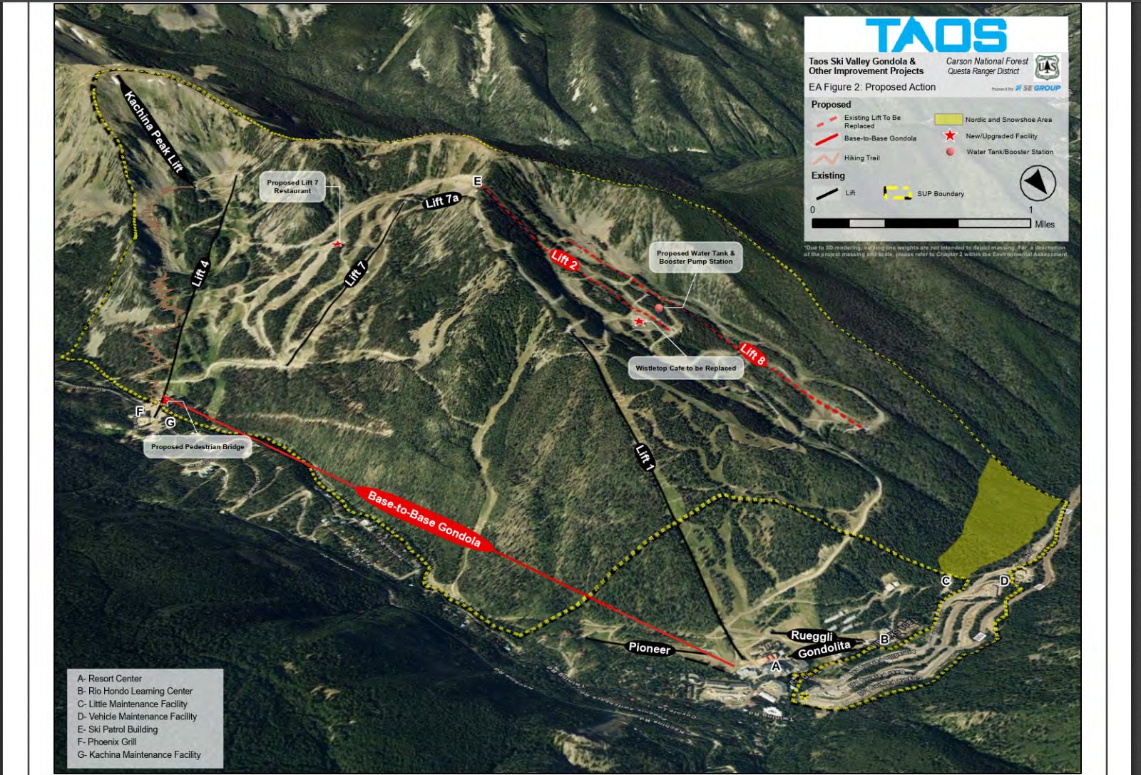

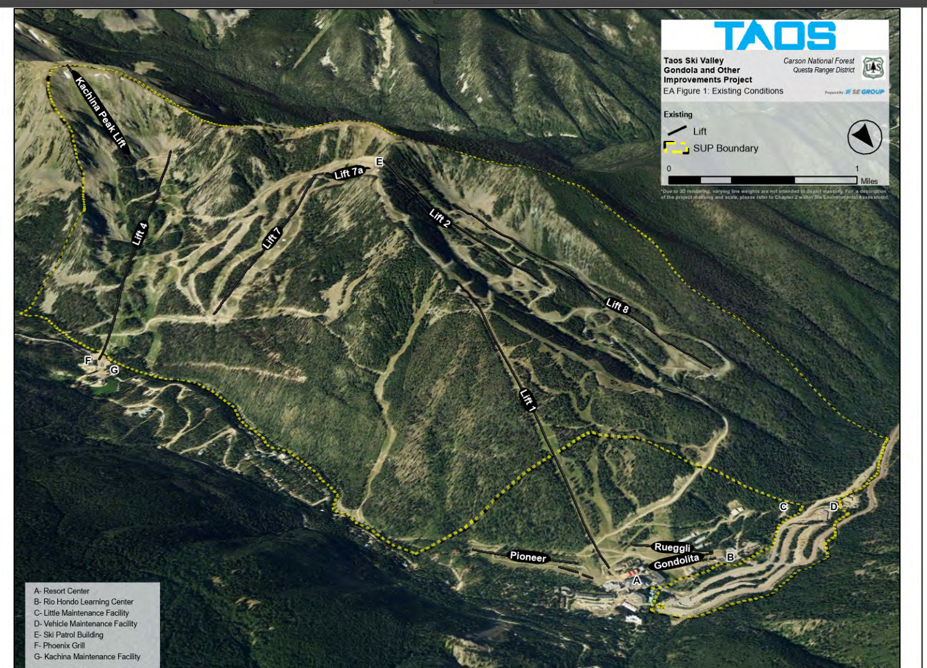

The TSV Draft proposal focuses on:

1. Connection issues between Front and Back side.
2. Improving guest on-mountain experience.
3. Expanding types of recreation.

(p.1, TSV Draft EA_230308)

The subsequent actions are proposed:

1. Base to base Gondola.
2. Replacement of lifts 2, 8.
3. Addition of a 5 million gallon water tank and booster station.
4. Addition of new Nordic trails (33 acres)
5. A new restaurant (Top of lift 7)
6. Replacement and relocation of Whistlestop Café.
7. A new hiking trail near Lift 4.

These changes attempt to address:

1. Winter out-of-base lift capacity and on mountain guest dispersal.
2. Reduce vehicle traffic frontside to backside.
3. Increase on mountain restaurant seating and service space.
4. Increase storage and pump pressure for snow making and fire suppression.
5. Increase non-skiing activities.

**Unstated assumptions include:**  
I. The need to maintain and increase the numbers of skiers.

Ernie Blake embraced skier limitations as a form of compromise. There is no such mention in this report.

II. Changes are framed as ‘needed to fulfill deficiencies.’ Therefore, the language in the proposal refers to ‘improvements’ instead of expansion. It could read as,

“Due to the success of our prior expansion, further improvements and expansions are needed.”

Replacing lifts, is an improvement. Renovating a Café, would be an improvement. Adding a Gondola, a 5 million gallon water tank, and a restaurant are generally what municipalites call ‘expansion’.

The understated assumption is that the resort must keep growing and expanding. A different goal would be attempting to achieve sustainability.

Aspects of the draft EA include:

**A. Base to Base Gondola.**

This section (p. 4, TSV draft EA) assumes:  
*“The road was not designed to support the traffic it experiences, is often congested, and requires frequent maintenance.*”

The premise is that, since TSV has expanded operations on the Backside of the mountain, but did not put a plan in place to accommodate an increase in traffic as a result of the expansion. This was an unintended consequence resulting from the previous plan.

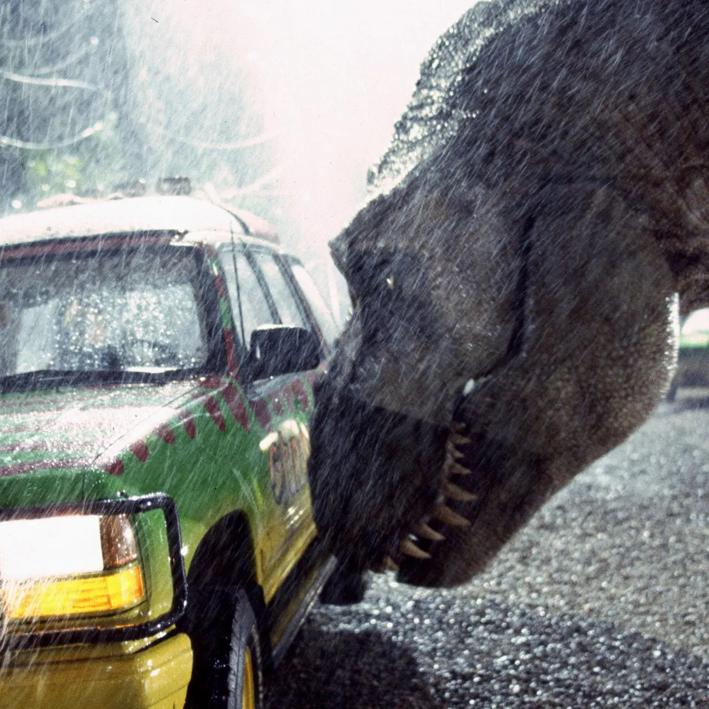

“Congestion? Looks like a lack of drivers to me.”

A1. The assumption of “congestion”

*“Parking spaces in these two lots are limited, but* ***some*** *TSV visitors choose to park in these areas for quicker access to the Backside lifts. Throughout the year non-TSV visitors use the Forest Service parking lot at the Williams Lake trailhead to access the popular Williams Lake Trail. Twining Road has experienced an uptick in vehicle traffic, primarily associated with the popularity of this trail, and has more frequently become a congested area.”* (p. 33, TSV Draft EA)

**“Some” c**ongestion is the reason given for the need for a Gondola. Yet there are no traffic studies included in this draft. Instead, the draft refers to data from NM Dot and estimates from the SE Group.

NM DOT’s data is only collected in “*short duration counts”* and does not include monthly counts.

SE Group states that “1,827 vehicles may travel to TSV”. This number includes non-skiing guests.

Of this 1,827 vehicles that reach TSV through the last 1/8 mile of highway 150, there is no estimate how many proceed on to the Backside along Twining road.

This is the portion of road we are interested in studying, not NM 150.

***“Average Daily Traffic (ADT) on NM-150 is likely higher during the winter months and lower during the summer months.“* (P. 34)**

This is logical if we consider traffic arriving at Taos Ski Valley without consideration of the Twining Road.

However,

*“Twining Road has experienced an uptick in vehicle traffic, primarily associated with the popularity of this trail (Williams Lake).”*

Hiking to William’s Lake is popular during the summer months. Thus, if the destination is the Backside of the mountain, and not just NM 150, we cannot presume higher congestion during winter months.

In February I drove to the Backside, around 1:30 pm. I encountered no traffic in my direction. The first parking lot was empty, normally 1/3 to 1/2 full on summer days. On slope, the day was warm and the mood was relaxed as people came down the mountain and lined up for the chair.

Upon leaving, three vehicles passed us in a span of about 15 minutes as we walked the dog. During my drive up and back, we encountered no congestion whatsoever.

The congestion referred to in the report and by other commentators may be real or experienced, but there are no concrete numbers.

An accurate vehicle counts along Twining road would answer whether there is increased congestion along this road or not.

A traffic study would tell the Ski Valley, the public, and the Forest Service, what problem a Gondola is solving, if any.

If the problem is distribution of guests, this should be studied instead of traffic. For a discount on a day’s lift ticket (coupon code), guests could geo-share their location on the mountain for the day. The Ski Valley could see in real-time where demand bottlenecks. CCC (Comfortable Carrying Capacity) could be measured statistically instead of estimated. Just displaying lift wait times in the app would be an incentive for people to shift bases. People could handle their own load distribution if they were given the information.

A2. Assumption: “Gondola relieves ‘congestion’”.

This assumption requires users to opt to ride the Gondola and not to drive to the Backside. For non-guests, during the summer, driving to the Backside is free. If the Ski Valley charges for Gondola use (Snow Mass charges ~$70.00), then most non-guests will continue to drive. Thus, no traffic is alleviated.

A3. Assumption: “No viable alternatives”.

1. Shuttles to the Backside.

The main parking lot for TSV has shuttles and trams. Why didn’t this proposal include a study looking at using a shuttle service to the back side instead of a Gondola? How many people an hour need to move back and forth? The Gondola will transport 1,800 per hour.

The report states parking lots with 1,740 spaces reach capacity (p. 34 TSV Draft EA). With an estimated average of 2.3 people per car, this is around 4,000 guests on the mountain. In 2.2 hours, the Gondola can carry 4,000 guests from the Front side to the Back side. Is this necessary? Is it desirable? This proposal includes no guest surveys, and includes no traffic studies. Thus, it puts the Gondola at risk of riding empty for most of the time. This would be a lose-lose scenario. If we build this, and people don’t use it, it is a waste. In order to fill empty Gondola cars, the Ski Valley would be incentivized to limit free traffic to the Backside via tolls or paid parking.

1. Let People Move themselves.

Basketball introduced the shot clock and the three point line. Both have changed the game.

Baseball recently introduced rule changes to speed up the game. And it is working. TSV, through their mobile app, could offer incentives for people to move to different parts of the mountain. Ie. Using geo-tagging, TSV could offer $20 in meal tickets for the first 200 people to reach Backside terrain. This is exactly how airlines deal with overbooked flights.

By gamifying redistribution, the resort could maximize guest engagement.

A4. Assumption: A base to base Gondola is a better way to distribute guests on the mountain.

Most Western style resorts have a gondola that goes to the top of the mountain or primary access to the most trails. By this logic, the Gondola should go from the base of the Frontside, to the top of Lift 7 (point E).

This gives skiers access to the Front and Backside of the mountain. A disembark station could be provided at the top of Lift 1.

This would alleviate usage of Lift 2 to get to the Backside.

On a typical day, my friends and I would use Lift 1 to ski the front side for some part of the morning. Then use Lift 2 to get to the Backside. A Gondola to the top would allow us to access the Backside in one ride.

As proposed, I would need to ride the Gondola to the Backside, then take Lift 4 up and even Lift 7 from there. As planned, as a guest, I need to take two lifts, minimum to access the Backside. A high capacity Gondola going to the top of the mountain is more likely to evenly distribute guests than a Base to Base Gondola. Most people, at most resorts, wish to get to the top of the mountain and ski down. A base to base Gondola doesn’t help this primary guest wish.

A Gondola to Peak plan is not mentioned nor discussed in this proposal, despite it appearing to be a more efficient way to distribute guests on the mountain.

This is especially true if we consider the numbers that make up the CCC number (Comfortable Carrying Capacity).

*“The CCC is calculated by dividing vertical supply by the vertical demand”* which includes time spent in line, on the lift and in descent.

With a rise of 3131 feet,

(<https://opensnow.com/news/post/insider-s-guide-to-skiing-taos-ski-valley-new-mexico-where-aspirations-thrive>)

Or 954 meters, a Gondola to the top of the mountain would provide an additional 711 meters of Vertical Supply compared to the Backside base at 800 feet, or 243 meters. (p. 9, TSV Draft EA). This would do far more to improve the overall CCC.

Thus, the current draft plan does little to improve CCC numbers when compared to alternatives, and because no studies of traffic on the Twining Road have been done, we have no data quantifying or measuring congestion or the problem we are trying to solve.

**B.** R**eplacement of lifts 2, 8.**

Logical and sensible. I fully support these actions.

**C. Addition of a five-million-gallon water tank and booster station.**

I. Where will the water come from?

a. Diversionary Rights.

There is a reference to TSV’s diversionary right’s (hold a diversionary right of 200 acre-feet) but no documentation is provided. No one downstream has been able to verify how the Ski Valley has arrived at this number and no one upstream has offered any validating documents. Inquiries to the State engineer’s office have also gone unanswered. If there is legal proof of this right, we want to see it.

II. Climate Change and reliance on snowmaking.

III. Loss of snow due to wind.

Snowmaking machines use about 107 gallons (405 litres) of water per minute.

(<https://en.wikipedia.org/wiki/Snowmaking>)

The TSV Draft EA gives no details on how much additional snow will blown or how much was made this last season. If we assume snow is blown for 9 hours out of 24 we have:

107 gal/min x 9 hr / day x 60 min / hr = 57,780 gallons / day.

At a loss of 20% due to evaporation, down stream users are losing 11,556 gallons for every 9 hour day that the Ski Valley makes snow.

A typical household uses 100 gallons of water per day.

(Loss Rate: https://www.frontiersin.org/articles/10.3389/feart.2019.00078/full)

I also wonder, how many snow guns will be operating at once?

A proper proposal should include types of snow making equipment and known flow rates. It should also include the estimated number of days and hours of operation and number of ‘guns’ so that so that loss of water to the water shed can be calcuated.

Known quantities, such as last year’s snowmaking activities should be stated and documented in a subsequent draft proposal.

A map should be included so the public can understand current operations and monitor their impact.

Snowmaking operations that come from reservoirs are known to affect the nutrient levels in the river. We assume that water blown from the proposed well, or piped from springs will not change the level of nutrients in the river but it would be best if this was addressed in this draft EA or a susequent EIS.

However, water from other sources may have nutrient levels and thus have unintended consequences on the Rio Hondo.

Man made snow is denser and slower to release – this affects stream flow and fish. A complete draft proposal should consider these effects. This would be welcome in a follow up EIS.

<https://apnews.com/article/science-sports-lifestyle-business-economy-ba133300868f2b8a65da8026c0ca2699>

The mountain itself experiences snow loss due to wind, even after the snow hits the slopes. (CNF personnel comment)

IV. Dirt Removal.

To improve the sight lines of the proposed five-million-gallon water tank, it will be partially buried. No depth is given in the proposal. If we assume that it will be buried halfway in the ground (25 ft), then it will require removal of substantial amounts of dirt.

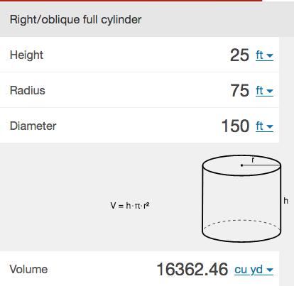

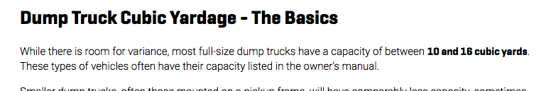

16,362 cu-yd / 18 cu-yd = 909 Dump trucks of Fill, assuming the tank is buried to half its height (25 ft).

The proposal does not address what will happen to the dirt will be dispersed. Will it be hauled from the site? Will it be spread on nearby runs? Will it be used to landscape up the side of tank?

One of the largest contributors to unhealthy river flows is construction. 900 Dump trucks of soil is a large operation. Especially mid-way up a steep mountain. Yet the proposed plan does not consider any of these necessities. I am concerned that inadequate planning leads to unintended consequences.

**E. New Restaurant (Top of lift 7)**

I. Water – how much will be used daily? Where will it come from?

**“Should it be determined that the proposed well is not viable, water and sewer would be provided from either trenching pipelines within existing ski trails and access roads or manually hauling these utilities in and out. ”**

This sentence gives three possibilities for obtaining water. Anyone who has had to have a well drilled in the last two years knows it is an arduous and tenuous process. Granite, as mentioned in the DEC / Drako / Glorietta report, is one of the more challenging materials to drill through, if that is what is beneath the Lift 7 site.

In upper Arroyo Hondo, it is necessary to drill close to 450 ft to reach the deep aquifer. And that is for locations close to the river with no vertical rise.

If trenched pipes are used, where will the water come from? How much will be needed? How much will be returned to the river? As grey water, or black (toilets and sinks) water?

If water is manually hauled, where will it come from? What will the mineral content be?

Will a road be put in place to allow for hauling of supplies and exporting of garbage and waste?

What will happen to the grease from the kitchen’s traps?

Here we see a sewage treatment plant that uses energy gathered from solids to produce power. This system can save up to a half million / year.

[How one utility powers its entire plant from wastewater](https://youtu.be/hbA0LEUSboA)

[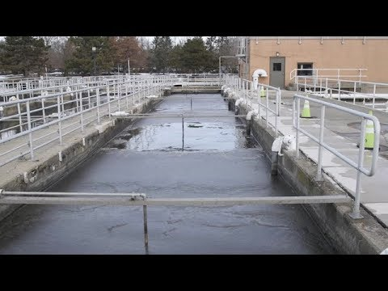](https://youtu.be/hbA0LEUSboA)

This is the kind of planning and forward thinking I would expect from a B Corp. Please consider such an implementation as part of planning for a sustainable future.

II. Assumption of Improvement.

i. Lack of Surveys.

**“Overall, both of these facilities would enhance the winter guest recreation experience by providing easily accessible facilities that are aligned with guest demands.”**

There is no listed documentation or collection of surveys assessing guest demand. Typically a company interested in bringing a new product or service to market, would survey a target demographic. One would hope to collect between 50 – 100 surveys initially. These surveys would contain broad questions to target a specific demographic of desired customer. Ie. First time skiers, families, local pass holders etc.

Follow up surveys would include more in depth questions and possible face to face interviews, complete with gift cards or some sort of incentive rewards for second stage particpants. In the case of TSV, this could be a free lift ticket or meal coupons.

Surveys could have been done by handing out clip boards to guests in lift lines, there could have been QR codes on the back of lift tickets allowing for mobile surveys, there could have been online surveys made available to guests.

There is no evidence of ‘guest’s demands’. There should be a list of responses that have been aggregated to formalize the demand that is driving this entire project.

These are basic research standards that appear to have not been performed or whose documentation has not been included.

It is important for all of us, TSV, the Forest Service, and us the public, to know that we are solving an actual problem.

“Build it and they will come.” is a formula for a movie. We should be using a data driven approach.

As it stands, by best estimate, this demand comes from 80 people who were gathered in a room and given a blank slate. I love the open approach the SE Group took to hear these people but we needed to conduct a series of these blank slate meetings with a variety of different groups over different time frames.

Ie. What was the percentage of annual pass holders in the room versus one time skiers? Because these are two different groups who have different demands of their resort experience. Whose demands are we designing solutions for?

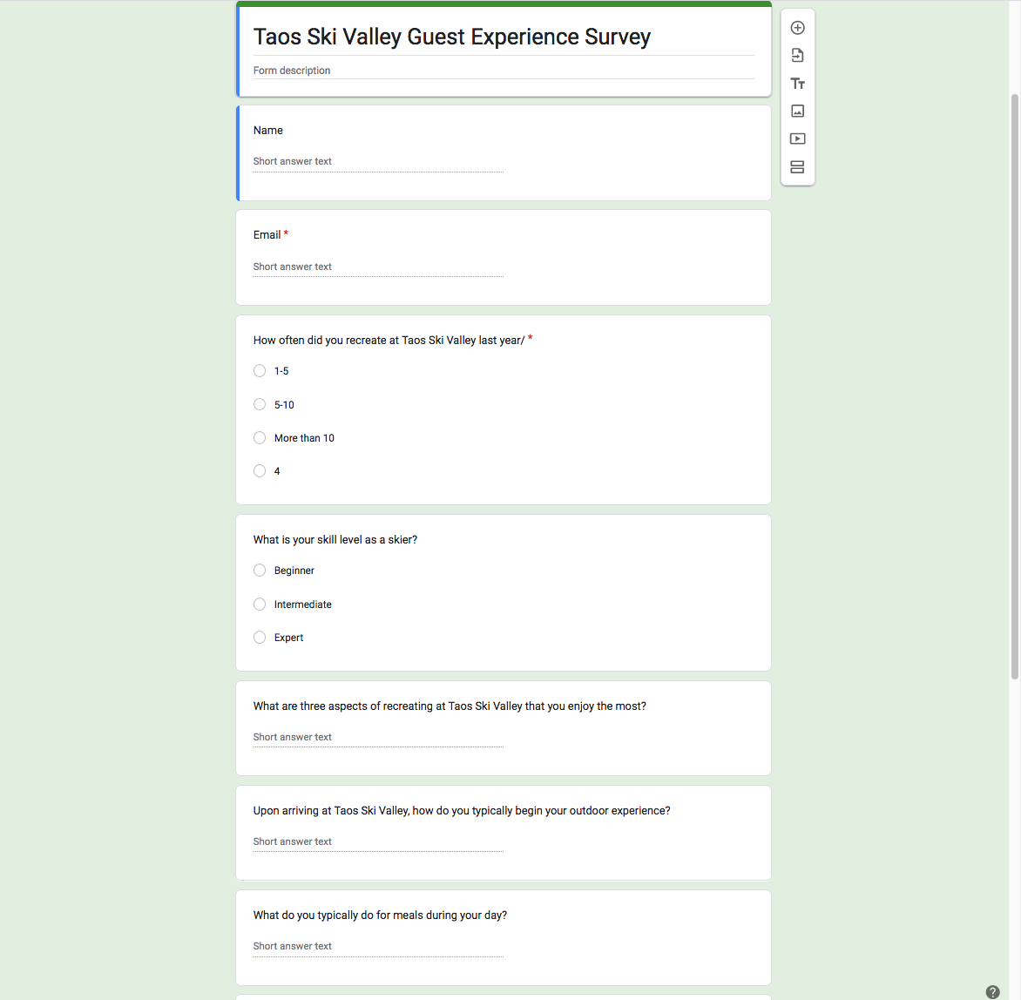

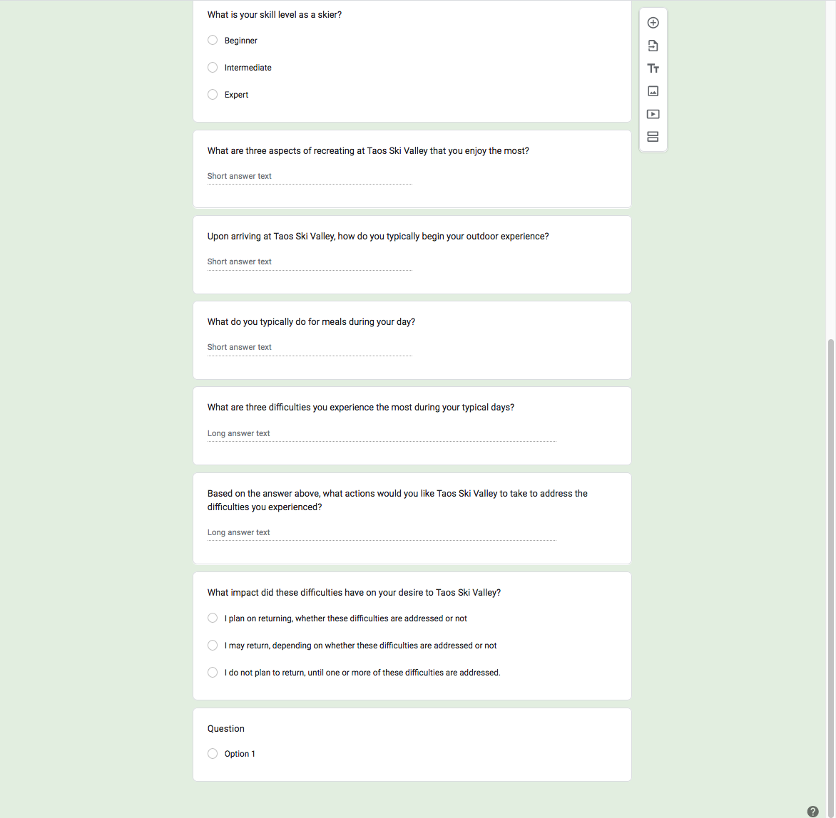

The 80 people who attended the initial scoping meeting appear to have set the tone for rest of the development. I greatly appreciate SE Group’s blank slate approach but I believe that the true needs of the TSV’s guests can not be determined in a single meeting. If the resort see around 4,000 guests on a high capacity day, a sample size of 80 people is too small and the survey methods may have been too informal to reveal the overall needs or pain points of guests on the mountain. In order to attract potential guests, TSV should be conducting surveys on potential guests who recreate at other resorts.

If survey’s were done, I’d like to see the results and expect that information to be included by reference in the proposal.

III. Local eateries not included in seating capacity count.

*“It was determined that TSV is deficient in food service seating by 189 seats, with 153 of these seats coming from the lack of on- mountain facilities (SE Group 2021). This does not account for non-TSV owned restaurants in the Frontside base area or outdoor seats across the resort, which may alleviate the deficit in food service seating; however, it is not anticipated that non-TSV owned restaurants in the Frontside base area fully compensate for this deficit.”* (p.15)

153. How was this number arrived at?

How can 153 seats come from the lack of on-mountain seating? What measures on-mountain seating demand vs. off-mountain seating demand? No study or survey is included for these critical calculations.

If this 153 seats is critical, and somehow it is determined that it must be an on-mountain dining experience, I ask that the Whistle Stop Café be expanded in lieu of the Lift 7 Restaurant.

This proposal does not know if non-TSV restaurants can provide additional seating. Here is a partial list of eateries already in place.

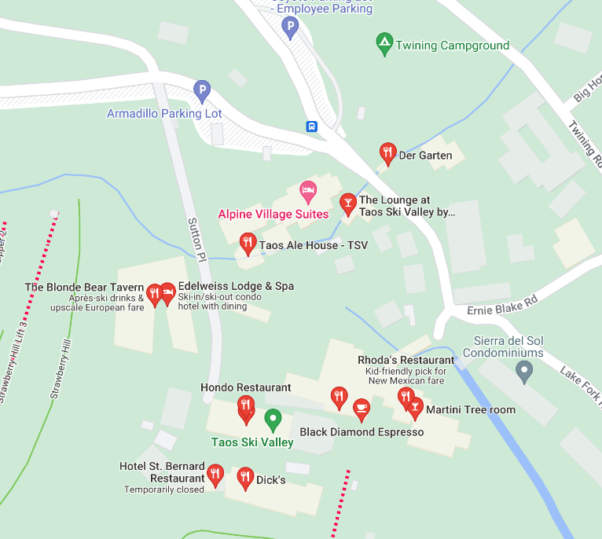

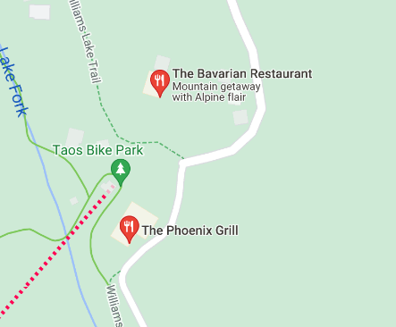

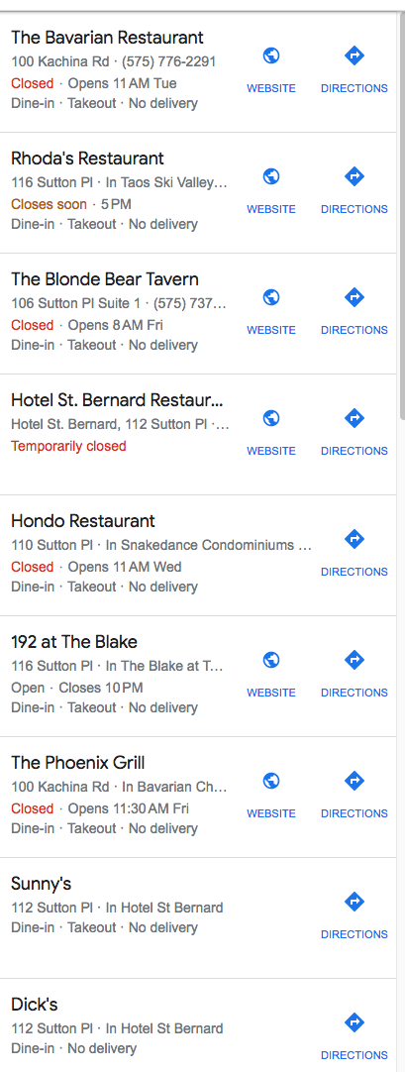

Plus Cid’s is now open.

The seating capacity of these non-TSV restaurants should be surveyed and included in the total seat count. Otherwise the ‘deficit’ count cannot be considered accurate.

*“Furthermore, there is currently no on-mountain dining on the Backside, along with this, the Kachina Basin guest facilities are smaller and often crowded, which does not create an ideal guest experience for Backside terrain users.”* (p.15)

The Phoenix was always our go to spot for lunch. A better plan would be to enlarge the capacity of the Phoenix to handle more guests. The Phoenix has water, sewage, trash and is in a location reachable by most guests on the Backside. In addition, non-guests can join guests, for lunch. Something not possible on-mountain. The Phoenix is accessible in the summer for hikers headed and returning from William’s Lake. TSV should seek to capture this traffic.

In addition, on-mountain restaurants are extremely hard to re-supply and all the trash must be carried out daily.

For all the reasons above, I request that you expand the Phoenix in order to better serve TSV’s guests.

**CLIMATE CHANGE**

* Transition to summer-based activities:

Placing eateries on-mountain in the proposed locations makes them inaccessible to guests during summer activities, unless multiple lifts will be running.

The majority of Western resorts are planning on shifting towards summer activities to address climate change. Renovations or add food options to the base of the Kachina would make the most sense to address the needs of guests.

* Snow blowing:  
  Predicted loss of snowpack throughout the Southwest means relying on snowblowing to make up the shortfall. With an average loss of up to 20% of 107 gallons per minute for blown snow, we can expect water to be lost due to vaporization.

(https://www.frontiersin.org/articles/10.3389/feart.2019.00078/full

* Increased Fire Danger:

The location of the 5-million-gallon tank, mid-mountain, makes it inaccessible to fire vehicles other than helicopters. In Paradise, CA, 88 people died, many in their vehicles, while stuck in traffic. Many deaths could have been avoided by having proper signage and a good fire and evacuation response plan in place. Inadequate planning resulted in unintended consequences. Putting the five-million-gallon tank where emergency vehicles can reach it, could save lives and homes in the village in the event of fire. See separate comment, ‘FIRE RISK’ for further details. “There is a further discussion needed here..”

Adding more summer visitors means adding more danger of human fire starts.

* Lack of Acknowledgement of the NM 50 year water plan.

**“Throughout the western US, impacts from climate change mean less water will be available while demands continue to increase. Runoff and recharge are expected to decline by as much or more than 25% across the state. The average temperature in New Mexico is expected to rise by 5 to 7 degrees, leading to hotter and more severe droughts as well as decreased snowpack with earlier runoff leading to diminished stream flow.”**

(<https://engagenmwater.org/new-mexico-50-year-water-plan>)

As a B Corporation, the Taos Ski Valley’s water plan should adhere to the State’s 50 year water plan. This TSV Draft EA does not yet reference the State’s plan. The next iteration of this plan should.

**FIRE RISK.**

(This section has been duplicated and added as a separate comment)

The Calf Canyon / Hermit Peak fire remains on everyone’s mind. Gratefully it did not reach Taos Ski Valley and the communities on the Rio Hondo, and thanks to the hard work of all the fire crews, the fire was contained at Highway 518.

Given drought and climate change, the next fire may reach TVS. It is probably not if, but when. The Ski Valley and the downstream communities should all have a shared plan in place.

The location of the five-gallon water tank would be one element of such a plan. It is not clear from the draft proposal that the preparers consulted experts in the field of wildland firefighting. Therefore I asked for the opinion of one of the fire incident commanders from last year's Calf Canyon fire.

For the given location designated on the map (bottom of Lift 2)The following should be considered according to his analysis:

1. **Approach and departure and where the bucket would go if there is a mishap and the pilot has to “punch the bucket” (drop it) you want to consider it will land somewhere not occupied by people or important assets.**
2. **The higher the elevation, the more work it requires the helicopter to do to lift the same load. On the other hand, it is easier to go downhill with a full load than uphill, so it is a bit of a balance.**
3. **Regarding tree removal, I would want an exit path and you absolutely do not want the helicopter to have to go up over timber or terrain close to the dipsite on either side. That just adds to the potential for error and really bad days.**
4. **If considering how the water may be used for all types of firefighting it gets more complicated.  But, generally I would be considering the following:**
5. **If the water will be plumbed to a location where fire apparatus can be filled, the plumbing should not be able to be damaged by falling trees, etc.**
6. **The water pressure at the fill outlet should be reduced to a level that regular fire hoses can handle.**
7. **Valves and other appliances should be of the type that they cannot be closed quickly and cause water hammering.**
8. **There should be a well-designed traffic pattern for apparatus that does not require backing up.**
9. **If there are hard-plumbed sprinklers to protect structures, then the system should be designed to allow for sprinkler use, water filling or both**
10. **Efforts should be biased towards 1) helping suppress fires when they are small, and 2) protecting everything that needs to be protected to maintain the ski resorts functionality after the fire.  That is a longer conversation but one that certainly needs to be had ahead of time, so you do not squander precious time in the moment.**

 Note:The incident commander wrote, **“This is a longer conversation that certainly need to be had...”** The Forest Service, TSV inc. & Village, and the public should all be having the discussion about fire suppression right now. So far as the current version of the TSV Draft EA is concerned, there is no such conversation. A well thought out plan should include a thorough discussion of fire and drought. Such a plan could save lives, homes, millions of dollars and irreparable damage to the watershed. The location and accessibility of water is critical to such a plan. Rather than optimizing the water tank’s location for snow blowing, TVS should consider overall fire suppression goals. i.e., water systems should be used to protect structures, instead of trees.

The following 2020,

SOURCE WATER PROTECTION PLAN for Village of Taos Ski Valley Region

PWS #NM 3533329

states:



The ratings of 5.0 and 3.6 are some of the highest scores in the table and are meant to be driver’s for TSV’s priorities. However, the TSV Draft EA does not adequately address this need. Fire suppression is treated as an afterthought or addon. I know we can, working together, create a better plan.

(https://www.vtsv.org/source-water-protection-plan-to-be-considered-for-adoption-june-1-2020/)

**COVID.**

Taos Ski Valley had strict Covid mandates in place and temporarily shuttered Taos Air. They worked with the State, the County and the Town to keep Covid at a minimum. I’m grateful for their efforts and their willingness to consider the safety of their guests and the public of Taos County.

Current Gondolas are a hotbox for Covid. Once you are inside, you are locked in the box breathing someone else’s air. This is counter intuitive as one appears to be outside in the wilderness. However, most Gondola’s are tightly sealed, or designed with small windows to keep heat in.

My cousin and his friend got Covid while riding the Gondola in Jackson. My friends and I rode the Gondola at Snowmass during the summer. One of us, who didn’t wear a mask, got chills that evening and tested positive for Covid four days later.

Gondola’s without proper ventilation inside, HEPA filters, or fans blowing fresh air into them upon arriving at the platform, are incubators for Covid. Coming to Taos and getting Covid at the resort is a negative experience for the guest and it also affects the community.

Monte’s Chowcart has been a Taos favorite for many years. Covid broke out amongst the staff and although Monte was airlifted to CO Springs, they couldn’t save him.

Not having a Gondola has made the Ski Valley a safer guest experience.

**NOISE.**

An increase in flight traffic and the airport expansion has put Valdez and Arroyo Hondo in the flight path for the airport. Our formerly quiet backyard is now something to gaze down upon as jet traffic roars over.

Taos Ski Valley’s neighbors are paying the cost for increased traffic, this comes as noise, lack of privacy, and altering the watershed.

The draft plan EA does not discuss:

- Helicopter Traffic (Duration of days and hours)

- Debris from landings and take offs.

**BIDEN’S SOCIAL JUSTICE ORDER**

**“Communities with environmental justice concerns experience disproportionate and adverse human health or environmental burdens. These burdens arise from a number of causes, including inequitable access to clean water, clean air, natural places, and resources for other basic human health and environmental needs; the concentration of pollution, hazardous waste, and toxic exposures; and underinvestment in affordable housing that is safe and healthy and in basic infrastructure and services to support such housing, including safe drinking water and effective sewage management. The cumulative impacts of exposure to those types of burdens and other stressors, including those related to climate change and the environment, further disadvantage communities with environmental justice concerns.”**

**- President Biden**

(Paragraph 4. April 21, 2023:

<https://www.whitehouse.gov/briefing-room/presidential-actions/2023/04/21/executive-order-on-revitalizing-our-nations-commitment-to-environmental-justice-for-all/>)

This executive order was put forth on April 21, 2023. The TSV draft EA plan, dating back to 2019-21 is now out of date and does include any of the responsibilities that are now assigned to all Federal agencies in order to support environmental justice. In particular, regarding the needs of minorities in the community.

**“Our Nation must also take further steps to dismantle racial discrimination and institutional bias that disproportionately affect the health, environment, safety, and resiliency of communities with environmental justice concerns.”**

The order calls for:

**“... safe drinking water and effective sewage management.”**

Taos Ski Valley has had numerous water issues, even without embarking on the proposed developments.

*“****Water service to a majority of the ski valley was first interrupted on the night of April 1, forcing Taos Ski Valley, Inc. to shut down "all aspects of the resort mountain operation."***

***“It was obvious that we had a big line break on Phoenix Switchback Road, and we got that repaired and things were looking up after that. I was out of water for six days.”*** *-* Mayor Pro-tem Tom Wittman

***“The total unaccounted-for water from February 2014 through December 2020 is approximately 342 million gallons (1,050 acre-feet) or 135,000 gallons per day."***

The Ski Valley will receive 1.7 million from gov. Grisham and $2.5 million from the state and the county.

***“Norden also confirmed that the resort plans to replace Lift 4 with a high-speed quad chair over the summer, as well as break ground on its new Hotel St. Bernard project.”***

The TSV draft EA does not mention the replacement of Lift 4 as referenced in the News Paper article. Is this a typo by the newspaper?

(https://www.taosnews.com/news/environment/water-service-restored-as-taos-ski-valley-wraps-up-season/article_26d42a51-8f91-5eb8-b2dd-341651e70b8e.html)

***“The Village has been dealing with aging infrastructure, mostly in the form of old pipes.***

***As we enter the spring freeze/thaw period a few pipes have failed and are now leaking. The leaks greatly reduce the water pressure running from the public water distribution system to our facilities.***

***Without water, we do not have the ability to prepare and serve food for our guests, and we don’t have adequate operable bathrooms to service our guests or staff in a safe manner.”***

*(*[*https://www.powder.com/trending-news/taos-closed-water*](https://www.powder.com/trending-news/taos-closed-water)*)*

***“Village Administrator John Avila has estimated that complete replacement of the water delivery system would cost up to $10 million; but for now, the repairs will be done in areas where major failures have recently occurred.”***

***“we're not in compliance with our debt covenants.. A 36-percent hike would enable the village to balance its sewer and water budget for the upcoming fiscal year, an increase Caldwell told the Taos News he will advocate strongly. For the past several years, the municipality has been shuffling monies from its general fund in order to tackle emergency water repairs.”***

The village has applied for almost $11 million in grants to address infrastructure debt. According to the EPA, aging water infrastructure is the number one problem municipalities face.

*(https://www.taosnews.com/news/local-news/ski-valley-looks-to-aerial-mapping-grants-to-solve-water-woes/article_803dc426-e66c-50f8-aa20-225a10689021.html)*

The stated purpose of the TSV draft proposal is to reduce guest dissatisfaction. TSV guests who travelled to New Mexico and planned their vacation around skiing at TSV were disappointed to not be able to go to the bathroom and not be able to ski as the resort shut down.

This was due to a leak from a single residence. With an approximate number of residencies, at approximately 80 or more, it is possible that aging pipes will again break.

(<https://worldpopulationreview.com/us-cities/taos-ski-valley-nm-population>)

The number one priority of the Ski Valley shouldn’t be expanding, it should be repairing water lines and fixing infrastructure.

The new Lift 7 restaurant will need water for guest services.

The five-million-gallon water tank, will need water.

The new Whistle Stop Café will need water.

The Drako / DEC / Glorietta / TSV Water Master Plan (WMP), 12-16-21, states,

**“The demand analysis, combined with the future water supply projection outlined in the GGI report, indicate that if no improvements are made to the water distribution system, supply could potentially be insufficient to meet existing demand in 2022, if in 2022 the Phoenix Springs Complex has historically low flows (equivalent to the lowest projected flow from the GGI report). If no improvements are made to the distribution system to reduce line losses, then it will be impossible to demonstrate that water will be available for any future development** "

(<https://www.vtsv.org/wp-content/uploads/2022/03/WMP-Report-FINAL-12-16-21.pdf>)

Yet, given the analysis of the Ski Valley’s own Water Master Plan, development is moving forward on the construction of the St. Bernard without assurances of water being supplied from the Village.

The Drako report states:  
**“if, however, system losses are reduced to 25% (a reasonable, but still relatively high number), then the water use projections indicate the VTSV system will be able to provide water for all proposed future development in the Base Area, Kachina Village, and Amizette, with an estimated 8% surplus at full build out.”**

From this analysis, the Ski Valley’s number one priority should be achieving a 25% loss, compared to current estimates of 60-70%. After fixing their water losses, they should permit growth.

The DEC report takes into account studies and predictions for climate change, whereas the TSV Draft EA does not mention climate change at all.

**EIS.**

We believe a project of this scope and size deserves an EIS. Given the number studies not done, and data not collected, an EIS would help evolve this plan into one that works for all the stakeholders.

**ECONOMIC GROWTH.**

Those of us who bear the pain of TSV’s growth, ideally would also reap some of the benefits to offset the costs borne.

Ie. At my residence, if noise from air or road traffic has become an issue, but my coffee shop in ‘Seco reaps some additional profits from that traffic, then at least there is some offset.

However, the TSV Draft states that

*“Any marginal changes in visitation would not cause changes to the existing economic impact that TSV has on Taos County.”*

In talking to local Taos business owners and retail workers, the common comment I hear is,

***“We don’t get any additional business because they just stay up on the mountain.”***

It makes sense to have TSV be a one-stop shop, but it also means that we, who bear the costs of TSV traffic and growth, are thrown into a win-lose paradigm instead of a win-win one. There is a plan out there that is a win-win for all the stakeholders, but this one needs to evolve further.

**RIVER QUALITY – MONITORING**

The Ski Valley has been incredibly gracious in working with members of the Rio Hondo acequias to procure funding for water monitoring. However, such a system has not been put in place yet so we have no established baseline for measuring what effects the proposed actions will have on the Rio Hondo.

This Draft proposal would be more appropriate after having established standard baseline measurements.

**SAFETY OF SWIMMING IN SEWAGE.**

Our pets drink from the Rio Hondo. Our kids swim in it. We eat fish from it. I get the Rio Hondo in my hair and eyes. As does anyone bathing in the lower hotsprings at John Dunn, or any person who flips out of a raft or barrel rolls a kayak. This water is part of our daily lives, we need to know if it is safe.

We know that remnants of Covid dna remain in the water. What about pharmaceuticals?

The sewage treatment plant installed by Ovivo has had multiple problems as recent as July of last year.

This includes issues as referenced below:

**“...remaining test to find the failure point of the current membranes remains.”**

**"The Integrated Water Systems engineers and technicians are in contact to address system operations issues including monitoring programs, ceramic plate performance, improving the ultraviolet treatment and injector corrections."**

**“The village has not accepted the plant as complete considering the continued required corrections to the system."**

Also at issue is the matter of transparency. We, who swim in the river downstream, want to verify that the Sewage plant is working correctly.

We need to be able to access Sewage treatment records to do that. Just as village resident Michael Fitzpatrick attempted to do.

**"I hope going forward that all of the [village's] activities are totally transparent and [provide] public access to any and all documents," Fitzpatrick told the Taos News. "Democracy cannot survive darkness."**

(July 06, 2022, Taos News: <https://www.taosnews.com/news/local-news/taos-ski-valley-village-council-settles-records-lawsuit-addresses-open-meetings-issue/article_f5dc8e69-d998-5f6d-9397-45fbbc984a19.html>)

An improvement would be for a third party to conduct testing and review of plant operations. This would give everyone Village and below the John Dunn bridge, the confidence that the water is safe to swim in, to have in our eyes, ears, hair – for our pets to drink, and for kids to eat the fish caught in the Rio Grande.

**B CORP.**



It is laudable that TSV, inc. aspires to meet the standards for

**‘an assessment of "social and environmental performance"’.**

During the early scoping for this expansion, TSV reached out to the Taos Pueblo. This was a great method to get early buy-in from an important stakeholder.

In a survey of other western ski resorts; Copper, Breckenridge, Winter Park, Vail, Aspen, Snowmass, and Buttermilk, TSV stands alone in that there are downstream communities who depend on the waters that flow from the head waters where TSV is located.

Unlike the Taos Pueblo, the acequias and its members were not on the contact list. Also noted in Section 4.2.

[5.04.2021 Master Development Plan Virtual Public Forum Recording](https://youtu.be/7qgG8T7eZGs?t=776)

[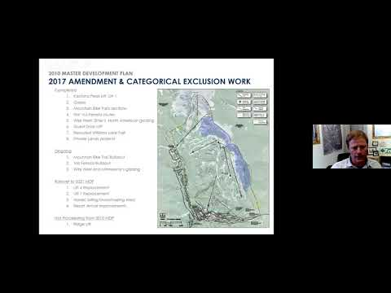](https://youtu.be/7qgG8T7eZGs?t=776)

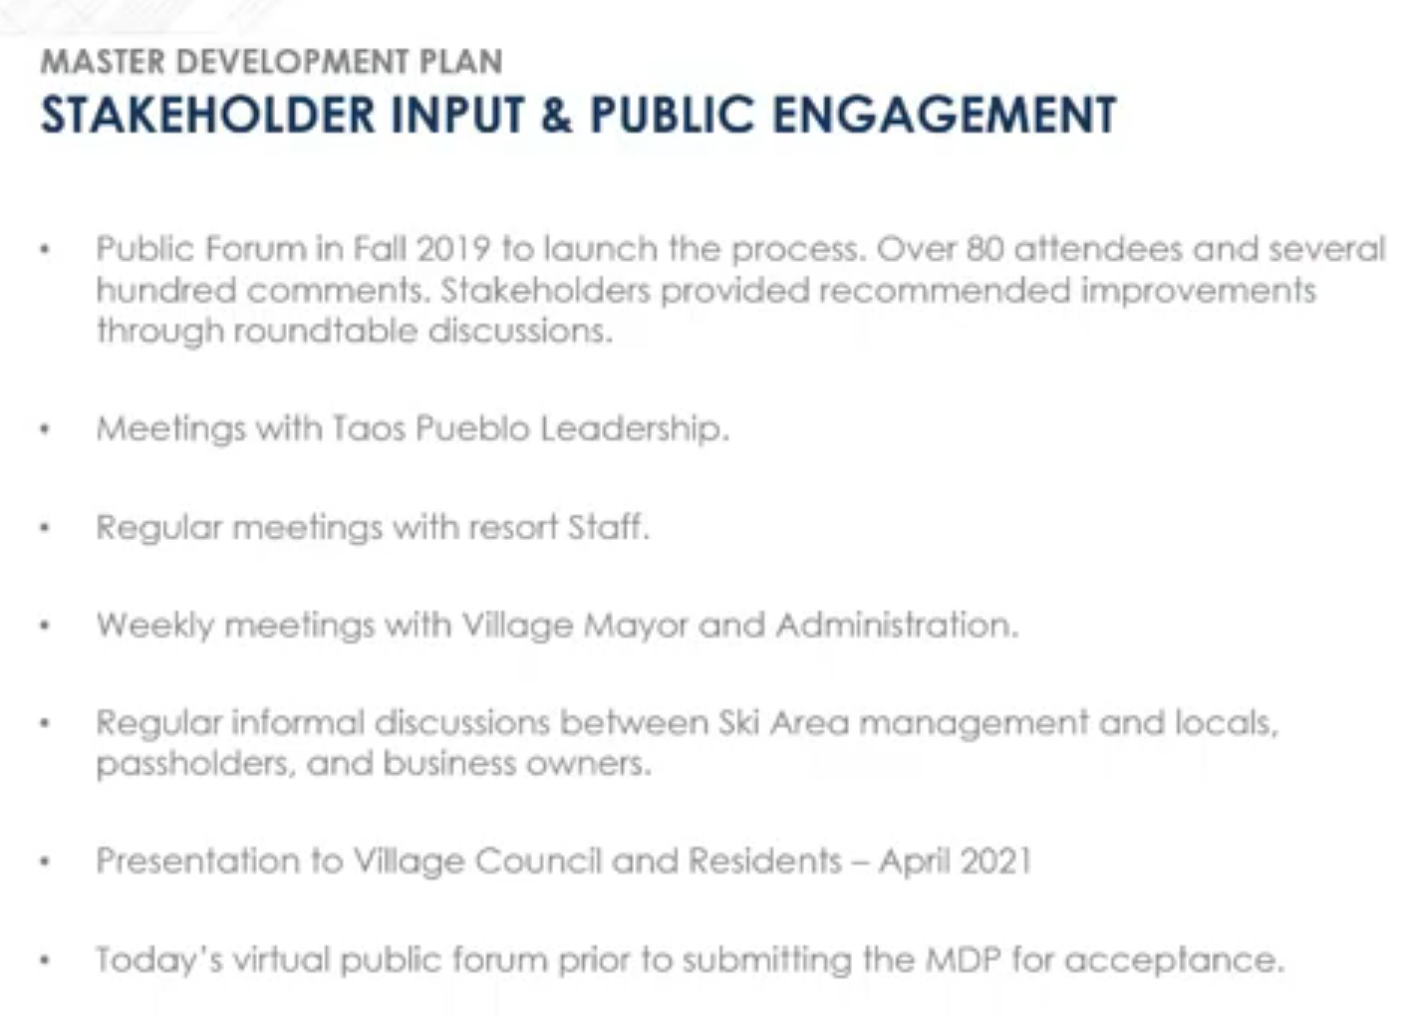

It appears that the TSV planning staff would have invited the mayor domo of each of the three main acequias in the valley, to the original scoping meeting, if they had thought of it. This oversight results in unintentionally excluding the downstream residents.

Skiers come and go. But for those of us along the river, we use it every day, so what is a trickle of an afterthought for those at the head waters, becomes a roar to the downstream users.

As a result, I believe that TSV is not upholding the requirements of social good that comes with being a B corporation. TSV can address this by amending this draft proposal to include the needs of the downstream residents. We don’t deserve to be forgotten.

I believe that the Ski Valley wants to do good, thus I ask them to ask the Forest Service for an EIS. The plan that emerges as a result of an EIS will be better than the one we have before us and one that is worthy of TSV being a B Corp.

**RESTRICTED PUBLIC ACCESS TO WILLIAM’S LAKE.**

If a Base-Base Gondola is built, and the capacity of carrying 1,800 people / hour is underutilized, as one would expect during summer months. It is in TSV’s monetary interest to restrict access and parking to the popular William’s Lake Trail head. This could include paid parking only, access by reservation or permit only. This would be another example of monetizing a public good. The public will be asked to bear the costs of the Ski Valley’s growth or it’s lack of in-depth planning regarding the actual need for a Gondola, beyond the input from a number of people in a room of 80.

In some ways, the Base-Base Gondola argument reminds me of being 16 and asking my parents to buy me a Corvette. I had some compelling reasons to tell them about why I needed that exact vehicle.

**THESE CHANGES ARE PERMANENT.**

Once a structure is built, it almost never comes down. The Gondola, the Water Tank and the Lift 7 restaurant are all massive structures. A handful of decision makers are deciding the future of the water shed for everyone in my generation, all of our kids, and even our grandkids will be living with the decisions that are made here today. It is important that we do our best.

**ALTERNATIVES.**

- No action taken should be considered an alternative.

- Suitable Location for the Water tank:  
Fire suppression is listed as one of the needs to justify a five-million-gallon tank. However, there is no documentation of analysis by individuals with a background in wildland fire fighting suppression. Section 4.2 indicates that Taos County Wildland Fire Coordinator was contacted, but we don’t have any documentation regarding their assessment of the tank location.

The only analysis done appears to be documented in this reply and was done by an individual with over twenty years of expertise in fighting wildland fire, who was kind enough to donate their time to look over TSV’s plans. In doing so, it appears that very little detailed planning, with regard to fire, went into selecting this site. The emphasis was on the ability to blow snow. “A greater discussion needs to be had.” The future of TSV being able to survive a fire, may have its roots in this planning cycle.

- No Water Tank, as an Alternative.

- No Base to Base Gondola Lift, as an alternative.

- No Water Tanks and no Base to Base Gondola lift, as an alternative.

- A Base to Peak Gondola, as an alternative.

- Pave Twining road as an alternative to a Gondola.

- Shuttle buses deployed to connect Front to Backside instead of a Gondola.

- Expanding the ‘Whistle Stop Café' to add on-mountain seating, is an alternative.

- Expand the Phoenix.

- App based incentives to catalyze guest self-redistribution.

- Utilize non-TSV restaurant capacity, distribute capacity info via app to guests.

- Mountain side reservation system.