17 July 2019

TO:   Jonathan Tucker, Middle Fork Ranger District Planner

VIA: <https://cara.ecosystem-management.org/Public//CommentInput?Project=55868>

**Subject: Youngs Rock Rigdon Project — scoping comments**

Please accept the following scoping comments from Oregon Wild and Many Rivers Group of the Sierra Club, concerning the Youngs Rock Rigdon Project, <https://www.fs.usda.gov/project/?project=55868>. Oregon Wild represents 20,000 members and supporters who share our mission to protect and restore Oregon’s wildlands, wildlife, and water as an enduring legacy. Our goal is to protect areas that remain intact while striving to restore areas that have been degraded. The Sierra Club is the nation’s oldest and largest grassroots environmental organization, representing over 1,400,000 members nationally. Our mission is to explore, enjoy and protect the planet. The Many Rivers Group represents over 3,000 Oregon members in Lane, Coos and Douglas Counties.

The proposed action alternative involves:

* 6700 acres of treatment in a 33000 acre project area
* 4500 acres of thinning and regen in stands from 40-200 years old
* 46-65 mmbf
* 160 miles of road maintenance
* 12 miles road decommissioning
* 60 miles road closure/storage
* 1200 acres understory fuel reduction (<7”dbh)
* 300 acres meadow restoration
* Recreation management activities
* Floodplain and watershed restoration activities

Representatives from our groups have been a part of the Rigdon Collaborative Committee of the Southern Willamette Forest Collaborative and supported the development of the Rigdon Landscape Analysis by the USFS. We have been involved in developing collaborative zones of agreement for the Rigdon landscape as well. While we are generally supportive of the outcomes of these analyses and agreements, which focus on the restoration of forest structure and natural processes that have been altered by fire suppression and past logging, we’d like to acknowledge that there are many project-level details of the Youngs Rock Rigdon project (a subset of the Rigdon Landscape) not captured in this landscape-level work, and that we have specific concerns and questions about some of these details, which are still emerging. We look forward to seeing our scoping comments here incorporated into the final EIS analysis and project design and are hopeful that we can support the final decision.

## Purpose and Need

We support much of the purpose and need and proposed action, especially meadow and oak savannah restoration where these special habitats are in need, floodplain and aquatic restoration, road closure and decommissioning, and recreation management that benefits users and natural resources. However we have some concerns about some of the proposed harvest and that “increasing diversity and structure” and “improve structural complexity and diversity” are too vague to fully address our concerns at this time.

While we support the idea of restoring legacy pine and oak trees and habitat, we think this can be done without 50 mmbf of timber harvest, and in a way that better harmonizes competing values, such as carbon, at-risk wildlife, and late successional forest.

The purpose and need for this project should be adjusted to include the following:

* retaining carbon in the forest to help mitigate the global climate crisis;
* retaining features of dense late successional habitat, especially in moist/mixed forests. These forests remain under-represented across the landscape, and may be difficult to retain and recreate in the face of climate change;
* retaining snag recruitment over time. Logging has a long-term adverse effect on snag recruitment that must be mitigate. The FS snag standards are outdated and need to be updated;
* meeting forest plan requirements, including the ACS and survey and manage. These are ant to be a constraint on management activities for good reason and should be followed carefully.;
* moderate hydrologic effects of logging and roads (by minimizing canopy removal and roads);
* moderate fire behavior (by retaining mature canopy cover that moderates fire effects. Lesmeister, D. B., S. G. Sovern, R. J. Davis, D. M. Bell, M. J. Gregory, and J. C. Vogeler. 2019. Mixed-severity wildfire and habitat of an old-forest obligate. Ecosphere 10(4):e02696. 10.1002/ecs2.2696. <https://esajournals.onlinelibrary.wiley.com/doi/pdf/10.1002/ecs2.2696>)

## The Purpose and Need should Address The Unmet Need for Carbon Storage.

Forests are among the largest stores of living carbon on the planet. The forests of the Pacific Northwest are globally significant for their ability to sequester carbon and keep it safely stored for centuries, but only if protected from industrial logging. How is the Forest Service protecting the carbon sequestering potential of this forests? We recommend a full and accurate quantitative analysis of carbon emissions versus storage of various alternatives, and the social cost of carbon emissions.

The agency says one of the purposes of this project is provide a supply of forest products. The agency should reconsider timber targets in light of the fact that the public *needs* carbon storage to reduce global climate change much more than they *need* wood products. The agency must recognize that wood products are already under-priced and over-supplied due to “externalities” (costs that are not included in the price of wood, so they are shifted from wood product producers and consumers to the general public who suffer the consequences of climate change without compensation from those who profit from logging related GHG emissions). Ecosystem carbon storage on the other hand is under-supplied because there is not a functioning market for carbon storage and climate services. The FS is in a position to address these market imperfections by focusing on unmet demand for carbon storage instead of offering wood products that are already oversupplied.

Land protection, both public and private, provides substantial ecological benefits by avoiding conversion of natural systems to intensive, developed uses. These benefits include carbon sequestration, watershed functioning, soil conservation, and the preservation of diverse habitat types (e.g., Daily 1997, Brauman et al. 2007, Kumar 2012, Watson et al. 2014). Land protection also solves a key market failure: private markets tend to underprovide socially beneficial land uses such as natural forests, agricultural lands, or managed timberlands. The reason for this failure is that many of the benefits of these lands go to the public in general, not individual landowners. When private values and market transactions determine land uses, less land will be devoted to socially beneficial uses than if citizens could collectively determine use on the basis of social values (e.g., Angelsen 2010, Tietenberg and Lewis 2016).

Katharine R.E. Sims, Jonathan R. Thompson, Spencer R. Meyer, Christoph Nolte, Joshua S. Plisinski. 2019. Assessing the local economic impacts of land protection. Conservation Biology. 26 March 2019 <https://doi.org/10.1111/cobi.13318>,

<https://harvardforest.fas.harvard.edu/sites/default/files/Sims_et_al-2019-Conservation_Biology.pdf>.

See attached comments on the importance of harmonizing climate adaptation and climate mitigation (carbon storage).

## Dry vs Moist Mixed Forest

While the project contains both moist and dry native forest stands with distinct species composition and biotic needs, the scoping notice does not yet distinguish different treatment plans for these stands, though we know they exist. Please make more specific proposed prescriptions available to the public on the project website so it is clear what is being proposed, and for what purpose, in the different forest types and stand ages. Please be clear in all documents about how treatment plans vary between these two types of forests.

We recommend that thinning for restoration of dry, fire-adapted species should focus in stands with existing pine habitat and dry mixed conifer stands and should avoid heavily removing trees in healthy moist forest. Please also consider that the Jims Creek EA, Table 17 shows that Douglas fir was still the dominant tree species on these sites 100 years ago. This indicates that large-scale removal of Douglas-fir is not necessary or desirable.

Treating any native moist mixed forests should be deprioritized. These forests can sustain high biomass which is more valuable for carbon storage and habitat for spotted owls than for open forest habitat. The historic disturbance regime in moist forests was likely driven by cultural practices of native people and is unlikely to be duplicated. In essence, we are concerned that logging mature moist forests has a greater likelihood of degrading the forests rather than restoring the forest. See Heiken, Doug. 2009. The Case for Protecting Both Old Growth and Mature Forests, Version 1.8. Oregon Wild. <https://www.dropbox.com/s/4s0825a7t6fq7zu/Mature%20Forests%2C%20Heiken%2C%20v%201.8.pdf?dl=0>

## Harmonizing Trade-offs

This project involves significant trade-offs. Logging to restore fire adapted dry and moist forests will unavoidably cause significant adverse effects on:

* endangered and at-risk species such as spotted owls and red tree voles. Logging will degrade spotted owl habitat.
* large trees and dense late successional forest habitat that is still under-represented on the landscape;
* carbon storage and climate stability;
* the risk of blow down;
* the spread of weeds;
* long-term maintenance costs (The frequent fire regime that created and maintained these forests no longer exists and the Forest Service is unlikely to allow it to return naturally. Activities to mimic those natural processes are imperfect surrogates, expensive, and inadequately funded. If the FS does not follow through on those activities, there is a significant risk that surface and ladder fuels will flourish and pose a greater fire hazard than retaining the existing dense mature forests.)

The preferred alternative should not go “all the way” toward restoring low density open stands, it should move in that direction while retaining significant features of the dense forests that provide valuable ecosystem services.

The project purpose and need and proposed action should be clear about its restoration goals and justification. Would it be possible to do the desired restoration in this area while removing fewer trees per acre and retaining more trees in the 20-30” diameter class? Can a sideboard be placed on only removing trees that originated after Euro-American settlement and fire suppression? If so, the Forest Service should consider those options. The EIS should develop a full range of alternatives that resolve trade-offs in different ways. Trade-offs such as open forest vs closed canopy habitat, roads and logging volume vs snag habitat, carbon storage, etc.

## Alternatives

It is important to acknowledge the trade-offs listed above and develop a full range of alternatives that harmonize these trade-offs in different ways.

We urge the FS to develop an alternative that we feel best harmonizes the competing values involved in this project:

* Focus on treating the plantations and the dryer forests. Defer the moist mature forests because they are more valuable as carbon stores and late successional habitat;
* Scale back the logging to only treat what we are very certain can be maintained over time with prescribed fire. This will reduce the cost of maintenance and avoid the risk that hazardous ladder fuels will develop.
* Retain all trees >24” dbh, including Douglas fir trees. These trees are valuable habitat and carbon stores and should be retained.
* Retain all trees with old growth characteristics, regardless of size;
* Conduct red tree vole surveys and develop a conservation strategy based on the information from those surveys, recognizing the fragmented nature of habitat and dispersal bottlenecks such as private lands and recent logging and recent fires;
* No commercial logging on riparian reserve stands >80 years old. Commercial sized trees help meet ACS objectives. Removing them violates the ACS;
* Retain significantly higher basal area in all dry mature forests to reduce the risk of blowdown, retain carbon, mitigate impacts on late successional wildlife.

This alternative will move things *toward* the open forest conditions in dry forests while better mitigating adverse effects by retaining more carbon and more features of late successional forest.

## Northern spotted owl

This project will have significant adverse impacts on the northern spotted owl which is at greater risk due to barred owls and climate change that was recognized when this area was designated as “Matrix” 25 year ago.

An important part of the strategy to help spotted owls coexist with barred owls is to maximize the availability of suitable habitat. This project violates that goal.

We are concerned about treatments that impact RA32 and other suitable nesting, roosting, and foraging habitat for northern spotted owls. Logging and other activities that impact habitat and other life requirements for this species must be carefully balanced with the other goals of this project (like restoring more open, dry forest structure). Suitable NFR habitat should not be degraded, and thinning or other activities surrounding them should be carefully considered to ensure connectivity is maintained or enhanced for both owls and red tree voles.

A telemetry study showed that in fragmented landscapes barred owls have a survival advantage relative to spotted owls, but that survival advantage diminishes in landscapes with a higher proportion of older forest. In other words, conservation of mature & old-growth forest should be favored because spotted owls are able to compete nearly equally with barred owls in landscapes with a high proportion of old forest.

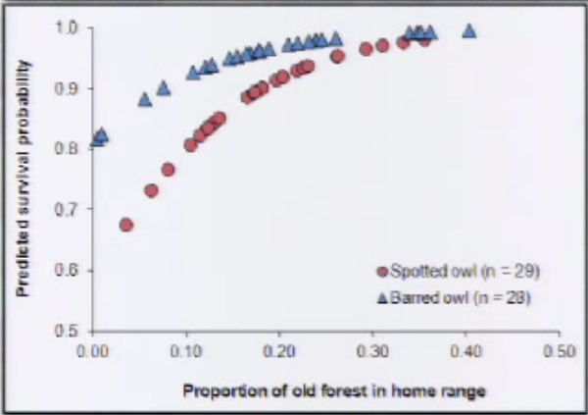

See Wiens, D. 2012. Presentation to The Wildlife Society. <http://tws.sclivelearningcenter.com/index.aspx?PID=6893&SID=163551> (at 1:12).

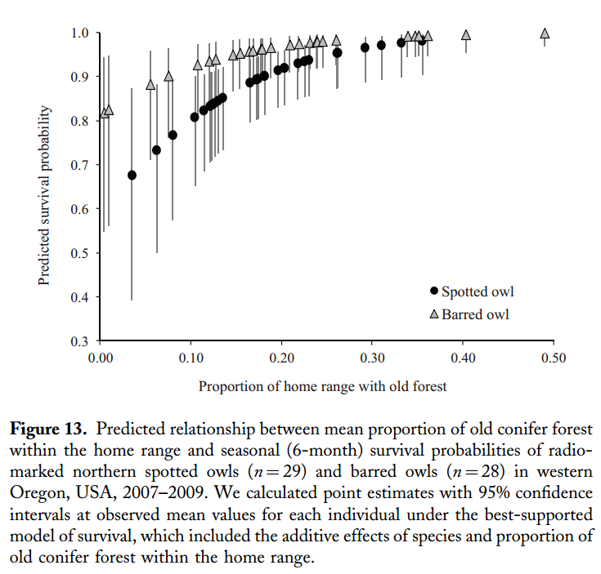

Wiens, J.D., Anthony, R.G., and E.D. Forsman. 2014: Competitive Interactions and Resource Partitioning Between Northern Spotted Owls and Barred Owls in Western Oregon. Wildlife Monographs 185:1–50; 2014; DOI: 10.1002/wmon.1009. <https://ir.library.oregonstate.edu/xmlui/bitstream/handle/1957/48214/AnthonyRobertFisheriesWildlifeCompetitiveInteractions.pdf>

David Wiens has conducted the most thorough research on the influence of barred owls on spotted owls and concluded -

**Conservation Implications**

* Results emphasize the importance of old conifer forest and moist streamside habitats to resource partitioning.
* Additional loss of older forest can further constrain both species to a common set of limiting resources, thereby increasing competitive pressure

Wiens, D.J. 2012. Dietary Overlap between Northern Spotted Owls and Barred Owls in Western Oregon, *workshop* What’s for Dinner: Spotted Owl Prey 2012 <http://ecoshare.info/projects/central-cascade-adaptive-management-partnership/workshops/spotted-owl/>; <http://ecoshare.info/wp-content/uploads/2012/08/Barred-compared-to-spotted-Owl-diets.ppt>

The final Recovery Plan for the Northern Spotted Owl has partially addressed the barred owl issue by adopting Recovery Action 32 which urges the FS and BLM to “Maintain substantially all of the older and more structurally complex multi-layered conifer forests on Federal lands outside of MOCAs…” based on the idea that “protecting these forests will not further exacerbate competitive interactions between spotted owls and barred owls as would occur if the amount of shared resources were decreased.” (FRP p 34). The revised critical habitat for the northern spotted owl was also expanded to “… increase the likelihood that spotted owls would be able to persist in areas where barred owls are also present. … [A]dditional critical habitat may allow for coexistence of the two species, potentially reducing competition (Dugger et al. 2011; Forsman et al. 2011).” FWS 2012. CHU draft EA, p 53, 62. <http://www.fws.gov/oregonfwo/Species/Data/NorthernSpottedOwl/Documents/CH_DRAFTEnvAssmnt_6.1.12.pdf>. In considering this recommendation the agencies must prepare NEPA analysis which considers the full potential of suitable habitat quantity and quality and its mediating influence on the interactions between spotted owls and barred owls. Maintaining a subset of suitable habitat as recommended by the recovery plan is one option, but the agencies must consider the full benefits of protecting all suitable habitat, not just a subset, and providing additional mitigation in matrix areas such as managing the matrix to enhance habitat for owl prey species. The recovery plan is not a NEPA document and FWS was not required to consider all reasonable alternatives. Action agencies like the FS and BLM on the other hand are required to fully consider alternatives. It would be wise to do so at a range-wide level, but until that is done, the agencies should not adversely modify any suitable habitat. Protection of additional suitable habitat in order to reduce competitive interactions between the two owls is now a recognized tool in the toolbox and represents significant new information about *any* proposal to modify suitable habitat regardless of how far the planning process may have proceeded.

A 2010 Draft report “Population Demography of Northern Spotted Owls” corroborates the need to protect more than just the highest quality spotted owl habitat as contemplated in the draft Recovery Action 32.

We also found a negative relationship between recruitment rates and the presence of Barred Owls and a positive relationship between recruitment and the amount of suitable owl habitat in the study areas. Recruitment was higher on federal lands where the amount of suitable owl habitat was generally highest. [p 96] …

While our observational results do not demonstrate cause-effect relationships, they provide support for the hypothesis that the invasion of the range of the Spotted Owl by Barred Owls is at least partly the cause for the continued decline of Spotted Owls on federal lands. Our results also suggest that Barred Owl encroachment into western forests may make it difficult to insure the continued persistence of Northern Spotted Owls (see also Olson et al. 2004). The fact that Barred Owls are increasing and becoming an escalating threat to the persistence of Spotted Owls does not diminish the importance of habitat conservation for Spotted Owls and their prey. In fact, the existence of a new and potential competitor like the Barred Owl makes the protection of habitat even more important, since any loss of habitat will likely increase competitive pressure and result in further reductions in Spotted Owl populations (Horn and MacArthur 1972, Olson et al. 2004, Carrete et al. 2005). [pp 97-98] …

Our results and those of others referenced above consistently identify loss of habitat and Barred Owls as important stressors on populations of Northern spotted Owls. In view of the continued decline of Spotted Owls in most study areas, it would be wise to **preserve as much high quality habitat in late-successional forests for Spotted Owls as possible**, distributed over as large an area as possible. This recommendation is comparable to one of the recovery goals in the final recovery plan for the Northern Spotted Owl (USDI Fish and Wildlife Service 2008), but **we believe that a more inclusive definition of high quality habitat is needed** than the rather vague definition provided in the 2008 recovery plan. Much of the habitat occupied by Northern Spotted Owls and their prey does not fit the classical definition of “old-growth” as defined by Franklin and Spies (1991), and a narrow definition of habitat based on the Franklin and Spies criteria would exclude many areas currently occupied by Northern Spotted Owls. [p 99]...

Eric D. Forsman, Robert G. Anthony, Katie M. Dugger, et al. “Population Demography of Northern Spotted Owls.” DRAFT COPY 17 December 2010. This draft manuscript is in press at the University of California Press with a projected publication date of July 2011. It will be No. 40 in Studies In Avian Biology, which is published by the Cooper Ornithological Society. [http://www.reo.gov/monitoring/reports/nso/FORSMANetal_draft_17_Dec_2010.pdf](http://www.reo.gov/monitoring/reports/nso/FORSMANetal_draft_17_Dec_2010.pdf#_blank).

Wiens (2012) has recommended retaining conifer forests older than 120 years of age as a method to reduce interspecific competition between the owl species. Where barred owls occur, he has found that spotted owl survival greatly declines as the percent of forests >120 years of age in the general home range drops below 35%.

USFS 2019. Calapooia EA, Sweet Home Ranger District, Willamette National Forest. <https://www.fs.usda.gov/nfs/11558/www/nepa/108782_FSPLT3_4527425.pdf>

Yackulic et al (2019) show that continued emphasis on habitat restoration can help mitigate uncertainty about barred owl removal efforts which remain untested. Yackulic, Charles, et al. 2019. The past and future roles of competition and habitat in the range-wide occupancy dynamics of Northern Spotted Owls. Ecological Applications, 2019 DOI: 10.1002/eap.1861. <https://esajournals.onlinelibrary.wiley.com/doi/pdf/10.1002/eap.1861>. (“ ... maintaining or improving habitat condition could be an important factor in promoting persistence of NSO populations over longer time spans and could allow managers to be less reliant on BO removals in the future ... habitat recovery could eventually lessen the need for intensive management actions such as Barred Owl removal. If, on the other hand, managers allow habitat conditions to decline they may have to rely more on BO removal ...”) Stated another way, the agencies can reduce uncertainty about the long-term funding and long-term effectiveness of barred owl removal by emphasizing recovery of high quality suitable nesting, roosting, foraging habitat for northern spotted owls.

## Red Tree Vole Management

Red tree voles are an important prey for the spotted owl and other predators. The rationale for amending the requirements for red tree vole surveys are not convincing. Focus treatments on areas that do not have red tree voles.

We recommend the Forest Service follow the commitments in the Northwest Forest Plan to survey for rare and uncommon species such as the red tree vole, and develop a conservation strategy that reflects on-the-ground data on the presence and absence of red tree vole and the connectivity of RTV habitat given barriers to movement such as private lands, young forest, and recently burned areas.

The Red tree vole is a Category C species which includes uncommon species for which pre-disturbance surveys are practical. And sites discovered during surveys will be protected according to a high-priority sites (HPS) strategy developed under the management recommendations (MR).

We have some significant concerns with the proposed plan amendment and red tree vole strategy:

* Page 20 of the standards & guidelines for the 2001 survey and manage ROD state that surveys will be conducted and sites will be managed under the HPS strategy. The glossary defines HPS as a subset of known sites. So the FS should be developing a HPS Strategy based on the results of surveys that identify actual known sites of RTV;
* The 2001 standards & guidelines also state that management recommendations may identify “areas” where surveys are no longer necessary, but in the case of the RTV, the management recommendations do not identify “areas” where surveys are not required. The approach being utilized here is not allowed by the 2001 ROD unless the FS uses “in lieu direction subject to further NEPA analysis.” This involves a significant forest plan amendment;
* The proposed strategy does not provide for “well-distributed” habitat. The proposed strategy is designed to leave large “gaps” (>1 km across) within the YRR project area where red tree vole will be unprotected so that logging can proceed;
* All riparian reserves over 80 years old should be retained as part of the red tree vole strategy. Riparian reserves objectives include conservation of red tree vole. Logging for pine habitat is not part of the ACS;
* The YRR Project will create an east-west barrier to RTV connectivity. The project is located in a pinch point between private land and Tumblebug fire area and the river. Federal lands need to mitigate for poor habitat conditions on non-federal lands;
* Conserving the red tree vole requires conserving the older denser forests that they rely on. Fire exclusion and resulting succession over the last century in the YRR project area is not all bad. It helps mitigate for the high rates of logging and loss of late successional habitat across the landscape.
* There is no assurance that high priority sites identified in the absence of surveys are in fact occupied;
* The RTV strategy should connect and protect and larger subset of suitable habitat, not just RA32.
* 10-25 acre patches don’t support viable colonies of red tree vole;
* The FS cannot assume that existing reserves are currently suitable for red tree voles. They may not be due to past logging and fire;
* The “ensemble of models” approach may leave important areas out. If the ensemble must agree before an area received protection, then one incorrect model can veto the correct models. Site-specific information should be used to determine red tree vole habitat;
* There is a low probability that relatively long narrow connectivity corridors will be effective;
* Linear models to identify high priority sites are not ideal.

## Wind Throw

We are very concerned about the increased risk of blow down caused by removing too many trees from these stands. Increasing the risk of blow down is reducing resilience, not increasing it.

Far too many valuable old growth trees blew down after the Jim’s Creek Project. Trees that survived for decades even with increased competition from ingrown trees, but then died after the FS tried to “save” them by logging. The risk of blow down can be mitigated by retaining significantly more trees in the stands.

A similar project to restore open forest and mixed conifer fire resilient habitat was conducted in the nearby Jim’s Creek project area, and the logging may have resulted in damage to mycorrhizal systems, and a major loss of remaining standing trees due to blowdown. How will this project ensure the integrity of the forest and avoid the elements of the Jims Creek project that failed (i.e., blowdown, soil healthy loss, destruction of underground mycorrhizal systems)? We recommend retaining more medium and large trees than in the Jim’s Creek project. This will serve several important purposes such as buffering the wind and reducing the risk of blowdown, mitigating the loss of snags and old growth impacts, retaining canopy that helps suppress the growth of surface and ladder fuels (and reduce slash production), and reducing carbon emissions.

## Riparian Reserves

Thinning dense young planted stands in riparian reserves should leave generous buffers to ensure ongoing recruitment of abundant dead wood both instream and throughout the width of the riparian reserves.

There is no compelling rationale for logging riparian reserves older than 80 years old. Any restoration treatments in older riparian stands should be non-commercial (fall and leave, prescribed fire, road removal, etc).

Be sure the NEPA analysis clearly shows that logging does not benefit dead wood recruitment. Rather, commercial wood removal from riparian reserves is a tax on wood recruitment and should be mitigated, not encouraged. This analysis must account for the fact(s) that: (i) trees continue to grow even if they are not thinned, (ii) logging dramatically reduces the population of green trees available for recruitment, (iii) small wood is functional, especially in small streams that are typical in most units, (iv) abundant wood is needed to meet ACS objectives not just instream, but throughout the full width of the riparian reserves.

The Youngs Rock Rigdon project area is host to a network of perennial, fish bearing streams and creeks that flow directly into the Middle Fork Willamette River. How will the Forest Service protect the integrity of fish-bearing waterways throughout the project area against the risk of erosion, sedimentation, higher water temperatures and lower stream flow? Will the Forest Service consider dropping logging in units with numerous waterways and especially steep grades? We recommend strong conservation of aquatic objectives in riparian reserves, including high canopy cover and high wood recruitment throughout the full width of the riparian reserves. This probably means using non-commercial restoration methods in riparian reserves with existing mature forests.

See more on riparian logging trade-offs attached.

## Fuel Reduction

Fuel reduction activities should be focused only on small trees if in native stands. These stands are naturally more resilient to fire, and if one of the larger goals of the project is to restore a natural fire regime, these stands should be prepared for natural and prescribed fire by retaining all large trees. Fuels reduction along private land boundaries should be a shared endeavor with private owners - encourage adjacent timber land owners to establish fuel breaks or more fire-resilient forests along their border with USFS as well.

Protecting private lands from fire should not be part of the purpose and need. Industrial tree farms pose a significant fire hazard to public lands. They are not being good neighbors. The public should not sacrifice ecological values, carbon values, and water quality in order to subsidize industrial forestry. Harold S. J. Zald, Christopher J. Dunn. 2018. Severe fire weather and intensive forest management increase fire severity in a multi‐ownership landscape. Ecological Applications. *Online Version of Record before inclusion in an issue.* 26 April 2018. <https://doi.org/10.1002/eap.1710>. Also, <https://phys.org/news/2018-04-high-wildfire-severity-young-plantation.html>; Carter Stone, Andrew Hudak, Panelope Morgan 2008. Forest Harvest Can Increase Subsequent Forest Fire Severity. PSW-GTR-208, pp 525-534.

<https://www.fs.fed.us/psw/publications/documents/psw_gtr208en/psw_gtr208en_525-534_stone.pdf>, *In* González-Cabán, Armando, tech. coord. 2008. Proceedings of the second international symposium on fire economics, planning, and policy: a global view. Gen. Tech. Rep. PSW-GTR-208, Albany, CA: Pacific Southwest Research Station, Forest Service, U.S. Department of Agriculture. 720 p. <https://www.fs.fed.us/psw/publications/documents/psw_gtr208en/>; Jerry Franklin, David Perry, Reed Noss, David Montgomery, Christopher Frissell. Simplified Forest Management To Achieve Watershed And Forest Health: A Critique. National Wildlife Federation. <http://www.coastrange.org/documents/forestreport.pdf>.

## Logging has complex effects on fire and fuels with some effects tending to reduce hazard, and other effects tending to increase hazard. The NEPA analysis must recognize that:

* Significant reduction of canopy cover can increase fire hazard by making the stand hotter/dryer/windier, generating more hazardous slash, stimulating the growth of future surface and ladder fuels, and additional roads increase human ignition risks;
* There is a very low likelihood that fuel treatments will interact with fire, so the benefits are unlikely, while the trade-offs on habitat and carbon are virtually certain to occur;
* “High overstory density can be resilient” when ladder fuel are sparse and there is a gap between surface and canopy fuels. Terrie Jain (2009) Logic Paths for Approaching Restoration: A Scientist's Perspective, *from* Workshop: Restoring Westside Dry Forests - Planning and Analysis for Restoring Westside Cascade Dry Forest Ecosystems: A focus on Systems Dominated by Douglas-fir, Ponderosa Pine, Incense Cedar, and so on. May 28, 2009. <http://ecoshare.info/projects/central-cascade-adaptive-management-partnership/workshops/restoring-westside-dry-forests/>

The non-commercial logging of fuels <7” dbh is probably effective, but commercial logging may not be necessary and will likely increase fire hazard.

## Basal Area Retention

We urge the FS to retain significantly more basal area than in the Jim’s Creek Project. This will help mitigate several significant adverse impacts of logging, including blow down risk, late successional habitat quality used by spotted owls and red tree voles, long-term snag habitat recruitment, carbon emissions, hydrologic effects, and weed spread.

## Site Specific Analysis

This is a large project with a diversity of conditions. The NEPA analysis must be site-specific and account for differences between young vs older forests, and moist vs dryer forests. Please provide detailed information about each logging unit and each road segment, including species composition before and after logging and a histogram of the size classes and age classes of trees before and after logging.

## Connect Prescriptions to Desired Outcomes

Provide clear and detailed rationale that connects proposed actions to desired conditions. Test the rationale for actions and effects analysis against the scientific evidence, including the full range of evidence, reasonable opposing viewpoints, and the evidence presented in these comments. For each treatment unit, provide clear descriptions of silvicultural prescriptions and marking guides in the NEPA document.

## Pacific Yew

We urge the FS to retain uncommon and unique species such as Pacific Yew trees in this project, including in the non-commercial fuel reduction treatments.

Each substantive issue discussed in these comments should be (i) incorporated into the purpose and need for the project, (ii) incorporated into a NEPA alternative, (iii) carefully analyzed as part of the effects analysis, and (iv) considered for mitigation.

Note: If any of these web links in this document are dead, they may be resurrected using the Wayback Machine at Archive.org. <http://wayback.archive.org/web/>

Sincerely,



Doug Heiken

For Oregon Wild and Many Rivers Group of the Sierra Club

# Supplemental Comments

## Weigh the trade-offs associated with logging in riparian reserves.

The agency often claims that logging in riparian reserves is necessary to improve attributes other than large wood. However, these benefits are often minor and transitory, and do not outweigh the significant long-term adverse effect of logging on recruitment of dead wood. The agency must focus on the most significant contributions of vegetation toward ACS objectives and the most significant effects of logging on the ACS objectives.

If the agency intends to log in riparian reserves to increase some nebulous goal like “vegetation diversity and complexity,” then please explain why the biophysical indicators for the ACS objectives (set forth below) do not include any mention of vegetation diversity or complexity. See the Jazz Thinning Preliminary Analysis, 2011. <http://bark-out.org/sites/default/files/bark-docs/Jazz_PA_0.pdf>.

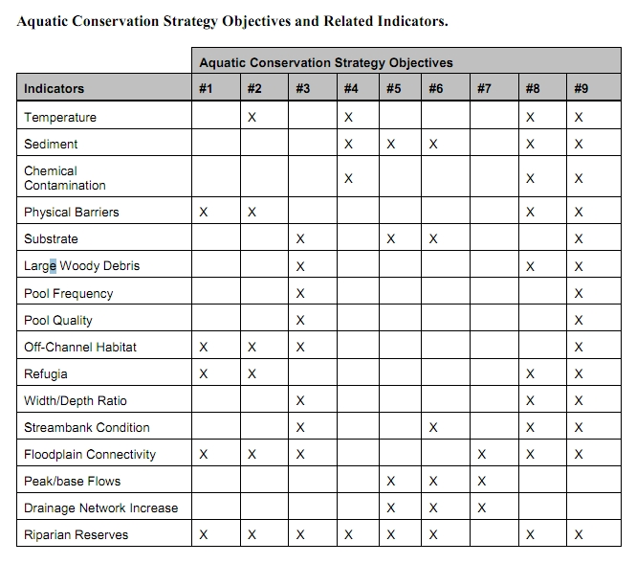

The Northwest Forest Plan and its supporting documentation make clear that the primary value of riparian vegetation is as a source of large wood and shade, not vegetation diversity and canopy layering, as often asserted by the agency to justify logging in riparian reserves. BLM admits “The primary function of Riparian Reserves is to provide shade and a source of large wood inputs to stream channels.” Medford BLM 2013. Pilot Thompson EA, p 3-76. <http://www.blm.gov/or/districts/medford/plans/files/PT_EA_ForWeb.pdf>

Stan Gregory notes the following trade-offs associated with logging riparian reserves to enhance early seral vegetation:

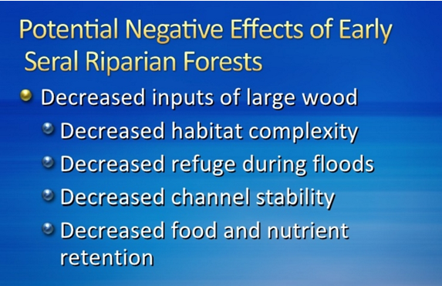

Gregory, Stan 2010. What About Riparian Systems: Who Benefits From an Early Seral Forest Condition. Workshop - Early Seral Forest - We know we need it -- How do we get it? Presentation sponsored by the Central Cascades Adaptive Management Partnership and NW Oregon Ecology Group <http://ecoshare.info/2010/07/06/what-about-riparian-systems-who-benefits-from-an-early-seral-forest-condition-gregory/>

The Northwest Forest Plan Aquatic Conservation Strategy Objectives (1994 ROD p B-11) enumerates specific purposes for “Maintain[ing] and restor[ing] the species composition and structural diversity of plant communities in riparian areas and wetlands” that is -

“to provide adequate summer and winter thermal regulation, nutrient filtering, appropriate rates of surface erosion, bank erosion, and channel migration and to supply amounts and distributions of coarse woody debris sufficient to sustain physical complexity and stability.”

All these values are provided as well or better by unthinned riparian stands.

The effects of logging on dead wood are significant and long term, adversely affecting a core function of the reserves, while the purported benefits to vegetation diversity are minor and transitory, and affect secondary purposes of the reserves.

**Large Wood**

Large quantities of downed trees are a functionally important component of many streams (Swanson et al. 1976; Sedell and Luchessa, 1982; Sedell and Froggat, 1984; Harmon et al. 1986; Bisson et al. 1987; Maser et al. 1988; Naiman et al. 1992). Large woody debris influences channel morphology by affecting longitudinal profile, pool formation, channel pattern and position, and channel geometry (Bisson et al. 1987). Downstream transport rates of sediment and organic matter are controlled in part by storage of this material behind large wood (Betscha 1979). Large wood affects the formation and distribution of habitat units, provides cover and complexity, and acts as a substrate for biological activity (Swanson et al. 1982; Bisson et al. 1987). Wood enters streams inhabited by fish either directly from the adjacent riparian zone from tributaries that may not be inhabited by fish, or hillslopes (Naiman et al. 1992).

Large wood in streams has been reduced due to a variety of past and present timber harvesting practices and associated activities. Many riparian management areas on federal lands are inadequate as long term sources of wood.

…

**Riparian Ecosystem Components**

…

Riparian vegetation regulates the exchange of nutrients and material from upland forests to streams (Swanson et al. 1982; Gregory et al. 1991). Fully functional riparian ecosystems have a suite of characteristics which are summarized below. Large conifers or a mixture of large conifers and hardwoods are found in riparian zones along all streams in the watershed, including those not inhabited by fish (Naiman et al. 1992). Riparian zone-stream interactions are a major determinant of large woody debris loading (House and Boehne 1987; Bisson et al. 1987; Sullivan et al. 1987). Stream temperatures and light levels that influence ecological processes are moderated by riparian vegetation (Agee 1988; Gregory et al. 1991). Streambanks are vegetated with shrubs and other low-growing woody vegetation. Root systems in streambanks of the active channel stabilize banks, allow development and maintenance of undercut banks, and protect banks during large storm flows (Sedell and Beschta 1991). Riparian vegetation contributes leaves, twigs, and other forms of fine litter that are an important component of the aquatic ecosystem food base (Vannote et al. 1980).

1993 FEMAT Report, pp V-13, V-25.

The effects of thinning on crown development are not very significant.

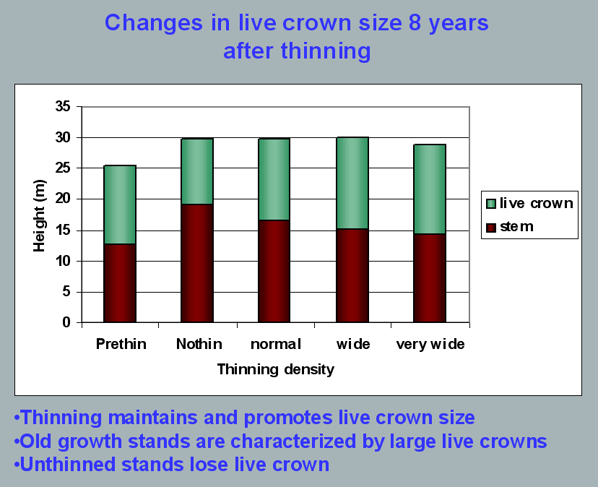

Aquatic/Riparian Ecosystem Dynamics and Associated Management Implications - Recent Findings. Powerpoint, 32.6M. This topic was presented at the Regional Interagency Executive Committee meeting on January 7, 2003. <https://web.archive.org/web/20161221100307/http://www.reo.gov/library/presentations/Szaro_present_Aquatic_Rip_Final.ppt>.

Stimulating the development of a diverse understory is often used as a justification for thinning, but this may not be justified in stands older than about 40 years. A systematic review of 917 Forest Inventory and Analysis (FIA) plots in western Oregon (mostly on non-federal lands) found,

Contrary to expectations of canopy closure, mean canopy cover by age class rarely exceeded 85 percent, even in unthinned productive young conifer forests. Possibly as a result, effects of stand age on understory vegetation were minimal, except for low levels of forbs found in 20- to 40-year-old wet conifer stands. … Although heavily thinned stands had lower total cover, canopy structure did not differ dramatically between thinned and unthinned stands. Our findings suggest potential limitations of simple stand succession models that may not account for the range of forest types, site conditions, and developmental mechanisms found across western Oregon.

McIntosh, Anne C.S.; Gray, Andrew N.; Garman, Steven L. 2009. Canopy structure on forest lands in western Oregon: differences among forest types and stand ages. Gen. Tech. Rep. PNW-GTR-794. Portland, OR: U.S. Department of Agriculture, Forest Service, Pacific Northwest Research Station. 35 p. <http://www.fs.fed.us/pnw/pubs/pnw_gtr794.pdf>. This seems to indicate that the benefits of thinning may be best realized in dense stands younger than 40 years old. This study also showed that in wet conifer stands the mean Canopy Height Diversity Index and the mean Simpson’s Diversity Index of tree heights leveled off at about age 65. This study also looked at canopy conditions after three levels of thinning intensities (heavy, light, and none). “Mean cover of the lower canopy layer was nominal for all three thinning intensities. … There were no evident trends between understory cover and thinning history; both shrub and forb cover were fairly similar among the three thinning intensities. … The lack of a strong effect of crown closure on understory cover may be related to our finding that mean crown cover did not exceed 85 percent. … We expected greater cover of understory vegetation in thinned than in unthinned stands but did not detect significant differences in this analysis.”

While one can generalize that vegetation diversity is more likely to flourish when conifer density is lower, there are data showing a wide range of conifer density can support a wide range of deciduous shrub cover. Thinning is not always necessary. The NEPA analysis should carefully document the site-specific “need” for thinning.

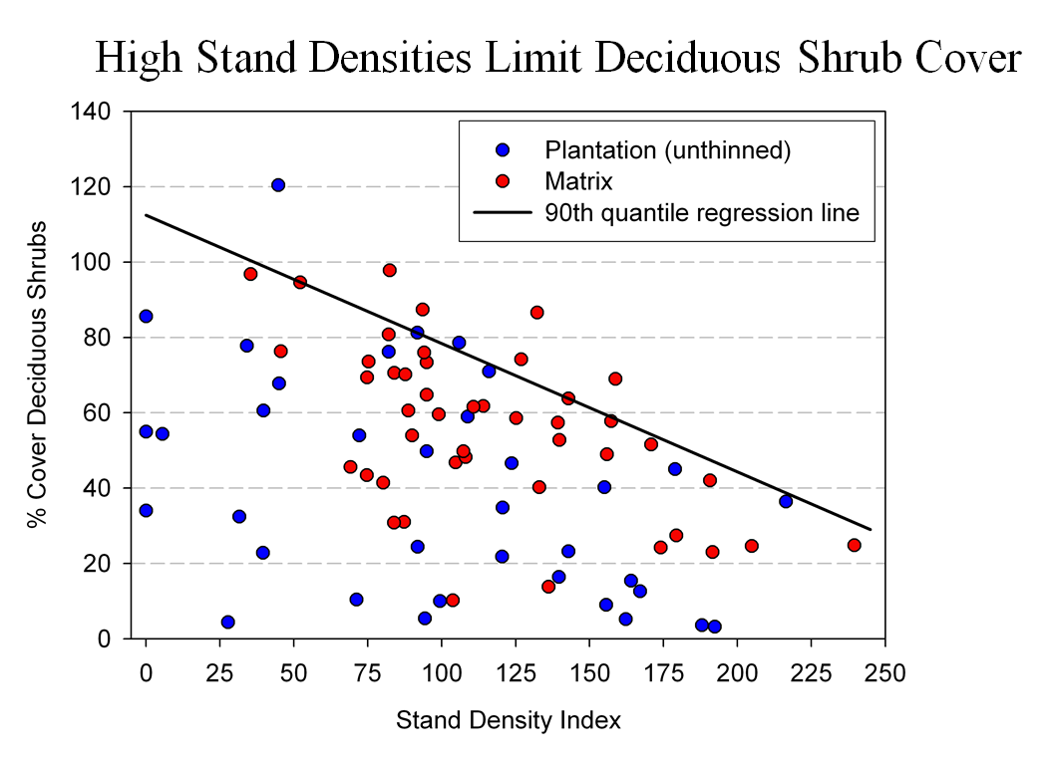

Spies, T. 2008. Powerpoint: Assumptions behind thinning young stands to create late successional riparian habitat. Presented at Riparian Thinning: Logic Paths for Silvicultural Prescriptions -- March 20, 2008. <https://ecoshare.info/projects/central-cascade-adaptive-management-partnership/workshops/riparian-thinning-logic-paths/>

It is also worth noting that where understories are well-stocked, midstory development can be enhanced by focusing on treating the understory itself rather than killing canopy trees.

[R]esults show that individual understory trees can be selectively favored for increased growth into the midstory by being released from competing saplings in the understory cohort. …Our results suggest that understory release treatments can be used to target individual saplings for increased growth, thereby recruiting a shade tolerant midstory cohort and accelerating the development of vertical foliar connectivity and a multi-layered stand structure. Abundance of non-coniferous understory vegetation is also augmented by this treatment. … [Note] The extent to which released understory trees collectively form a cohesive midstory canopy stratum is dependent on the density and horizontal arrangement of those released individuals. … . Inducing spatial variability within the midstory tree cohort would emulate the finescale disturbances of natural stands that create gaps and patches.

Taylor, Andrew 2016. : Understory Vegetation Dynamics and Midstory Development Following Understory Release Treatments in Northwest Oregon Thinned Douglas-fir Stands. OSU MS Professional Paper.

Anderson (2007) looked at the effects of thinning in young Douglas fir forests and found -

[T]hinning treatments … had little impact on the abundance, size, or diversity of understory vegetation. Disturbance resulted in short-term decreases in understory vegetation cover, particularly tall shrubs. However, within five years of treatment, understory vegetation abundance returned to approximate pretreatment condition. … The general lack of understory vegetation response to the thinning treatments was likely due to the inherent resistance and resilience of the plant communities to disturbance, as well as the low intensity of disturbance attributable to the treatments.

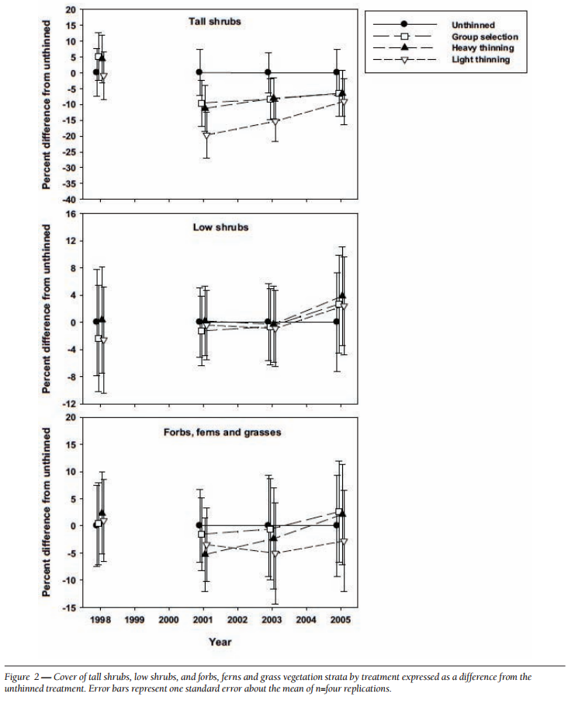

[Four years after thinning] tall shrub cover that was approximately four to nine percent less than the unthinned treatment … [C]over by low shrub species was unchanged by the harvest activity … Forbs, ferns, and grasses [experienced] little difference in cover between thinned and unthinned stands. … [F]ollowing treatment, the mean number of species declined somewhat, [then] return[ed] to pretreatment levels… [T]he evenness component of diversity did not differ among treatments or vary over time …. [T]here was little evidence of substantial alterations of understory shrub and herbaceous vegetation. This lack of strong understory vegetation response in terms of composition, abundance, or size is consistent with several studies of thinning in Douglas-fir. In a recent review of seven operational-scale silviculture experiments, Wilson and Puettmann (2007) report that percent cover by shrubs and percent cover by herbs, one to seven years following thinning showed little difference across a wide range of residual basal area.

Paul D. Anderson 2007. Understory Vegetation Responses to Initial Thinning of Douglas-fir Plantations Undergoing Conversion to Uneven-Age Management. Proceedings of the 2007 National Silviculture Workshop. <http://www.fs.fed.us/pnw/publications/gtr733/PNW_GTR_733_4.pdf> This paper was published in: Deal, R.L., tech. ed. 2008. Integrated restoration of forested ecosystems to achieve multi-resource benefits: proceedings of the 2007 national silviculture workshop. Gen. Tech. Rep. PNW-GTR-733. Portland, OR: U.S. Department of Agriculture, Forest Service, Pacific Northwest Research Station. 306 p.

[W]hile specific structural attributes of forest ecosystems have been correlated with certain species, it is uncertain how such species will respond to treatments designed to recreate these features. There is always the possibility that in our attempt to create a structural attribute we think is important, we eliminate another attribute that is equally important, but unrecognized. One example is that attempts to restore spotted owl habitat by heavily thinning to accelerate the development of large diameter nesting trees could actually delay spotted owl recovery by reducing production of the large down wood utilized by the species it preys upon (Forsman et al., 1984; Carey, 1995; North et al., 1999). Similarly, heavily thinning stands to accelerate the development of marbled murrelet nesting trees also create open stands with a dense understory that is ideal habitat for a number of corvid species that prey on marbled murrelet nest eggs (USFWS, 2010). Riparian thinning efforts to create long-term supplies of very large diameter instream wood that can initiate complex wood jam formation (e.g., key pieces) are also likely to reduce the supply of large diameter wood that will create pools (Beechie and Sibley, 1997; Beechie et al., 2000; Fox and Bolton, 2007). Thus, we suggest that any efforts to actively restore riparian forests for the benefit of certain species should be treated as scientific experiments and proceed cautiously, skeptically, and with robust pre- and post-treatment data collection efforts. Hypothesized effects of thinning on riparian forest structure and the use of that structure by targeted species should be tested against empirical data.

Pollock, Michael M. and Timothy J. Beechie, 2014. Does Riparian Forest Restoration Thinning Enhance Biodiversity? The Ecological Importance of Large Wood. Journal of the American Water Resources Association (JAWRA) 50(3): 543-559. DOI: 10.1111/jawr.12206. <http://oregon-stream-protection-coalition.com/wp-content/uploads/2014/07/Pollock-and-Beechie.-2014.-Riparian-thinning-and-biodiversity.pdf>.

## Do not rely on the flawed boilerplate climate analyses

As explained below, the Forest Service’s boilerplate NEPA analysis regarding carbon and climate fails to take a hard look that NEPA requires. The analysis makes several highly misleading statements about forest carbon and climate change. The analysis inappropriately mischaracterizes the role of individual logging projects in the cumulative problem of global GHG emissions. The analysis misstates the effects of logging related carbon emissions that are not related to “deforestation.” The analysis grossly misstates the climate effects of logging intended to reduce disturbance. The analysis misleadingly implies that logging benefits the climate by increasing forest productivity.

The NEPA analysis should consider the adverse climate consequences of GHG emissions caused directly and indirectly by logging. The Forest Service should not rely on the boilerplate NEPA language from the regional office which is flawed in many ways. Instead the Forest Service:

* Must recognize the cumulative nature of the GHG emissions and climate problems. It does not matter that this project is small in the global scheme because all emissions matter when the causation is global and cumulative;
* Cannot credibly assert that this project is harmless because it’s not causing deforestation. This is immaterial. All GHG emissions, regardless of the source or how it is labelled, are part of the problem and cause the same climate impacts.
* Cannot credibly assert that thinning for forest health justifies or mitigates emissions from logging. Logging does not increase the capacity for growing trees. To the contrary, logging harms soil and reduces site productivity.
* Must not compare carbon *before and after* logging. That is an improper framework for NEPA analysis. The proper NEPA framework is to compare the effects of NEPA alternatives over time, so please describe the carbon emissions and carbon storage in the forest over time *with and without* logging.
* Logging to reduce fire effects does not result in a net increase in forest carbon storage. The agency cannot predict the location, timing, or severity of future wildfires, so most fuel treatments will cause carbon emissions without any offsetting benefits from modified fire behavior. Studies clearly show that the total carbon emissions from logging (plus unavoidable wildfire) are greater than carbon emissions from fire alone.
* Cannot credibly assert that carbon storage in wood products is a useful climate strategy. Logging kills trees, stops photosynthesis, and initiates decay and combustion, with the end result being a significant transfer of carbon from the forest to the atmosphere. In stark contrast, an unlogged forest continues to grow and transfer more carbon from the atmosphere to the forest. Carbon emissions caused by logging far exceed the small fraction of carbon transferred to wood products. Carbon accounting methods that attempt to account for *substitution* of wood for other high-carbon building materials are fraught with uncertainty and too often represent maximum potential substitution effects rather than lower realistic estimates.

## Harmonize climate change mitigation and adaptation

The President has established a clear policy mandate to minimize and mitigate impacts of federal land use:

Section 1. Policy. It shall be the policy of the Departments of Defense, the Interior, and Agriculture; the Environmental Protection Agency; and the National Oceanic and Atmospheric Administration; and all bureaus or agencies within them (agencies); to avoid and then minimize harmful effects to land, water, wildlife, and other ecological resources (natural resources) caused by land- or water-disturbing activities, and to ensure that any remaining harmful effects are effectively addressed, consistent with existing mission and legal authorities. Agencies shall each adopt a clear and consistent approach for avoidance and minimization of, and compensatory mitigation for, the impacts of their activities and the projects they approve.

… Sec 2. Definitions … (f) "Mitigation" means avoiding, minimizing, rectifying, reducing over time, and compensating for impacts on natural resources. As a practical matter, all of these actions are captured in the terms avoidance, minimization, and compensation. These three actions are generally applied sequentially, and therefore compensatory measures should normally not be considered until after all appropriate and practicable avoidance and minimization measures have been considered.

…

Sec. 3. Establishing Federal Principles for Mitigation. … (b) Agencies' mitigation policies should establish a net benefit goal or, at a minimum, a no net loss goal for natural resources the agency manages that are important, scarce, or sensitive, or wherever doing so is consistent with agency mission and established natural resource objectives. When a resource's value is determined to be irreplaceable, the preferred means of achieving either of these goals is through avoidance, consistent with applicable legal authorities. Agencies should explicitly consider the extent to which the beneficial environmental outcomes that will be achieved are demonstrably new and would not have occurred in the absence of mitigation (i.e. additionality) when determining whether those measures adequately address impacts to natural resources.

Presidential Memorandum: Mitigating Impacts on Natural Resources from Development and Encouraging Related Private Investment. Nov 3, 2015. <https://www.whitehouse.gov/the-press-office/2015/11/03/mitigating-impacts-natural-resources-development-and-encouraging-related> In the context of climate change this means that greenhouse gas emissions should be avoided and that the climate forcing effects of any emissions that do occur must be mitigated.

Sometimes climate change mitigation and adaptation are in complete harmony, such as protecting riparian forests that both store carbon and buffer streams from hydrological extremes caused by climate change. However, there are also times when efforts directed at climate change adaptation conflict with climate change mitigation goals. For instance, some people argue that we should reduce the density of federal forests so they are more resilient to soil-water stress caused by global warming. However, forest density reduction will accelerate the transfer of carbon from the forest to the atmosphere where it will contribute to global climate change.

Federal agencies must strive to harmonize climate change mitigation (carbon storage or avoided emissions) and climate change adaptation (making ecosystems more resilient to climate change). For example, if the agency uses climate change adaptation as a rationale for forest thinning, they must not only fully disclose the increased GHG emissions caused by their proposal, they must also consider alternatives that harmonize these competing goals, such as by thinning very lightly and retaining all of the medium and large trees that store most of the carbon.

There may be climate benefits from thinning but there will also be climate trade-offs in the form of carbon emissions, unless thinning is done very early in stand development. Schaedel et al (2017) said --

Thinning in second growth forests is often suggested as a climate change adaptation strategy (Bradford and D’Amato, 2012; Churchill et al., 2013), because thinning can be used to promote the development of complex stand structures

resilient to disturbances and drought. However, these climate change adaptation outcomes attainable with thinning generally require a tradeoff with climate change mitigation objectives: most studies have shown decreased forest C storage in thinned stands (Bradford and D’Amato, 2012).

...

We found that: (1) fifty-four years after PCT total aboveground C is similar across treatments, due primarily to the increase in mean tree C of trees grown at lower stand densities; (2) deadwood legacies from the pre-disturbance forest still play an important role in long-term C storage 62 years after current stand initiation, accounting for approximately 20–25% of aboveground C stores; and (3) given enough time since early thinning, there is no trade-off between managing stands to promote individual tree growth and development of understory vegetation, and maximizing stand level accumulation of aboveground C over the long term. We infer that early PCT can be used to simultaneously achieve climate change mitigation and adaptation objectives, provided treatments are implemented early in stand development before canopy closure and the onset of intense intertree competition.

Michael S. Schaedel, Andrew J. Larson, David L.R. Affleck, R. Travis Belote, John M. Goodburn, Deborah S. Page-Dumroese. 2017. Early forest thinning changes aboveground carbon distribution among pools, but not total amount. Forest Ecology and Management 389 (2017) 187–198. <https://www.fs.fed.us/rm/pubs_journals/2017/rmrs_2017_schaedel_m001.pdf>. There are actually conflicting results on pre-commercial thinning ...

... precommercial thinning (PCT) when the thinned trees have no commercial value, show inconsistent results. Some PCT studies of this type found that decreasing stand density decreased total forest C stores (Skovsgaard et al., 2006; Jiménez et al., 2011), while others noted that the increased growth rate of trees grown at lower densities can maintain or increase live tree C (Hoover and Stout, 2007; Dwyer et al., 2010), especially in the case of longer-term responses to thinning (Horner et al., 2010). Short-term studies of PCT effects on aboveground C have shown consistent decreases in aboveground C (Campbell et al., 2009; De las Heras et al., 2013; Jiménez et al., 2011; Dwyer et al., 2010), indicating that low densities of small trees do not fully occupy the site (Turner et al., 2016). Given these conflicting results, it is still unclear whether PCT is compatible with the climate change mitigation goal of forest C storage (Jiménez et al., 2011).

This is important because, even if thinning provides climate benefits in future decades, short-term carbon emissions conflict with climate policy priorities. The next few decades are critical to achieving goals related to decarbonizing our economy. Delayed climate benefits should be strongly discounted because we should have decarbonized our economy by then, so future effects are not nearly as important as near-term effects. If thinning causes a short-term pulse of GHG emissions, that’s a problem.

The Oregon Global Warming Commission’s Roadmap to 2020 (<https://www.keeporegoncool.org/roadmap-to-2020/>) guides the state’s efforts to meet its legislatively mandated GHG emissions reduction goals, including broad objectives for increasing carbon storage in Oregon forests.

The Roadmap also set out general strategies for dry forests east of the Cascade Mountains versus moist west of the Cascades. Based on improved understanding of the carbon storage capacity of the state’s forests, the 2017 Global Warming Commission Report explained that, “The Roadmap sees ‘Eastside forests . . . managed primarily for ecosystem restoration, safety and climate adaptation with a minimum of incurred carbon (loss). West-side forests (are) managed . . . to increase carbon storage . . . private forestlands (are) managed primarily for production of timber and wood products . . . ’ with carbon stores remaining stable or increasing”.

Fain, S.J.; Kittler, B.; Chowyuk, A. Managing Moist Forests of the Pacific Northwest United States for Climate Positive Outcomes. Forests 2018; 9(10):618. <https://www.mdpi.com/1999-4907/9/10/618>. Following this strategy will require the agencies to retain all medium and large trees that store carbon and that do not pose a substantial fire hazard.

The agencies often claim that density reduction treatments are expected to increase the resiliency of treated stands to the projected effects of climate change. But this small increase in resiliency comes at a tremendous cost. The NEPA analysis needs to disclose and consider the fact that logging will result in greenhouse gas emissions that make climate change worse. Think about that trade-off. Logging might make a small area more resilient to climate change while making climate conditions (and ocean acidification) worse for ecosystems all over the rest of the world. This significant trade-off needs to be carefully evaluated in the NEPA document.

Even well-intentioned logging also has impacts that make ecosystems less resilient to climate change. For instance, (i) roads and soil degradation make watershed less resilient to the expected effects of the amplified hydrologic cycle; (ii) reduction of complex forest structure and dense forest conditions makes certain species populations less resilient to climate change, including species associated with relatively dense forests and species associated with snags and dead wood. These species are already stressed by the cumulative effects of non-federal land management and fragmentation caused by past and ongoing management on federal lands; (iii) Also, “High overstory density can be resilient” when ladder fuel are absent and there is a gap between surface and canopy fuels. Terrie Jain (2009) Logic Paths for Approaching Restoration: A Scientis’s Perspective, from Workshop: Restoring Westside Dry Forests - Planning and Analysis for Restoring Westside Cascade Dry Forest Ecosystems: A focus on Systems Dominated by Douglas-fir, Ponderosa Pine, Incense Cedar, and so on. May 28, 2009. [http://ecoshare.info/projects/central-cascade- adaptive-management-partnership/workshops/restoring-westside- dry-forests/](http://ecoshare.info/projects/central-cascade-%20adaptive-management-partnership/workshops/restoring-westside-%20dry-forests/). New information indicates that El Ninos will likely become stronger even if we are able to limited warming to 1.5 degrees C. Guojian Wang, et al. 2016. Continued increase of extreme El Niño frequency long after 1.5 °C warming stabilization. Nature Climate Change (2017). doi:10.1038/nclimate3351. <https://www.nature.com/nclimate/journal/vaop/ncurrent/full/nclimate3351.html>. A bet-hedging strategy should retain trees of all sizes and stands of various densities. “Removal of most small trees to reduce wildfire risk may compromise the bet-hedging resilience, provided by small trees and diverse tree sizes and species, against a broad array of unpredictable future disturbances.” William L. Baker and Mark A. Williams. 2015. Bet-hedging dry-forest resilience to climate-change threats in the western USA based on historical forest structure. Front. Ecol. Evol., 13 January 2015 | doi: 10.3389/fevo.2014.00088. <http://journal.frontiersin.org/Journal/10.3389/fevo.2014.00088/full>

Also, wildfire is mostly climate driven, not fuel driven, and the actual effects of fuel reduction on the spatial extent of wildfires is highly variable and fairly modest. “Analysis of simulation results from the 14 wildfires indicates that fuels treatments reduced the average size of any given wildfire by an estimated 7.2%, with amount of change correlated with the proportion of the landscape treated (Spearman’s correlation *p*=0.692, n=14; P=0.008).” M. A. Cochrane, C. J. Moran, M. C. Wimberly, A. D. Baer, M. A. Finney, K. L. Beckendorf, J. Eidenshink, and Z. Zhu. 2012. Estimation of wildfire size and risk changes due to fuels treatments. International Journal of Wildland Fire.  <http://dx.doi.org/10.1071/WF11079>. <http://www.publish.csiro.au/?act=view_file&file_id=WF11079.pdf>. This raises a serious question whether the modest increase in resilience really justifies the adverse effects of landscape fuel treatments on climate, wildlife, soil, water, etc.

When all these trade-offs are considered, we feel that climate change mitigation should receive emphasis over climate adaptation on federal land management (especially when adaptation efforts come with significant trade-offs). When climate change mitigation and adaptation may be in conflict, the agency needs to focus on reducing GHG emissions (or maintaining carbon stores). These mitigation actions are more important because (i) mitigation is shown to be more challenging (institutionally) and it is perennially under-achieved, (ii) mitigation has global benefits, and (iii) mitigation ultimately reduces the need for adaptation. An emphasis on mitigation is in accord with international law, e.g. the European Convention on Human Rights:

The court emphasises that the [State’s duty of care] first and foremost should concern mitigation measures, as adaptation measures will only allow the State to protect its citizens from the consequences of climate change to a limited level. If the current greenhouse gas emissions continue in the same manner, global warming will take such a form that the costs of adaptation will become disproportionately high. Adaptation measures will therefore not be sufficient to protect citizens against the aforementioned consequences in the long term. The only effective remedy against hazardous climate change is to reduce the emission of greenhouse gases.

*Urgenda Foundation v. The State of the Netherlands*. Hague Court of Appeal. October 9, 2018. <https://uitspraken.rechtspraak.nl/inziendocument?id=ECLI:NL:RBDHA:2015:7196>

“According to a recently published analysis, increasing carbon storage could lead to more favorable conditions for northern spotted owls, pileated woodpeckers, olive-sided flycatchers, Pacific marten and red tree voles. These species may benefit from management policies that favor less intensive logging and longer periods between tree harvests.” Nick Houtman 2016. Storing more carbon in western Cascades forests could benefit some wildlife species, not others. Phys.org News. November 17, 2016. <http://phys.org/news/2016-11-carbon-western-cascades-forests-benefit.html>, <http://onlinelibrary.wiley.com/doi/10.1002/eap.1358/abstract>.

## Disclose and Mitigate Trade-offs

Land management inevitably involves trade-offs among competing uses of the public lands. Alternatives should be developed to resolve trade-offs in different ways.

The agency must avoid portraying the effects of the proposed action in uniformly positive terms, while describing the effects of no action in uniformly negative terms.

If the agency purpose and need includes a mix of restoration goals and timber production, the NEPA analysis needs to clearly disclose to what extent optimal restoration outcomes are being sacrificed in order to produce timber volume. It is often the case that optimal restoration calls for retention of more trees, especially commercial-sized trees, that serve a variety of ecosystem services. Retaining optimal levels of medium and large trees –

* Provides habitat for wildlife that depend on (i) relatively dense forests and/or (ii) abundant snags and dead wood;
* Stores carbon that helps moderate global climate change;
* Enhances recreational/scenic values;
* Suppresses the growth of hazardous ladder fuels and reduces future maintenance costs associated with removing non-commercial in-growth; and
* Provides cool/moist microclimate buffering that benefits wildlife, recreation, and moderates fire hazard;

Removing trees to meet timber objectives sacrifices all these values. The agency needs to carefully disclose the extent to which these public values are sacrificed in order to achieve timber volume objectives. Clearly disclosing such trade-offs helps the public provide informed comment, and helps achieve the informd decision-making requirements of NEPA. It also furthers the requirements of NEPA related to:

* “... To determine the scope of environmental impact statements, agencies shall consider ... 3 types of alternatives, .... They include: ... (b) Alternatives, which include: (1) No action alternative. (2) Other reasonable courses of actions. (3) Mitigation measures (not in the proposed action).” 40 CFR §1508.25.
* “Federal agencies shall to the fullest extent possible: ... (e) Use the NEPA process to identify and assess the reasonable alternatives to proposed actions that will avoid or minimize adverse effects of these actions upon the quality of the human environment. (f) Use all practicable means, consistent with the requirements of the Act and other essential considerations of national policy, to restore and enhance the quality of the human environment and avoid or minimize any possible adverse effects of their actions upon the quality of the human environment.” 40 CFR §1500.2.
* “Study, develop, and describe appropriate alternatives to recommended courses of action in any proposal which involves unresolved conflicts concerning alternative uses of available resources.” 40 CFR §§1501.2(c), 1507.2(d), 42 USC § 4332(2)(E).
* “The discussion [of environmental consequences] will include the environmental impacts of the alternatives including the proposed action, any adverse environmental effects which cannot be avoided should the proposal be implemented, the relationship between short-term uses of man’s environment and the maintenance and enhancement of long-term productivity, and any irreversible or irretrievable commitments of resources which would be involved in the proposal should it be implemented”40 CFR §1502.16, 42 USC § 4332(2)(C). <https://www.energy.gov/sites/prod/files/NEPA-40CFR1500_1508.pdf>

NEPA requires disclosure of the trade-offs among competing uses.

Project-level planning and implementation pursues management activities in accordance with forest plans to enhance flows of particular ecosystem services—to improve a specific fish or wildlife population, for example, or reduce the likelihood that natural disturbance (e.g., wildfire) might adversely affect flows of ecosystem services. However, many ecosystem services and the associated landscape conditions from which they derive are interrelated in either conflicting or synergistic ways such that changes in one service necessarily involve changes in another service. In some cases, increased flows of one service may only be possible by accepting decreased flows of another service. Evaluating and communicating expected management outcomes necessarily must account for these interrelationships and the tradeoffs—the exchange of one level of service for another—made necessary when implementing a project that will affect multiple ecosystem service flows.

Conceptually, tradeoffs among ecosystem services are best illustrated by using the economic concept of “production possibility frontiers” (e.g., Bowes and Krutilla 1989: 49, Stevens and Montgomery 2002). Production possibility frontiers show the combinations and levels of ecosystem services that can be produced on a landscape given that landscape’s capacity to produce those services (e.g., its size and biophysical features) and management inputs (e.g., labor) and capital improvements (e.g., roads, trails, culverts).

…

Understanding the production possibilities for a given landscape enables managers to identify and weigh the possible output combinations that might be expected on a given landscape, and may make it more feasible to avoid unnecessary tradeoffs.

…

Another important step in evaluating forest management tradeoffs is characterizing how valued ecosystem services are likely to change in response to management activities under consideration. … Ideally, analysis of the likely outcomes of landscape management would be based on credible scientific information linking expected changes in ecosystem services to specific changes in landscape conditions and processes resulting from proposed plans and projects. The quantity and quality of scientific information available for evaluating management effects in this way can differ depending on how well particular ecosystem processes are understood and how well they can be described by ecologists and biophysical scientists as changes in ecosystem services.

… [M]any economists refer to a need for ecological production functions (e.g., Polasky 2008) that link the production of a given ecosystem service in space and time to landscape conditions and processes necessary to its production. …

Whether dealing with empirical data and models or qualitative data and narratives, evaluating and communicating expected management outcomes calls for managers to (1) identify key landscape conditions that affect the quantity and quality of valued ecosystem services; (2) characterize key relations between those landscape conditions and the levels of ecosystem services produced; and (3) describe the degree of uncertainty in the data and models used to predict management outcomes. This process includes describing the spatial and temporal aspects of expected outcomes.

Kline, Jeffrey D.; Mazzotta, Marisa J. 2012. Evaluating trade-offs among ecosystem services in the management of public lands. Gen. Tech. Rep. PNW-GTR-865. Portland, R: U.S. Department of Agriculture, Forest Service, Pacific Northwest Research Station. 48 p. <http://www.fs.fed.us/pnw/pubs/pnw_gtr865.pdf>.

[W]hile specific structural attributes of forest ecosystems have been correlated with certain species, it is uncertain how such species will respond to treatments designed to recreate these features. There is always the possibility that in our attempt to create a structural attribute we think is important, we eliminate another attribute that is equally important, but unrecognized. One example is that attempts to restore spotted owl habitat by heavily thinning to accelerate the development of large diameter nesting trees could actually delay spotted owl recovery by reducing production of the large down wood utilized by the species it preys upon (Forsman et al., 1984; Carey, 1995; North et al., 1999). Similarly, heavily thinning stands to accelerate the development of marbled murrelet nesting trees also create open stands with a dense understory that is ideal habitat for a number of corvid species that prey on marbled murrelet nest eggs (USFWS, 2010). Riparian thinning efforts to create long-term supplies of very large diameter instream wood that can initiate complex wood jam formation (e.g., key pieces) are also likely to reduce the supply of large diameter wood that will create pools (Beechie and Sibley, 1997; Beechie et al., 2000; Fox and Bolton, 2007). Thus, we suggest that any efforts to actively restore riparian forests for the benefit of certain species should be treated as scientific experiments and proceed cautiously, skeptically, and with robust pre- and post-treatment data collection efforts. Hypothesized effects of thinning on riparian forest structure and the use of that structure by targeted species should be tested against empirical data.

Pollock, Michael M. and Timothy J. Beechie, 2014. Does Riparian Forest Restoration Thinning Enhance Biodiversity? The Ecological Importance of Large Wood. Journal of the American Water Resources Association (JAWRA) 50(3): 543-559. DOI: 10.1111/jawr.12206. <http://oregon-stream-protection-coalition.com/wp-content/uploads/2014/07/Pollock-and-Beechie.-2014.-Riparian-thinning-and-biodiversity.pdf>

The agency should look for tools to help illuminate and transparently resolve trade-offs. “An integrated planning process focuses on multiple-objective planning rather than single-objective planning from the beginning of the project. It favors a transparent and interactive process that offers opportunities for understanding ecosystem complexity, stakeholder positions, and clear articulation of decision trade-offs and benefits.” Jain, Theresa B.; Battaglia, Mike A.; Han, Han-Sup; Graham, Russell T.; Keyes, Christopher R.; Fried, Jeremy S.; Sandquist, Jonathan E. 2012. A comprehensive guide to fuel management practices for dry mixed conifer forests in the northwestern United States. USDA Forest Service Gen. Tech. Rep. RMRS-GTR-292. 2012 <http://www.firescience.gov/projects/09-2-01-16/project/09-2-01-16_09-2-01-16_rmrs_gtr292web.pdf> Chapter 7 of this document highlights the importance of clearly articulated project objectives, quantitative metrics defining success across multiple objectives, “a format to display the benefits and trade-offs among the metrics...,” and a clearly articulated rationale linking treatment prescriptions to desired objectives.

“[F]uel-reduction activities may have undesirable environmental effects (e.g., the need for periodic treatments, introduction of weeds, soil disturbance, or maintenance of some roads).” Spies, Thomas A.; Hemstrom, Miles A.; Youngblood, Andrew; Hummel, Susan. 2006. Conserving old-growth forest diversity in disturbance-prone landscapes. Conservation Biology. 20(2): 351-362. <http://www.fs.fed.us/pnw/pubs/journals/pnw_2006_spies001.pdf>.

Another potentially useful framework for weighing trade-offs among ecosystem services (such as timber production and biodiversity) is presented here: Cavender-Bares, J., S. Polasky, E. King, and P. Balvanera. 2015. A sustainability framework for assessing trade-offs in ecosystem services. Ecology and Society 20(1): 17. <http://dx.doi.org/10.5751/ES-06917-200117>; <http://www.ecologyandsociety.org/vol20/iss1/art17/> (“Similar to Bator’s 1957 article, ‘The simple analytics of welfare maximization,’ which sought to provide a coherent unified treatment of welfare economics that was widely accessible, we sought to provide a coherent unified and clear treatment of ecosystem service trade-offs in the context of sustainability. We did so in a series of steps that (1) defined the biophysical constraints of the system in the form of an efficiency frontier, (2) combined the values of stakeholders and the efficiency frontier, (3) examined temporal lags and intergenerational inequalities, and (4) incorporated thresholds and nonlinear system dynamics. … Our sustainability framework emphasizes the ecological processes underlying the production of ecosystem services that contribute to human well-being. This emphasis complements the work of economists on “inclusive wealth ” (Hamilton and Clemens 1999, Dasgupta and Mäler 2000, Heal 2000, Arrow et al. 2004, 2012). Inclusive wealth is a measure of the value of all capital assets, i.e., manufactured, human, social, and natural capital, with value reflecting the contribution of the asset to providing benefits both now and in the future. To be sustainable, inclusive wealth should be nondeclining, so that future generations have bundles of assets that are of equal or greater value than the value of current assets. The advantage of the inclusive wealth approach is that it offers a clear and simple criterion for sustainability with a comprehensive and global scope (Cavender-Bares et al. 2013). … The process of developing a study in the context of the sustainability framework as we have outlined it is a valuable exercise (cf. Ewing and Runck 2015, Grossman 2015, Mastrangelo and Laterra 2015; P. Balvanera, F. Mora, A. Castillo, and J. Trilleras, unpublished manuscript, M. ). It untangles the known from the perceived, makes transparent disparate viewpoints and underlying assumptions of stakeholders, and clarifies the information base that stakeholders rely on for informing themselves about the system. Moreover, it identifies the data gaps so that stakeholders can make more informed decisions about the most appropriate intervention for an area, given social and biophysical constraints (Grossman 2015; P. Balvanera, F. Mora, A. Castillo, and J. Trilleras, unpublished manuscript). The process itself, however, may be more valuable than any immediate outcome of the analysis. As such, the framework has the potential to contribute to a participatory approach (E. G. King, J. Cavender-Bares, T. Mwampamba, P. Balvanera, and S. Polasky, unpublished manuscript) that builds trust, common ground, and the working environment needed to address ecological problems in a way that can secure long-term commitment to resolving them, which is a necessary building block for sustainability. Ultimately, an integrated social-ecological analysis of the trade-offs among ecosystem services and their dynamics through time is necessary to assess how close or far we are from attaining sustainability.”)

Yang et al (2015) created a framework linking ecosystem services to human welling being. They “used *net benefits* rather than *gross benefits* to allow the indices to capture both [ecosystem services] and disservices, account for costs associated with provision of [ecosystem services], consider trade-offs and synergies between different [ecosystem services], and facilitate cross-context comparisons (Yang et al. 2013b).” Yang, W., T. Dietz, D. B. Kramer, Z. Ouyang, and J. Liu. 2015. An integrated approach to understanding the linkages between ecosystem services and human well-being. Ecosystem Health and Sustainability 1(5):19. <http://dx.doi.org/10.1890/EHS15-0001.1>; <http://onlinelibrary.wiley.com/doi/10.1890/EHS15-0001.1/epdf>. In this framework, the benefits of ecosystem services provided by wood products would be adjusted to reflect the costs of water pollution, loss of biodiversity, and carbon emissions , and other values associated with logging.

See also:

* Maass, M., P. Balvanera, P. Bourgeron, M. Equihua, J. Baudry, J. Dick, M. Forsius, L. Halada, K. Krauze, M. Nakaoka, D. E. Orenstein, T. W. Parr, C. L. Redman, R. Rozzi, M. Santos-Reis, A. M. Swemmer, and A. Vădineanu. 2016. Changes in biodiversity and trade-offs among ecosystem services, stakeholders, and components of well-being: the contribution of the International LongTerm Ecological Research network (ILTER) to Programme on Ecosystem Change and Society (PECS). Ecology and Society 21(3):31. <http://dx.doi.org/10.5751/ES-08587-210331>; <https://www.ecologyandsociety.org/vol21/iss3/art31/ES-2016-8587.pdf>
* Deng, X., Li, Z. & Gibson, J. J. 2016. A review on trade-off analysis of ecosystem services for sustainable land-use management. Geogr. Sci. (2016) 26: 953. <https://doi.org/10.1007/s11442-016-1309-9>
* Cordingley JE, Newton AC, Rose RJ, Clarke RT, Bullock JM (2015) Habitat Fragmentation Intensifies Trade-Offs between Biodiversity and Ecosystem Services in a Heathland Ecosystem in Southern England. PLoS ONE 10(6): e0130004. <https://doi.org/10.1371/journal.pone.0130004>; <http://journals.plos.org/plosone/article/file?id=10.1371/journal.pone.0130004&type=printable>
* Turkelboom F., Thoonen M., Jacobs S., García-Llorente M., Martín-López B. and Berry P. (2016): Ecosystem services trade-offs and synergies. *In:* Potschin, M. and K. Jax (eds): OpenNESS Ecosystem Services Reference Book. EC FP7 Grant Agreement no. 308428. <http://www.openness-project.eu/sites/default/files/SP-Trade-offs-and-synergies.pdf>
* Bennett E.M. et al. (2009): Understanding relationships among multiple ecosystem services. Ecology letters12(12): 1394-1404.
* Howe C. et al. (2014): Creating win-wins from trade-offs? Ecosystem services for human well-being: A meta-analysis of ecosystem service trade-offs and synergies in the real world. Global Environmental Change28: 263-275. <https://www.sciencedirect.com/science/article/pii/S0959378014001320>
* Mouchet M. et al. (2014): An interdisciplinary methodological guide for quantifying associations between ecosystem services. Global Environmental Change 28: 298-308.
* Lydia Olander, Robert J. Johnston, Heather Tallis, Jimmy Kagan, Lynn Maguire, Steve Polasky, Dean Urban, James Boyd, Lisa Wainger, and Margaret Palmer. 2015. “Best Practices for Integrating Ecosystem Services into Federal Decision Making.” Durham: National Ecosystem Services Partnership, Duke University. doi:10.13016/M2CH07. <https://nicholasinstitute.duke.edu/sites/default/files/publications/es_best_practices_fullpdf_0.pdf> (There’s also a guidebook: <https://nespguidebook.com/> )