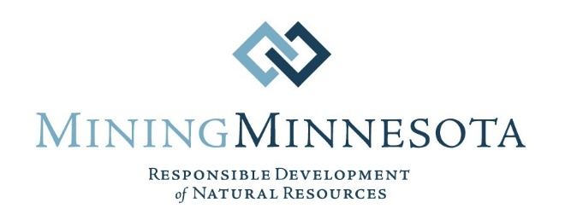

Submitted Electronically To:
https://cara.ecosystem-management.org/Public/CommentInput?Project=50516

October 28, 2020

U.S. Forest Service, Payette National Forest
Attn: Linda Jackson, Payette Forest Supervisor
500 North Mission Street
McCall, ID 83638

RE: Comments on the Payette and Boise National Forests’ Draft Environmental Impact Statement for the Stibnite Gold Project

Dear Ms. Jackson:

On behalf of Mining Minnesota, I am submitting these comments on the Draft Environmental Impact Statement (Draft EIS) prepared by the Payette and Boise National Forests for the Stibnite Gold Project in Central Valley, Idaho. Mining Minnesota is a diverse coalition of organizations, companies, and individuals that support sustainable and environmentally responsible copper and nickel mining. We realize that Midas Gold Idaho Inc.’s (Midas Gold’s) Stibnite Gold Project will not produce copper. Nonetheless, we are quite interested in this project and the Forest Service’s Draft EIS because we see some similarities between the challenges proposed Minnesota mining projects face and some of the opposition to the Stibnite Gold Project. However, we also recognize there is tremendous local support for the Stibnite Gold Project – just as there is for proposed copper-nickel mining projects in Northeastern Minnesota.

Mining Minnesota’s mission is to provide the facts about modern mining and how today’s stringent regulations provide comprehensive environmental protection at modern mining operations. We believe the Forest Service’s Draft EIS does a very thorough job of helping the public understand how the many environmental safeguards and mitigation measures required for the Stibnite Gold Project will protect the environment. We are especially impressed with the long list of mitigation measures presented in Appendix D of the Draft EIS.

The Draft EIS clearly discusses the numerous federal and state environmental laws and regulations that will govern the Stibnite Gold Project. Despite this discussion, we suspect that project opponents will essentially ignore the important information in the Draft EIS.
Instead, they will try to use outmoded images of past, pre-regulation mines developed someplace else to foment public opposition and to convince the Forest Service to deny Midas Gold’s permit application for the Stibnite Gold Project. These are the tactics that Minnesota anti-mining interests use.
One of our key messages to our members and the public is that scary stories about old mines developed on lands far away at a time long before the enactment of modern regulations provide no useful information about a modern mining proposal like the Stibnite Gold Project (and the proposed Minnesota copper-nickel mines). We emphasize that modern proposed mines will be highly regulated and fully bonded operations in marked contrast to unregulated and un-bonded mines of the past. Although Mining Minnesota realizes the Forest Service has to consider all public comments provided on the Draft EIS, we ask you to give comments about old mines elsewhere as little weight as possible because such comments are not relevant to the Stibnite Gold Project and therefore should not be considered in your decisionmaking process.
Another important similarity between the Stibnite Gold Project and two of the proposed Minnesota copper-nickel mines (the PolyMet and Twin Metals mines) is that they will all produce critical minerals. The Stibnite Gold Project will produce antimony. The Minnesota mines will produce cobalt and platinum group metals. Antimony, cobalt, and platinum group metals are included in the U.S. Geological Survey’s (USGS’) 2018 list of critical minerals. According to the USGS’ 2020 Minerals Commodity Summary, the U.S. imported 84 percent of the antimony we used in 2019, with over one-half coming from China. This Summary also shows we imported 78 percent of the cobalt, 64 percent of the platinum, and 32 percent of the palladium we used. Development of the Stibnite Gold Mine, just like development of the PolyMet and Twin Metals mines, will reduce our reliance on foreign sources of these essential critical minerals.

Mining Minnesota members are extremely impressed with Midas Gold’s commitment to use some of the proceeds from mining the Stibnite gold-silver-antimony deposit to finance an extensive brownfields cleanup at Stibnite. The numerous environmental restoration measures that will remediate lands and waters adversely impacted by government-sponsored mining operations during World War II and the Korean War attest to Midas Gold’s extraordinary environmental stewardship.

The modern regulations that will govern the Stibnite Gold Project, the financial assurance that the Forest Service will require Midas Gold to provide, the antimony that will be produced, the environmental restoration that will be achieved, and the hundreds of jobs that will be created are compelling reasons why the Forest Service should complete the permitting process as quickly as possible and authorize this important project.

Thank you for this opportunity to provide comments on your Draft EIS.

Sincerely yours,

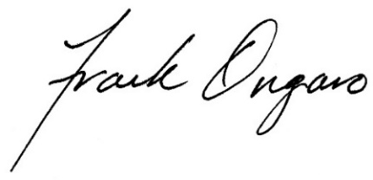
Frank Ongaro
Executive Director
MiningMinnesota
P.O. Box 16666
Duluth, MN 55816
Phone: (218) 393-2301
Email: fongaro@miningminnesota.com
www.miningminnesota.com

https://www.federalregister.gov/documents/2018/05/18/2018-10667/final-list-of-critical-minerals-2018
https://pubs.er.usgs.gov/publication/mcs2020

