28 Aug 2019

TO:   Tiller District, Umpqua National Forest

VIA: [https://cara.ecosystem-management.org/Public//CommentInput?Project=50991](https://cara.ecosystem-management.org/Public/CommentInput?Project=50991)

**Subject: Skillem Integrated Resource Project EA — comments**

Please accept the following comments from Oregon Wild and Cascadia Wildlands concerning the Skillem Integrated Resource Project EA, <https://www.fs.usda.gov/project/?project=50991>. Oregon Wild represents 20,000 members and supporters who share our mission to protect and restore Oregon’s wildlands, wildlife, and water as an enduring legacy. Our goal is to protect areas that remain intact while striving to restore areas that have been degraded. This can be accomplished by moving over-represented ecosystem elements (such as logged and roaded areas) toward characteristics that are currently under-represented (such as roadless areas and complex old forest). Cascadia Wildlands is part of a movement to protect and restore wild ecosystems of the Cascadia Bioregion, including vast old-growth forests, rivers full of wild salmon, wolves howling in the backcountry, and vibrant communities sustained by the unique landscapes. Cascadia Wildlands contact info is: P.O. Box 10455, Eugene, OR 97440 | Eugene, OR 97401 | 541-434-1463 | [info@cascwild.org](mailto:info@cascwild.org).

The proposed action alternative involves:

* commercial thinning on 526 acres in even-aged stands from 54 to 68 y/o (140 acres in riparian reserves)
* 2.9 miles of temporary roads (600 feet in riparian reserves);
* non-commercial thinning on 85 acres;
* activity fuels removal by underburning or burning hand piles, grapple piles, or landing piles;
* 1,004 acres of prescribed fire;
* decommissioning of eight miles of road and 1.5 miles of motorized trail;
* placing 7.8 miles of road into storage for future use;
* activating 0.1 miles of road and adding 0.3 miles of road;
* removal of encroaching conifers in a 3-acre opening; and
* felling or topping of trees obstructing the view at the Acker Rock lookout

Oregon Wild and Cascadia Wildlands typically do not object to careful thinning of dense young stands that developed after past clearcutting. However, there are trade-offs that must be minimized and mitigated.

The EA needs to conduct a better analysis of the adverse effects of commercial logging on wood recruitment which is important for spotted owls, fish, and cavity-associated species, and other ecological functions.

Critical habitat unit (CHU) Klamath East Sub Unit 1, covers approximately 32,464 acres, or 99% of the project area, so it is important to provide high quality habitat for spotted owls and mitigate adverse effects on owls.

The EA (p 153) says:

The DecAID planning tool also allows land managers to establish snag and down wood management objectives ... The tool includes preset tolerance levels of 30%, 50%, and 70%. These preset tolerance levels may be thought of as low, medium, and high abundance ratings ... The 50% tolerance level was identified as the analysis benchmark considering the high degree of recent regeneration timber harvest in the analysis area.

This is confusing. DecAID does not set standards, but we do know that the current Forest Plan standards for dead wood are scientifically discredited and need to be replaced. (Rose et al 2001). The EA fails to provide a compelling rationale why the 50% tolerance level is the benchmark here. Past regen logging has left a severe long-term shortage of snag habitat. The FS should be doing more to address that shortage, especially in this critical habitat area and near streams. Commercial logging move things in the wrong direction, and little is being done to mitigate that trade-offs.

The EA displays existing and reference snag habitat levels (e.g., Figures 24-29 ), but fails to disclose the effects of the alternatives on snag recruitment over time. This is a core purpose of NEPA which is not being fulfilled. The graph below is from the Curran Junetta Thin EA (on the nearby Cottage Grove Ranger District). It shows that similar thinning prescriptions in similar stand types delays by more than 60 years the attainment of habitat objectives for large snags (i.e. mid-point of the gray band representing 30-80% tolerance level).



<http://a123.g.akamai.net/7/123/11558/abc123/forestservic.download.akamai.com/11558/www/nepa/32805_FSPLT2_053506.pdf>. This would not meet DecAID 50% tolerance levels or meet the objectives for spotted owl critical habitat or riparian reserves.

Logging disrupts behavior of nesting birds and could harm other aspects of their life needs. Federal biologists acknowledge that —

Current research has shown that spotted owls are likely to increase the size of their home ranges to utilize untreated stands in preference to newly treated stands both during and after harvest. Factors that reduce the quality of habitat within a home range or cause increased movement by owls in order to meet prey requirements may decrease the survival and reproductive fitness of owls at that site (Meiman *et al.*, 2003).

Roseburg BLM 2010. Third Elk EA. <http://www.blm.gov/or/districts/roseburg/plans/files/ThirdElkEA.pdf>.

A radio-telemetry study in the north Coast Range of Oregon showed that thinning in 40-65 year old stands near a spotted owl pair resulted in the owl: (1) shifting habitat use patterns to avoid thinned areas, especially heavily thinned areas, (2) enlarging its home range requiring the owl to expend more energy to fulfill its life functions. Before harvest the study made 23 owl locations in the areas to be thinned, only one owl location was made in the thinned area during the harvest period, and only 8 locations were made in the thinned area after harvest. The area added to the home range after harvest was larger than the area harvest. Recognize that this study looked at only one bird and only looked at short-term effects in the first few years after thinning. Long term effects might be different, but because the effects of thinning could affect survival and reproductive success over the course of several breeding seasons, this could be significant for a Threatened species. Based on these preliminary findings, the authors said—

We therefore recommend that thinning operations not be conducted within core use areas in this region until further research on this topic is conducted. … [W]e recommend that land managers identify the best spotted owl habitat (old conifer with multi-layered canopy and abundant snags) around the nest site and designate an area where no timber harvest activities will occur. The mean (100-ha) and maximum (250-ha) size of core use areas in the North Coast Range … should be used as guidelines for delineating reserve areas. Where forest stands are homogenous and/or the best habitat cannot be identified, an area with 600 –m radius (~115-ha) around the nest should be used.

Meiman, S., R. Anthony, E. Glenn, T. Bayless, A. Ellingson, M.C. Hansen, and C. Smith. 2003. Effects of commercial thinning on home-range and habitat-use patterns of a male spotted owl: a case study. Wildlife Society Bulletin. 2003. 31(4):1254-1262.

The Skillem EA (p 90) says “Thinning under Alternatives 2 and 3 would lower snag and down wood recruitment rates compared to Alternative 1, by removing trees that would die from suppression mortality.”

Salem BLM’s Turner Creek EA made an honest disclosure about thinning that should be acknowledged in other projects. “Overall the No Action alternative would result in much more coarse wood in the next several decades as compared to the Proposed Action which would provide better overall habitat for small mammals which in turn may benefit the spotted owl.” <http://www.blm.gov/or/districts/salem/plans/files/TC_EA.pdf>.

“Snag and down woody debris are important components of spotted owl habitat … [If stands are not thinned] [e]ventually the stands would start to differentiate to varying degrees and show a substantial increase in the levels of snags, down wood and understory development. Where these developments occurred, they would improve the dispersal habitat characteristics ….” Mt Hood NF 2011. Huckleberry Thin EA. <http://a123.g.akamai.net/7/123/11558/abc123/forestservic.download.akamai.com/11558/www/nepa/59590_FSPLT2_034896.pdf>.

Courtney (2004) summarized spotted owl habitat use studies and found positive relationships between spotted owl habitat use and several forest attributes that are *detrimentally affected by thinning*, including: canopy volume, canopy closure, snag basal area or volume, and log volume. Importantly, these relationships appear to hold true whether the owl sites were old growth or non-old growth forest. See Jim Thrailkill 2006. “Effects of Habitat Thinning on Northern Spotted Owls? Literature Summarized Through 2005.” Appendix F *of* Interagency Level 1 Team, North Coast Province. 2010. Biological Assessment of Habitat Modification Projects Proposed During Fiscal Years 2011 and 2012 in the North Coast Planning Province, Oregon, that are Not Likely to Adversely Affect (NLAA) Northern Spotted Owl and Marbled Murrelets and Their Critical Habitats, April 13, 2010 (page 101). *citing* Courtney *et al* 2004, Scientific Evaluation of the Status of the Northern Spotted Owl, SEI, Sept 2004.

Other relevant findings from this Thrailkill white-paper include:

* “Snag volume is correlated with increased [spotted owl] foraging use (North 1999). (p 102)
* “Snag volume is important to owl foraging sites because it influences local prey abundance (Carey 1995).” (p 102)
* “[S]tudies (Carey et al 1999) conducted in the Oregon and Washington Cascades and Coast Ranges have demonstrated a direct relationship between increasing levels of coarse wood debris (CWD) in a stand and the abundance of small mammals (e.g. northern flying squirrel) in those stands.” (p 102)
* “[T]hinning prescriptions should take advantage of creating conditions where coarse wood debris recruitment can be hastened.” (p 102)

Note: This white paper does not address new information since 2005 showing longer-term (multi-decade) adverse effects of thinning on flying squirrels and dead wood recruitment.

It is important to retain unthinned patches as source areas for spotted owl prey.

Sakai and Noon found the highest number of woodrats in sapling and brushy pole timber (20 – 30 year old) although these stands are seldom used by spotted owls (Forsman) probably because woodrats are inaccessible to the owls. Still these areas are a good source of woodrats dispersing out into older stands more frequented by foraging spotted owls and accessible to owls hunting along the edges where old forest meets young.

Heaney, J. 2012. Workshop on spotted owl prey. Ecology of and Habitat Management for the Dusky-Footed and Bushy-Tailed Woodrat. <http://ecoshare.info/wp-content/uploads/2012/08/Ecology-of-and-Habitat-Management-for-the-Dusky-Footed-woodrat.ppt>

The analysis of effects on wood recruitment to streams also needs to be corrected for accuracy and clarity. The EA (p 90) says

“Thinning under Alternatives 2 and 3 would lower snag and down wood recruitment rates compared to Alternative 1 ... Although channel and riparian habitat quality would be somewhat diminished by the loss of smaller-sized trees, the extent of the proposed thinning is not expected to result in riparian species population declines. There would be some acceleration of larger wood available to channels, especially intermittent ones, due to release of remaining trees.”

The EA provides not analysis to support the assertion that logging will lead to “acceleration of larger wood available to channels.” The best available science indicates that logging will reduce larger wood available to riparian reserves, as shown in Figure 15 from the Curran-Junetta Project, above.

The EA also says “Alternatives 2 and 3 would result in long-term beneficial effects to Riparian Reserve forest structure and composition with the development of more desired riparian conditions than under Alternative” but the EA did not look at all the evidence carefully.

The agency often claims that logging in riparian reserves is necessary to improve attributes other than large wood. However, these benefits are often minor and transitory, and do not outweigh the significant long-term adverse effect of logging on recruitment of dead wood. The agency must focus on the most significant contributions of vegetation toward ACS objectives and the most significant effects of logging on the ACS objectives.

If the agency intends to log in riparian reserves to increase some nebulous goal like “vegetation diversity and complexity,” then please explain why the biophysical indicators for the ACS objectives (set forth below) do not include any mention of vegetation diversity or complexity. See the Jazz Thinning Preliminary Analysis, 2011. <http://bark-out.org/sites/default/files/bark-docs/Jazz_PA_0.pdf>.

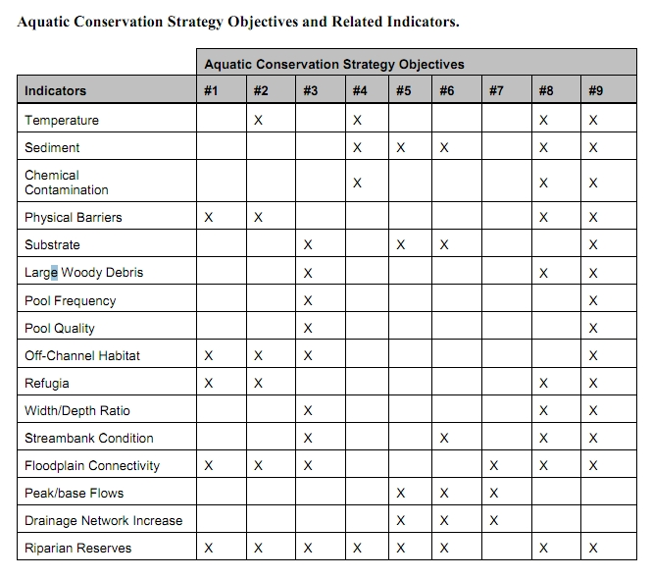

The Northwest Forest Plan and its supporting documentation make clear that the primary value of riparian vegetation is as a source of large wood and shade, not vegetation diversity and canopy layering, as often asserted by the agency to justify logging in riparian reserves. BLM admits “The primary function of Riparian Reserves is to provide shade and a source of large wood inputs to stream channels.” Medford BLM 2013. Pilot Thompson EA, p 3-76. <http://www.blm.gov/or/districts/medford/plans/files/PT_EA_ForWeb.pdf>

Stan Gregory notes the following trade-offs associated with logging riparian reserves to enhance early seral vegetation:

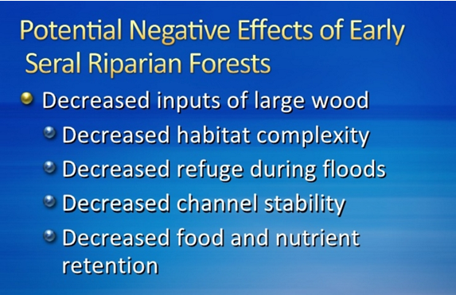

Gregory, Stan 2010. What About Riparian Systems: Who Benefits From an Early Seral Forest Condition. Workshop - Early Seral Forest - We know we need it -- How do we get it? Presentation sponsored by the Central Cascades Adaptive Management Partnership and NW Oregon Ecology Group <http://ecoshare.info/2010/07/06/what-about-riparian-systems-who-benefits-from-an-early-seral-forest-condition-gregory/>

The Northwest Forest Plan Aquatic Conservation Strategy Objectives (1994 ROD p B-11) enumerates specific purposes for “Maintain[ing] and restor[ing] the species composition and structural diversity of plant communities in riparian areas and wetlands” that is -

“to provide adequate summer and winter thermal regulation, nutrient filtering, appropriate rates of surface erosion, bank erosion, and channel migration and to supply amounts and distributions of coarse woody debris sufficient to sustain physical complexity and stability.”

All these values are provided as well or better by unthinned riparian stands.

The effects of logging on dead wood are significant and long term, adversely affecting a core function of the reserves, while the purported benefits to vegetation diversity are minor and transitory, and affect secondary purposes of the reserves.

**Large Wood**

Large quantities of downed trees are a functionally important component of many streams (Swanson et al. 1976; Sedell and Luchessa, 1982; Sedell and Froggat, 1984; Harmon et al. 1986; Bisson et al. 1987; Maser et al. 1988; Naiman et al. 1992). Large woody debris influences channel morphology by affecting longitudinal profile, pool formation, channel pattern and position, and channel geometry (Bisson et al. 1987). Downstream transport rates of sediment and organic matter are controlled in part by storage of this material behind large wood (Betscha 1979). Large wood affects the formation and distribution of habitat units, provides cover and complexity, and acts as a substrate for biological activity (Swanson et al. 1982; Bisson et al. 1987). Wood enters streams inhabited by fish either directly from the adjacent riparian zone from tributaries that may not be inhabited by fish, or hillslopes (Naiman et al. 1992).

Large wood in streams has been reduced due to a variety of past and present timber harvesting practices and associated activities. Many riparian management areas on federal lands are inadequate as long term sources of wood.

…

**Riparian Ecosystem Components**

…

Riparian vegetation regulates the exchange of nutrients and material from upland forests to streams (Swanson et al. 1982; Gregory et al. 1991). Fully functional riparian ecosystems have a suite of characteristics which are summarized below. Large conifers or a mixture of large conifers and hardwoods are found in riparian zones along all streams in the watershed, including those not inhabited by fish (Naiman et al. 1992). Riparian zone-stream interactions are a major determinant of large woody debris loading (House and Boehne 1987; Bisson et al. 1987; Sullivan et al. 1987). Stream temperatures and light levels that influence ecological processes are moderated by riparian vegetation (Agee 1988; Gregory et al. 1991). Streambanks are vegetated with shrubs and other low-growing woody vegetation. Root systems in streambanks of the active channel stabilize banks, allow development and maintenance of undercut banks, and protect banks during large storm flows (Sedell and Beschta 1991). Riparian vegetation contributes leaves, twigs, and other forms of fine litter that are an important component of the aquatic ecosystem food base (Vannote et al. 1980).

1993 FEMAT Report, pp V-13, V-25.

The effects of thinning on crown development are not very significant.

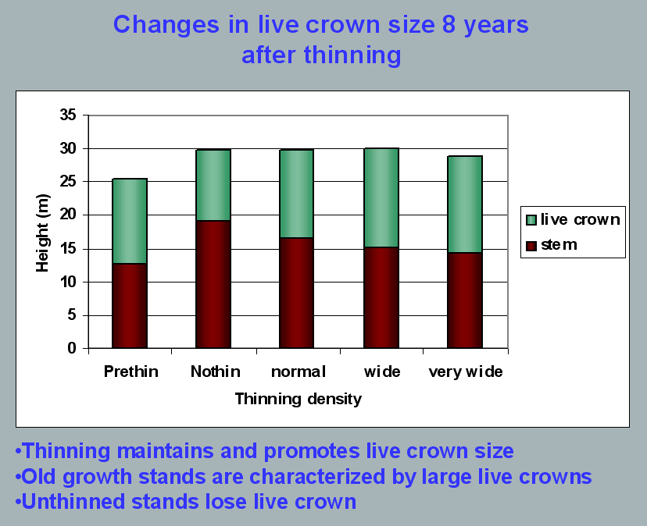

Aquatic/Riparian Ecosystem Dynamics and Associated Management Implications - Recent Findings. Powerpoint, 32.6M. This topic was presented at the Regional Interagency Executive Committee meeting on January 7, 2003. <https://web.archive.org/web/20161221100307/http://www.reo.gov/library/presentations/Szaro_present_Aquatic_Rip_Final.ppt>.

Stimulating the development of a diverse understory is often used as a justification for thinning, but this may not be justified in stands older than about 40 years. A systematic review of 917 Forest Inventory and Analysis (FIA) plots in western Oregon (mostly on non-federal lands) found,

Contrary to expectations of canopy closure, mean canopy cover by age class rarely exceeded 85 percent, even in unthinned productive young conifer forests. Possibly as a result, effects of stand age on understory vegetation were minimal, except for low levels of forbs found in 20- to 40-year-old wet conifer stands. … Although heavily thinned stands had lower total cover, canopy structure did not differ dramatically between thinned and unthinned stands. Our findings suggest potential limitations of simple stand succession models that may not account for the range of forest types, site conditions, and developmental mechanisms found across western Oregon.

McIntosh, Anne C.S.; Gray, Andrew N.; Garman, Steven L. 2009. Canopy structure on forest lands in western Oregon: differences among forest types and stand ages. Gen. Tech. Rep. PNW-GTR-794. Portland, OR: U.S. Department of Agriculture, Forest Service, Pacific Northwest Research Station. 35 p. <http://www.fs.fed.us/pnw/pubs/pnw_gtr794.pdf>. This seems to indicate that the benefits of thinning may be best realized in dense stands younger than 40 years old. This study also showed that in wet conifer stands the mean Canopy Height Diversity Index and the mean Simpson’s Diversity Index of tree heights leveled off at about age 65. This study also looked at canopy conditions after three levels of thinning intensities (heavy, light, and none). “Mean cover of the lower canopy layer was nominal for all three thinning intensities. … There were no evident trends between understory cover and thinning history; both shrub and forb cover were fairly similar among the three thinning intensities. … The lack of a strong effect of crown closure on understory cover may be related to our finding that mean crown cover did not exceed 85 percent. … We expected greater cover of understory vegetation in thinned than in unthinned stands but did not detect significant differences in this analysis.”

While one can generalize that vegetation diversity is more likely to flourish when conifer density is lower, there are data showing a wide range of conifer density can support a wide range of deciduous shrub cover. Thinning is not always necessary. The NEPA analysis should carefully document the site-specific “need” for thinning.

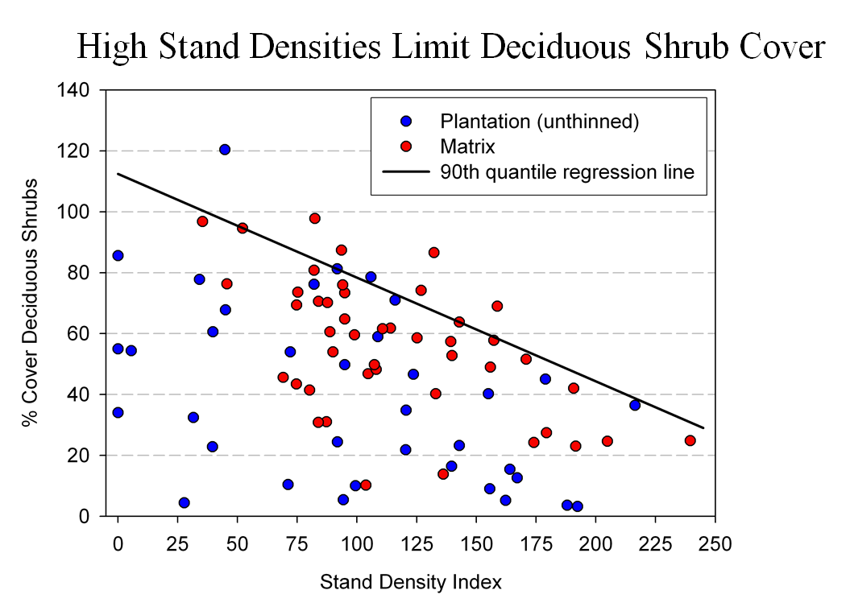

Spies, T. 2008. Powerpoint: Assumptions behind thinning young stands to create late successional riparian habitat. Presented at Riparian Thinning: Logic Paths for Silvicultural Prescriptions -- March 20, 2008. <https://ecoshare.info/projects/central-cascade-adaptive-management-partnership/workshops/riparian-thinning-logic-paths/>

It is also worth noting that where understories are well-stocked, midstory development can be enhanced by focusing on treating the understory itself rather than killing canopy trees.

[R]esults show that individual understory trees can be selectively favored for increased growth into the midstory by being released from competing saplings in the understory cohort. …Our results suggest that understory release treatments can be used to target individual saplings for increased growth, thereby recruiting a shade tolerant midstory cohort and accelerating the development of vertical foliar connectivity and a multi-layered stand structure. Abundance of non-coniferous understory vegetation is also augmented by this treatment. … [Note] The extent to which released understory trees collectively form a cohesive midstory canopy stratum is dependent on the density and horizontal arrangement of those released individuals. … . Inducing spatial variability within the midstory tree cohort would emulate the finescale disturbances of natural stands that create gaps and patches.

Taylor, Andrew 2016. : Understory Vegetation Dynamics and Midstory Development Following Understory Release Treatments in Northwest Oregon Thinned Douglas-fir Stands. OSU MS Professional Paper.

Anderson (2007) looked at the effects of thinning in young Douglas fir forests and found -

[T]hinning treatments … had little impact on the abundance, size, or diversity of understory vegetation. Disturbance resulted in short-term decreases in understory vegetation cover, particularly tall shrubs. However, within five years of treatment, understory vegetation abundance returned to approximate pretreatment condition. … The general lack of understory vegetation response to the thinning treatments was likely due to the inherent resistance and resilience of the plant communities to disturbance, as well as the low intensity of disturbance attributable to the treatments.

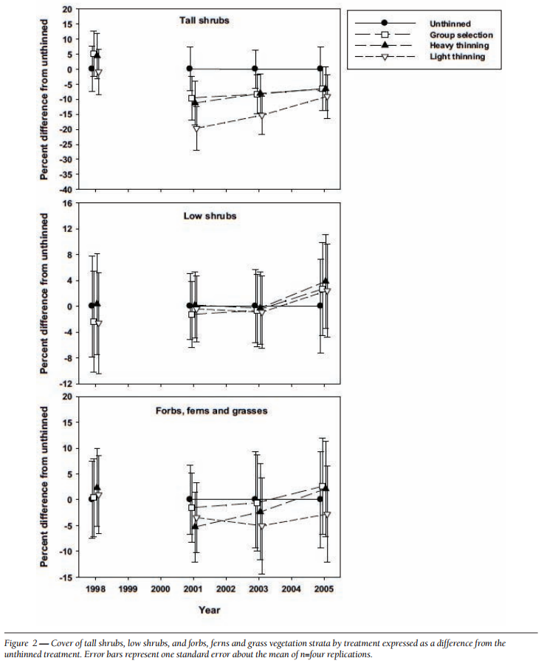

[Four years after thinning] tall shrub cover that was approximately four to nine percent less than the unthinned treatment … [C]over by low shrub species was unchanged by the harvest activity … Forbs, ferns, and grasses [experienced] little difference in cover between thinned and unthinned stands. … [F]ollowing treatment, the mean number of species declined somewhat, [then] return[ed] to pretreatment levels… [T]he evenness component of diversity did not differ among treatments or vary over time …. [T]here was little evidence of substantial alterations of understory shrub and herbaceous vegetation. This lack of strong understory vegetation response in terms of composition, abundance, or size is consistent with several studies of thinning in Douglas-fir. In a recent review of seven operational-scale silviculture experiments, Wilson and Puettmann (2007) report that percent cover by shrubs and percent cover by herbs, one to seven years following thinning showed little difference across a wide range of residual basal area.

Paul D. Anderson 2007. Understory Vegetation Responses to Initial Thinning of Douglas-fir Plantations Undergoing Conversion to Uneven-Age Management. Proceedings of the 2007 National Silviculture Workshop. <http://www.fs.fed.us/pnw/publications/gtr733/PNW_GTR_733_4.pdf> This paper was published in: Deal, R.L., tech. ed. 2008. Integrated restoration of forested ecosystems to achieve multi-resource benefits: proceedings of the 2007 national silviculture workshop. Gen. Tech. Rep. PNW-GTR-733. Portland, OR: U.S. Department of Agriculture, Forest Service, Pacific Northwest Research Station. 306 p.

[W]hile specific structural attributes of forest ecosystems have been correlated with certain species, it is uncertain how such species will respond to treatments designed to recreate these features. There is always the possibility that in our attempt to create a structural attribute we think is important, we eliminate another attribute that is equally important, but unrecognized. One example is that attempts to restore spotted owl habitat by heavily thinning to accelerate the development of large diameter nesting trees could actually delay spotted owl recovery by reducing production of the large down wood utilized by the species it preys upon (Forsman et al., 1984; Carey, 1995; North et al., 1999). Similarly, heavily thinning stands to accelerate the development of marbled murrelet nesting trees also create open stands with a dense understory that is ideal habitat for a number of corvid species that prey on marbled murrelet nest eggs (USFWS, 2010). Riparian thinning efforts to create long-term supplies of very large diameter instream wood that can initiate complex wood jam formation (e.g., key pieces) are also likely to reduce the supply of large diameter wood that will create pools (Beechie and Sibley, 1997; Beechie et al., 2000; Fox and Bolton, 2007). Thus, we suggest that any efforts to actively restore riparian forests for the benefit of certain species should be treated as scientific experiments and proceed cautiously, skeptically, and with robust pre- and post-treatment data collection efforts. Hypothesized effects of thinning on riparian forest structure and the use of that structure by targeted species should be tested against empirical data.

Pollock, Michael M. and Timothy J. Beechie, 2014. Does Riparian Forest Restoration Thinning Enhance Biodiversity? The Ecological Importance of Large Wood. Journal of the American Water Resources Association (JAWRA) 50(3): 543-559. DOI: 10.1111/jawr.12206. <http://oregon-stream-protection-coalition.com/wp-content/uploads/2014/07/Pollock-and-Beechie.-2014.-Riparian-thinning-and-biodiversity.pdf>.

Each substantive issue discussed in these comments should be (i) incorporated into the purpose and need for the project, (ii) incorporated into a NEPA alternative, (iii) carefully analyzed as part of the effects analysis, and (iv) considered for mitigation.

Note: If any of these web links in this document are dead, they may be resurrected using the Wayback Machine at Archive.org. <http://wayback.archive.org/web/>

Sincerely,



Doug Heiken

[dh@oregonwild.org](mailto:dh@oregonwild.org)