9 Jan 2023

TO: McKenzie Ranger District, Darren Cross, District Ranger

ATTN: Dean Schlichting, Project Lead

VIA: <https://cara.fs2c.usda.gov/Public/CommentInput?Project=63148>

**Subject: Calloway Project — scoping comments**

Please accept the following scoping comments from Oregon Wild and Cascadia Wildlands concerning the Calloway Project, <https://www.fs.usda.gov/project/?project=63148>. Oregon Wild represents 20,000 members and supporters who share our mission to protect and restore Oregon’s wildlands, wildlife, and water as an enduring legacy. Our goal is to protect areas that remain intact while striving to restore areas that have been degraded. Cascadia Wildlands is part of a movement to protect and restore wild ecosystems of the Cascadia Bioregion, including vast old-growth forests, rivers full of wild salmon, wolves howling in the backcountry, and vibrant communities sustained by the unique landscapes.

This proposal primarily involves ~8,000 acres of thinning in young managed stands in the Blue River watershed outside of the area affected by recent wildfires for purposes of timber production, stand management, fuels work, riparian restoration, and road management, … more specifically -

• Treat up to 8,213 acres of timber less than 80 years old in previously managed stands.

• Construct up to 25 miles of temporary roads, with decommissioning upon project

completion.

• Complete maintenance on 222 miles of existing roads including culvert replacement to

protect water quality.

• Decommission, closure or storage of up to 44.6 miles of existing roads.

• Complete roadside hazardous fuels treatments to create potential control lines to fight

future fires more effectively. This includes up to 5,069 acres of roadside thinning along

main haul routes within the project area and up to 1,432 acres outside the project area.

The scoping notice asks for specific input on specific proposed actions, but the scoping notice does not provide much detail about treatments. It does not say whether forest “treatments” involve thinning or regen, and whether roadside fuel treatments are shaded fuel breaks or clearings. Informed public comments would be easier if the public was provided a more informative scoping notice.

Oregon Wild and Cascadia Wildlands support a focus on thinning young managed stands. We also support road closure/decommissioning to improve habitat and watershed functions. Roadside fuel work make the most sense if the focus in on small surface and ladder fuels <9” dbh.

Considering the extensive effects of recent stand-replacing wildfires, there would appear to be no compelling need to conduct regen logging.

We urge the FS to carefully consider the need for road construction. Even so-called temporary roads have long-term effects on soil, water, and vegetation. Road construction will add to the cumulative effects of recent fires on soil, water, and vegetation. The FS should develop an alternative that avoids new road construction and focuses on portions of stands that are accessible from existing roads.

Logging in riparian reserves is not allowed unless it is “needed” to meet ACS objectives. Given the many trade-offs caused by commercial wood removal from riparian reserves, it is unlikely that stands over 50 years old need to be commercially thinned. Those trade-offs include significant and long-lasting reduction in wood recruitment that adversely affects habitat for both aquatic and terrestrial wildlife.

## Producing Wood for Mills

In the discussions surrounding the nearby Flat Country Project, the FS has emphasized the need to get wood flowing to the mills. This purpose needs close scrutiny given the climate crisis and the biodiversity crisis, and the economic benefits of conservation outweigh the economic benefits of logging, as well as the ongoing flow of wood to the mills from private lands.

The FS should keep in mind that young stand thinning projects like this (as parts of the Flat Country Project) help produce some wood for the mills without as many trade-offs compared to projects that log mature & old-growth forests or projects that involve regen/clearcutting.

The significant volume from this project should make it easier for the FS to permanently cancel the mature & old-growth logging components of Flat Country.

## Avoid Winter Log Hauling

The Forest Service should NOT allow log hauling during winter or during any wet weather. The adverse effects of wet weather log hauling are significant, and those effects are greatly amplified in a landscape affected by wildfire. Vegetation and ground cover will likely not be there to intercept sediment that leaves the roadway. Streams are already dealing with a pulse of sediment from the fires and subsequent storms. The NEPA analysis should show that adding additional chronic sediment input from log hauling will cause unacceptable cumulative effects.

The timber industry wants the flexibility of hauling logs during wet weather but it is NOT in the public interest to allow this practice. The public’s water quality and the public’s fish will be adversely affected. Sediment and turbidity produced by wet weather haul is an *externality* - a real cost created by the timber industry but not included on their balance sheet or included in the price of wood products. By allowing wet weather haul, BLM is effectively shifting costs from the timber industry to the public. The agencies should be working for the public, not the timber industry.​

Hauling logs on wet roads is inconsistent with the Aquatic Conservation Strategy, especially where roads cross streams or are located in riparian reserves, or where road drainage may be connected to streams.

The ACS prohibits activities that will retard attainment of ACS objectives, such as ACS Objective #5: “Maintain and restore the sediment regime under which aquatic ecosystems evolved. Elements of the sediment regime include the timing, volume, rate, and character of sediment input, storage, and transport.” The natural sediment regime is more episodic, but the sediment regime produced by modern forest management is chronic.

Mitigation and BMPs are partially effective at best.

## (Shaded) Fuel Breaks

The scoping notice says that some fuels work would be implemented outside the project area. Shouldn’t the project area be expanded to include the entire treatment area?

Fuel breaks can have numerous, potentially significant trade-offs. We think many trade-offs can be minimized by following some guidelines, such as:

* Focus on treating plantations. Avoid/minimize treating high quality mature & old-growth habitat;
* Focus on small (<9” dbh) surface and ladder fuels within 150 feet of roads;
* Retain dense, mid-to-high canopy to help maintain a cool, moist microclimate, retain fuel moisture, and help suppress the growth of surface and ladder fuels (which also minimizes maintenance costs);
* Treat a well-planned network of roads that create polygons with a high area/perimeter ratio. Too much redundancy will create cumulative impacts;
* Retain deciduous hardwoods which can serve as heat sinks during fires;
* Retain important elements of diversity, such as Pacific yew, and some patches of shrubs that produce berries, nuts, nectar, etc.;
* Consider and minimize the effects on wildlife large and small that need to cross roads. Opening the forest reduces cover and increases barriers to safe movement of wildlife;
* Treatments in riparian reserves should be avoided/minimized and modified to retain more large wood and diverse vegetation to meet ACS objectives.

There is uncertainty whether fuel breaks are effective and careful NEPA analysis needs to be done to describe the trade-offs. See Kauffman, Beschta et al 2020. Comments on Boise BLM’s Tri-State Fuel Break Project. 22 Dec 2020. <https://drive.google.com/open?id=1AEA3PTs31Sv_-RZZnMsduhHCb1hniZ_e> (“Shinneman *et al*. (2019) reported that there is little scientific information available regarding their [fuel breaks] ecological effects. They report that fuel breaks can: (1) directly alter ecosystems; (2) create edges and edge effects; (3) serve as vectors for wildlife movement and plant invasions; and (4) preemptively fragment otherwise contiguous sagebrush landscapes.”) *citing* Shinneman, Douglas J.; Germino, Matthew J.; Pilliod, David S.; Aldridge, Cameron L.; Vaillant, Nicole M.; Coates, Peter S. 2019. The ecological uncertainty of wildfire fuel breaks: examples from the sagebrush steppe. Frontiers in Ecology and the Environment 17(5):279-288. <https://doi.org/10.1002/fee.2045>. (“Fuel breaks are increasingly being implemented at broad scales (100s to 10,000s of square kilometers) in fire‐prone landscapes globally, yet there is little scientific information available regarding their ecological effects (eg habitat fragmentation). … Given uncertain outcomes, we examine how implementation of fuel breaks might (1) directly alter ecosystems, (2) create edges and edge effects, (3) serve as vectors for wildlife movement and plant invasions, (4) fragment otherwise contiguous sagebrush landscapes, and (5) benefit from scientific investigation intended to disentangle their ecological costs and benefits.”). See also Shinneman, D.J., Aldridge, C.L., Coates, P.S., Germino, M.J., Pilliod, D.S., and Vaillant, N.M., 2018, A conservation paradox in the Great Basin—Altering sagebrush landscapes with fuel breaks to reduce habitat loss from wildfire: U.S. Geological Survey Open-File Report 2018–1034, 70 p., <https://doi.org/10.3133/ofr20181034>.

## Unroaded Areas

The Blue River watershed contains several large (>1,000 acre) inventoried and uninventoried roadless areas (outlined in red below) where commercial logging should be avoided. In fact, the purpose and need should include efforts to restore the natural range of variability of large intact forest areas that fish & wildlife evolved with.

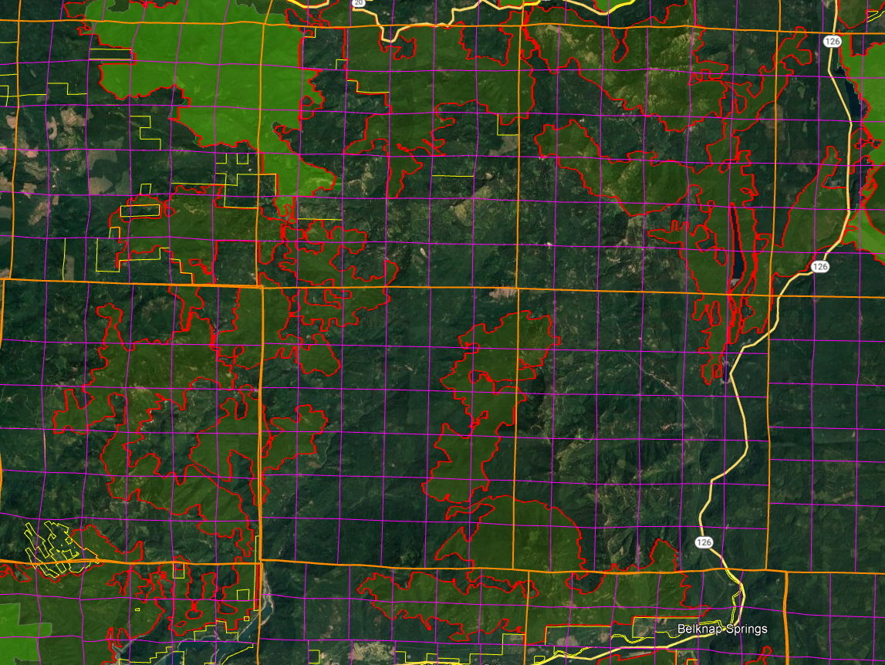

The agency cannot limit its analysis of roadless areas to inventoried areas >5,000 acres, because smaller roadless areas that were not inventoried are ecologically relevant and potentially significant. The NEPA analysis must reflect the growing scientific evidence (cited below) indicating the significant value of roadless areas smaller than 5,000 acres and larger than 1,000 acres. Recent scientific literature emphasizes the importance of unroaded areas greater than 1,000 acres as strongholds for the production of fish and other aquatic and terrestrial species, as well as sources of high quality water. Commercial logging and/or road building within large unroaded areas threatens these significant ecological values.

First, it is important to recognize that about 30% of inventoried roadless areas (IRA) nationwide are smaller than 5,000 acres. It is therefore likely that the diverse and significant values of IRAs can be found within many other unroaded areas between 1,000 and 5,000 acres that were simply not inventoried. NEPA requires that these values be recognized and the effects of logging and roads be carefully disclosed and considered. Martin, DeVelice, Brown. 2001. Landscape Analysis and Biodiversity Specialist Report. Forest Service Roadless Area Conservation FEIS. November 2000. <http://www.fs.usda.gov/Internet/FSE_DOCUMENTS/fsm8_035781.pdf>

Small areas are important for conserving biodiversity of species with small home ranges, species with special habitat needs, or for providing linkages between larger areas. … Of the more than 2,800 named inventoried roadless areas, about 70% of these areas are larger than 5,000 acres (USDA Forest Service 2000a).

Large unroaded areas are important simply due to the fact that they better represent the historic condition that species evolved with but they are now rare on the landscape due to human activities that have degraded and fragmented the majority of the landscape. The Northwest Forest Plan LSOG Effectiveness Monitoring Plan says that “perhaps 80 percent or more [of the historic late-successional old-growth forest] would probably have occurred as relatively large (greater than 1,000 acres) areas of connected forest.” Miles Hemstrom, Thomas Spies, Craig Palmer, Ross Kiester, John Teply, Phil McDonald, and Ralph Warbington; Late-Successional and Old-Growth Forest Effectiveness Monitoring Plan for the Northwest Forest Plan, USFS General Technical Report PNW-GTR-438; December 1998; <http://www.fs.fed.us/pnw/pubs/gtr_438.pdf>. Currently, these 1,000 acre and larger patches are rare on the landscape.

Boakes et al (2009) explained why it is important to retain large unroaded areas.

**Abstract:** Habitat clearance remains the major cause of biodiversity loss, with consequences for ecosystem services and for people. In response to this, many global conservation schemes direct funds to regions with high rates of recent habitat destruction, though some also **emphasize the conservation of remaining large tracts of intact habitat**. If the pattern of **habitat clearance is highly contagious**, the latter approach will help **prevent destructive processes gaining a foothold** in areas of contiguous intact habitat. Here, we test the strength of spatial contagion in the pattern of habitat clearance. Using a global dataset of land-cover change at 50x50 km resolution, we discover that intact habitat areas in grid cells are refractory to clearance only when all neighbouring cells are also intact. The **likelihood of loss increases dramatically as soon as habitat is cleared in just one neighbouring cell**, and remains high thereafter. **This effect is consistent for forests and grassland, across biogeographic realms and over centuries, constituting a coherent global pattern**. Our results show that landscapes become vulnerable to wholesale clearance as soon as **threatening processes begin to penetrate**, so actions to prevent any incursions into large, intact blocks of natural habitat are key to their long-term persistence.

Elizabeth H. Boakes, Georgina M. Mace, Philip J. K. McGowan and Richard A. Fuller 2009. Extreme contagion in global habitat clearance. Proceedings of the Royal Society B: Biological Sciences. November 25, 2009. doi: 10.1098/rspb.2009.1771

World Wildlife Fund and the Conservation Biology Institute summarized the important attributes of small roadless areas (1,000-5,000 acres).

Small roadless areas share many of attributes in common with larger ones, including:

• Essential habitat for species key to the recovery of forests following disturbance such as herbaceous plants, lichens, and mycorrhizal fungi

• Habitat refugia for threatened species and those with restricted distributions (endemics)

• Aquatic strongholds for salmonids

• Undisturbed habitats for mollusks and amphibians

• Remaining pockets of old-growth forests

• Overwintering habitat for resident birds and ungulates

• Dispersal “stepping stones” for wildlife movement across fragmented landscapes

DellaSala, Dominick and James Strittholt. 2002. Scientific Basis For Roadless Area Conservation. World Wildlife Fund. Ashland, OR; Conservation Biology Institute. (June 2002 - Updated October 2003) <https://d2k78bk4kdhbpr.cloudfront.net/media/reports/files/Scientific_Basis_For_Roadless_Area_Conservation.pdf>.

In a 1997 letter to President Clinton, 136 scientists said:

There is a growing consensus among academic and agency scientists that existing roadless areas–irrespective of size–contribute substantially to maintaining biodiversity and ecological integrity on the national forests. The Eastside Forests Scientific Societies Panel, including representatives from the American Fisheries Society, American Ornithologists’ Union, Ecological Society of America, Society for Conservation Biology, and The Wildlife Society, recommended a prohibition on the construction of new roads and logging within existing (1) roadless regions larger than 1,000 acres, and (2) roadless regions smaller than 1,000 acres that are biologically significant…. Other scientists have also recommended protection of all roadless areas greater than 1,000 acres, at least until landscapes degraded by past management have recovered…. As you have acknowledged, a national policy prohibiting road building and other forms of development in roadless areas represents a major step towards balancing sustainable forest management with conserving environmental values on federal lands. In our view, a scientifically based policy for roadless areas on public lands should, at a minimum, protect from development all roadless areas larger than 1,000 acres and those smaller areas that have special ecological significance because of their contributions to regional landscapes.

Letter to President Clinton from 136 scientists (Dec. 10, 1997).

<https://drive.google.com/file/d/0B4L_-RD-MJwrRzhFcm5QcFR0MHM/view?usp=sharing&resourcekey=0-2-sbGMN3bOUBQGGMDBQM1Q>

To the list of special values found within unroaded areas must be added carbon storage. European policy leaders consider roadless areas effective for carbon storage and climate mitigation:

[T]he European Parliament has agreed to raise the issue of roadbuilding in intact forests at the UN Climate Change Conference to be held next month in Warsaw (Poland); it calls on parties to use the existence of roads in forest areas as an early negative performance indicator of REDD+ projects, and to prioritise the allocation of REDD+ funds towards road free forests.

Oct 24, 2013 Press release: EUROPEAN PARLIAMENT BACKS THE PROTECTION OF ROADFREE AREAS. <http://kritonarsenis.gr/eng/actions/view/european-parliament-backs-the-protection>. Federal land managers should recognize the tremendous carbon values in unroaded/unmanaged forests and avoid actions that would threaten these values. See also, William R. Moomaw, Susan A. Masino, and Edward K. Faison. 2019. Intact Forests in the United States: Proforestation Mitigates Climate Change and Serves the Greatest Good Front. For. Glob. Change, 11 June 2019 | <https://doi.org/10.3389/ffgc.2019.00027>; <https://www.frontiersin.org/articles/10.3389/ffgc.2019.00027/full>. See also, Kun, Z., DellaSala, D., Keith, H., Kormos, C., Mercer, B., Moomaw, W.R. and Wiezik, M. (2020), Recognising the importance of unmanaged forests to mitigate climate change. GCB Bioenergy. Accepted Author Manuscript. doi:10.1111/gcbb.12714 <https://onlinelibrary.wiley.com/doi/pdfdirect/10.1111/gcbb.12714>. (“The most effective means for keeping carbon out of the atmosphere to meet climate goals is to protect primary forests (Mackey et al. 2020) and continue growing secondary forests to accumulate additional carbon (proforestation) (Moomaw et al. 2019) while reducing emissions from all sources including bioenergy. … The importance of primary (unlogged) forests lies in the magnitude and longevity of their carbon stock. In order to reverse the decreasing forest carbon stocks in Europe (EEA, 2019), the largest forest carbon stores must be protected and additional forests must be allowed to continue accumulating carbon (proforestation).”).

“While primary forests of all extents have conservation value, areas of greater extent warrant particular attention where they persist, as they support more biodiversity, contain larger carbon stocks, provide more ecosystem services, encompass larger-scaled natural processes, and are more resilient to external stresses. The significance of large areas of primary forests has been highlighted by the global mapping of Intact Forest Landscapes (IFL) greater than 500 km2 in extent. While suitable for many purposes, other thresholds may be more suitable at regional and national levels that reflect local ecological factors.”

IUCN Policy Statement on Primary Forests, <https://www.iucn.org/sites/dev/files/content/documents/iucn_pf-ifl_policy_2020_approved_version.pdf>

There are tremendous co-benefits from conserving large blocks of unmanaged forests, such as climate mitigation and biodiversity conservation.

Based on the species–area relationship, regarded as one of ecology’s few universal laws, protection of [too] little habitat will condemn thousands of species to extinction if habitat outside them is converted, degraded or lost. It is this logic that underpins calls for ‘Nature Needs Half’ [26], together with an understanding that ecosystem processes and services of the scale needed to sustain the well-being of life on Earth require large wildlife populations and huge expanses of intact and restored habitat. ... Climate change adds a new dimension to the question of how much protected area coverage is needed to assure conservation of wild nature. Climate change is already reducing wildlife population sizes and forcing range shifts as conditions alter [28,29]. Protected areas counter such stresses by building up populations, and connectivity of populations and habitats is emerging as a key property in securing species persistence and resilience to rapid change [5]. Hence networked protected areas, especially where embedded within well-managed landor seascapes, provide crucial stepping stones to accommodate range shifts and, where no further movements are possible, refuges of last resort [5]. Analyses suggest that adequate levels of population viability and connectivity can be achieved only with marine protected area coverages of 30% or more [27]. ... [G]iven that many ecosystems are already degraded, ensuring continued provision of ecosystem services requires not only the precautionary protection of currently intact habitats, but also large-scale habitat restoration.

Providing greater space for recovery of intact, vibrant nature is not altruistic conservation, but is, we argue, an indispensable act of self- preservation, producing a cascade of benefits that will help maintain the habitability of the biosphere as the climate changes, thereby securing the well-being of generations to come.

Roberts CM, O’Leary BC, Hawkins JP. 2020 Climate change mitigation and nature conservation both require higher protected area targets. Phil. Trans. R. Soc. B 375: 20190121. <http://dx.doi.org/10.1098/rstb.2019.0121>. See also, Soto-Navarro C et al. 2020 Mapping co-benefits for carbon storage and biodiversity to inform conservation policy and action. Phil. Trans. R. Soc. B 375: 20190128. <http://dx.doi.org/10.1098/rstb.2019.0128> showing the congruence of high carbon value and high biodiversity value in PNW forests.

Law et al (2022) make a strong case that conservation of intact forests advances the twin goals of protecting the climate and biodiversity, and that broad-scale thinning to reduce fire severity conflicts with climate and biodiversity goals.

…

“While primary forests of all extents have conservation value, areas of greater extent warrant particular attention where they persist, as they support more biodiversity, contain larger carbon stocks, provide more ecosystem services, encompass larger-scaled natural processes, and are more resilient to external stresses. The significance of large areas of primary forests has been highlighted by the global mapping of Intact Forest Landscapes (IFL) greater than 500 km2 in extent. While suitable for many purposes, other thresholds may be more suitable at regional and national levels that reflect local ecological factors.” (IUCN Policy Statement on Primary Forests, <https://www.iucn.org/sites/dev/files/content/documents/iucn_pf-ifl_policy_2020_approved_version.pdf> , accessed on 22 April 2020).

…

Instead of regularly harvesting on all of the 70% of U.S. forest land designated as “timberlands” by the U.S. Forest Service, setting aside sufficient areas as Strategic Reserves would significantly increase the amount of carbon accumulated between now, 2050 and 2100, and reestablish greater ecosystem integrity, helping to slow climate change and restore biodiversity. The 2022 IPCC AR6 report stated that “Recent analyses, drawing on a range of lines of evidence, suggest that maintaining the resilience of biodiversity and ecosystem services at a global scale depends on effective and equitable conservation of approximately 30% to 50% of Earth’s land, freshwater and ocean areas, including currently near-natural ecosystems (high confidence).” Continuing commercial timber harvest on a portion of the remaining public lands and tens of millions of hectares of private lands would continue to adequately supply a sustainable forestry sector.

Preserving and protecting mature and old forests would not only increase carbon stocks and growing carbon accumulation, they would slow and potentially reverse accelerating species loss and ecosystem deterioration, and provide greater resilience to increasingly severe weather events such as intense precipitation and flooding.

…

Many of the existing forest management practices allegedly protect forests and homes from wildfire and are having severe adverse effects on forest ecosystem integrity and resilience, and are worsening climate change and diminishing biodiversity.

…

To summarize, harvest-related emissions from thinning are much higher than potential reduction in fire emissions. In west coast states, overall harvest-related emissions were about 5 times fire emissions …

Law, Beverly E., William R. Moomaw, Tara W. Hudiburg, William H. Schlesinger, John D. Sterman, and George M. Woodwell. 2022. Creating Strategic Reserves to Protect Forest Carbon and Reduce Biodiversity Losses in the United States. Land Vol. 11, no. 5: 721. <https://doi.org/10.3390/land11050721>, <https://www.mdpi.com/2073-445X/11/5/721/htm>.

Law et al (2022) describe a strategic reserve approach to protect water, biodiversity, and carbon in Oregon’s forests. Existing unroaded areas could make a significant contribution to such an approach.

Our study demonstrated that Oregon has high carbon density forests that also have high biodiversity and connectivity for species movement. When these characteristics were prioritized within each ecoregion, it identified sufficient forestland to meet both the 30% protection by 2030 and 50% by 2050 targets that are important nationally and internationally. … the climate resilience rank highlights large areas within the ecoregions with larger landscape features that are important for resilience (Figure 2D), such as the topography of mountain ranges in southwest Oregon, the Coast Range, Cascades, and Blue Mountains in the northeast. … Meeting the forest preservation targets would substantially increase protection of tree carbon stocks, animal and tree species’ habitat, and surface drinking water source areas. … Meeting these forest preservation targets would substantially increase forest habitat protection for threatened and endangered (T&E) species and other species of interest … Mitigation strategies need to explicitly protect existing oldgrowth forests, and allow mature secondary forests to regrow to their carbon capacity. For climate mitigation using natural climate solutions, effectiveness is based on the time that a unit of biomass carbon is resident in a forest ecosystem stock and thus kept out of the atmosphere (Körner, 2017; Mackey et al., 2020). … We also found that limiting harvest to half of current levels on public lands and doubling harvest cycles to 80 years on private lands was three times more effective as a land use strategy than replanting and reforestation after cutting within current forest boundaries in Oregon (Law et al., 2018). … There is concern that protecting areas that are vulnerable to increased drought and fire will be ineffective, however, species diversity, and threatened and endangered species still need habitat, refugia and connectivity with other protected areas. Wildfires tend to be patchy, and a majority of trees survive low to mixed-severity fires (Halofsky et al., 2011) that can be critical habitat, and burned forests still retain the vast majority of their carbon (Hudiburg et al., 2009; Law et al., 2018). … Older forests in Oregon’s watersheds exhibit greater water retention and improved late summer stream flows compared to managed plantations (Segura et al., 2020). Intact forests also tend to harbor more large and old trees, bolstering carbon stores and biodiversity services that large trees provide (Lutz et al., 2018; Plumtre et al., 2021). … The most important action Oregon can take to mitigate climate change, reduce biodiversity losses, and protect watersheds for drinking water is to set aside existing forests.

Law BE, Berner LT, Mildrexler DJ, Bloemers RO and Ripple WJ (2022) Strategic reserves in Oregon’s forests for biodiversity, water, and carbon to mitigate and adapt to climate change. Front. For. Glob. Change 5:1028401. doi: 10.3389/ffgc.2022.1028401. <https://www.frontiersin.org/articles/10.3389/ffgc.2022.1028401/pdf>.

## Snag and Deadwood Habitat

The NEPA analysis should include a cumulative effects analysis showing *quantitatively* the combined effects over time of wildfire, plus logging, on snags and deadwood habitat. Recent wildfire killed a lot of trees and created a lot of snags, but those snags are ephemeral. They will mostly fall down in the next 3 decades leaving a long-lasting shortage of snags until the next generation of trees grows large and begins suffering natural mortality. Yet the effects of thinning and captured mortality resulting from this project will persist for 6 or more decades, so there is a period when the combined effects of logging and fire may be significant. This needs to be mitigated by retain more trees per acre, leaving riparian reserves unthinned, and leaving significant unthinned skips.

We are very concerned that heavy thinning “captures mortality” and increases vigor thereby delaying recruitment of snags and delaying development of critical components of old growth forests. This is especially critical in riparian reserves where recruitment of large wood is important. It is often asserted that thinning grows big trees faster and therefore results in more rapid recruitment of large snags faster, but FVS and other tools show this NOT to be true. Thinning both reduces and delays snag recruitment, by removing trees that would otherwise suffer suppression mortality, and by increasing vigor and delaying overall mortality. Thinning may increase growth of individual trees but the alternative to thinning (i.e. natural growth and succession) does NOT result in NO growth. Unthinned stand continue to grow and actually result in more large snags sooner. The effects of this fact must be reflected in the NEPA analysis. The implications are that heavy thinning should be used sparingly and generous unthinned patches should be retained WITHIN thinned stands in order to continue the snag recruitment process and mitigate for captured mortality.

The vast majority of agency NEPA analyses make erroneous conclusions about the effects of logging on snags and dead wood, claiming that logging is beneficial when available evidence indicates the opposite is true. This is not an error about the degree of effect (small versus large effects), but an error on the character and direction of effects (detrimental versus beneficial). See Heiken, D. 2010. Dead Wood Response to Thinning: Some Examples from Modeling Work. <https://www.dropbox.com/s/m4671mhsstg61ss/dead_wood_slides_2.pdf?dl=0>. First, the agencies have put too much faith in professional opinion, which can be fallible. “Models provide a basis but lack variables in the program. Only on-the-ground work of an experienced forester can take in all the variables. Years of experience cannot be replaced by a computer.” Wallowa-Whitman National Forest. 2011. Muddy Sled DN, Appendix E. Second, the agencies appear to suffer from a malady called “belief perseverance.”

“People tend to hold on to their beliefs even when it appears that they shouldn't. Belief perseverance is the tendency to cling to one's initial belief even after receiving new information that contradicts or disconfirms the basis of that belief. … The third type involves *naive theories*, beliefs about how the world works. … At least three psychological processes underlie belief perseverance. One involves use of the “availability heuristic” to decide what is most likely to happen. … A second process concerns “illusory correlation,” in which one sees or remembers more confirming cases and fewer disconfirming cases than really exists. A third process involves “data distortions,” in which confirming cases are inadvertently created and disconfirming cases are ignored. … Research also has investigated ways to reduce belief perseverance. The most obvious solution, asking people to be unbiased, doesn't work. However, several techniques do reduce the problem. The most successful is to get the person to imagine or explain how the opposite belief might be true. This de-biasing technique is known as *counterexplanation*.”

Anderson, C.A. (2007). Belief perseverance (pp. 109-110). In R. F. Baumeister & K. D. Vohs (Eds.), Encyclopedia of Social Psychology. Thousand Oaks, CA: Sage. <http://www.psychology.iastate.edu/faculty/caa/abstracts/2005-2009/07a.pdf>.

Looking at recent stand simulation analyses the effects of thinning on recruitment of large wood, e.g. the Curran-Junetta and Holland Moonsalt Projects on the Cottage Grove Ranger District, it appears that thinned stands may not reach the 80% DecAID tolerance levels for large snags, not even in 100 years. If thinning really forecloses that opportunity, then we better set aside large areas of the landscape where thinning does not occur and large snag recruitment can occur at natural levels. These unthinned area need to be planned in advance and left unmanaged for very long periods so this process can operate without the interference of foresters who think they can improve on things with chainsaws. The lesson of the stand simulation models is that virtually any logging, reduces and delays recruitment of large snags. This is very significant and very under-appreciated new information.

Using data from stand exams modeled through FVS-FFE (West Cascades variant) the Umpqua NF found that the actual effect of thinning 40-60 year old stands is to capture mortality and *delay* recruitment of large wood for up to 60 years. Other NEPA analyses should emulate the honest disclosure of thinning impacts on snag habitat found in the Cottage Grove District’s Curran Junetta Thin EA:

There is currently an excess of forested land in this area without snags (roughly 5 times higher than what DecAID recommends) and a deficiency in areas with high snag densities (roughly 12% of what DecAID recommends). Management prescriptions should allow for these extremes because they are ecologically important (White et al. 2002, Mellen et al. 2005). Common natural disturbances that produce areas with high levels of dead wood include wildfire, insects and disease, and wind (blow down) events.

…

The action alternatives cause a decrease in stand levels of snags and down wood caused by incidental falling of snags for logging or safety reasons, and consumption of down wood during the fuels reduction treatments. Thinning would then reduce the amount of suppression mortality within the thinned portions of stands, indirectly affecting future recruitment of CWD. Existing snags and logs would be protected to the extent practical and safe. However, it is probable that the action alternatives would lower levels of these structures (to approximately one to two snags per acre) through mechanical disturbance from tree falling and harvesting. … To mitigate for effect on large snags, the action alternatives would include the inoculation of two trees per acre on 857 acres and five snags per acre on 379 acres (within CHU OR-20) with locally collected native heart rot fungus. Inoculated trees begin to develop heart rot within five years as they continue to grow (Duncan, 1999), eventually producing larger trees with cavities and future snags that remain standing longer than if girdled. Inoculation is a management tool being used to offset the reduction of suppression mortality caused by thinning and to maintain a component of decadence within these managed stands. Additional snag mitigation would occur within CHU OR-20; six snags per acre would be created by fire during fuels reduction activities. In unit seven, mitigation would occur by girdling trees (>15 inch dbh or largest trees available) to achieve six snags per acre within the thinned portions of the unit.

…

Large snag (≥20” DBH) densities within the stands are currently below the levels advised for in DecAID (4.7 snags/acre – 30% tolerance level). Under the no action alternative this level of snags would not be achieved for another two decades (Figure 15). The action alternatives would delay reaching this level by an additional 10 to 30 years (10 years for units thinned to 70 to 90 trees per acre, 30 years for units thinned to 40 to 60 trees per acre).

…

**Cumulative impacts**

Substantial adverse impacts to levels of CWD at both the stand and landscape-scale have resulted from past clearcut timber harvesting, road building, roadside salvage and fire exclusion. The Layng Creek inventory showed an overabundance of land area with no snags, and a deficit of land area with high snag densities (caused by fire exclusion). It would take several decades to restore snag and log conditions to within the ranges advised for in DecAID at these two extreme ends of the range of CWD.

USDA Forest Service. 2007. Curran Junetta Thin EA. Cottage Grove Ranger District, Umpqua National Forest. June 2007. <http://a123.g.akamai.net/7/123/11558/abc123/forestservic.download.akamai.com/11558/www/nepa/32805_FSPLT2_053506.pdf>.

This graph from the Curran Junetta Thin EA shows that heavy thinning delays by more than 60 years the attainment of habitat objectives for large snags (i.e. mid-point of the gray band representing 30-80% tolerance level).



<http://a123.g.akamai.net/7/123/11558/abc123/forestservic.download.akamai.com/11558/www/nepa/32805_FSPLT2_053506.pdf>.

The figure below, from Pollock et al (2012), shows that tree removal through thinning can lead to stand development trajectories that miss the reference condition for dead wood. We point this out to highlight one of the trade-offs involved in thinning, and to encourage careful thinking about mitigation. Leaving the cut trees in the woods is a good short-term mitigation, but the small trees do not last long enough to fill the temporal gap between now and when the stand begins recruiting more dead wood on its own. Leaving unthinned patches within treated stands is a good mid-to-long-term mitigation.

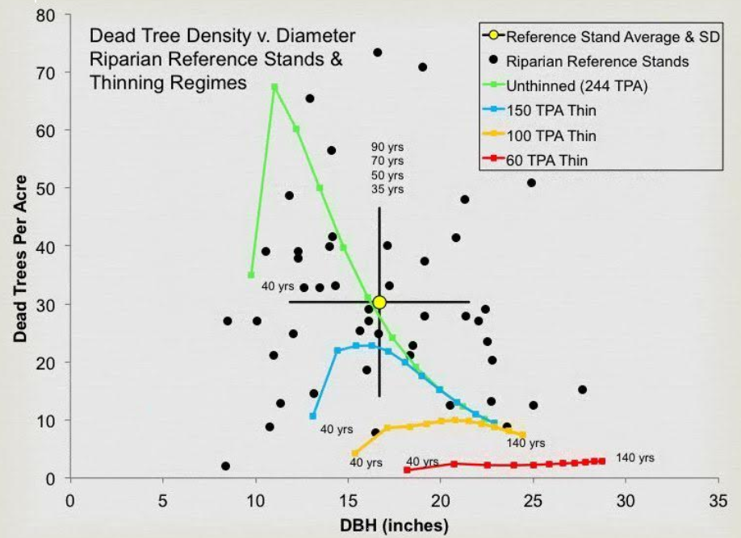

Pollock, M. M., T. J. Beechie, and H. Imaki. 2012. Using reference conditions in ecosystem restoration: an example for riparian conifer forests in the Pacific Northwest. Ecosphere 3(11):98. <http://dx.doi.org/10.1890/ES12-00175.1>

## Weigh the trade-offs associated with logging in riparian reserves.

It’s clear that logging is a subtractive endeavor that is adverse to recruitment of dead wood. So, the agency often claims that logging in riparian reserves is necessary to improve attributes other than large wood. However, these benefits are often minor and transitory, and do not outweigh the significant long-term adverse effect of logging on recruitment of dead wood. The agency must focus on the most significant contributions of vegetation toward ACS objectives and the most significant effects of logging on the ACS objectives.

If the agency intends to log in riparian reserves to increase some nebulous goal like “vegetation diversity and complexity,” then please explain why the biophysical indicators for the ACS objectives (set forth below) do not include any mention of vegetation diversity or complexity. See the Jazz Thinning Preliminary Analysis, 2011. <http://bark-out.org/sites/default/files/bark-docs/Jazz_PA_0.pdf>.

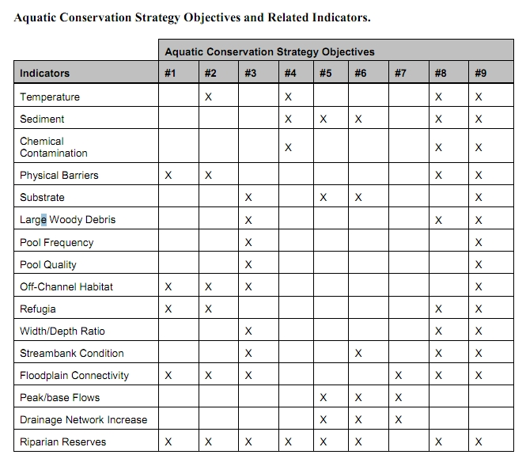

These ACS objectives and biohysical indicators are consistent throughout the Pacific Northwest and are not unique to the Mt Hood NF.

The Northwest Forest Plan and its supporting documentation make clear that the primary value of riparian vegetation is as a source of large wood and shade, not vegetation diversity and canopy layering, as often asserted by the agency to justify logging in riparian reserves. BLM admits “The primary function of Riparian Reserves is to provide shade and a source of large wood inputs to stream channels.” Medford BLM 2013. Pilot Thompson EA, p 3-76. <http://www.blm.gov/or/districts/medford/plans/files/PT_EA_ForWeb.pdf>

Stan Gregory notes the following trade-offs associated with logging riparian reserves to enhance early seral vegetation:

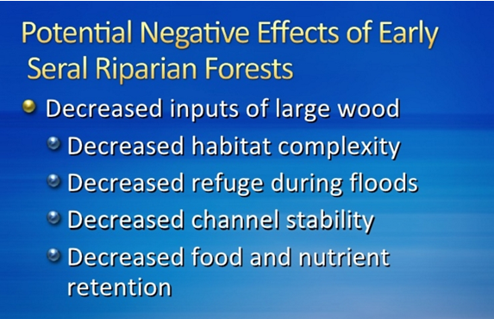

Gregory, Stan 2010. What About Riparian Systems: Who Benefits From an Early Seral Forest Condition. Workshop - Early Seral Forest - We know we need it -- How do we get it? Presentation sponsored by the Central Cascades Adaptive Management Partnership and NW Oregon Ecology Group <http://ecoshare.info/2010/07/06/what-about-riparian-systems-who-benefits-from-an-early-seral-forest-condition-gregory/>

The Northwest Forest Plan Aquatic Conservation Strategy Objectives (1994 ROD p B-11) enumerates specific purposes for “Maintain[ing] and restor[ing] the species composition and structural diversity of plant communities in riparian areas and wetlands” that is -

“to provide adequate summer and winter thermal regulation, nutrient filtering, appropriate rates of surface erosion, bank erosion, and channel migration and to supply amounts and distributions of coarse woody debris sufficient to sustain physical complexity and stability.”

All these values are provided as well or better by unthinned riparian stands.

The effects of logging on dead wood are significant and long term, adversely affecting a core function of the reserves, while the purported benefits to vegetation diversity are minor and transitory, and affect secondary purposes of the reserves.

**Large Wood**

Large quantities of downed trees are a functionally important component of many streams (Swanson et al. 1976; Sedell and Luchessa, 1982; Sedell and Froggat, 1984; Harmon et al. 1986; Bisson et al. 1987; Maser et al. 1988; Naiman et al. 1992). Large woody debris influences channel morphology by affecting longitudinal profile, pool formation, channel pattern and position, and channel geometry (Bisson et al. 1987). Downstream transport rates of sediment and organic matter are controlled in part by storage of this material behind large wood (Betscha 1979). Large wood affects the formation and distribution of habitat units, provides cover and complexity, and acts as a substrate for biological activity (Swanson et al. 1982; Bisson et al. 1987). Wood enters streams inhabited by fish either directly from the adjacent riparian zone from tributaries that may not be inhabited by fish, or hillslopes (Naiman et al. 1992).

Large wood in streams has been reduced due to a variety of past and present timber harvesting practices and associated activities. Many riparian management areas on federal lands are inadequate as long term sources of wood.

…

**Riparian Ecosystem Components**

…

Riparian vegetation regulates the exchange of nutrients and material from upland forests to streams (Swanson et al. 1982; Gregory et al. 1991). Fully functional riparian ecosystems have a suite of characteristics which are summarized below. Large conifers or a mixture of large conifers and hardwoods are found in riparian zones along all streams in the watershed, including those not inhabited by fish (Naiman et al. 1992). Riparian zone-stream interactions are a major determinant of large woody debris loading (House and Boehne 1987; Bisson et al. 1987; Sullivan et al. 1987). Stream temperatures and light levels that influence ecological processes are moderated by riparian vegetation (Agee 1988; Gregory et al. 1991). Streambanks are vegetated with shrubs and other low-growing woody vegetation. Root systems in streambanks of the active channel stabilize banks, allow development and maintenance of undercut banks, and protect banks during large storm flows (Sedell and Beschta 1991). Riparian vegetation contributes leaves, twigs, and other forms of fine litter that are an important component of the aquatic ecosystem food base (Vannote et al. 1980).

1993 FEMAT Report, pp V-13, V-25.

The effects of thinning on crown development are not very significant.

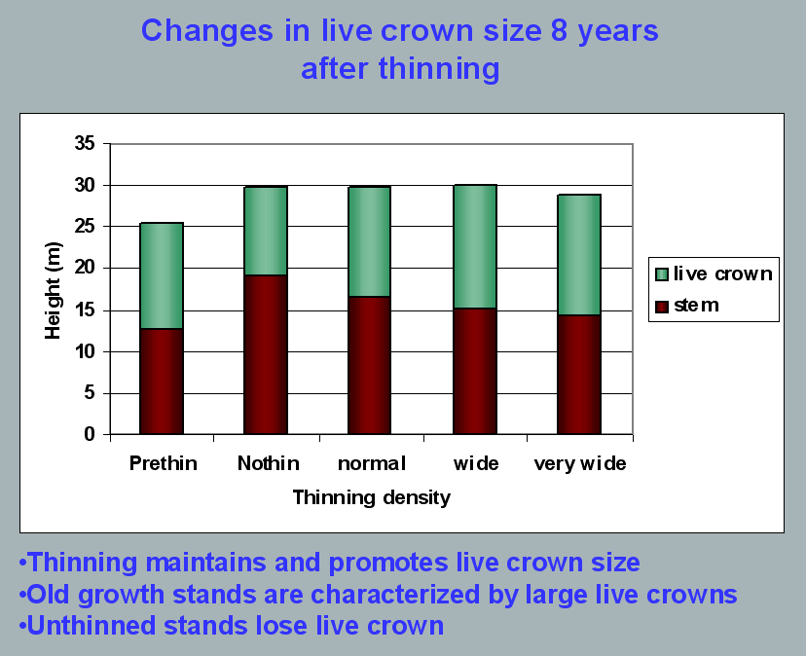

Aquatic/Riparian Ecosystem Dynamics and Associated Management Implications - Recent Findings. Powerpoint, 32.6M. This topic was presented at the Regional Interagency Executive Committee meeting on January 7, 2003. <https://web.archive.org/web/20161221100307/http://www.reo.gov/library/presentations/Szaro_present_Aquatic_Rip_Final.ppt>.

Stimulating the development of a diverse understory is often used as a justification for thinning, but this may not be justified in stands older than about 40 years. A systematic review of 917 Forest Inventory and Analysis (FIA) plots in western Oregon (mostly on non-federal lands) found,

Contrary to expectations of canopy closure, mean canopy cover by age class rarely exceeded 85 percent, even in unthinned productive young conifer forests. Possibly as a result, effects of stand age on understory vegetation were minimal, except for low levels of forbs found in 20- to 40-year-old wet conifer stands. … Although heavily thinned stands had lower total cover, canopy structure did not differ dramatically between thinned and unthinned stands. Our findings suggest potential limitations of simple stand succession models that may not account for the range of forest types, site conditions, and developmental mechanisms found across western Oregon.

McIntosh, Anne C.S.; Gray, Andrew N.; Garman, Steven L. 2009. Canopy structure on forest lands in western Oregon: differences among forest types and stand ages. Gen. Tech. Rep. PNW-GTR-794. Portland, OR: U.S. Department of Agriculture, Forest Service, Pacific Northwest Research Station. 35 p. <http://www.fs.fed.us/pnw/pubs/pnw_gtr794.pdf>. This seems to indicate that the benefits of thinning may be best realized in dense stands younger than 40 years old. This study also showed that in wet conifer stands the mean Canopy Height Diversity Index and the mean Simpson’s Diversity Index of tree heights leveled off at about age 65. This study also looked at canopy conditions after three levels of thinning intensities (heavy, light, and none). “Mean cover of the lower canopy layer was nominal for all three thinning intensities. … There were no evident trends between understory cover and thinning history; both shrub and forb cover were fairly similar among the three thinning intensities. … The lack of a strong effect of crown closure on understory cover may be related to our finding that mean crown cover did not exceed 85 percent. … We expected greater cover of understory vegetation in thinned than in unthinned stands but did not detect significant differences in this analysis.”

While one can generalize that vegetation diversity is more likely to flourish when conifer density is lower, there are data showing a wide range of conifer density can support a wide range of deciduous shrub cover. Thinning is not always necessary. The NEPA analysis should carefully document the site-specific “need” for thinning.

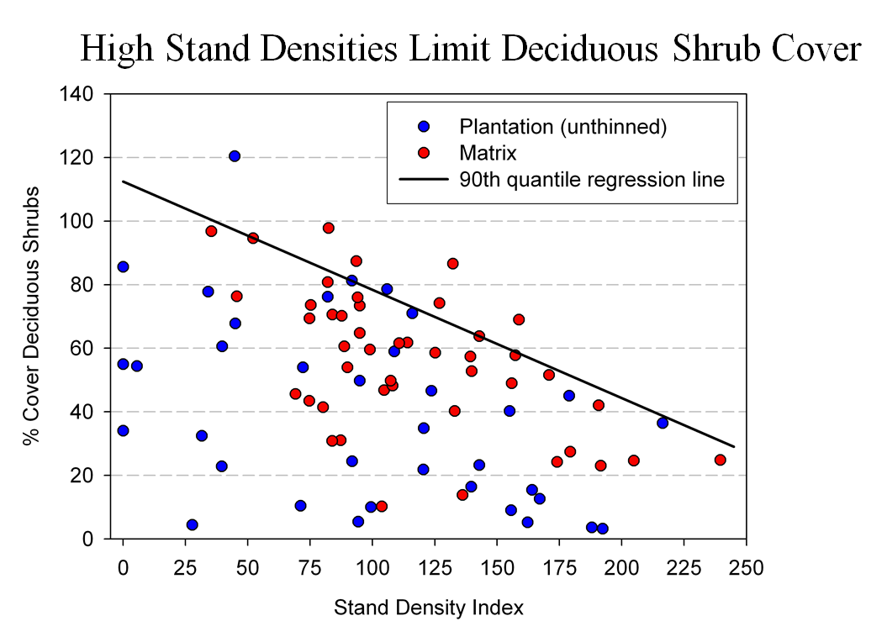

Spies, T. 2008. PowerPoint: Assumptions behind thinning young stands to create late successional riparian habitat. Presented at Riparian Thinning: Logic Paths for Silvicultural Prescriptions -- March 20, 2008. <https://ecoshare.info/projects/central-cascade-adaptive-management-partnership/workshops/riparian-thinning-logic-paths/>

It is also worth noting that where understories are well-stocked, midstory development can be enhanced by focusing on treating the understory itself rather than killing canopy trees.

[R]esults show that individual understory trees can be selectively favored for increased growth into the midstory by being released from competing saplings in the understory cohort. …Our results suggest that understory release treatments can be used to target individual saplings for increased growth, thereby recruiting a shade tolerant midstory cohort and accelerating the development of vertical foliar connectivity and a multi-layered stand structure. Abundance of non-coniferous understory vegetation is also augmented by this treatment. … [Note] The extent to which released understory trees collectively form a cohesive midstory canopy stratum is dependent on the density and horizontal arrangement of those released individuals. … . Inducing spatial variability within the midstory tree cohort would emulate the finescale disturbances of natural stands that create gaps and patches.

Taylor, Andrew 2016. : Understory Vegetation Dynamics and Midstory Development Following Understory Release Treatments in Northwest Oregon Thinned Douglas-fir Stands. OSU MS Professional Paper.

Anderson (2007) looked at the effects of thinning in young Douglas fir forests and found –

[T]hinning treatments … had little impact on the abundance, size, or diversity of understory vegetation. Disturbance resulted in short-term decreases in understory vegetation cover, particularly tall shrubs. However, within five years of treatment, understory vegetation abundance returned to approximate pretreatment condition. … The general lack of understory vegetation response to the thinning treatments was likely due to the inherent resistance and resilience of the plant communities to disturbance, as well as the low intensity of disturbance attributable to the treatments.

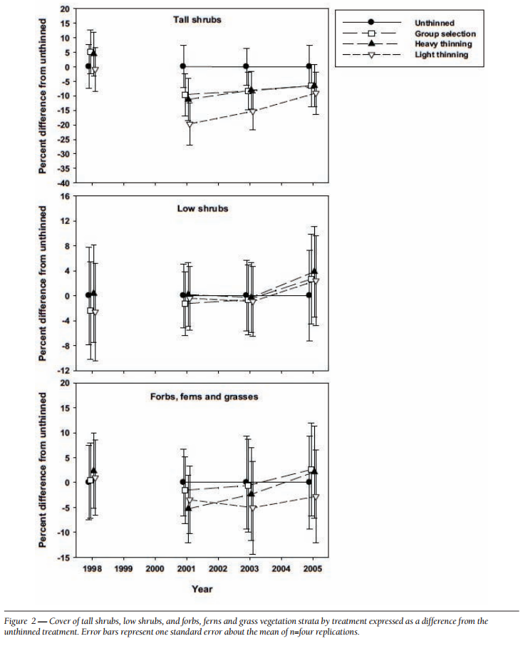

[Four years after thinning] tall shrub cover that was approximately four to nine percent less than the unthinned treatment … [C]over by low shrub species was unchanged by the harvest activity … Forbs, ferns, and grasses [experienced] little difference in cover between thinned and unthinned stands. … [F]ollowing treatment, the mean number of species declined somewhat, [then] return[ed] to pretreatment levels… [T]he evenness component of diversity did not differ among treatments or vary over time …. [T]here was little evidence of substantial alterations of understory shrub and herbaceous vegetation. This lack of strong understory vegetation response in terms of composition, abundance, or size is consistent with several studies of thinning in Douglas-fir. In a recent review of seven operational-scale silviculture experiments, Wilson and Puettmann (2007) report that percent cover by shrubs and percent cover by herbs, one to seven years following thinning showed little difference across a wide range of residual basal area.

Paul D. Anderson 2007. Understory Vegetation Responses to Initial Thinning of Douglas-fir Plantations Undergoing Conversion to Uneven-Age Management. Proceedings of the 2007 National Silviculture Workshop. <http://www.fs.fed.us/pnw/publications/gtr733/PNW_GTR_733_4.pdf> This paper was published in: Deal, R.L., tech. ed. 2008. Integrated restoration of forested ecosystems to achieve multi-resource benefits: proceedings of the 2007 national silviculture workshop. Gen. Tech. Rep. PNW-GTR-733. Portland, OR: U.S. Department of Agriculture, Forest Service, Pacific Northwest Research Station. 306 p.

[W]hile specific structural attributes of forest ecosystems have been correlated with certain species, it is uncertain how such species will respond to treatments designed to recreate these features. There is always the possibility that in our attempt to create a structural attribute we think is important, we eliminate another attribute that is equally important, but unrecognized. One example is that attempts to restore spotted owl habitat by heavily thinning to accelerate the development of large diameter nesting trees could actually delay spotted owl recovery by reducing production of the large down wood utilized by the species it preys upon (Forsman et al., 1984; Carey, 1995; North et al., 1999). Similarly, heavily thinning stands to accelerate the development of marbled murrelet nesting trees also create open stands with a dense understory that is ideal habitat for a number of corvid species that prey on marbled murrelet nest eggs (USFWS, 2010). Riparian thinning efforts to create long-term supplies of very large diameter instream wood that can initiate complex wood jam formation (e.g., key pieces) are also likely to reduce the supply of large diameter wood that will create pools (Beechie and Sibley, 1997; Beechie et al., 2000; Fox and Bolton, 2007). Thus, we suggest that any efforts to actively restore riparian forests for the benefit of certain species should be treated as scientific experiments and proceed cautiously, skeptically, and with robust pre- and post-treatment data collection efforts. Hypothesized effects of thinning on riparian forest structure and the use of that structure by targeted species should be tested against empirical data.

Pollock, Michael M. and Timothy J. Beechie, 2014. Does Riparian Forest Restoration Thinning Enhance Biodiversity? The Ecological Importance of Large Wood. Journal of the American Water Resources Association (JAWRA) 50(3): 543-559. DOI: 10.1111/jawr.12206. <http://oregon-stream-protection-coalition.com/wp-content/uploads/2014/07/Pollock-and-Beechie.-2014.-Riparian-thinning-and-biodiversity.pdf>.

Climate change highlights an additional trade-off related to logging riparian buffers. New science shows that more frequent drought makes upland habitats less suitable, so increasing numbers of upland birds flock to riparian corridors, which become more crowded, with negative effects on riparian-dependent species. The agency should do more to increase space for wildlife that need moist streamside habitat during droughts. Gabrielsen, Paul 2021. In dry years, rivers become birds’ crowded corridors. University of Utah @THEU.

<https://attheu.utah.edu/uncategorized/in-dry-years-rivers-become-birds-crowded-corridors/> (“New research from the University of Utah and the Utah Division of Wildlife Resources (UDWR) finds that in dry years, birds funnel into the relative greenness of riparian (adjacent to river) environments. That increased diversity is accompanied by overcrowding that may cause increased competition for habitat and resources, the study finds, and an overall decrease in populations of birds who call the river home. … Neate-Clegg and his colleagues noticed that during particularly dry years they were finding more birds than usual in the mist nets near rivers. … The multi-year data showed that total bird captures and total species were higher in hotter and drier years, El Niño years, and less green years. The effect was strongest for non-riparian species, suggesting that in harsh conditions, birds from all over the landscape found their way to the rivers. “This suggests that the wider landscape is unable to support migrants and so they are forced to use greener areas,” Neate-Clegg says. But just as an influx of tourists can crowd out locals, the uptick in birds may have taken its toll on typically riparian species, especially those that breed on river banks…. In warmer years, population growth rates slowed for 47% of riparian bird species. The slowing, the researchers found, wasn’t due to more birds deaths, but rather to fewer new birds joining the population. There could be several reasons that bird breeding goes down in hotter years, but the authors suspect that more species in riparian habitats can mean more competition and fewer resources to go around. ‘This study shows how native bird populations utilize these habitats,’ Norvell says. ‘As droughts intensify, this becomes increasingly the refuge that everything’s relying on. And I don’t think humans are all that different in this case. We’re all increasingly relying on these very same areas.’ Neate-Clegg says that rivers provide connections for birds across the landscape, enabling them to transport nutrients or disperse seeds. A hotter, drier climate could affect those important functions that birds provide, called ‘ecosystem services.’”)

## Avoid unnecessary construction of temporary roads

Temporary roads still cause serious adverse impacts to soil, water and wildlife, and spread weeds. Decommissioning such roads is not entirely successful and the soil compaction effects can last for decades. The agency should consider avoiding building spurs by treating some areas non-commercially (e.g. thin lightly, create lots of snags, and leave the material on site).

We urge the agency to avoid road construction, including temporary road construction. The ecological costs of road construction almost always outweigh any benefits of the associated commercial logging activity. Since an optimal landscape restoration plan includes a mix of treated and untreated areas, the agency can easily avoid road construction by co-locating untreated areas and inaccessible areas.

Temporary roads have many of the same impacts as permanent roads, including complete vegetation removal, severe soil disturbance and compaction, severe modification of the flow of water and air through the soil, impairment of soil biological activity, wildlife habitat fragmentation (especially for microfauna), and wildlife cover loss. In spite of the fact that some roads may only be used by heavy equipment on a temporary basis, the biophysical effects of temporary roads can be long-lasting. The FS may even come back and use these temporary roads for future vegetation management or fire management. The temporal effects of temp roads can also be extended by legal or illegal use by off highway vehicles, woodcutters, hunters, mushroom collectors, etc.

The November 2000 National Forest Roadless Area Conservation FEIS p 3-30 says that temporary roads are not designed and constructed to the same standard as classified roads and therefore result in a “higher risk of environmental impacts.” The NEPA analysis must account for this increased risk of temporary roads compared to permanent roads.

The Roadless FEIS also says:

Temporary roads present most of the same risks posed by permanent roads, although some may be of shorter duration. Many of these roads are designed to lower standards than permanent roads, are typically not maintained to the same standards, and are associated with additional ground disturbance during their removal. Also, use of temporary roads in a watershed to support timber harvest or other activities often involves construction of multiple roads over time, providing a more continuous disturbance to the watershed than a single, well-designed, maintained, and use-regulated road. While temporary roads may be used temporarily, for periods ranging up to 10 years before decommissioning, their short- and long-term effects on aquatic species and habitats can be extensive. [The FEIS has similar disclosures citing extensive impacts to terrestrial species and habitats, and rare plant populations.]

Roadless Area Conservation FEIS — Specialist Report for Terrestrial and Aquatic Habitats and Species prepared by Seona Brown and Ron Archuleta, EIS Team Biologists <http://web.archive.org/web/20040515020554/http://roadless.fs.fed.us/documents/feis/specrep/xbio_spec_rpt.pdf>.

"Temporary roads are constructed with no engineering specifications since they are targeted to be used for a short time (ideally a single season), and then obliterated. This lack of construction design makes it particularly important to follow Project Design Criteria for avoiding potentially unstable slopes, even with potentially short time frame of use. That is because even temporary roads which are constructed with road cuts in steep, unstable terrain can trigger debris avalanches and slope failures by removing downslope support and interfering with surface and subsurface water flows that can weaken slopes."

USDA 2020. Stella Landscape Restoration Project Draft Environmental Impact Statement. Page III-30. Rogue River Siskiyou National Forest. <https://www.fs.usda.gov/project/?project=53241>.

For the semi-permanent roads that will be tilled, BLM’s own soils scientist has little faith in the restorative value of this technique. He says: “What I have seen so far have been nothing more than modified rock rippers and little lateral fracture of the soil occurs and the extent of de-compacting is very limited.” Coos Bay BLM, Big Creek Analysis file, section F, Soils Report. page 4.

The agency typically assumes that temporary roads will have little or no effect because they are temporary. The agency has shown no scientific evidence to support this assumption. In fact, scientific research has shown exactly the opposite. Effectiveness of Road Ripping in Restoring Infiltration Capacity of Forest Roads. Charles H. Luce, USDA Forest Service Intermountain Research Station, 1221 S. Main, Moscow, ID 83843. September 1996. Restoration Ecology, Vol. 5, No. 3. page 268.

Please consider George Wuerthner’s summary of the many problems with so-called temporary roads. George Wuerthner 2009. Temporary Roads Are Like Low Fat Ice Cream, NewWest. 3-17-09. <http://www.newwest.net/topic/article/temporary_roads_are_like_low_fat_ice_cream/C564/L564/> (“The problem is that temporary roads have most of the same environmental impacts as regular roads.”). See also, Wuerthner’s April 2020 blog post showing the persistent impacts of temporary roads. <http://www.thewildlifenews.com/2020/04/22/are-temporarily-roads-ecologically-invisible/>.

Research results, published in *Restoration Ecology,* shows there is nothing temporary about temporary roads, and that ripping out a road is NOT equal to never building a road to begin with. The saturated hydraulic conductivity of a ripped road following three rainfall events was significantly greater than that of the road surface before ripping... most saturated hydraulic conductivities after the third rainfall event on a ripped road were in the range of 22 to 35 mm/hr for the belt series and 7 to 25 mm/hr for the granitics. These conductivities are modest compared to the saturated hydraulic conductivity of a lightly disturbed forest soil of 60 to 80 mm/hr.” id. Even this poor showing of restoring pre-road hydrologic effects worsened with repeated rainfall. “Hydraulic conductivity values for the ripped treatment on the granitic soil decreased about 50% with added rainfall (p(K1=K2)=0.0015). This corresponded to field observations of soil settlement and large clods of soil created by the fracture of the road surface dissolving under the rainfall... The saturated hydraulic conductivity of the ripped belt series soils also dropped from its initial value. Initially, and for much of the first event, the ripped plots on the belt series soil showed no runoff. During these periods, run-off from higher areas flowed to low areas and into macropores.... Erosion of fine sediment and small gravel eventually clogged these macropores... Anecdotal observations of roads ripped in earlier years revealed that after one winter, the surfaces were nearly as solid and dense as the original road surfaces.” Id. Even though ripped roads increase water infiltration over un-ripped roads, it does not restore the forest to a pre-road condition. “These increases do not represent ‘hydrologic recovery’ for the treated areas, however, and a risk of erosion and concentration of water into unstable areas still exists.” Luce, C.H., 1997. Effectiveness of Road Ripping in Restoring Infiltration Capacity of Forest Roads, Restoration Ecology; 5(3):265-270. <http://library.eri.nau.edu/gsdl/collect/erilibra/import/Luce.1997.EffectivenessOfRoadRippingIn.pdf>.

The Rogue River-Siskiyou National Forest’s Rustler EA (2010) says:

Temporary roads are also expected to have an irretrievable reduction in soil productivity since they are bladed (soil is mixed and displaced) and compacted. Even once rehabilitated, the soil profile is modified to a degree that may take many years to return to the productive state of the undisturbed forest soils adjacent to it.

To help weigh trade-offs, the agency should do an analysis that illuminates how many acres of accessed by each road segment so that we can distinguish between short segments of spur that allow access to large areas (large accomplishment of goals, with small cost/trade-off) and long spurs that access small areas (small accomplishment, large cost/trade-off). This can help inform the decision-maker’s balancing of the costs and benefits of logging and roading.

The 1994 NWFP ROD (p 68) says “Standards and guidelines for Alternative 9 require that new road construction be substantially limited. Any road construction associated with silvicultural treatments inside late-successional reserve would be subject to the overall ‘beneficial’ requirement for such activities. That is, if the value of a thinning was negated by the habitat lost through road construction to the thinning, the activity should not proceed.”

The Coos Bay BLM’s Brummit Creek Density Management EA (2005) includes a useful table showing the length of each road (new, renovated, improved), the unit acres that are accessed by each road, and the acres of unit per mile of road. This is a useful way to evaluate and prioritize road work relative the expected benefits of thinning.

## The Purpose and Need Should Address The Unmet Need for Carbon Storage

Meeting resource management objectives set forth in the RMP requires properly functioning ecosystems with biophysical conditions and disturbance regimes within the historic range of variability. Global climate change is a clear and present threat to forest ecosystems and watersheds and is preventing the agency from meeting the goals and standards & guidelines described in the applicable Resource Management Plan. The agency cannot meet the RMP without bringing climate change under control, which requires reducing emissions, including emissions from logging. The agency cannot say that carbon storage is outside the scope of this project or not part of the purpose and need. The agency must include carbon storage as part of the purpose and need for this project.

The agency typically says one of the purposes of this project is to provide a supply of wood products to the public. The agency should reconsider timber targets in light of the fact that the public *needs* carbon storage to reduce global climate change much more than they *need* wood products. The NEPA analysis also needs to account for the fact that managing forests for water quality, water quantity, quality of life, and carbon storage for a stable climate will contribute far more to community stability than propping up the timber boom-bust industry with subsidized logging.

The agency must recognize that wood products are already under-priced and over-supplied due to “externalities” (costs that are not included in the price of wood, so those costs are shifted from wood product producers and consumers to the general public who suffer the consequences of climate change without compensation from those who profit from logging related externalities). Ecosystem carbon storage on the other hand is under-supplied because there is not a functioning market for carbon storage and climate services. The agency is in a position to address these market imperfections by focusing on unmet demand for carbon storage instead of offering wood products that are already oversupplied.

Land protection, both public and private, provides substantial ecological benefits by avoiding conversion of natural systems to intensive, developed uses. These benefits include carbon sequestration, watershed functioning, soil conservation, and the preservation of diverse habitat types (e.g., Daily 1997, Brauman et al. 2007, Kumar 2012, Watson et al. 2014). Land protection also solves a key market failure: private markets tend to underprovide socially beneficial land uses such as natural forests, agricultural lands, or managed timberlands. The reason for this failure is that many of the benefits of these lands go to the public in general, not individual landowners. When private values and market transactions determine land uses, less land will be devoted to socially beneficial uses than if citizens could collectively determine use on the basis of social values (e.g., Angelsen 2010, Tietenberg and Lewis 2016).

Katharine R.E. Sims, Jonathan R. Thompson, Spencer R. Meyer, Christoph Nolte, Joshua S. Plisinski. 2019. Assessing the local economic impacts of land protection. Conservation Biology. 26 March 2019 <https://doi.org/10.1111/cobi.13318>, <https://harvardforest.fas.harvard.edu/sites/default/files/Sims_et_al-2019-Conservation_Biology.pdf>.

Maintaining and increasing carbon storage in ecosystems on public lands is also required to meet LRMP desired future conditions and standards & guidelines. Carbon emissions from logging and other land management activities exacerbate global climate change and drive ecosystem changes that diverge from desired future conditions, such as uncharacteristic drought, fire, insect outbreaks, vegetation and wildlife mortality, species range shifts, low summer stream flows, unfavorable stream temperatures, extreme precipitation and peak flows and erosion, uncertainty related to vegetation recovery post-disturbance, uncertainty about the ability to provide a predictable, sustainable supply of forest products, etc. The agency should identify a purpose and need that recognizes the necessity of avoiding carbon emissions from logging and optimizing carbon storage to fulfill the promises in the LRMP.

## Do not rely on the flawed boilerplate climate analyses

As explained below, the Forest Service’s standardized NEPA language regarding carbon and climate change fails to take a hard look that NEPA requires. The analysis makes several highly misleading statements about managing forests for carbon storage, climate resilience, and the effects on climate change. The analysis inappropriately mischaracterizes the role of individual logging projects in the cumulative problem of global GHG emissions. The analysis misstates the effects of logging related carbon emissions that are not related to “deforestation.” The analysis grossly misstates the climate effects of logging intended to reduce disturbance. The analysis misleadingly implies that logging benefits the climate by increasing forest productivity.

The NEPA analysis should consider the adverse climate consequences of GHG emissions caused directly and indirectly by logging. The NEPA analysis should estimate the quantity of GHG emitted by logging and associated activities throughout the wood products supply chain, and describe the contribution of this project to cumulative impacts of excess GHG in the atmosphere. The NEPA analysis should use a proxy such as the social cost of carbon dioxide emissions to describe effects.

The Forest Service should not rely on the boilerplate NEPA language from the regional office which is flawed in many ways. Instead the Forest Service:

* Must recognize the cumulative nature of the GHG emissions and climate problems. It does not matter that this project is small in the global scheme because all emissions matter when the causation is global and cumulative;
* Cannot credibly assert that this project is harmless because it’s not causing deforestation. This is immaterial. All GHG emissions, regardless of the source or how it is labelled, are part of the problem and cause the same climate impacts.
* Cannot credibly assert that thinning for forest health justifies or mitigates emissions from logging. Logging does not increase the capacity for growing trees. To the contrary, logging harms soil and reduces site productivity. Storing carbon in wood products is not preferable to storing carbon in forests. Evidence shows that forests are a more secure way of storing carbon. If this forest is not logged, or if more green tree are retained *in situ*, the agency cannot conclude that natural mortality will be greater than logging mortality. In fact, it is quite easy to predict that logging causes significantly more mortality than natural processes.
* Must not compare carbon *before and after* logging. That is an improper framework for NEPA analysis. The proper NEPA framework is to compare the effects of different alternatives (over time), so the agency must describe the carbon emissions and carbon storage in the forest over time *with* logging and *without* logging.
* Logging to reduce fire effects does not result in a net increase in forest carbon storage. The agency cannot predict the location, timing, or severity of future wildfires, so most fuel treatments will cause carbon emissions without any offsetting benefits from modified fire behavior. Studies clearly show that the total carbon emissions from logging (plus unavoidable wildfire) are greater than carbon emissions from wildfire alone.
* Cannot credibly assert that carbon storage in wood products is a useful climate strategy. Logging kills trees, stops photosynthesis, and initiates decay and combustion, with the end result being a significant transfer of carbon from the forest to the atmosphere. In stark contrast, an unlogged forest continues to grow and transfer more carbon from the atmosphere to the forest. Carbon emissions caused by logging far exceed the small fraction of carbon transferred to wood products. Carbon accounting methods that attempt to account for *substitution* of wood for other high-carbon building materials are fraught with uncertainty and too often represent maximum potential substitution effects rather than lower realistic estimates.

Each substantive issue discussed in these comments should be (i) incorporated into the purpose and need for the project, (ii) used to develop NEPA alternatives that balance tradeoffs in different ways, (iii) carefully analyzed and documented as part of the effects analysis, and (iv) considered for mitigation.

Note: If any of these web links in this document are dead, they may be resurrected using the Wayback Machine at Archive.org. <http://wayback.archive.org/web/>