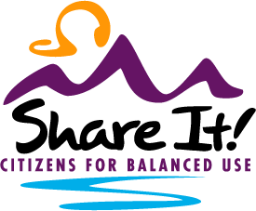

Citizens for Balanced Use

Box 606, Gallatin Gateway, Mt 59730

[www.balanceduse.org](http://www.balanceduse.org)

1-406-600-4228

**Stillwater Mining Company, East Boulder Mine Amendment 004 Expansion EIS #61385 comment.**

Please accept the following comment from CBU and our 7000 active members and the 68 supporting organizations representing 1000s of Montana citizens in support of the East Boulder Amendment 004 Expansion.

The Stillwater Mine has been a very good neighbor and contributed greatly to the local community and area. The mine has operated for many years and provided the critical minerals that are vital to our national security and products beneficial to our environment. The expansion will increase the life of the mine by nearly 20 years and allow continued production of these critical minerals.

The proposed tailings storage facility meets or exceeds all of the engineering design, operating, and closure planning requirements in the Montana Metal Mines Reclamation Act. Montana has probably the most stringent regulations in protecting our environment and Stillwater Mine has complied with all of these regulations.

During a time when critical minerals are so important to be produced domestically rather than increase our dependance on foreign nations who may not have our best interest in mind, the Stillwater Mine must be approved for expansion to maintain their ability to continue production of these critical minerals.

Finally, the economic benefit to Montana from the Stillwater Mine provides the funds necessary in providing public services to insure the health, safety, and welfare of Montana citizens.

Thank you for the opportunity to comment and we urge you to approve the 004 expansion of the Stillwater Mine.

Sincerely,

Kerry White

Executive Director