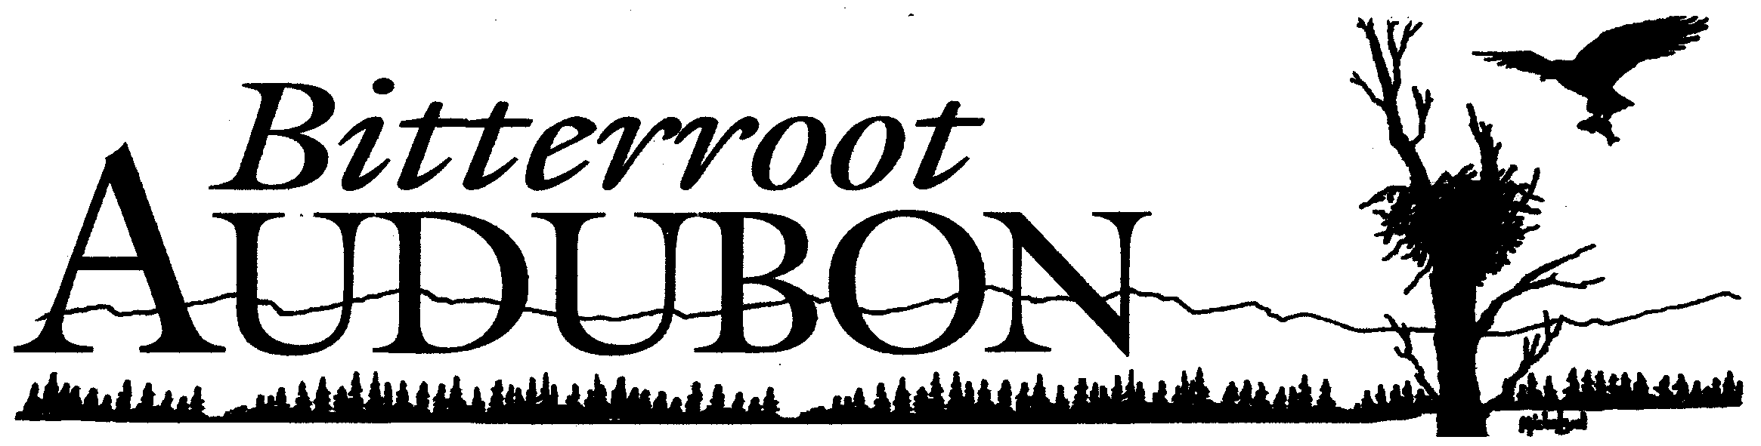Bitterroot Audubon Society

Post Office Box 326

Hamilton, Montana 59840-0326

20 April 2021

The Board of Bitterroot Audubon Society (BAS) appreciates the opportunity to submit comments on the Draft EA for the Mud Creek project. We are submitting the following comments to be entered into the public record for the project.

1. In our previous comments (September 2019), we asked what, if any, treatments would be used in the Inventoried Roadless Areas (Blue Joint and Allan Mountain IRAs) and in the Blue Joint Wilderness Study Area (WSA). Those areas offer less disturbance to birds and other wildlife than do most other areas in the Forest. From the Draft EA, we understand that there will be no commercial or non-commercial logging in these areas. According to Seth Carbonari, West Fork District Ranger, the only activity that might occur in the WSA is prescribed fire. We ask that you leave burned snags standing, for the benefit of woodpeckers and other wildlife that thrive in burned areas and/or rely on snags for nesting and other activities. Again according to Ranger Carbonari, the only treatments that might occur in the IRAs are “non-commercial treatments associated with Whitebark Pine stands to improve their health and resiliency” (email exchange). We ask that treatments in Whitebark stands do not include removing Old Growth trees, the backbone of forests.
2. While we are happy to see that many crucial areas will not have any road construction (Draft EA 41-42), we would like to see no net increase in roads, as the area has one of the highest road densities on the Forest. Over 40 miles of new specified and temporary roads are proposed in the project area. The Draft EA says, “Each HUC 12 watershed will show a net reduction in road miles (total miles decommissioned will exceed total miles of specified road constructed) 41). We would like to see the net reduction calculation include temporary roads as well as specified roads, for as our climate grows ever hotter and dryer, it could take longer than the FS anticipates for the vegetation on the temp roads to regenerate. Charney et al. (2016) says that climate change will negatively impact forest growth rates in the interior West. While roads are necessary for active forest management, their impacts on wildlife and habitat must be seriously considered. Roads fragment habitat, spread noxious weeds, and increase sedimentation. Road construction during breeding seasons would be particularly disruptive.
3. In our original comment, we expressed concern about the project’s impact on important bird species, including the Flammulated Owl, a Montana Species of Concern and a U.S. Forest Service Sensitive Species. The Draft EA’s Wildlife Effects Analysis concedes that “Some snags could be removed during times when flammulated owls are nesting” (16). The Forest plans to minimize the impact to nesting owls by prohibiting activities during nesting season within areas the owls have been detected. The Forest Service will conduct a survey of Flammulated Owls beginning in May (one has not been conducted since 2008). According to Justin Martens, the Forest will use the Partners in Flight Protocol for the survey. Both that protocol and one recommended in Smucker et al. (2008) indicate that the optimal time for Flammulated Owl detection is from mid-May until the end of June. We ask that you survey within this period and that you repeat the survey at least once (as both protocols cited above indicate).
4. Another issue related to Flammulated Owls is their dependence on Old Growth (OG) trees. The Montana Field Guide cites Linkhart and Reynolds (1997): “Territories consistently occupied by breeding pairs were those containing the largest portion (more than 75 percent) of old-growth (200 to 400 years), whereas territories occupied by unpaired males and rarely by breeding pairs contained 27 to 68 percent old-growth” (Linkhart and Reynolds 1997). The Old-Growth standard used by the Forest is Green et al., which recommends a bare minimum of eight OG trees per acre, significantly lower than the current Forest Plan’s minimum of 15 OG trees per acre. Both of these minimums are below what Flammulated Owls require. Further, Fielder et al. (2007a) and Hessburg et al. (2015) recommend reserving all or nearly all large trees. OG trees are essential to the health of a forest habitat. Please do not use Green et al. as the standard for OG in the project area. Avoid cutting OG trees where at all possible.
5. Given the relative novelty, at least to the public in the Bitterroot Valley, of Condition-Based Analysis, we are concerned about the ability of the public to see and comment on the project as it moves forward. At the virtual Open House on 6 April 2021, attendees were assured that there would be yearly workshops at which the public could learn about and comment on project activities. We look forward to participating in these annual events and assume that public comments offered in this context will be seriously considered, thus allaying concerns about Forest accountability under Condition-Based Analysis.

Again, thank you for the opportunity to comment on this project.

Micki Long

President, Bitterroot Audubon Society

[mickilong@gmail.com](mailto:mickilong@gmail.com)

440-221-5256

Sources

Charney, N.D., Babst, F., Poulter, B., Record, S., Trouet, V.M., Frank, D., Enquist, B.J. and Evans, M.E.K. (2016), Observed forest sensitivity to climate implies large changes in 21st century North American forest growth. Ecol Lett, 19: 1119 -1128.  <https://doi.org/10.1111/ele.12650>

Fiedler, C. E., P. Friederici, M. Petruncio, C. Denton, and W. D. Hacker. 2007a. Managing for old growth in frequent-fire landscapes. *Ecology and Society***12**(2): 20. URL: <http://www.ecologyandsociety.org/vol12/iss2/art20/>

Fylling, M.A., J.D. Carlisle, A.N. Cilimburg, J.A. Blakesley, B.D. Linkhart, and D.W. Holt. 2010. Flammulated Owl survey protocol. Partners in Flight Western Working Group. <http://rmbo.org/v3/Portals/5/Protocols/WWGPIF_Flam%20Methods%20Manual_FINAL2.pdf>

Hessburg, P.F., et al., 2015, Restoring fire-prone Inland Pacific landscapes: seven core principles: Landscape Ecology, v. 30, p, 1805–1835. DOI 10.1007/s10980-015-0218-0

Linkhart, B. D. And R. T. Reynolds. 1997. Territories of Flammulated Owls (*Otus flammeolus*): Is Occupancy a Measure of Habitat Quality? pp 150-154 In: J.R. Duncan, D.H. Johnson, and T.H. Nicholls, Editors. Biology and Conservation of Owls in the Northern Hemisphere.

Montana Field Guide <http://fieldguide.mt.gov/speciesDetail.aspx?elcode=ABNSB01020>

Smucker, K., A. Cilimburg, and M. Fylling. 2008. 2008 Flammulated Owl Surveys Final Report.Northern Region Landbird Monitoring Program. Avian Science Center. University of Montana: Missoula, MT. <https://www.yumpu.com/en/document/read/17835131/2008-final-report-avian-science-center-university-of-montana>