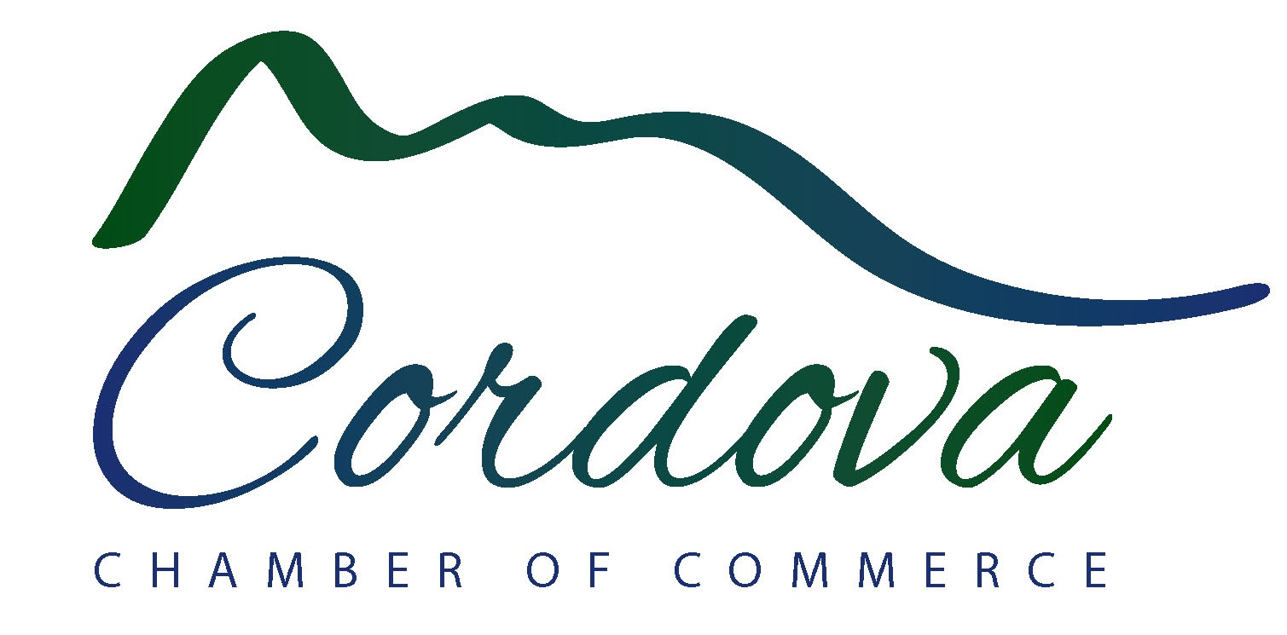

Chugach National Forest November 1, 2018

Supervisors Office

1161 East 1st Ave

Anchorage, AK 99501

RE: Chugach NF Plan Revision Comment

The Cordova Chamber of Commerce represents approximately 140 business, organizations, and corporations in Cordova and Prince William Sound; and works to sustainably strengthen Cordova’s economic base through destination marketing/tourism development, quality of life enhancement, economic development, and business development support. I hope you will find the following comments helpful in executing a new draft plan that meets all your forest goals to the fullest extent.

We have the pleasure of partnering with Chugach National Forest on several local festivals throughout the year. Copper River Delta Shorebird Festival, Copper River Salmon Jam and Cordova Fungus Festival are integral pillars of tourism in Cordova. They also stimulate the local economy and enhance quality of life for Cordova residents. Your primary goals for the national forest as outlined in this draft plan are to foster collaborative relationships, contribute to social and economic sustainability, and provide for ecological sustainability. If that is the case, I am surprised to see that there is no explicit mention of these events in your draft plan, as they meet all three of your goals. I would like to see language added that a desired condition to meet each of those goals would be to **maintain or increase the Chugach National Forest’s involvement and contribution to local festivals and events such as Copper River Delta Shorebird Festival, Copper River Salmon Jam, and Cordova Fungus Festival**.

I would also like to see language added that **emphasizes measurable objectives for increasing authorized special use permits for outfitters and guides that help meet forest goals.** Perhaps this could be addressed on page 41 under “Management Approaches” and on page 43 under “Objectives”. Clarity could also be added on page 36 to articulate which areas are suitable for outfitter and guide use (not just assigned sites). There are several outfitters ready to apply that would like to offer tours with relatively small environmental or cultural impacts. I understand the work capacity of your offices is limited by budget and other factors, and I plan to reach out to Senator Murkowski on this issue as well. Lastly, it may be beneficial for Chugach National Forest to evaluate the capacity for guided sport fishing on the Copper River Delta, to achieve the best balance of socio-environmental and socio-economic benefits to communities and the broader user base. Thank you for your consideration.

Sincerely,

**Cathy Renfeldt**

Executive Director

Cordova Chamber of Commerce