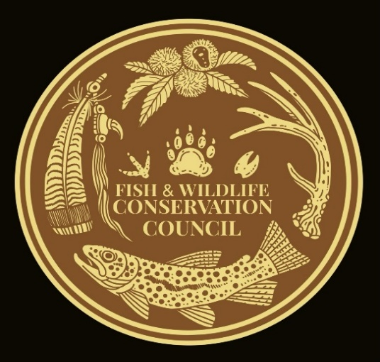
David Whitmire
Fish and Wildlife Conservation Council
2700 Flat Creek Valley Road
Lake Toxaway, NC 28747
avery@citcom.net
828-553-0083

October 15, 2023

Allyson Conner
Land Management Planner
Forest Service, National Forest in North Carolina

RE: Setzer Fish Hatchery Project

To Allyson Conner,

On behalf of the Fish and Wildlife Conservation Council thank you for the opportunity to review and comment on this project.

FWCC recognizes the importance of the history and heritage of what a fish hatchery has meant to the Pisgah District. For generations, the current hatchery has helped establish WNC has a trout designation. While streams are designated and managed differently, it is many of the hatchery supported streams that are most popular. This popularity leads to conservation dollars through license and fishing gear that often supports all streams in WNC and is a major economic engine for local economies. We also appreciate the location within the Pisgah District that allows for a large number of visitors to be exposed to an educational experience of working conservation.

We have reviewed the updated redesign and support the project has designed. We appreciate the features that improve water quality above the outdated hatchery. We also support retro fitting the existing dam to meet the new facilities needs. We feel the dam protects the upstream wild fishery and work taking it out would be a negative on downstream water quality. Updating the intakes etc. makes perfect sense to our council. We are hopeful for a quick and efficient project completion. We would also like to see the public education for the hatchery and restrooms restored as soon as possible. The concentration of visitors without these services has added to degradation of the area.
We also appreciate the partnership and leadership between the USFS and the NCWRC that has made this much needed update to this facility possible.

Regards,
David Whitmire
FWCC Chair

