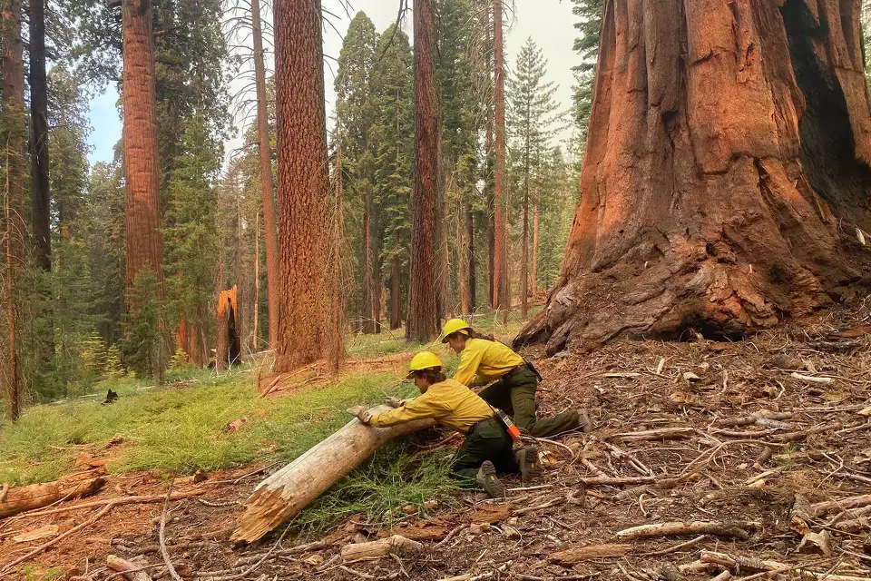

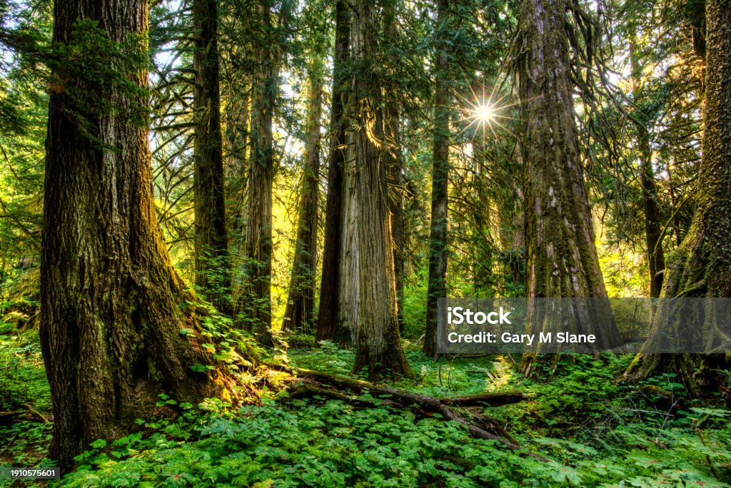

What Old Growth is currently defined as and depicted on the internet. This is what the public currently understands as Old Growth. Changing the definition will cause confusion in the public’s perception of Old Growth.