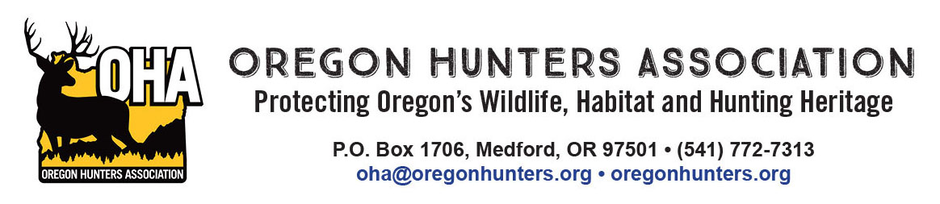

January 17, 2022

RE: Oregon Hunters Association input on the USFS Clackamas River Ranger District “Clackamas Fires Roadside Danger Tree Assessment”

The Oregon Hunters Association (OHA) is a sportsmen’s conservation organization with 10,000

members in 26 chapters across Oregon. OHA values our National Forests as a public place to hunt and recreate, and also as a valuable asset providing habitat for the wildlife we care about. As such, the management and access of these lands are of critical importance to OHA. We have been engaged in numerous projects to improve and protect habitat conditions, and we value our partnership with the U.S. Forest Service (USFS). We are providing comments and input on the Clackamas Fires Roadside Danger Tree Assessment.

Access of our public lands, including those in this proposal, are a priority to OHA. Managing and balancing this access with wildlife needs should be considered.

Road Closures and Decommissioning

OHA supports the project proposal to close approximately 27 miles of low-use roads and decommission approximately 9.4 miles of potentially unneeded roads as depicted on the project maps. Closing low-use roads will potentially minimize disturbance to wildlife in those area. We recommend the USFS incorporate large ungulate disturbance in their road closure evaluations, particularly in the areas where significant fire damage has reduced or eliminated cover for these species.

USFS should consider, when closing or decommissioning roads, to leave adequate space for safe parking, turnarounds and dispersed camping at those junctions with the main-line roads which will be converted to walk-in access at those points.

Danger Tree Removal on Open Roads

OHA supports the project proposal to cut danger trees using the “striking distance” criteria as described. Not only will this provide safe public and administrative access to these lands on approximately 200 miles of roads, the associated timber sales will help support local communities. We have no specific comments on the roads depicted for this activity at this time.

It is imperative that the USFS expedite this work. The fires that caused this situation occurred well over a year ago. The public has been unable to access these lands, and the timber value is declining with the decomposing of the salvageable trees. The USFS should use every means possible within the NEPA process (use of Categorical Exclusions), planning processes and contract procurement processes with strict deadlines for completion.

We appreciate the opportunity to comment on the proposal and look forward to contributing to habitat and recreation work in the future.

Mike Totey

Conservation Director

Oregon Hunters Association