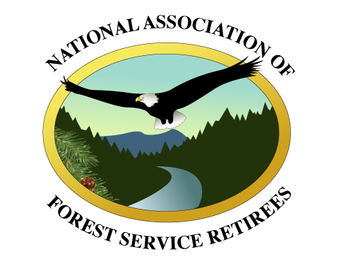

***Board of Directors***

***Steve Ellis, Chair***

***Jamie Connell, Vice Chair***

***Johnny Hodges, Secretary***

***Cheryl Probert***

***Frank Beum***

***Jerry Perez***

***Lynn Sprague***

***Teresa Benson***

***Becki Heath***

***Marisue Hilliard***

***Don Howlett***

***Earl Stewart***

***Rich Guldin***

***Gene Blakenbaker***

***Doug Crandall***

***Ranotta McNair***

***Nora Rasure***

***Susan Skalski***

***Bill Timko***

***Jeanne Wade Evans***

***Bill Avey***

***Ralph Crawford***

***Tim DeCoster***

***Ed Shepard***

***Chiefs Emeritus***

***F. Dale Robertson***

***Michael Dombeck***

***Dale Bosworth***

***Abigail Kimbell***

***Tom Tidwell***

***Victoria Christiansen***

August 27, 2024

Comments on USDA Forest Service Old Growth DEIS

The National Association of Forest Service Retirees (NAFSR) appreciates the opportunity to provide comments on the Forest Service Old Growth Draft Environmental Impact Statement (DEIS).

It is appropriate that the Forest Service recognizes the value of old growth forests specifically, and resilient forests overall. Old growth forests are critical for wildlife, carbon sequestration and storage, watershed and other environmental values.

We are comfortable with the agency taking a national approach to amending Forest Plans to incorporate generally consistent old growth management strategies. This is a much better approach than a “one size fits all” rulemaking.

The agency has produced a quality DEIS with good depth and quality of analysis. We submit the following comments which were reviewed by our NAFSR Board of Directors:

* *NAFSR supports the Preferred Alternative as modified*, which allows continued commercial harvest of old growth as an outcome of management activities to increase forest resilience.
* Appendix C, which shows the effect of the Old Growth Amendment on current Forest Plans is a good attempt to show what the actual effects of this effort will be on each national forest. However, forests listed in categories 3 and 4; “noticeable change” and “very noticeable change,” respectively, appear to have considerable changes to their current management direction. It would have been helpful if Appendix C had provided examples of noticeable and very noticeable changes, so that the reviewer could have better understood expected effects.
* The DEIS is clear that the actual plan amendments would take place after development of an “Adaptive Management Strategy”. The description of what the “Adaptive Management Strategy” entails, both scale (the DEIS implies either single or multiple units) and actual components is vague in the document. Additionally, this approach appears to lead to yet another level of analysis, possibly incorporating different scales across the nation. NAFSR suggests a clear description of, and a framework for the Adaptive Management Strategy be included in the FEIS. This would help better define the publics and partner’s expectation for the next process steps and the overall process. We don’t believe the Forest Service intends this step to be another analysis layer, but the DEIS is unclear.
* Related to the previous comment, NAFSR has questions about the Forest Service’s capacity to complete the Adaptive Management Strategy in the timeframes outlined by the Preferred Alternative’s Objective 1. Given the priority of the Wildfire Crisis Strategy, the current and expected shortfall in the NFS budget, as well as what appears to be many currently unfilled positions, perhaps a description of how this objective would be accomplished could be included in the final EIS.
* Pursuant to the previous comment, NAFSR also has concerns about the prescriptive nature of the Preferred Alternative’s Objectives 1, 2 and 3. Again, given the priority of the Wildfire Crisis Strategy, the current and expected budget shortfalls in the NFS budget, and current level of vacancies throughout the agency, should these objectives be so prescriptive in their timeframe and expectations? Perhaps some reconsideration of the prescriptive nature of these objectives should be considered to ensure that unreal, or unachievable expectations are not being created. An inability to meet unrealistic expectations, as well as the new associated workload may well have a negative impact on employee morale by increasing stress, which could contribute to further decline in the workforce.

NAFSR also has a more general concern about the ability of the field units to develop Adaptive Management Strategies and meet the objectives without sacrificing attention to the Wildfire Crisis Strategy as approved and funded by Congress.

We appreciate the opportunity to comment on the Old Growth DEIS. Please don’t hesitate to reach out with any questions you may have.

***Steve Ellis, Chair***

Steve Ellis, Chair

National Association of Forest Service Retirees