**The Fire Restoration Group**

**Stephanie Miller, Assistant Director for Future Forest October 15, 2024**

**Denver Federal Center, Building 40,**

**Lakewood, CO 80215.**

**Sent electronically at:** https:// cara.fs2c.usda.gov/Project/Details/4178.

Comments on the Federal Register Notice and draft revisions to the Forest Service Manual 2470 Silvicultural Practices--Federal Register / Vol. 89, No. 159 / Friday, August 16, 2024 / Notices 66671

General Comments

We are very supportive of the effort to revise and update the FSM on Silvicultural Practices published in the Federal Register 8-16-24. It is past time for an update given stated reasons including, **“Increases climate change considerations** **throughout the directive. Adds considerations for indigenous knowledge, and old-growth forests.”**

1) Climate change considerations should include a scientific assessment of wildfire risk, drought and insect damage related reforestation patterns and density (uniformity) in frequent fire ecosystems. The revision effort should also include the Forest Planning Rule (2012) direction to protect and enhance Ecological Integrity (36 CFR § 219.8) Sustainability and section (a) (1):

**(1)** ***Ecosystem Integrity.*** The plan must include plan components, including standards or guidelines, to [maintain](https://www.law.cornell.edu/definitions/index.php?width=840&height=800&iframe=true&def_id=b9e11ec5d7ef87635e8b12e168bb1c5c&term_occur=999&term_src=Title:36:Chapter:II:Part:219:Subpart:A:219.8) or [restore](https://www.law.cornell.edu/definitions/index.php?width=840&height=800&iframe=true&def_id=513d8af73eed96dafe0fa948b32f2597&term_occur=999&term_src=Title:36:Chapter:II:Part:219:Subpart:A:219.8) the [ecological integrity](https://www.law.cornell.edu/definitions/index.php?width=840&height=800&iframe=true&def_id=8f45f62cf4fb3e189563e682f997a93d&term_occur=999&term_src=Title:36:Chapter:II:Part:219:Subpart:A:219.8) of terrestrial and aquatic [ecosystems](https://www.law.cornell.edu/definitions/index.php?width=840&height=800&iframe=true&def_id=7311dc59ccdd25626478f978bdc0330e&term_occur=999&term_src=Title:36:Chapter:II:Part:219:Subpart:A:219.8) and [watersheds](https://www.law.cornell.edu/definitions/index.php?width=840&height=800&iframe=true&def_id=66b2006a617c06e9c40a9c493454ce77&term_occur=999&term_src=Title:36:Chapter:II:Part:219:Subpart:A:219.8) in the [plan area](https://www.law.cornell.edu/definitions/index.php?width=840&height=800&iframe=true&def_id=c78b2a1bf289e3c7e1735882024f62af&term_occur=999&term_src=Title:36:Chapter:II:Part:219:Subpart:A:219.8), including plan components to [maintain](https://www.law.cornell.edu/definitions/index.php?width=840&height=800&iframe=true&def_id=b9e11ec5d7ef87635e8b12e168bb1c5c&term_occur=999&term_src=Title:36:Chapter:II:Part:219:Subpart:A:219.8) or [restore](https://www.law.cornell.edu/definitions/index.php?width=840&height=800&iframe=true&def_id=513d8af73eed96dafe0fa948b32f2597&term_occur=999&term_src=Title:36:Chapter:II:Part:219:Subpart:A:219.8) structure, function, composition, and [connectivity](https://www.law.cornell.edu/definitions/index.php?width=840&height=800&iframe=true&def_id=ef275c8a245cef13c51cb118f7a187b7&term_occur=999&term_src=Title:36:Chapter:II:Part:219:Subpart:A:219.8), taking into account:

**(i)** Interdependence of terrestrial and aquatic [ecosystems](https://www.law.cornell.edu/definitions/index.php?width=840&height=800&iframe=true&def_id=7311dc59ccdd25626478f978bdc0330e&term_occur=999&term_src=Title:36:Chapter:II:Part:219:Subpart:A:219.8) in the [plan area](https://www.law.cornell.edu/definitions/index.php?width=840&height=800&iframe=true&def_id=c78b2a1bf289e3c7e1735882024f62af&term_occur=999&term_src=Title:36:Chapter:II:Part:219:Subpart:A:219.8).

**(ii)** Contributions of the [plan area](https://www.law.cornell.edu/definitions/index.php?width=840&height=800&iframe=true&def_id=c78b2a1bf289e3c7e1735882024f62af&term_occur=999&term_src=Title:36:Chapter:II:Part:219:Subpart:A:219.8) to [ecological conditions](https://www.law.cornell.edu/definitions/index.php?width=840&height=800&iframe=true&def_id=c495d26cbc95aecd2ee7556a0681be1c&term_occur=999&term_src=Title:36:Chapter:II:Part:219:Subpart:A:219.8) within the broader [landscape](https://www.law.cornell.edu/definitions/index.php?width=840&height=800&iframe=true&def_id=84775a3b95928c2adfa6f06981beebc1&term_occur=999&term_src=Title:36:Chapter:II:Part:219:Subpart:A:219.8) influenced by the [plan area](https://www.law.cornell.edu/definitions/index.php?width=840&height=800&iframe=true&def_id=c78b2a1bf289e3c7e1735882024f62af&term_occur=999&term_src=Title:36:Chapter:II:Part:219:Subpart:A:219.8).

**(iii)** Conditions in the broader [landscape](https://www.law.cornell.edu/definitions/index.php?width=840&height=800&iframe=true&def_id=84775a3b95928c2adfa6f06981beebc1&term_occur=999&term_src=Title:36:Chapter:II:Part:219:Subpart:A:219.8) that may influence the [sustainability](https://www.law.cornell.edu/definitions/index.php?width=840&height=800&iframe=true&def_id=9a7f4f5af4020c966b08d30a1465ed32&term_occur=999&term_src=Title:36:Chapter:II:Part:219:Subpart:A:219.8) of resources and [ecosystems](https://www.law.cornell.edu/definitions/index.php?width=840&height=800&iframe=true&def_id=7311dc59ccdd25626478f978bdc0330e&term_occur=999&term_src=Title:36:Chapter:II:Part:219:Subpart:A:219.8) within the [plan area](https://www.law.cornell.edu/definitions/index.php?width=840&height=800&iframe=true&def_id=c78b2a1bf289e3c7e1735882024f62af&term_occur=999&term_src=Title:36:Chapter:II:Part:219:Subpart:A:219.8).

**(iv)** System drivers, including dominant ecological processes, [disturbance](https://www.law.cornell.edu/definitions/index.php?width=840&height=800&iframe=true&def_id=96285b99148b58e1aa63de72b9ccb8ee&term_occur=999&term_src=Title:36:Chapter:II:Part:219:Subpart:A:219.8) regimes, and [stressors](https://www.law.cornell.edu/definitions/index.php?width=840&height=800&iframe=true&def_id=8ef63a332844e7a0e2619ed526fd1226&term_occur=999&term_src=Title:36:Chapter:II:Part:219:Subpart:A:219.8), such as natural succession, wildland fire, invasive species, and climate change; and the ability of terrestrial and aquatic [ecosystems](https://www.law.cornell.edu/definitions/index.php?width=840&height=800&iframe=true&def_id=7311dc59ccdd25626478f978bdc0330e&term_occur=999&term_src=Title:36:Chapter:II:Part:219:Subpart:A:219.8) on the [plan area](https://www.law.cornell.edu/definitions/index.php?width=840&height=800&iframe=true&def_id=c78b2a1bf289e3c7e1735882024f62af&term_occur=999&term_src=Title:36:Chapter:II:Part:219:Subpart:A:219.8) to adapt to change.

**(v)** Wildland fire and opportunities to [restore](https://www.law.cornell.edu/definitions/index.php?width=840&height=800&iframe=true&def_id=513d8af73eed96dafe0fa948b32f2597&term_occur=999&term_src=Title:36:Chapter:II:Part:219:Subpart:A:219.8) fire adapted ecosystems.

**(vi)** Opportunities for [landscape](https://www.law.cornell.edu/definitions/index.php?width=840&height=800&iframe=true&def_id=84775a3b95928c2adfa6f06981beebc1&term_occur=999&term_src=Title:36:Chapter:II:Part:219:Subpart:A:219.8) scale [restoration](https://www.law.cornell.edu/definitions/index.php?width=840&height=800&iframe=true&def_id=45f47f92b0628e155cb44d2aeb35e5b4&term_occur=999&term_src=Title:36:Chapter:II:Part:219:Subpart:A:219.8).

**2) Heterogeneity=Resilience**--See (Levine et al. 2022 attached) for a robust critique of the high severity fire effects of plantation forestry and NOTE that while the emphasis of the Levine paper pointed to industrial timberlands, **it’s the primary uniform, high density stand structure that is the likely culprit** which is regularly replicated on federal lands when planting 200-300 Trees/acre. The

(From Levine et al. 2022 pg. 6) “The heightened likelihood of high- severity fire both on and around industrially managed forests suggests that the predominant forest management practice on these lands (even- aged plantation forestry) may contribute to the broader pattern of increased high- severity fire incidence in California on land of all ownership types. This, together with the complex intermix of ownership types and **evidence that high- severity fire effects may be spread across ownership boundaries**, emphasizes the necessity of cross- ownership cooperation to reverse recent, concerning trends in extreme fire effects.”

**Levine et al. 2022 pg. 4 graph**

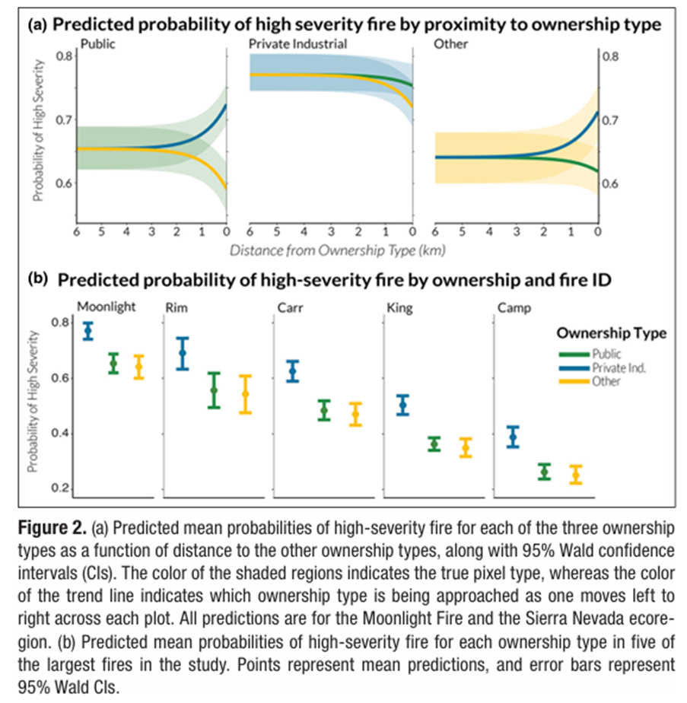

**3) Consideration of Indigenous Knowledge**—it should be noted that traditional Native American cultures (in California and elsewhere) have a deep economic, ecological, and spiritual relationship with fire. They generally abhor the use of toxic chemicals in land management where the risk of contamination is high for food and fiber gathering, central to Tribal cultures. There is a deep cultural need to move away from management with chemicals to a more appropriate management and maintenance of resilience with fire with a critical benefit of supporting traditional (safe) gathering sites for Tribal communities and increasing opportunities for indigenous fire use.

**4) Consideration of Old Growth Forests**—the pending Old Growth Forest Conservation Strategy will require a solid commitment to re-establishing the old forest component in ecosystems across the country and doing so with active management with fire and thinning prescriptions that support resilience and enhance the larger tree size class across the landscape based on appropriate scientific understanding of ecosystems across the country. Silvicultural prescriptions that support replacement cohorts for larger trees lost to disturbance and at the same time limiting ladder fuels and densities that easily carry fire will be critical.

5) The new NEPA requirements to address **new Climate Change regulations under the CEQ GHG Interim Guidelines Executive Order 13990** on January 9, 2023, at:

<https://ceq.doe.gov/guidance/ceq_guidance_nepa-ghg.html>

This is particularly relevant because adapting restoration efforts to showcase increased climate and wildfire sensitive reforestation and early fire reintroduction are essential to climate adaptation. In California, Regional Ecologists and PSW scientists correctly assert that there is “no ecological analog” associated with landscape plantation uniformity.

Reforestation recommendations that fail to consider ecological integrity are outdated, lack fire resilience and drought tolerance and have “no ecological analog” in our frequent fire ecosystems (Meyer and North 2024)**—**Fire Science Consortium presentations at: <https://www.youtube.com/watch?v=Tu92373T8Gg&t=208s>

Also see the slide presentation (below) from PSW Vegetation Ecologist Malcolm North making the case for rethinking reforestation approaches:

<https://scale.sierrainstitute.us/wp-content/uploads/2023/07/Malcolm-North_Keynote.pdf>

**6) Climate informed reforestation** (2472.3 page 29 of the draft language) is critical across the country and especially so in frequent-fire ecosystems in the West (especially in California in Region 5) where we live in one of the most naturally fire prone landscapes on Planet Earth (Moreira et al. 2020). Key considerations are uncharacteristic, uniform stand structure and drought intolerance in a warming climate. Traditional timber production tree densities in old forest plans (example: the 1989 Eldorado NF-Forest Plan makes no mention of climate change and proposes planting densities over 300/TPA. The ENF plan was amended in 2004 BUT NOT THE REFORESTATION CHAPTER). These production plantation forestry models have no place in the frequent fire landscapes of California—they are the antithesis of Ecological Integrity called out in the 2012 Forest Planning Rule at 36 CFR 219.8 (a) (1).

The Silvicultural Practices FSM should reference the 2012 Forest Planning Rule and not based on “as directed by land management plans” when that plans have not been updated to be consistent with the 2012 Forest Planning Rule (which itself is 12 years old).

**7) Improving Working Relationships between silvicultural and fuels (especially with fire** **managers).** The workforce should 100 percent focused on ecosystem management and to “[maintain](https://www.law.cornell.edu/definitions/index.php?width=840&height=800&iframe=true&def_id=b9e11ec5d7ef87635e8b12e168bb1c5c&term_occur=999&term_src=Title:36:Chapter:II:Part:219:Subpart:A:219.8) or [restore](https://www.law.cornell.edu/definitions/index.php?width=840&height=800&iframe=true&def_id=513d8af73eed96dafe0fa948b32f2597&term_occur=999&term_src=Title:36:Chapter:II:Part:219:Subpart:A:219.8) the [ecological integrity](https://www.law.cornell.edu/definitions/index.php?width=840&height=800&iframe=true&def_id=8f45f62cf4fb3e189563e682f997a93d&term_occur=999&term_src=Title:36:Chapter:II:Part:219:Subpart:A:219.8) of terrestrial and aquatic [ecosystems](https://www.law.cornell.edu/definitions/index.php?width=840&height=800&iframe=true&def_id=7311dc59ccdd25626478f978bdc0330e&term_occur=999&term_src=Title:36:Chapter:II:Part:219:Subpart:A:219.8) and [watersheds](https://www.law.cornell.edu/definitions/index.php?width=840&height=800&iframe=true&def_id=66b2006a617c06e9c40a9c493454ce77&term_occur=999&term_src=Title:36:Chapter:II:Part:219:Subpart:A:219.8) in the [plan area](https://www.law.cornell.edu/definitions/index.php?width=840&height=800&iframe=true&def_id=c78b2a1bf289e3c7e1735882024f62af&term_occur=999&term_src=Title:36:Chapter:II:Part:219:Subpart:A:219.8), including plan components to [maintain](https://www.law.cornell.edu/definitions/index.php?width=840&height=800&iframe=true&def_id=b9e11ec5d7ef87635e8b12e168bb1c5c&term_occur=999&term_src=Title:36:Chapter:II:Part:219:Subpart:A:219.8) or [restore](https://www.law.cornell.edu/definitions/index.php?width=840&height=800&iframe=true&def_id=513d8af73eed96dafe0fa948b32f2597&term_occur=999&term_src=Title:36:Chapter:II:Part:219:Subpart:A:219.8) structure, function, composition, and [connectivity](https://www.law.cornell.edu/definitions/index.php?width=840&height=800&iframe=true&def_id=ef275c8a245cef13c51cb118f7a187b7&term_occur=999&term_src=Title:36:Chapter:II:Part:219:Subpart:A:219.8)” . . .

Ending the power struggles and siloed thinking while empowering science-based ecosystem management teams should be the goal of the FSM Silvicultural Practices revisions.

**8) Judging successful reforestation** should be based upon function, compositions, connectivity (not just structure) and reforested areas should be monitored longer than the 5-year stocking requirement. Reforestation efforts should be judged successful only when they are exposed to fire-regime based fire frequency of 2 fire disturbance events within roughly 30 years (in Sierra Nevada mixed conifer for example).

Cost effective reforestation should be judged by levels of survival of natural disturbance. High density, uncharacteristic stocking levels (plantation forestry) should be held accountable for their flammability and for the contribution to high-severity wildfire. (see Levine et al. 2022).

(attached)

In section 2471.5 #2 Staying current with the knowledge of science-based literature in forest ecology, including climate change and silvicultural strategies, and natural resources management.

This should be more than a reading exercise. The best available scientific information (BASI) should be incorporated into silvicultural practices like addressing stocking levels dictated by archaic and outdated forest plans that fail to address climate warming impacts, drought intolerance, flammability, and susceptibility to insect damage. These call for new Ecological Reforestation strategies, not just a reading exercise. (see attached Meyer and North 2024)

At 2472.21 the Economic Analysis should include the potential for fire susceptibility, contribution to wildfire severity, and a resilience rating that is examined and reported through time.

At 2476.3 Stand Improvement—there needs to be more emphasis on the use of prescribed fire to reduce understory fuels but also to reducing stocking, increase heterogeneity and resilience.

Thank you for this opportunity to comment on the FSM 2470 Silvicultural Practices revisions.

Sincerely,



Craig Thomas, Director

Fire Restoration Group

[craigthomas068@gmail.com](mailto:craigthomas068@gmail.com)

916-708-9409

