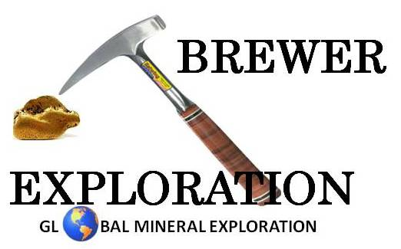
Brian T. Brewer, CPG, QP, M.Sc.
P.O. Box 305
Salmon, Idaho 83467 USA
+1.208.940.0898
brian@brewerexploration.com

25 September 2020

Ms. Linda Jackson
Payette Forest Supervisor
500 North Mission Street
McCall, ID 83638

Dear Ms. Jackson,

I am writing this brief letter to offer my full support for Alternative 2 of the Draft Environmental Impact Statement for the Stibnite Gold Project.

As a citizen of Idaho, avid outdoorsman, business owner, father of 3 boys and a grandfather to a young grandson, I fully understand the natural beauty of our wonderful state and the importance of maintaining our culture and protecting the environment for future generations. As a professional geologist with over 26 years of experience, I also understand the importance of mining in our society and I know that today’s mining companies work to operate in as safe of manner as possible while working hard to help protect our environment.

After thoroughly investigating the Stibnite Gold Project, I am convinced that the project can successfully operate to create local jobs and help stimulate Idaho’s economy while also operating in a safe manner with constant consideration for Idaho’s environment. In fact, I think that the operation would, in fact, help clean up many years of environmental neglect and deterioration brought about by historic operations in the area.

The Stibnite Gold Project will generate numerous economic and environmental benefits to our local communities. I strongly urge you to make decisions regarding the project based on sound science and not impetuous emotions. Please approve Alternative 2 of the Draft Environmental Impact Statement and help advance the Stibnite Gold Project to an operational decision.

Thank you very much for your time and efforts.

Best Regards,

Brian T. Brewer

