“Objection for the Thunder Basin National Grassland 2020 Plan Amendment

USDA Forest Service Rocky Mountain Region

Attn: Objection Reviewing Officer

P.O. Box 18980

Golden, CO 80402

Objector: Denise L Langley

PO Box 530

Wright, Wy, 82732

307-359-3327 or 298-0308

[dnslng.0642@gmail.com](mailto:dnslng.0642@gmail.com)

Emphasis is mine.

1. **Objection: Sage Grouse Protection:**

*As covered in RCOWS petition(submitted Sept. 4, 2018) and also in my own comments on the draft FEIS(submitted 11/28/2019); none of the alternative plan amendments offer any specific protection to the grouse core area within the Grasslands from encroachment, fragmentation and destruction of habitat by the black-tailed prairie dog.*

*In the TBNG it has been proven over and over that the prairie dog will destroy existing sage grouse habitat which includes the birds’ leks, nesting and feeding areas.*

*The preferred and proposed plan amendments:*

1. ***Do NOT offer any protection to the grouse core area habitat from fragmentation and destruction caused prairie dog (p/d) colonization.*** 
   1. *There are no buffers or barriers to protect the outer boundaries from prairie dog (p/d) infestation*
   2. *There are no buffers, barriers or plans to prevent prairie dogs (p/d) from encroaching upon leks*
   3. *There are no plans to remove the prairie dogs that currently reside within grouse core area habitat. The p/ds are destroying the sage brush habitat for sage grouse, to such an extent that the sage brush is forever removed. The rodent kills the roots not just the stem above ground and is much more destructive than fire is for the sage brush ecosystem.*
   4. *The rodenticide the Forest Service prefers to use for treatments is highly toxic to avian species. Just a .1 oz of the zinc phosphide is toxic to a ¼ pound bird and the rodenticide is placed on top of the ground within easy reach of the sage grouse. The anticoagulant (Rozol or Kaput) are placed inside the p/d burrow out of reach of sage grouse and this rodenticide takes 1.1 pounds to kill a ¼ pound bird. What type of treatment options are the Forest Service going to utilize to prevent grouse from ingesting the rodenticide?*
   5. *Uncontrolled prairie dog colonies will infest grouse core habitat if they are within migration distance so what is the Forest Service actually doing on the ground to protect the grouse habitat from current and future destruction?*
2. **Draft EIS, Pg. 132** ``One third of management area 3.67 is designated as greater sage-grouse priority habitat management area in the Grassland plan. There are four active leks currently in management are 3.63; however, plan direction does not conflict with the greater sage-grouse amendment…” “Change in the size, distribution, and total extent of prairie dog colonies has not been shown to have a measurable effect on greater sage-grouse populations on the TBNG.” This is NOT true! I have picture after picture showing the destruction of grouse habitat by the black-tailed prairie dog.

**The Forest Service’s Greater Sage Grouse’s Record of Decision for Northwestern Colorado and Wyoming:** *The following excerpts are from the Forest Service’s own signed document for “protecting” the sage grouse and its habitat.*

**PHMA**— NFS lands identified as having the highest habitat value for maintaining sustainable GRSG populations .

**Priority-core habitat management areas** – In Wyoming, areas of priority habitat management areas that are the most important breeding and nesting habitat.3

**SFAs** (Sagebrush focal areas) maximize protection from new surface disturbance, given that they contain high-quality sagebrush habitat, highest breeding densities, have been identified as essential to conservation and persistence of the species, represent a preponderance of current federal ownership and, in some cases, are adjacent to protected areas that serve to anchor the conservation importance of the landscape.

In Wyoming, lek buffer distances will be consistent with the State of Wyoming’s Core Area Strategy

The Wyoming LMP amendment is built upon the foundation for GRSG management established by and complementary to the *Governor’s Executive Order 2011-05, Greater Sage Grouse Core Area Protection* (Core Area Strategy) (Wyoming Office of the Governor 2011) (http://will.state.wy.us/sis/wydocs/execorders/EO2011-05.pdf) and updated Executive Order (http://www.blm.gov/style/medialib/blm/wy/programs/wildlife/SG.Par.27910.File.dat/WY-SGoverview.pdf), by establishing similar conservation measures and focusing restoration efforts in the same key areas most valuable to the GRSG. Recognizing that the USFWS has found that “the core area strategy . . . if implemented by all landowners via regulatory mechanisms, would provide adequate protection for sage-grouse and their habitats in the state,” the Forest Service plan amendment, works to ensure that any impacts not addressed through avoidance and minimization will be addressed through compensatory mitigation. However, unlike the Core Area Strategy, the Forest Service plans commit to achieving a net conservation gain for GRSG in PHMA for new authorizations. Page 42

Sagebrush Focal Areas (SFAs) were only identified in the Wyoming LMP amendment in the Rocky Mountain region, and additional conservation measures for these areas include recommending withdrawal of a portion of the area from the General Mining Act of 1872 and prioritization of habitat management actions.

Measures incorporated into the plans remain consistent with the range-wide objective of protecting, enhancing, and restoring GRSG habitat by reducing, eliminating, or minimizing threats to GRSG habitat, such that the need for additional protections under the ESA may be avoided. Pg 43

**The Biological Evaluations** concluded that implementation of the GRSG amendments will provide habitat on NFS lands that will support persistent populations on each involved NFS unit. The amendments were developed to provide assurances that conservation and management actions would provide conditions to support the persistence of GRSG on the NFS units to meet the associated life-cycle requisites on those NFS lands that are suitable for and capable of providing habitat. Pg 61

**Priority habitat management areas** – National Forest System lands identified as having highest habitat value for maintaining sustainable greater sage-grouse populations. The boundaries and management strategies for priority habitat management areas are derived from and generally follow the preliminary priority habitat boundaries. Priority habitat management areas largely coincide with areas identified as priority areas for conservation in the Conservation Objectives Team report. Pg 90

***Table 1.*** *Seasonal Habitat Desired Conditions for Greater Sage- grouse at the Landscape Scale. Pg 96 gives landscape requirements for desired habitat.*

Page 126; shows a map of the priority sage grouse core habitat. When this map is overlaid with the proposed 3.67 short grass stature vegetation area for prairie dog colonization several thousands of acres are involved in both areas. ***This is not feasible in reality. Both species are at odds with each other so why “encourage” them to live in the same area but different habitat?***

*The Forest Service is stating they will protect an area of high priority for a sensitive species then at the next opportunity they are stating this same area will become “short grass”?*

From the Draft ROD 2020 TBNG Plan Amendment:

Page 10: **Greater sage-grouse habitat:** Commenters are concerned that occupancy of greater sage-grouse habitat management areas by both prairie dogs and greater sage-grouse could create management conflicts. This concern is analyzed in the biological evaluation of animal species (final environmental impact statement appendix E). The plan amendment addresses this concern by removing a portion of management area 3.63 that currently lies within a greater sage-grouse priority habitat management area. Although management area 3.67 still overlaps with the greater sage-grouse priority habitat management area**, Forest Service staff expect conflicts to be minimal and flexibility in plan direction to allow appropriate management in specific locations and situations.** ***The desired condition for management area 3.67 states that in greater sage-grouse priority habitat management areas where greater sage-grouse habitat exists, desired conditions for priority habitat management areas apply. In addition, according to plan components in the Greater Sage-grouse Plan Amendment, plan direction for management area 3.67 supersedes plan direction for general habitat management areas when they are in conflict regarding the management of grazing or prescribed fire to meet desired vegetation conditions.***

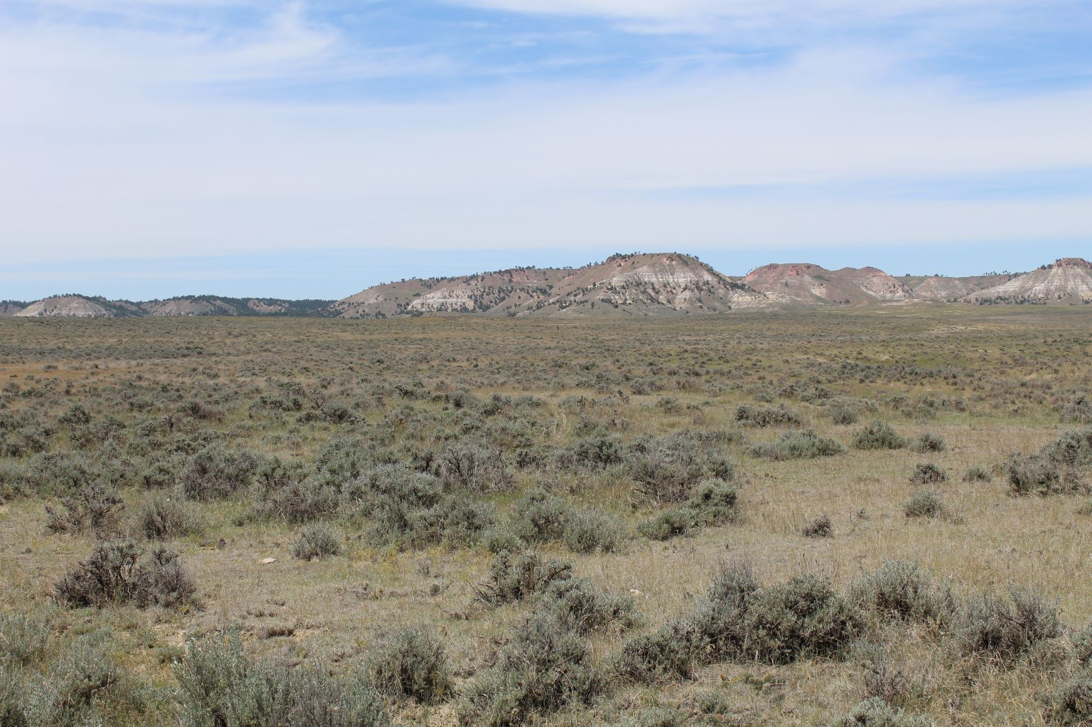

Large tracts of land with varying heights and thicknesses of sage brush cover for sage grouse within priority core habitat areas

* *How can conflicts be minimal when there are prairie dogs and grouse habitat in the same management area.*
* *“Flexibility in plan direction to allow appropriate management in specific locations and situations.” Exactly what is “appropriate management” to prevent prairie dogs from killing sage brush and eating vegetation the grouse need? In the past the Forest Service has expanded the prairie dog colonization at the expense of the grouse so what is changing-how and what is specifically going to occur to prevent prairie dogs from killing the sage brush and destroying more grouse habitat?*

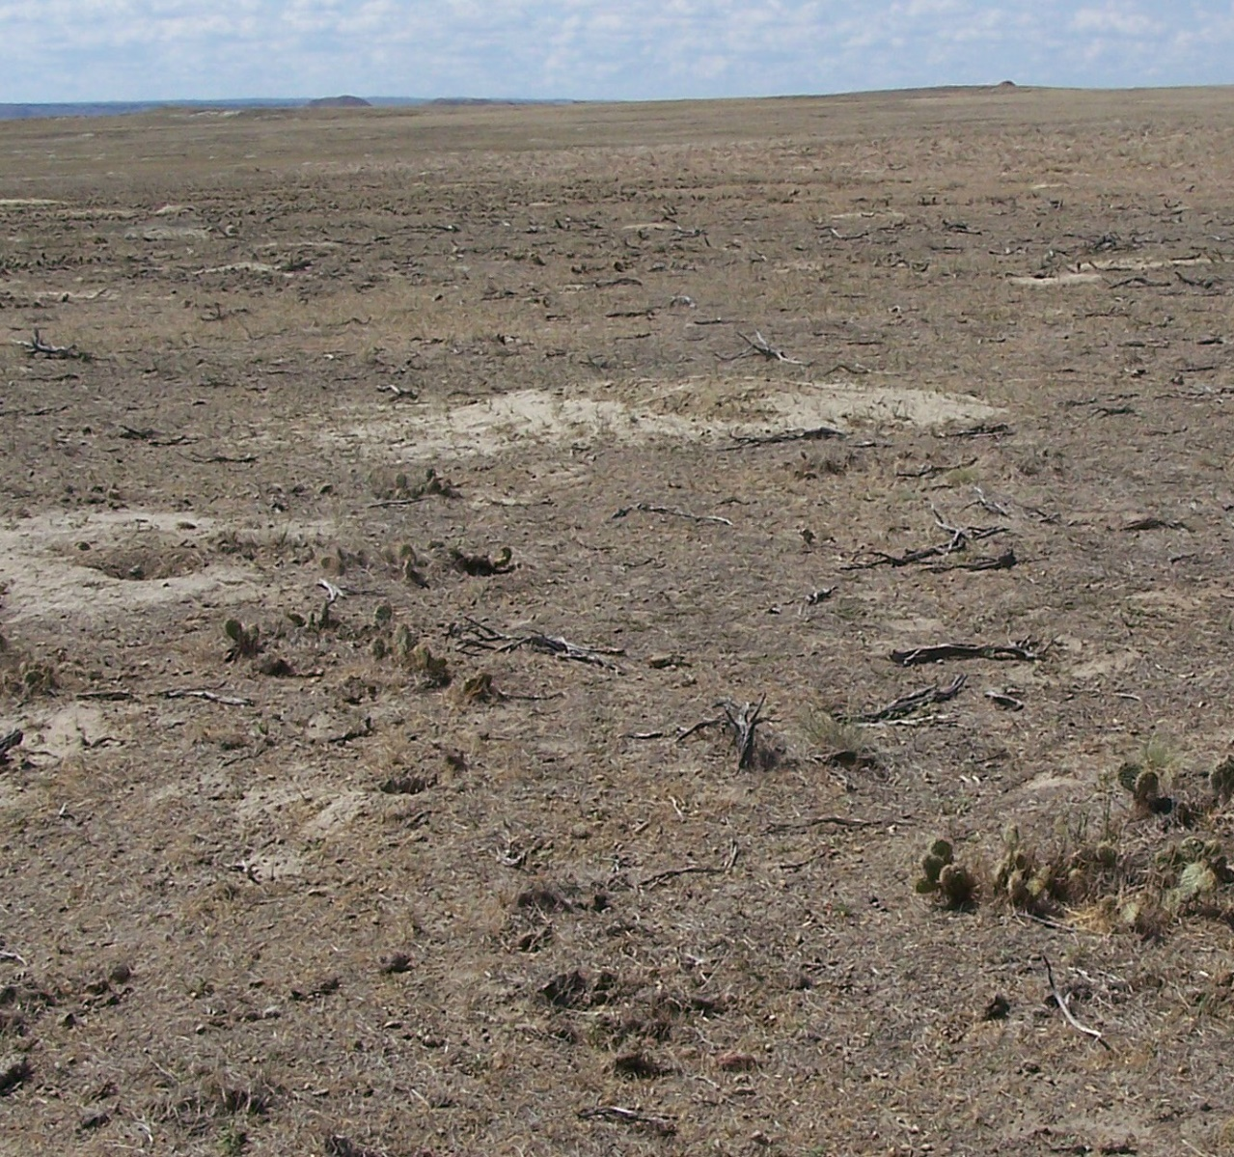

*This area used to be a sage grouse nesting area but prairie dogs were allowed to remain and expand their colony which destroyed what used to be a sage brush steppe ecosystem. This is what short stature vegetation looks like under Forest Service management. Losing situation for all grouse habitat. Both species cannot coexist into the future within same area! There is no MINIMAL CONFLICT IN THIS SITUATION! It is impossible to have 3.67 and priority grouse core area habitat to coexist and be functional.*

* *In greater sage grouse PHMA it states priority habitat management areas apply-what exactly does this mean? Will the prairie dog be moved out of the area, will there be conservation buffers, what specifically will be done to prevent fragmentation of grouse core area and* *prevent the expansion of short grass stature vegetation within grouse habitat by the prairie dog?*
* *How can you state you want to protect the grouse and still allow prescribed intensive grazing or prescribed fire in the general habitat areas as these management applications will further expand the prairie dog within general habitat grouse area.*
* *Both species cannot be EFFECTIVELY managed within the same area as both species take opposite ecosystem parameters to live.*
* *The prairie dogs cannot be treated with rodenticide once every X number of years to keep them at bay within grouse area habitat; costly, not effective; toxic to grouse using zinc phosphide. Could be done with fumigants but must be continual treatment to keep prairie dog density down and would be too time consuming. Removal of all prairie dogs within the priority core area would be much more feasible, cost effective, progressive management.*

*The Wyoming Sage Grouse Executive Order 2019-3 states the overall goal is to maintain habitat (of the sage grouse) and minimize future disturbances. The effect the black-tailed prairie dog has on the sage grouse sagebrush steppe is definitely a negative disturbance as referenced by the picture below.*

Page 2-5 of Grassland wide LRMP: Sage Grouse (MIS) 1. Provide diverse and quality sagebrush habitat across the geographic area at levels that, in combination with habitat on adjoining lands, helps support stable to increasing populations of sage grouse and other wildlife with similar habitat needs. Objective

Suggestions for Improvement:

* Remove all prairie dogs from within sage grouse **primary** core habitat unless they are within a private CCAA.
* Establish boundaries of ½ mile or more that will be prairie dog free to prevent further destruction and encroachment upon protected grouse habitat.
* To remove the prairie dogs use Rozol or Kaput and not the zinc phosphide in order to prevent the rodenticide from killing the grouse thru unwanted ingestion.
* Protect all leks with at least ½ mile boundary of prairie dog free buffer.
* All boundaries will be continuous unless next to private lands.
* Activate conservation projects to reseed grouse habitat and treat for cheat grass and other unwanted plants, yes this should be so stated in the prairie dog amendment as the rodent is the reason for a large amount of the destruction of primary core habitat.
* Do not encourage intensive prescribed grazing, mowing, and prescribed burns for plover within core habitat as this also encourages prairie dog expansion.
* Never translocate prairie dogs into grouse primary core habitat as has been done under previous management.

*All of the above steps will help protect the grouse primary and general habitat from future surface destruction and fragmentation. The prairie dog must be prevented from encroaching upon grouse core area habitat for a more effective, practical, less costly management process. Both species will win within their own ecosystem, if the prairie dogs, which can colonize most places, are separated from the limited habitat of the grouse.*

1. **Objection: Boundaries of 3.67:**

*Because the lines were redrawn during the draft ROD these issues were* ***not covered*** *in RCOWS petition(submitted Sept. 4, 2018) and in my own comments on the draft FEIS(submitted 11/28/2019.*

*The Forest Service has expanded Management Area 3.67 into Irwin Livestock Company allotments The line seems to be drawn out in the middle of a pasture where there are no natural barriers. The line could be changed at the whim of Forest Service officials annually. In the two allotments there are no logical places to put a boundary that public hunters, Forest Service employees and especially the landowners would know where the supposed management boundary is.*

*On page 45 of the Final EIS the Forest Service moves the 3.67 boundary back to the original place in Irwin’s Calf Pasture allotment. As Stated: “ (g) exclude more of the westernmost portion of the management area at the Calf pasture of the Irwin allotment to* ***create a more logical boundary “****(by placing the boundary along an existing fence line). This makes good sense as a fence line is noticeable by all, is stationary, does not change with the seasons and can be distinguished on a map. Whereas the boundary lines drawn to encompass portions of Irwin Livestock’s allotments follow no distinguishing characteristics, can change by several hundred feet, are not distinguishable from the air, and contain no natural hydrologic and topographic barriers to prairie dog colonization.*

*The area in Irwin Livestock Company’s East Pasture is also in* ***sage grouse priority core*** *habitat, and is an area that* ***will be*** *involved in future land exchanges with Forest Service and Irwin Livestock Company. To avoid future issues concerning this specific parcel I request that the Forest Service use a more logical manageable boundary and place 3.67 boundaries along existing fence lines and not out in the middle of a pasture.*

*As for the boundary along Vest Draw, in Irwin Livestock Company’s Scotplace allotment: the same argument applies as there is no distinguishing characteristics to mark the boundary which will make management for treatment with rodenticide and prairie dog shooting by the public hard to control. As the Forest Service stated above: a more logical boundary---is a fenceline.*

Suggestions for Improvement:

* Have all boundaries for 3.67 follow along existing fence line boundaries to avoid land exchange issues and management issues due to lack of distinguishing characteristics.
* The boundaries ought to be understood by all not just lines drawn on a map but must also fit on-the-ground topography as well.

1. **Objection: Boundary Management:**

*As covered in RCOWS petition(submitted Sept. 4, 2018) and also in my own comments on the draft FEIS(submitted 11/28/2019); none of the alternative plan amendments offer effective boundary management.*

*Previous Comments: Boundary Control: Page 4; When the p/d juveniles migrate twice a year at an average distance of 3-6 miles just how effective is a ¼ mile or 1/8 mile boundary? The proposed boundaries are not continuous and any break in a boundary control area would just funnel more rodents into the area “being protected from” encroaching p/d. When there is an area of non-treatment and the p/d travel thru then the infestation onto the private lands is much greater than a straight frontal assault. Any attempt at boundary control must not have “open gates” of non-treatment areas for the rodents to pass through. The Forest Service will not treat the other infested lands outside of the “conservation” area so the federally managed lands become a three-prong infestation source to invade the neighboring private lands.*

Page 11 2002 FEIS and ROD: Being a good neighbor also means cooperating with other landowners in controlling noxious weeds and other pests and providing for animal damage control.

Pg 115, ***Discussing Effects to Reintroduction of Black-Footed Ferret: Alternative 1 Current Plan``Requirement 4, resources in place to conduct boundary control efforts:***  ( It has been shown that)***…… boundary control has not been effective during population expansions*.**

*If it has not been effective before how is this actually changing this time around time around?*

*As shown on the map below; boundaries that are not continuous have a negative effectiveness. The untreated areas serve as open doors for the agricultural pests to travel thru and this allows much more land infestation because they can migrate into more areas. Also it would seem logical that since the boundary control was not effective before it will have minimal impact upon protecting private lands now. Fumigants will certainly help but again if there are large areas of high prairie dog populations the pests will move more quickly than a rodenticide treatment performed once a year will be able to control.*

* *Any areas where there has been severe private land infestation of prairie dogs from Forest Service lands in the past should automatically start with a ¾ mile managed prairie dog free buffer zone. These same areas do not need to be studied for 3 years before decisions that the boundary control is non-effective. Treating in boundaries once a year is just not effective as the rodents travel 3-6 miles annually for juvenile dispersal and re-infest areas that were just treated. Fumigant use will delay for a few more weeks their re-infestation but again unless the fumigants are used continually they will have no real impact upon boundary management in a high impact boundary zone.*
* Page 74, Draft ROD: Boundary Management Zone: “A defined area of National Forest System lands that adjoins non-National Forest System lands in which prairie dog colonies may be controlled **at all times** to prevent colony encroachment onto the adjoining lands.”—

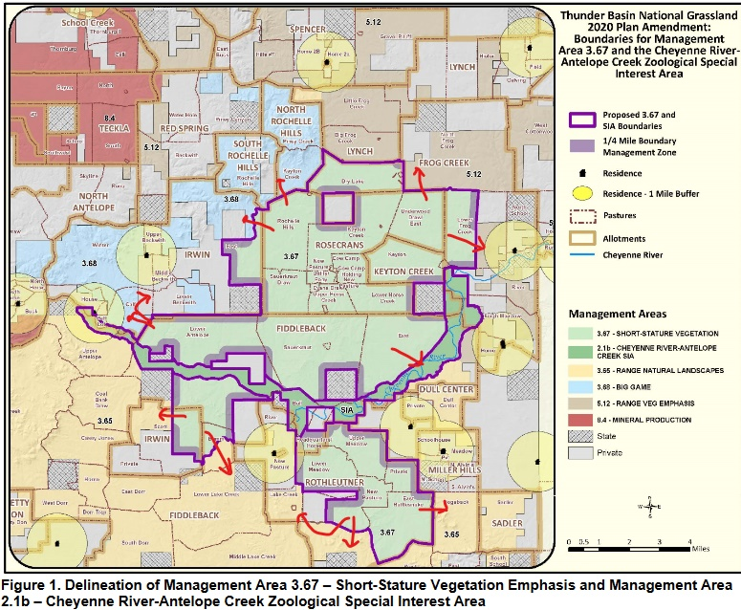

* *Does this mean fumigants will be used throughout the year? Or what other methods is the Forest Service going to utilize to allow control at all times?*

*The Forest Service gives no solution to the question: after 3 years of treatments and bait shyness is occurring then what will be done to protect the landowner and their private lands and forage? Doing no treatments should not be an option since the boundary zones are high priority so what is plan B,C etc? If other species of concern exist within the boundary zones then what will be done to protect the private lands from encroachment as well as the species of concern?*

* *Prairie dogs exist throughout the Grassland and there is no objective for management of the rodents outside of 3.67. Again if the prairie dogs are allowed to expand as before without rodenticide treatments-“ because there is no funding or no time or?” then the problem of encroachment and issues of forage availability will grow with the prairie dogs. There are no boundaries per se on the rest of the* *Grassland* ***so what exactly is the Forest Service going to do to******prevent***  *prairie dogs from infesting neighboring lands throughout the Grassland when the federal agency* *is throwing* *what money they have at homes and boundaries around 3.67. There really is no change from existing management-ignore, not treat, or use excuses after 3 years of treatment that does not work. After 3 years of treatment the prairie dogs have infested neighboring lands then the Forest Service says it is the landowner’s problem. What has changed from past failed management?*

Forest Service Comment: “Nonlethal control methods such as translocation and vegetation barriers have been impractical to prevent encroachment on sufficient scales because they are inefficient and costly. If cumulative colony area were to exceed targets under current management direction, many colonies would likely already be encroaching, meaning we would not be meeting the purpose of minimizing encroachment even though we would then be able to use rodenticides within ½ mile of non-Federal lands.”

Suggestions for Improvement:

* Move all boundary zones out immediately to ¾ mile if they are in high impact areas at present time and do not wait 3 years to do so.
* Using past treatment records any areas with a high number of treatment requests should be automatically expanded to ¾ mile boundary treatment zone
* Use fumigants as needed not just once a year to keep the prairie dogs away
* Keep any colonies feeding into boundary zones at **very low density** **or eradicate** the colonies causing the encroachment issues.
* All boundary management treatment areas around 3.67 must be continuous boundaries to prevent “open gate” areas for the pest to travel thru.
* All areas next to private lands EVERYWHERE should have a boundary of ¾ mile or more to help diminish the number of prairie dogs from infesting private lands. The ¼ mile boundary is really a waste of time and money with high prairie dog density as the treated area is repopulated within a month or less.
* Use more than one type of rodenticide within boundaries so you can rotate treatments. Fumigants can work but are very labor intensive and must be continued as needed for effectiveness.
* Manage Grassland wide not just 3.67 and around those boundaries.
* Find more funding to eradicate large areas of prairie dogs to eliminate continued issues

1. **Objection: Density Control:**

*My submitted comments on draft EIS pg 25; Large p/d colonies with high density populations will deplete the soil, water retention and forage. Page 3, If a colony is treated for density control, why only 50% of it will be treated? This is a waste of time and money because if the pd population is so dense as to require treatment then placing rodenticide on only half of a colony will only allow the untreated area of p/d to expand and migrate readily into the treated area which solves nothing. If the p/d are so dense they are* *migrating onto neighboring lands or eating too much forage then a 50% treatment will not stop the damage caused or lessen the migration from such a colony.*

*Draft ROD: page 17; Alt. 5 Density control: “If scientific information is developed and indicates that density control achieves vegetation or dispersal objectives and maintains habitat for associated species, then density control may be authorized in management area 3.67 when acreages are below 7,500. “*

* *how long is it going to take to get information to see what density control does-a time frame must be given for a baseline: 2 years, 5 years, 10 years?*
* *The Forest Service states there are no triggers for density control but they will wait until asked. There should be a maximum number of burrows per acre that the Forest Service is striving towards for management. If there is no minimum or maximum then how do you know density control is working, how do you know how to do treatments, how do you know if an area needs treated again to achieve the minimum baseline. There must be a minimum to strive towards a specific desired condition and a maximum to control below. Otherwise what are you hoping to achieve-what goals?*
* *How will you know if density control works if it is only done on 50% of the colony? The area treated will be repopulated by the untreated expansion within a very short time frame so the time, effort and money used to treat will have been wasted. If an entire colony is treated for density control, then a study of the results will be more definitive.*

*When livestock grazing is proposed using an adaptive management strategy, the proposed action needs to set the outer limits of what is allowed in terms of timing, intensity, frequency, and duration of livestock grazing. This sets standards that can be checked with implementation monitoring to determine if actions prescribed were followed and if changes are needed in management*.

Appendix C: Response to Comments section of plan amendment: ``…density control would not occur on sites occupied by species associated with prairie dog colonies. Occupation by associated species would be based on the previous survey effort; …Throughout implementation of the preferred alternative, no more than 50 percent of the area of any colony would be treated during an application of density control, and density control would occur no more frequently than every other year. Pre- and post-treatment monitoring of vegetation and prairie dog activity would be a critical element in every application of density control.”

* *What species would prevent the treatment of a prairie dog colony for density control? If these species are present then what form of treatment will be done if density treatment is asked for but none is performed-what is the Forest Service’s method of decreasing the population of prairie dogs in a colony if other species are present?*
* *What are you looking for in the monitoring of vegetation after density treatment-more or less forage? Do you expect more forage when only 50% of colony is* *treated? If there is no change is that positive or negative? What does ``preventing undesirable vegetation state changes” (page 76 Draft ROD)mean in relation to density control?*
* *What are examples of undesireable vegetation state changes in an overpopulated prairie dog colony?*
* *What other control tools may be used for density control as stated page 75 in the Draft ROD?*
* *What would determine if density control is performed ,when asked by lessee or neighboring landowner, on colonies outside of 3.67-what requirements must be met? If the grass/forb ratios are shifting towards a community dominated by forbs and increased bare ground isn’t that too late to change the vegetation back to original vegetation? Shouldn’t density control be done before the shift starts and when the bare ground is occurring?*
* *If a density limit was set at 10 burrows per acre then forage would be acceptable and there would be a maximum limit for population density of prairie dogs using burrow density. This would be more effective than just doing density after vegetation starts to change and when someone requests!*
* *Why can’t you use information from the 4W ranch on burrow density and forage availability to start with your monitoring protocols-the data is there and available for several years which is more than the Forest Service has right now and then they would not have to wait for years scientific reviews collecting what has already been done?*

**5). Objection: Land Trades**

As covered in RCOWS petition(submitted Sept. 4, 2018) and also in my own comments on the draft FEIS(submitted 11/28/2019); land trades within the TBNG could make management of areas of the Grassland much less contentious. But the Forest Service is putting up their own roadblocks to completion.

Page 48, RCOWS petition:

“One barrier to land exchanges in the Thunder Basin National Grassland is that Forest Service officials for the Thunder Basin National Grassland have stated they cannot exchange lands to private parties that were previously acquired from other private parties. There is no statutory or regulatory prohibition on exchanging land that was previously acquired from a private owner. Further, the limit on exchanges is not articulated in the Resource Management Plan or any other substantive documents for the Thunder Basin National Grassland. Therefore, the Douglas Ranger District managing the Thunder Basin National Grassland should change its internal policy to allow for exchanges of lands that were previously acquired from private owners.

Perhaps the greatest barrier to land exchanges in the Thunder Basin National Grassland is the length of time it has taken to successfully complete a land exchange.”

Page 41: Standards and Guidelines for acquiring lands: “Lands that reduce Forest Service administrative costs and improvement of management efficiency. This includes: reducing miles of landline boundaries and number of corners, special uses, title claims, rights-of-way grants and easements, numbers of allotments and intermingled ownership livestock pastures, and other factors that decrease administrative costs and improve management efficiency.

Lands that would reduce conflicts between Forest Service, tribal lands, and private landownership objectives, especially when conflicts are adversely impacting National Forest System management. This includes reducing conflicts involving the management of prairie dog colonies along National Forest System lands.

Lands within or around existing blocks of public ownership of at least 2,000 acres.

Lands that would correct maladjustments of land use as described in the Bankhead-Jones Farm Tenant Act. Guideline”

Page 10 LRMP Rod and FEIS: “Furthermore, land exchanges in intermingled landownership areas will be pursued where prairie dog habitat expansion is desired and where we want to reduce conflicts with private landowners.”

*Irwin Livestock Company has approached the Forest Service several times about a land trade but the Douglas Ranger District is not interested. The Ranch has the Section 16 in T 41N, R68W which is a section surrounded by land managed by the Forest Service within the Rosecrans Community Pasture and within primary sage grouse core area habitat.*

*The issue is the Ranch has been feeding on private lands in a specific area for 60-70 years. These parcels are important because during deep snow the Ranch cannot reach their livestock except in these areas. These parcels were sold by another individual and now will be going to Forest Service management. But the Ranch wants these parcels back so they can feed their livestock during deep snow and to solve some other issues. The Douglas Ranger District does not want to re-trade lands they are acquiring in the Inyan Kara land trade proposal. If the Irwin Livestock Company cannot trade the Section 16 for other desired land managed by the Forest Service then the Section 16 parcel will be sold for home lots within sage grouse primary core habitat.*

*Having home lots in the middle of sage grouse primary habitat would probably not be beneficial to the grouse. Nor would it be beneficial for the Forest Service because they would have many more miles worth of boundary control as well as constant human traffic within the Rosecrans Community pasture complex.*

Suggestions for Improvement:

* If a land trade proposal would lessen the administrative costs and reduce miles of landline boundaries and intermingled ownership livestock pastures then a trade should go thru. The Douglas Forest Service policy of not re-trading some land parcels because they were acquired in another trade is limiting the ability of the Forest Service to utilize land trades to the benefit of both parties.
* The rules and regulations for land trades need to be streamlined and condensed so the process of trading land does not continue for several years on one trade.
* The Forest Service requirements should be efficient, direct and able to be met within 3 years. Using a short time frame for individual land trades would allow for more trades to be accomplished.
* There should be the possibility of doing more than one land trade at a time if the requirements for trades are compiled into a more direct and efficient method.

6). **Objection: Special Interest Area Management:**

*The extension of the riparian habitat to include Antelope Creek and the Cheyenne River is new to the plan:*

### 23.11e – Riparian Areas

(ii) Plans must establish width(s) for riparian management zones around all lakes, perennial and intermittent streams, and open water wetlands, within which the plan components required by paragraph (a)(3)(i) of this section will apply, giving special attention to land and vegetation for approximately 100 feet from the edges of all perennial streams and lakes.

Forest Service Response Comments: The riparian corridor is expected to act as a natural hydrologic and vegetative deterrent to prairie dog colonization; however, it is not expected that the riparian corridor will prevent prairie dog movement across the river or repel all colonization. We intend that shifting the boundaries and management emphasis in the special interest area would allow the riparian corridor to aid in management of prairie dog colonies in management area 3.67. In the preferred alternative, plan components that apply to prairie dog management in management areas other than management area 3.67 also apply to the special interest area. For example, if prairie dogs were to colonize the special interest area, the Forest Service could poison them if within 1 mile of a residence, endangering infrastructure, encroaching, or upon any other request as long as the presence of breeding, nesting, and denning habitat for associated species has been considered.

Appendix A: Manage livestock grazing to promote development of mature cottonwood willow riparian areas and other desired habitat conditions

*My objection: This response to a comment is not clear to me. Does this mean the Forest Service will use rodenticide to treat prairie dogs encroaching upon and within a riparian area? Just how is the Forest Service going to “manage” the riparian special emphasis area-the agency is not specific and the general term “manage” leaves everything wide open.*

*The allotments cannot be diminished in size so fencing out the Cheyenne and Antelope Creek riparian areas is not a workable alternative. If the Forest Service takes the forage in Lower Antelope pasture, ( for example), via expanding the colonization of prairie dogs; then the riparian corridor will be the only area in the pasture with forage for* livestock. If the prairie *dogs were controlled at a density of 10 burrows per acre or less there should be* *enough forage for* *the livestock as well. Therefore-at what density will the Forest Service “ manage” the prairie dogs and how will the Forest Service keep the rodents out of the riparian area. Vegetation buffers have not worked in the past in the TBNG due to lack of moisture so what methods is the Forest Service going to utilize to provide forage to livestock in the pasture, keep prairie dogs from taking all the forage outside of the riparian area, and keep the riparian area improving?*

**6). Objection: Destruction of Soils and changing vegetation:**

*As covered in RCOWS petition(submitted Sept. 4, 2018) and also in my own comments on the draft FEIS(submitted 11/28/2019); The Forest Service neglects to address the fact that a prairie dog colony that is not regulated for low density and a continual presence of the rodent in an area will increase soil erosion and change the forage base to a less desirable forage base from a productive mixed grass prairie to short grass prairie baseline. Your alternative does not sufficiently address this major issue!*

Pg 51 of LRMP 2002 FEIS and ROD

The Revised Plan is our strategic plan for ensuring the long-term health of the land. We will use adaptive management as we work to implement it. We will carefully monitor our activities, the condition of the land, the goods and services produced, and the effectiveness of the resource protection measures included in the Revised Plan to ensure a healthy grassland for the next generation.

Chapter 1-5 Livestock Grazing Objectives:

1. Annually, provide forage for livestock on suitable rangelands.

*The following areas of the planning Handbook need revisited because the Forest Service did not sufficiently address the loss of ground cover, ground litter, loss of top soil to erosion, vegetation changes, lower quality of forage in a prairie dog colony and more. Looking at the pictures which show the Forest Service’s definition of short grass vegetation would you state the land is healthy, unimpaired, productive and sustainable? The Forest Service needs to change their management of short grass to leave forage, ground litter, stop and prevent erosion and to produce ground cover organic gain to the soil. What are the parameters for short grass vegetation? Why allow the formation of vegetation that has a very low nutritional value as compared to other sustainable livestock forage?*

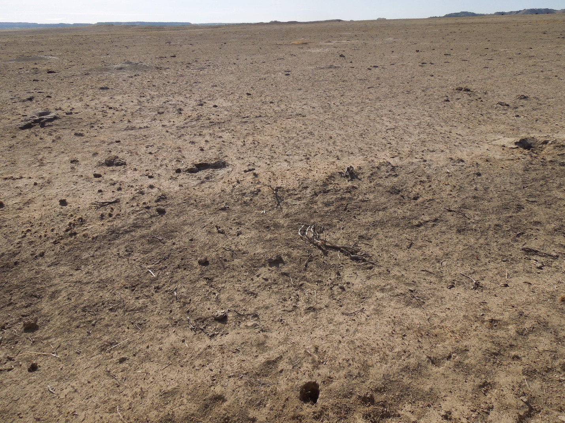

*Ungrazed pasture-Short grass vegetation management by the Forest Service severely impairs the land and pastures do not have forage for wildlife, livestock or for ground cover. Different pasture but same issue with Forest Service Short grass vegetation management on the next picture as well—again ungrazed. Where is the forage for livestock and wildlife?*

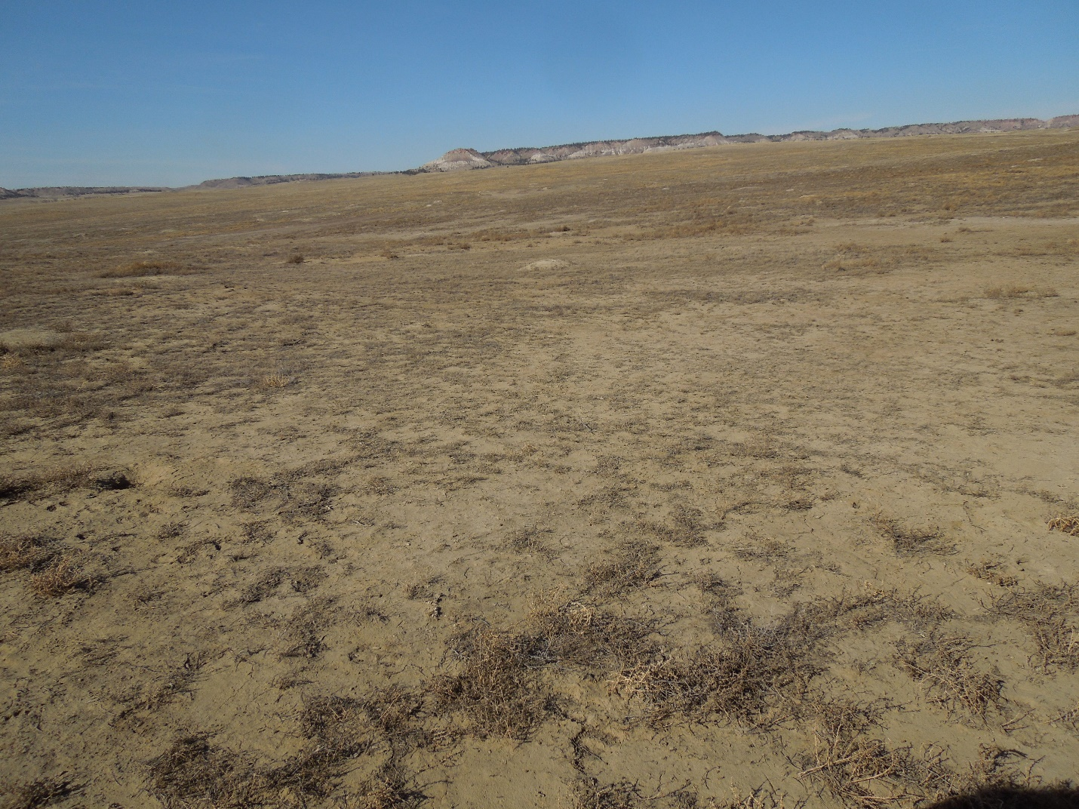

*This desolation extended as far as the eye can see-many miles in all directions when prairie dogs were expanding.*

*There must be ground cover left to prevent top soil from blowing away. The soil was even covering up cacti due to erosion. Land and soil, and vegetation were impaired negatively in wide expanses for many miles.* ***The land is not suitable*** *for heavy concentrations of prairie dogs because the climate is arid and the soils are highly erodible. There is no continued soil productivity shown in these photos. The soil and vegetation have not been protected and enhanced in any way. This should not be the “desired condition” for the Grassland directive for short-grass prairie ecosystem. When rereading the Forest Service’s own rules and regulations it is* *noticeable the federal agency still has a lot of work to do before stating it has met the directives in the 2012 Planning Handbook.*

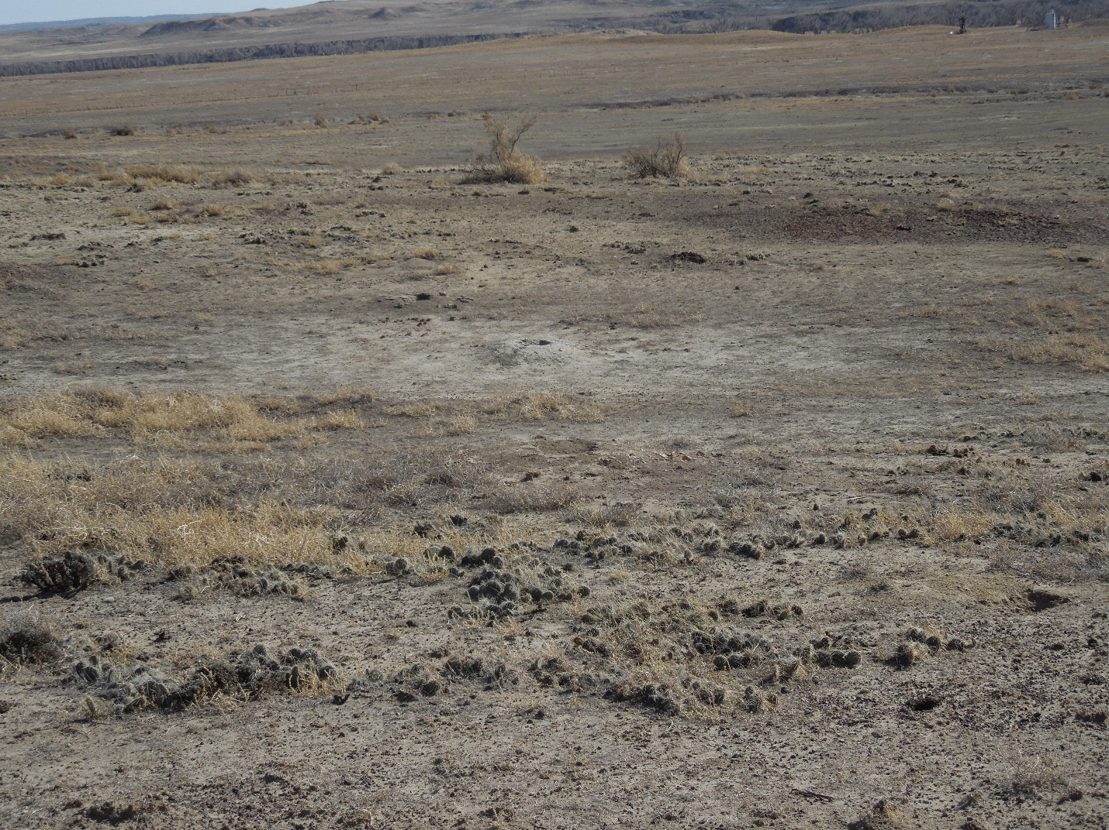

*Third picture showing the Forest Service’s interpretation of short-grass prairie vegetation.*

### 23.12b – Soils and Soil Productivity

The rule requirements for soils and soil productivity are listed in 36 CFR 219.8(a)(2)(ii). The development of plan components for soils and soil productivity, including standards or guidelines, should be based on the need to change the plan identified from the assessment   
(FSH 1909.12, ch. 10, sec. 12.22) or information brought forward during the public and governmental participation process.

2. When designing plan components for soils and soil productivity to sustain the productive capability of the land, its ecological resources, and watershed functions, the Interdisciplinary Team should consider whether it would be appropriate for plan components to give direction regarding :

a. Restoring degraded areas.

b. Maintaining the ecological integrity and functions of soils by managing vegetation communities and the type, degree, and amount of disturbance to soils. (See FSM 2550.5 and FSM 2551.5 for definition of soil function).

c. Maintaining biological properties of soils, such as an appropriate level of organic matter to sustain biological cycling.

d. Maintaining organic matter inputs and avoiding losses, to help maintain or increase net soil carbon storage.

g. Limiting potential impacts on soil physical properties, for example, compaction, rutting, puddling, displacement of the soil surface, and erosion.

”Based on published scientific studies and other best available scientific information, we did not identify black-tailed prairie dogs as significant agents of soil erosion, decreased soil health, or impaired productivity. Because of these findings, soil health was not identified as a driving issue in the plan amendment, and we presented a summary rather than a detailed analysis of effects to soil resources in the final environmental impact statement.” *The pictures show reality as it exists upon the TBNG due to Forest Service management for short grass prairie.*

As described in the Framing the Analysis section at the beginning of chapter 3 in the final environmental impact statements, short-stature vegetation is vegetation that typically reaches heights of less than 6 inches (15 centimeters), either due to species composition or due to natural or managed disturbance of taller vegetation. Forest Service personnel expect some short-stature vegetation would be achieved in management area 3.67 or 3.63 by managing for plant species and communities that naturally are short in stature, such as those included in the proposed desired condition statement: grasses such as blue grama, buffalograss, western wheatgrass, sand dropseed, sixweeks fescue, and marsh muhly; sedges; forbs such as scarlet globemallow and woolly plantain; and prostrate shrub species such as birdfoot sagebrush and plains pricklypear.

*This forage is not very nutritious for livestock or wild game. Why encourage a diminished forage baseline for a Grasslands and the change of a mixed-grass prairie ecosystem to a short grass prairie ecosystem.*

Page 7 LRMP ROD and FEIS 2002 : **Ensuring the long-term health of the grassland:** This criterion encompasses all of the revision topics, particularly grassland and forest health and plant and animal damage control. It includes protection of soil, air, and water resources. It also includes maintaining the diversity and productivity of the grassland vegetation, including the forested component. It includes maintaining the sustainability of ecosystem characteristics and the quality of watershed functions and conditions.

**Implementing a balanced variety of natural resource programs featuring a sustainable output of multiple uses: …**I choose to focus on the concept of “balance” among the various uses. By “sustainable,” I mean providing outputs of renewable resources and high quality experiences, in perpetuity, without impairing the productivity of the land.

Livestock and prairie dogs utilize forage in most areas annually, but some areas receive little to no use. Forage is available for both wildlife and livestock, and livestock and prairie dogs often occupy the same areas. Appendix A

*The pictures show this is just not true under Forest Service management throughout the Grasslands.*

### 22.11 – Desired Conditions

*Desired conditions*. A desired condition is a description of specific social, economic, and/or ecological characteristics of the plan area, or a portion of the plan area, toward which management of the land and resources should be directed. Desired conditions must be described in terms that are specific enough to allow progress toward their achievement to be determined, but do not include completion dates. (36 CFR 219.7(e)(1)(i)).

A plan’s set of desired conditions must be internally consistent so they are feasible and attainable, and they must be written clearly so that they can be understood by the public as well as the Agency. **The set of desired conditions must reflect the capability of the plan area and the fiscal capability of the Agency.**

When designing desired conditions, the Responsible Official should take into account the condition of the land adjacent to the plan area and the larger surrounding landscape. Consider the desires by adjacent agencies, landowners, interested and affected individuals, or communities for the plan area.

2. Desired conditions have functional characteristics; they:

a. Must be written with enough detail so the condition of on-the-ground achievement is clear and progress toward their achievement can be measured or evaluated;

*There are no actual desired conditions stated in the amendment* ***to prevent soil erosion and forage loss in a prairie dog colony.***

### 22.15 – Suitability of Lands

(v) *Suitability of lands*. Specific lands within a plan area will be identified as suitable for various multiple uses or activities based on the desired conditions applicable to those lands. The plan will also identify lands within the plan area as not suitable for uses that are not compatible with desired conditions for those lands. The suitability of lands need not be identified for every use or activity. Suitability identifications may be made after consideration of historic uses and of issues that have arisen in the planning process. Every plan must identify those lands that are not suitable for timber production   
(§ 219.11). (36 CFR 219.7(e)(1)(v)).

A plan may not identify a use or activity as being suitable in the plan area or relevant part of the plan area, and should identify the area as not suitable for that use or activity, if any of the following conditions apply:

a. A law, regulation, Executive Order, or Forest Service directive prohibits the use;

b**. The use would result in substantial and permanent impairment of the productivity of the land or renewable resources;**

*Again reference the pictures that show exactly how the Forest Service is managing the land. The TBNG is not suitable for bare ground and little ground cover and that is why the lands were originally placed in the Land Utilization Projects. The homesteaders found out that with lack of moisture the top soil blew away and crops did not survive. The land was in very poor condition. I would call the land substantially impaired and not productive with high concentrations of prairie dogs present. What is needed is a much lower density of prairie dogs (less than 10 burrows per acre) concentrated over a larger area if the Forest Service insists upon “raising the agricultural pests”.*

### 23.12 – Plan Components for Air, Soil, and Water

The rule requirements for air, soil and water from 36 CFR 219.8(a)(2) are:

The plan must include plan components, including standards or guidelines, to maintaiWn or restore:

(ii) Soils and soil productivity, including guidance to reduce soil erosion and sedimentation.

“persist over the long term with sufficient distribution to be resilient and adaptable to stressors and likely future environments.” There is no requirement to provide an exact number of each species to show viability. Instead, the Planning Rule states that “sufficient distribution” of a species should be considered in the context of the species’ natural history and historical distribution and on the potential distribution of the habitat within the plan area. C-70”

### 23.23d – Rangelands, Forage, and Grazing

The Planning Rule (§ 219.10(a)) requires that a plan include plan components including standards or guidelines, for integrated resource management to provide for ecosystem services and multiple use [including range].

When developing plan components, the Responsible Official shall take into account **range that contributes to local, regional, and national economies in a sustainable manner** (§ 219.8(b)(3)) **and consider forage, grazing, and rangelands** ((§ 219.10 (a)(1).

1. When developing components, the Interdisciplinary Team should:

d**. Consider current range management (FSM 2200) of existing allotments in the development of plan components that apply to the allotments within the plan area.**

**e. Recognize potential adverse interactions between domestic livestock and native species and provide appropriate plan components to avoid or mitigate these risks.**

2. The plan must include plan components, including standards or guidelines, to provide for integrated resource management to provide for ecosystem services and multiple use integrated with other plan components as described in 23.21a. To meet this requirement the plan may include:

a. Desired conditions for rangelands, transitory range, and other grazing lands that describe the type, level, and general location of grazing anticipated in the plan area **while considering the sustainability** of this contribution to the social, cultural, and economic conditions affecting communities in the area(s) of influence and the broader landscape.

b. Objectives that identify **expected progress for indicators of rangeland health or other intended achievements such as acres or number of range improvements** and accommodations for native species.

e. **Other plan content to describe the approach to range management to provide for rangeland health, restoration, and grazing opportunities for domestic livestock.**

2. The plan must include plan components including standards or guidelines to provide for scenic character integrated with other plan components as described in 23.21a. To meet this requirement the plan:

a. Must include a description of desired scenic character based on the scenery management system, unless an exception is established pursuant to FSM 1921.03.

(2) Desired conditions may also describe scenic stability, sustainability, and other measures used in scenery management system. Desired conditions may include maps, graphics, photographs, or visual simulations that give a visual representation of desired scenic character and associated scenic integrity objectives.

b. Should contain standards or guidelines as needed to avoid or mitigate undesirable effects incompatible with desired scenery conditions. Pg 104-105

*What is the desired scenic character of the proposed 3.67 area? Is it better than the referenced pictures of total destruction of soil impairment and forage loss? What is the desired soil and forage condition going to look like in 3.67? There seems to be no minimal loss of forage or soil the Forest Service is assuming as the baseline minimum allowed. What is/are the solution(s) to prevent destruction of the allotments THROUGHOUT the ENTIRE Grassland caused by an overpopulation of the black-tailed prairie dog other than a treatment that might occur if it is prioritized, every so many years?*

Northern Great Plains Response to Comment: The Forest Service is required to **“Conserve soil and water resources and not allow significant or permanent impairment of the productivity of the land” (36 CFR 219.27(a) (1)).**

*This sounds good but this guidance has been completely ignored by the local ranger district over the past MANY decades as referenced by the photos and past management of the Grasslands. The lands as managed are NOT sustainable nor productive.*

**7) Objection: Economics of grasslands and economics of FS funding:**

### 21.12 – Considerations when Preparing New or Revised Plans

1. The Responsible Official shall base the plan components on likely budgets and other assumptions that are realistic as required by 36 CFR 219.1(g):

(g) The responsible official shall ensure that the planning process, plan components, and other plan content are within Forest Service authority, the inherent capability of the plan area, and the fiscal capability of the unit.

4. The Responsible Official shall ensure an integrated set of plan components that:

a. Together provide for **sustainability**, ecological integrity, diversity of plant and animal communities, ecosystem services, and multiple use;

b. Contribute to **social and economic sustainability**;

d. **Are within Forest Service authority, the inherent capability of the plan area, and the fiscal capability of the unit;**

LRMP Rod and FEIS 2002: **Contributing to the economic diversity of neighboring communities by implementing a variety of natural resource programs that provide a sustainable output of multiple uses: To have sustainable communities, we must ensure a sustainable flow of resources and services. Page 10**

“The Analysis of Socioeconomic Resources section of the final environmental impact statement provides a quantitative comparison of the costs of each alternative. The plan amendment would not change the range management direction on the grassland, and the costs of implementing the range management program on the grassland are outside the scope of the analysis for this plan amendment. C-68”

FEIS Pg 111: “Although managed differently under each alternative, total annual expenditures associated with prairie dog control are expected to be limited by available funding each fiscal year, and thus, be nearly the same across the alternatives.”

*None of the alternatives presented for assessment are affordable with the current Forest Service budget. The amendments should be presented within the fiscal capability of the unit. As in the past there will be several requests for treatment and the Forest Service will not treat many of the areas due to lack of funding. If the Forest Service had put forth plans a directed by the 2012 Planning Handbook that are capable of being managed with the current budgets there would be much fewer issues of disagreement. The entire Grassland area needs pro-active management to prevent expansion of unwanted prairie dog pests but the Forest Service is mainly concerned with a specific area while allowing infestation from an agricultural pest to continue without substantive treatment due to lack of funding! The Forest Service needs to follow their own rules and regulations as put forth which means every plan must be fiscally capable and responsible within the planning unit. If this means decreasing areas of management by eradication then so be it. Ignoring areas and treating areas of concern every so many years is a disaster in the making and it will not be long before landowners are requesting treatments be done!*

### 23.21 –Contributions of the Plan Area to Social and Economic Sustainability

(b) *Social and economic sustainability*. The plan must include plan components, including standards or guidelines, to guide the plan area’s contribution to social and economic sustainability, taking into account:

(1) Social, cultural, and economic conditions relevant to the area influenced by the plan;

The plan components should be designed to guide sustainable contributions to social, cultural, and economic conditions while recognizing the reasonably foreseeable risks and uncertainties affecting the plan area.

**The desired conditions of the plan should describe the desired social, economic, and cultural conditions in the plan area and the major contributions the plan area makes to social, cultural, and economic conditions outside of the plan area. --** What are the desired economic, social and cultural conditions the Forest Service is looking for and what major contributions is the plan area making to social, cultural and economic conditions outside of the plan area?

§ 219.10 [Multiple use](https://www.law.cornell.edu/definitions/index.php?width=840&height=800&iframe=true&def_id=6b012557dba9f932b0a7083b9aa9fa67&term_occur=999&term_src=Title:36:Chapter:II:Part:219:Subpart:A:219.10).

Integrated resource management for multiple use; … the [responsible official](https://www.law.cornell.edu/definitions/index.php?width=840&height=800&iframe=true&def_id=749c060c20afd4c4df37073f4bf928c6&term_occur=999&term_src=Title:36:Chapter:II:Part:219:Subpart:A:219.10) shall consider:

(7) Reasonably foreseeable [risks](https://www.law.cornell.edu/definitions/index.php?width=840&height=800&iframe=true&def_id=85a77d0abed35b119e9bd17f4745422b&term_occur=999&term_src=Title:36:Chapter:II:Part:219:Subpart:A:219.10) to ecological, social, and [economic sustainability](https://www.law.cornell.edu/definitions/index.php?width=840&height=800&iframe=true&def_id=c5825e81d5922e9e235c4947a5439b76&term_occur=999&term_src=Title:36:Chapter:II:Part:219:Subpart:A:219.10).

The Interdisciplinary Team should consider the following kinds of questions in developing plan components related to social and economic sustainability:

**1. What is needed or desired for contributions from the plan area to contribute to social, cultural, and economic conditions?**

**2. Will the plan area (under the management of the plan) be able to sustain these contributions?**

**3. How will the plan components influence the contributions of the plan area to social and economic sustainability?**

Asking just what contributions is this plan going to have to the plan area and local and state economies:

* Will the plan protect sage grouse habitat from all future encroachment by prairie dogs and protect the current leks, nesting and feeding areas: The answer is NO as long as prairie dogs are allowed to inhabit and infest current and future sage grouse habitat. There are no buffer zones, not treatment options planned to remove encroaching prairie dogs and the habitat areas of both overlap
* Will the plan help the Grasslands be more productive and sustainable: The answer is NO as long as prairie dogs are allowed to populate in large densities which will remove vegetation and allow the expansion of less desireable forage for all wildlife and livestock.
* Will the plan prevent erosion of topsoil: If the Forest Service continues to allow large densities of prairie dogs and allows the rodent to denude and lay barren large expanses of ground, then no there will be more erosion not less.
* Will the plan protect the mountain plover: Yet to be determined, but the use of delta dust within areas where plovers exist leads to the summary judgement the plover will be harmed as much as it is supposedly helped. Plover exist over the Grassland and have been here for decades before the Forest Service elected to “protect” them so it will be difficult to say whether all the prairie dog colonization will actually increase the population of plover in the Grassland.
* Will the plan help the State of Wyoming: Actually NO, because more requests for rodenticide treatments will cost the State money. Also ignoring the Governor’s EO on sage grouse will cause future fragmentation and destruction of grouse core habitat as there is no treatment planned to remove existing prairie dogs and prevent the expansion of the rodent within protected grouse core area.
* Will the Grasslands be more scenic: NO, the general public will see large expanses of barren ground with maybe cockleburs present as the prairie dog does not eat the noxious weed. There will also be an expansion of less desireable grasses and noxious weeds that follow prairie dog colonization.
* Does this plan help the big game habitat: Each time a plan is written the big game habitat is decreased. The big game used to be found in most areas within the Grasslands but due to the past expansion of prairie dogs and lack of forage the areas where big game inhabit has decreased as well.
* Does this plan help the respective counties: NO, this plan will increase the costs to the citizens of each county due to cost/ share with the Weed and Pest. The increased rodenticide treatments done by the landowners have to be paid out of county coffers. As for shooters the limited number of shooters would have minimal effect on county income and would not offset the costs associated with prairie dog treatment.
* Does this plan help provide sustainable economic delivery of resources for the community and counties: NO, the plan will have high costs and “growing” prairie dogs will not deliver any sustainable economic resources for either communities or counties.
* Does this plan help the lessees and neighboring landowners : NO, the Good-Neighbor Policy has gone out the window; the encroaching prairie dogs, loss of forage, extra hay needed, loss of AUMs that could occur, limits on grazing capacity and destruction of land that is needed for grass production will cause significant economic hardship to landowners dependent upon federal grazing leases for their ranch operations. The Forest Service has stated that yes there could/will be loss of AUM on the ground if not on paper, more grazing on private lands in needed, cuts in herds, hay and supplemental feed purchased but the federal agency has NOT offered any solutions, grazing fee decreases, payments for supplemental feeds required, or anything to offset the costs that the landowners and lessees will have to bear.

Other than more prairie dogs and maybe more noticeable short grass prairie species I do not seen any other benefits from any of the alternatives proposed. The management of the Grasslands is supposed to be a positive reinforcement activity but instead has a severe negative impact on the lessees, landowners, big game, and Grasslands as a whole. Who benefits other than a rodent which is an agricultural pest?

**8) Objection: RCOWS Alternative:**

*Rochelle Community Organization Working for Sustainability submitted an alternative proposal for prairie dog management upon the Thunder Basin National Grassland. The Forest Service stated that the proposal would not provide a viable population of short grass prairie species yet they have no documented basis for this denial. The proposed alternative should be tried and monitored for several years before such a direct statement is put forth.*

*The mountain plover and other short grass species exist throughout the Grassland not just on prairie dog towns. The proposed alternative submitted by RCOWS would be affordable on the Forest Service’s budget and would allow the plover and other associated species to continue throughout the Grassland. It would protect the grouse habitat, big game habitat and the short grass prairie species. Their proposal would also protect the neighboring landowners and their economic base as well as the sustainability and productivity of the land.*

Page 7 of the Draft ROD states: “In addition, short-stature vegetation and prairie dog colonies will continue to persist in many areas of the grassland outside of management area 3.67….” so if they will continue to persist under the chosen alternative 5 they should also continue to persist under the RCOWS alternative.

**9). Laws**

*I submit the following excerpts for study. The Forest Service is not following their own Land and Resource Management Plan 2002, their own Handbook and the rules and regulation they profess they must follow. The Forest Service is not following the laws for Grassland management, the MUSYA, Bankhead-Jones Act and other laws regulating the originally acquired lands in the LUP-1-Wyoming.*

Page 7 LRMP ROD and FEIS 2002 : **Ensuring the long-term health of the grassland:** This criterion encompasses all of the revision topics, particularly grassland and forest health and plant and animal damage control. It includes protection of soil, air, and water resources. It also includes maintaining the diversity and productivity of the grassland vegetation, including the forested component. It includes maintaining the sustainability of ecosystem characteristics and the quality of watershed functions and conditions.

**Implementing a balanced variety of natural resource programs featuring a sustainable output of multiple uses: …**I choose to focus on the concept of “balance” among the various uses. By “sustainable,” I mean providing outputs of renewable resources and high -quality experiences, in perpetuity, without impairing the productivity of the land.

## **22.1 – Plan Components (land management plan document 2012)**

(e) *Plan components*. Plan components guide future project and activity decision making. The plan must indicate whether specific plan components apply to the entire plan area, to specific management areas or geographic areas, or to other areas as identified in the plan. (36 CFR 219.7(e)).

**h. May not interfere with statutory or valid existing rights**

### 22.12 – Land Management Plan Objectives

*Objectives*. An objective is a concise, measurable, and time-specific statement of a desired rate of progress toward a desired condition or conditions. Objectives should be based on reasonably foreseeable budgets. **(36 CFR 219.9(e)(1)(ii)).**

3. **Must be clearly stated in measurable terms with specific and reasonable timeframes;** (Timeframe can be identified by either an end date (“by 2020”) or by a period of time from an identified start point (within 5 years of plan approval.”);

4. Should be expressed in terms of outcomes, not actions; and

5. **Must be attainable within the fiscal capability of the unit, determined through a trend analysis of the recent past budget obligations for the unit (**3 to 5 years); (Other plan content (such as potential management approaches, sec. 22.4 of this Handbook) may identify how the Responsible Official would respond to enhanced resources or other efficiencies that would facilitate attaining desired conditions (36 CFR 219.1(g)).

# 23 –RESOURCE REQUIREMENTS FOR INTEGRATED PLAN COMPONENTS

A plan provides vision, strategy, and constraints to guide integrated resource management of the plan area. This section provides a framework for developing the plan components that together provide for ecological sustainability and contribute to social and economic sustainability in the plan area as well as the broader landscape. Plan components must be within the inherent capability of the plan area, Forest Service authority, and the fiscal capability of the unit (36 CFR 219.1(g)).

§ 219.8 Sustainability.

a) Ecological sustainability. (1) Ecosystem Integrity. The plan must include plan components, including standards or guidelines, to maintain or restore the ecological integrity of terrestrial and aquatic ecosystems and watersheds in the plan area, including plan components to maintain or restore structure, function, composition, and connectivity, taking into account: . . . .

* * *

The plan must provide for social, economic, and ecological sustainability within Forest Service authority and consistent with the inherent capability of the plan area, as follows: . . . .

(b) Social and economic sustainability. The plan must include plan components, including standards or guidelines, to guide the plan area’s contribution to social and economic sustainability, . . .

### 23.11 – Plan Components for Ecosystem Integrity and Diversity

2. **The Responsible Official should direct the Interdisciplinary Team to design plan components that are within Forest Service authority, the inherent capability of the plan area, and the fiscal capability of the unit (36 CFR 219.1(g)):**

**a. Provide ecological conditions to restore, establish, and maintain functioning ecosystems on National Forest System lands that can sustainably support multiple uses and provide a broad range of goods and services.**

**b. Restore, establish, and maintain functioning ecosystems that will have greater adaptive capacity to withstand stressors and recover from disturbances, especially changing and uncertain environmental conditions and extreme weather events.**

e. Provide for ecological integrity, ecosystem services, and multiple uses within the plan area in an integrated manner (36 CFR 219.10).

### 

### 23.12 – Plan Components for Air, Soil, and Water

The rule requirements for air, soil and water from 36 CFR 219.8(a)(2) are:

The plan must include plan components, including standards or guidelines, to maintain or restore:

(ii) Soils and soil productivity, including guidance to reduce soil erosion and sedimentation.

“persist over the long term with sufficient distribution to be resilient and adaptable to stressors and likely future environments.” There is no requirement to provide an exact number of each species to show viability. Instead, the Planning Rule states that “sufficient distribution” of a species should be considered in the context of the species’ natural history and historical distribution and on the potential distribution of the habitat within the plan area. C-70”

Viable population. A population of a species that continues to persist over the long term with sufficient distribution to be resilient and adaptable to stressors and likely future environments.   
(36 CFR 219.19)

The following principles must be kept in mind when developing plan components to provide for ecological conditions necessary to maintain a viable population of species of conservation concern in the plan area:

a. The rule only requires ecological conditions to maintain a viable population.

### 23.22 – Social, Cultural, and Economic Conditions Influenced by the Plan

b. Consider the following when developing plan components for social, cultural, and economic conditions:

(1) Opportunities for the plan area to contribute to **social conditions** including the health, safety, education, social wellbeing, and quality of life of people and communities affected by the plan area. Opportunities can provide for service or civic engagement, and other activities that connect people to the land and to one another.

(3) Opportunities for the plan area to contribute to **economic conditions** such individual employment, small businesses, personal income, Federal receipts shared with local governments, and the provision of economically significant benefits, products, and services, including those with both market and nonmarket value.

(4) **Ways to reduce or eliminate adverse impacts to any environmental justice communities identified during the assessment or public participation process.**

. The plan desired conditions should also contain **a description of the contributions of the plan area to the social, cultural, and economic conditions in the area(s) of influence and beyond in the broader landscape.** This can include contributions such as the following examples:

c. Use of resources or infrastructure such as recreation, grazing, timber, or water and energy transmission corridors or roads that help to sustain businesses and employment opportunities.

**This analysis should include an evaluation of the sustainability of the contributions of the plan area.**

### 23.23b – Fish, Wildlife, and Plants

The Planning Rule (§ 219.10(a)) requires that a plan include plan components including standards or guidelines, for integrated resource management to provide for ecosystem services and multiple use [including wildlife and fish].

When developing plan components, the Responsible Official shall take into account plants, wildlife and fish, and related uses, **that contribute to local, regional, and national economies in a sustainable manner** (§ 219.8(b)(3))

### 23.23d – Rangelands, Forage, and Grazing

When developing plan components, the Responsible Official shall take into account range that **contributes to local, regional, and national economies in a sustainable manner (§ 219.8(b)(3)) and consider forage, grazing, and rangelands** ((§ 219.10 (a)(1).

1. When developing components, the Interdisciplinary Team should:

b. Consider the conditions, trends, and stressors, that affect the ability of the plan area to sustain native ungulates, other species, and domestic livestock that depend on the forage produced in the plan area, consistent with meeting requirements for ecological integrity and species diversity described in section 23.1 of this Handbook.

d. Consider current range management (FSM 2200) of existing allotments in the development of plan components that apply to the allotments within the plan area.

e. Recognize potential adverse interactions between domestic livestock and native species and provide appropriate plan components to avoid or mitigate these risks.

*There are several legitimate concerns about the loss of forage for livestock caused by the infestation of prairie dogs. The Forest Service states these concerns were analyzed in detail in “ Rangeland Vegetation and Livestock Grazing” but there are no solutions or mitigation given. What is the Forest Service doing to compensate the landowners for loss of forage, expense for treating encroaching prairie dogs, hay expense, private pasture leases, etc., all because the prairie dogs are too numerous to control.*

2. The plan must include plan components, including standards or guidelines, to provide for integrated resource management to provide for ecosystem services and multiple use integrated with other plan components as described in 23.21a. To meet this requirement the plan may include:

e. Other plan content to describe the approach to range management to provide for **rangeland health, restoration, and grazing opportunities for domestic livestock.**

2. The plan must include plan components including standards or guidelines to provide for scenic character integrated with other plan components as described in 23.21a. To meet this requirement the plan:

a. Must include a description of desired scenic character based on the scenery management system, unless an exception is established pursuant to FSM 1921.03. Desired scenic character may be different from existing or potential scenic character identified in the assessment. Depending on the biophysical and cultural attributes of the plan area’s landscape, there may be multiple desired scenic character descriptions associated with specific areas.

(1) Desired conditions describing scenic character should include scenic integrity objectives that describe the degree to which desired attributes of the scenic character are to remain. Scenic integrity objectives should be assigned throughout the plan area. (Note that scenery integrity objectives are not the same as plan component “objectives” under the Planning Rule).

(2) Desired conditions may also describe scenic stability, sustainability, and other measures used in scenery management system. Desired conditions may include maps, graphics, photographs, or visual simulations that give a visual representation of desired scenic character and associated scenic integrity objectives.

*What is the desired scenic character of 3.67 and other areas with prairie dog colonies? What are the scenic integrity objectives the Forest Service will follow for the grouse habitat infested with prairie dogs, the riparian area with prairie dogs, the 3.67 area with no baseline for density control? What is the baseline the Forest Service is striving towards for an average scenic sustainability?*

### 23.23m – Land Status, Ownership, Use, Access and Linkage of Open Space with Other Ownerships

The Planning Rule requires that the development of plan components must consider habitat and habitat connectivity (§ 219.10 (a)(1)) and:

**(4) Opportunities to coordinate with neighboring landowners to link open spaces and take into account joint management objectives where feasible and appropriate.**

**(6) Land status and ownership, use and access patterns, relevant to the plan area. (§ 219.10 (a))**

1. When developing plan components, the Interdisciplinary Team should:

b. Recognize and actively consider the nature of land status, ownership, and access within the plan area and surrounding the plan area. In particular, the resource and management influences related to land status, ownership, and use must be considered in the planning process. For example, consider such issues as: the potential impacts of fragmentation to habitats in areas of mixed ownership An additional important concern is the consideration of opportunities to create connectivity of habitat and open space across these ownerships.

c. Consider also the plans of any private landowners that are relevant to the plan area and that are made available to the Responsible Official.

(2) Valid existing rights associated with other ownerships within and adjacent to the plan area;

(4) Changing ownership, uses, or fragmentation either underway or planned near the plan area and how these may affect the plan area’s resources;

(6) Open space commitments of adjacent landowners where connectivity with the plan area connects or could connect open space across boundaries;

(7) Risks to either the plan area or to adjacent ownerships along plan area boundaries; and

c. Suitability of lands for uses and standards or guidelines to restrict projects or activities in consideration of land ownership, status, and other influences that cross ownership boundaries.

### 23.23n – Other Considerations for Multiple Uses

(7) Reasonably foreseeable risks to ecological, social, and economic sustainability.

## 24.2 – Plan Components for Designated Areas and Areas Recommended for Designation

c. The Responsible Official shall provide for plan components for designated areas that do not interfere with the exercise of valid existing rights.

*Under the allotment system private citizens do have a surface right to graze. The following cases uphold that reasoning:* ***Western Ag Reporter, 12/26/2019****; Atherton v Fowler; Rector v Gibbon, Griffith v Godey, Brooks v Warren, Community National Bank of Odgen v Davidson, Wilson v Everett, Cameron v US, supra, Lonergran v Buford, Swan Land and Cattle Co v Frank, Grayson v Lynch, Salina Stock Co v Salina Creek Irr. Co., Ward v Sherman, Bacon v Walker, Brown v Walling, Curtin v Benson, Omaechevarria v Idaho*

**Federal Land Ownership: Overview and Data: February 21, 2020**

This settlement trend accelerated with federal acquisition of additional territory through the Louisiana Purchase in 1803, the Oregon Compromise with England in 1846, and cession of lands by treaty after the Mexican War in 1848. Page 5 These major land acquisitions gave rise to a distinction in the laws between *public domain lands*, which essentially are those ceded by the original states or obtained from a foreign sovereign (via purchase, treaty, or other means), and *acquired lands*, which are those obtained from a state or individual by exchange, purchase, or gift. About 90% of all federal lands are public domain lands, while the other 10% are acquired lands. Many laws were enacted that related only to public domain lands. Even though the distinction has lost most of its underlying significance today, different laws may still apply depending on the original nature of the lands involved.

Executive Order 7616—WITHDRAWAL OF PUBLIC LANDS FOR THE USE OF THE DEPARTMENT OF AGRICULTURE

May 13, 1937

SECTION 2. Subject to the conditions expressed in the above-mentioned acts and to all valid existing rights, **all vacant, unappropriated, and unreserved public lands** within the above-described area are hereby temporarily withdrawn from settlement, location, sale, or entry, and reserved and set apart for use and development by the Department of Agriculture for soil erosion control and other land utilization activities in connection with the Thunder Basin Project, LA-WY 1: Provided, that nothing herein contained shall restrict prospecting, locating, developing, mining, entering, leasing, or patenting the mineral resources of the lands under the applicable laws.

SECTION 3. This order shall be applicable to all lands within the area described in section 1 hereof upon the cancellation, termination, or release of prior entries, selections, rights, appropriations, or claims, or upon the revocation of prior withdrawals, unless expressly otherwise provided in the order of revocation.

SECTION 4. **The reservation made by section 2 of this order shall remain in force until revoked by the President or by act of Congress.**

The U.S. Supreme Court declared in United States v. New Mexico, 438 U.S. 696, 714 (1978) **(federal lands must be managed for the purposes for which they were originally reserved or acquired and any subsequently designated uses are** **secondary)**.

10). Other Objections:

To help provide suitable habitat for black-footed ferrets and their young during the breeding and whelping seasons, the following activities should not be authorized within prairie dog colonies, or those portions of larger colonies,

Fencing: p. 1-15/F.20 occupied by black-footed ferrets from March 1 through August 31: construction (e.g. pipelines, utilities, fencing); seismic exploration; permitted recreation events involving large groups of people. Guideline

P 1-16 F29 To help reduce disturbances and risks to nesting mountain plover, the following activities should not be authorized in plover nesting areas or within 0.25 miles of plover nests from April 1 through August 15: construction (e.g. pipelines, utilities, fencing);

*Please specify this is NOT fencing for livestock but for utilization of oil/gas/ and mineral? This could pose a hardship for mineral development i.e. mining expansion and for landowners having to repair fences or put up new in an area.*

*The alternatives proposed are not feasible due to the large area of the Grasslands. By “managing” just a small area and basically ignoring the rest the Forest Service is going to set up a repeat scenario of what has happened in the past with over 75,000 acres of prairie dogs. No one can effectively manage several thousand acres of rodents unless a large expanse is managed for eradication. These plans as written will destroy the Grasslands and will fail. Write a plan that is affordable and actually sustainable!*

*Attachments:*

1. *RCOWS petition*
2. *Laws detailing grazing rights by McIntosh*
3. *FDR Executive Order*
4. *LUP formation*