The Izaak Walton League is a nationwide organization of over 40,000 members that are conservation minded individuals promoting sustainable use of our resources and investing in outdoor recreation that all Americans can enjoy. We strongly feel America's public lands are an asset and treasure to be passed onto future generations.

We thank you for your time and consideration.

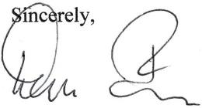

Dean Farr

Public Lands Committee

Crystal Lake, IL

Rick Cerwick

Chairman

Public Lands Committee

Des Moines, IA

Mike Penfold

Montana Member

Retired, BLM State Director in Alaska

CC:

Alaskan Department of Natural Resources

*"Of all the questions which can come before this nation, short of the actual   
preservation of its existence in a great war, there is none which compares in   
importance with the great central task of leaving this land even a better land for   
our descendants that it is for us. "*

*Teddy Roosevelt (1910)*