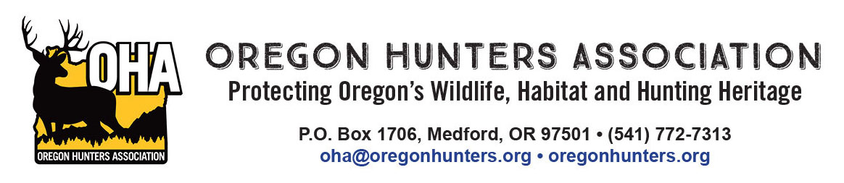

April 21, 2025

McKenize River Ranger District

Attn: Calloway Project

57600 McKenzie Highway

McKenzie Bridge, OR 97413

RE: Oregon Hunters Association comments on the draft Calloway Environmental Assessment

The Oregon Hunters Association (OHA) is a sportsmen’s conservation organization with over 12,000 members in 26 chapters across Oregon. OHA values our National Forests as a public place to hunt and recreate, and as a valuable asset providing habitat for the wildlife we care about. As such, the management and access of these lands are of critical importance to OHA. We have been engaged in numerous projects to improve and protect habitat conditions, and we value our partnership with the U.S. Forest Service (USFS) and the Willamette National Forest. We are providing comments and input on the draft Upper Canyon Environmental Assessment (EA).

OHA is supportive of the proposed action (Alternative 2) in the EA and the overall project proposal and proactive management on the forest. With that, we have the following comments to consider.

OHA supports active management for a variety of reasons that were articulated in the draft EA including restoring meadows, improving/maintaining stand health, and ensuring there is a well managed and appropriately sized transportation system.

OHA wants to encourage the USFS for to use of the westside elk model when developing both stand specific and project wide stand prescriptions. Elk populations on the Willamette National Forest are below the management objectives set by the Oregon Department of Fish and Wildlife.

This information points to a need for work to develop or improve elk and deer habitat on the project area. Relying on catastrophic, stand replacement level wildfires, such as those on the Labor Day weekend of 2020, to potentially provide habitat is not a desirable approach. OHA believes that there is a very limited opportunity to improve habitat for ungulates with the proposed project. This leads us to specific recommendations where stand treatments outlined in the draft EA.

First, where using the creation of gaps in the stand treatment prescriptions, the USFS should favor using larger gaps and at an abundance to actually promote (temporarily at least) some semblance of early seral habitat. Alternative 2 prescriptions detail the creation of gaps that are up to three acres in size, with leave trees. OHA strongly recommends that gaps be a minimum of three acres in size. Smaller gaps, in Douglas-fir stands, on high sites, will close in so rapidly that understory will be excluded within a decade.

Second, OHA recommends that the USFS employ heavier thinning prescriptions where possible to allow understory vegetation to develop and persist as long as possible before the stand closes in again. Once again, Douglas-fir stands on high sites will rapidly close in any openings in the overstory canopy. Using heavier thinning prescriptions on at least a portion of the project area will allow understory forage to persist longer.

Other management actions can benefit both elk and deer. OHA supports the meadow restoration included in the project. Our experience tells us that enhancing and maintaining natural meadows is not something that can typically be done with a single management entry. OHA encourages the USFS to use on-going maintenance of this work.

OHA supports the actions in the “Transportation” section of the draft EA. Specifically the statement “*Upon the completion of project activities, these roads would then be physically blocked to traffic. All roads treated would be left in a hydrologically stable condition to drain properly and protect water quality.”* And other actions outlined in the draft EA that will keep a well maintained, and appropriately sized road system in the project area. OHA recommends that the USFS consider at least seasonal road closures in areas where gaps are developed in the stands to avoid disturbance of elk.

OHA would like to specifically recognize the action listed in Appendix C – Project Design Features; Wildlife 6; All gated roads: “To provide a balance of hunting opportunities.”

“Project activities would not be allowed behind wildlife gates beginning the Friday before the General West Cascade Elk Rifle Season and ending the Friday after it; only emergency vehicles would be allowed.” This proactive step to recognize one of the most long-standing recreational activities on the forest is sincerely appreciated.

Thank you for the opportunity to comment.

Mike Totey

Conservation Director

Oregon Hunters Association