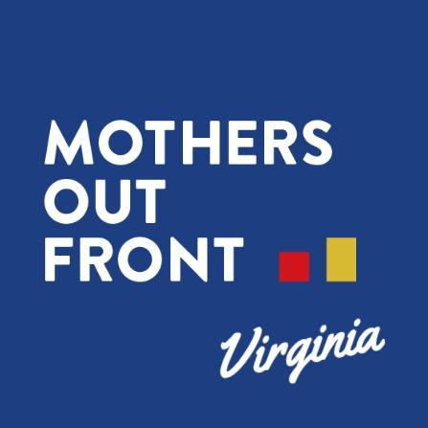

February 21, 2023

To: U.S.F.S.
ATTN: Dr. Wilkes, Under Secretary for Natural Resources and Environment at USDA
RE: Mountain Valley Pipeline and Equitrans Expansion Project Supplemental EIS #50036

From:Elizabeth Kreydatus, Mothers Out Front Virginia Coordinator

VIA: Website comment letter

Please choose the no-action alternative, to not amend the Jefferson National Forest Plan, and not provide concurrence to the BLM for a ROW/TUP regarding the Mountain Valley Pipeline’s attempt to cross the Jefferson National Forest.

The EPA sent a letter in May 2021 to the ACE recommending that they reject MVP’s application for a Clean Water Act (CWA) permit at this time because of several unanswered questions about the MVP application.

From the EPA's letter to ACE: “EPA has identified a number of substantial concerns with the project as currently proposed--including deficient characterization of the aquatic resources to be impacted...Furthermore, the direct, secondary, and cumulative impacts from the discharges associated with this project to these watersheds may result in significant degradation of the waters of the United States and reduce the ability for remaining aquatic resources to maintain hydrologic, geochemical and biological functions, insufficient assessment of secondary and cumulative impacts and potential for significant degradation and whether all feasible avoidance and minimization measures have been undertaken...While many of the fill discharges associated with the proposed construction activity may be considered temporary, the impacts from those discharges may have lasting effects, particularly due to the sensitivity of the aquatic resources and the repetitive nature of impacts to some of the tributaries.”

Since the EPA’s letter there were several attempts in the fall of 2022 to exempt the Mountain Valley Pipeline from environmental protections. Congress rebuffed all those attempts to sacrifice our environment for the MVP project. The fact that MVP was pushing for exemptions is paramount to the admission that they can build their project through the sensitive habitat of endangered species without harming them, our water and our forest.

From the beginning of the project scientists and engineers have pleaded with MVP to conduct a Soil 1 survey with ground truthing to have the data to determine if they can successfully build their project. The DSEIS relies on previous flawed hydrologic analysis and RUSLE2 modeling.

An Order 1 Soil Survey would make performing a RUSLE2 calculation possible, but not without it. Soils
change frequently, within 100 feet, in the Appalachian Mountains, with slopes over 35 % steep.
This means, that every soil location greater than 35% slope cannot be used in the RUSLE calculation –
the calculation falls apart and does not reflect real life soil behavior.

Soils in a continuous linear path may have but a short length of landscape that could be less than 35%
slope and that length, slope, soil characteristics, climate all go into the calculation. Large
sections of the landscapes are removed from the total value, because there cannot be accurately predicted soil behavior over 35% slope, like the ones that exist in the Jefferson National Forest.
RUSLE was designed for less than 9% slope. RUSLE has a limit of area of 285 acres of uniform soils. However, there are not uniform soils in a linear path through steep mountains of the Jefferson National Forest. MVP doesn’t have the data for accurate calculations to successfully create their building specifications.

After having the courts vacate their permits twice due to environmental harm, there is no public evidence that MVP has conducted an Order 1 Soil Survey or appropriate ground truthing to be successful. This is unacceptable and enough grounds to deny their current request to cross the JNF.

New evidence documented and reported by professional certified soil scientist Nan Gray, substantiates the need to create LiDAR maps from 2017, 2019 and 2023 to compare how the MVP project has been impacting the flow of groundwater. Her research is near the JNF boundary and raises alarms about the irreversible harm MVP is causing to sensitive habitat for endangered species.

Some of our Mothers Out Front members witnessed MVP construction workers ignoring the pleadings of land owners not to puncture an aquifer and to bring a qualified hydrologist to evaluate the land before proceeding. Our members saw the MVP workers drill into the land and then saw water spewing up high into the air. MVP didn’t have a permit at the time to cross water bodies.

It’s imperative that the USFS protect our forest from harm due to an unnecessary project. Since FERC granted MVP its certificate of necessity in 2017, the economy has had many changes. There is a global agreement to reduce methane emissions 30% by 2030 because of their role in accelerating extreme weather events. There has been a glut of gas supply causing gas producers to reduce the production of gas. This results in there no longer being a need for more gas infrastructure like the MVP.

Mothers Out Front Virginia urges the Forest Service to protect the National Forest and select Alternative 1, the No Action alternative. The Mountain Valley Pipeline is inconsistent with the Forest Plan, and we urge you to reject the eleven proposed amendments and exceptions.

Sincerely,
Elizabeth Kreydatus
Mothers Out Front Virginia Coordinator

