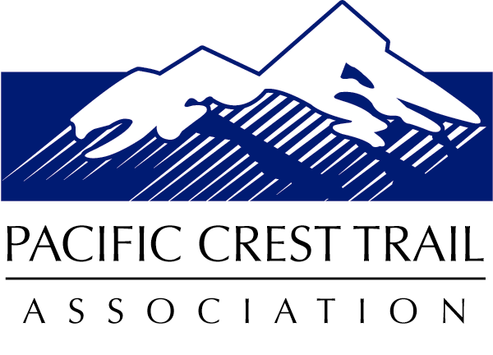

Northern Sierra Regional Trail Operations Office

P.O. Box 1092 ● Portola, CA 96122

530-414-3422 ● [jkooyman@pcta.org](mailto:jkooyman@pcta.org)

Deciding Officer:

Jeanne Higgins, Stanislaus National Forest Supervisor

Supervisor’s Office

19777 Greenley Road  
Sonora, CA 95370

July 28, 2015

**Re: Pacific Crest Trail Association’s Comments on the Stanislaus National Forest Over-Snow Vehicle Use Designation Proposed Action**

Dear Supervisor Higgins,

I am writing on behalf of the 10,000 member Pacific Crest Trail Association (PCTA). As you know, PCTA is the Forest Service’s major private partner in the management, maintenance and protection of the Pacific Crest National Scenic Trail (PCT). As such, it is PCTA’s role to advocate for the best possible protection of the PCT and the experience it affords trail users, year round. Further, PCTA and the Stanislaus National Forest have a strong partnership in the management and maintenance of the PCT.

PCTA has reviewed the Over-Snow Vehicle Use Designation Proposed Action document and has a clear understanding of the purpose and need for the project. Although I was not able to attend the open house meetings on the Stanislaus NF, I did attend open house meetings on other Forests and spoke with local Forest Service staff as well as members of the Enterprise Team who are leading up the OSV Use Designation Projects. Further, I have shared PCTA’s perspectives and concerns regarding appropriate winter management of the PCT in email communications and phone conversations with Stanislaus NF Staff, Sue Warren and Phyllis Ashmead. I specifically want to thank Phyllis for all of her time and support discussing this project with me.

PCTA commends the Stanislaus NF for prohibiting snow mobile use on the 17.7 miles of the PCT that travel through the Forest. PCTA is also pleased to see the PCT clearly illustrated in the project map. Importantly, where the PCT is located outside of Designated Wilderness there is approximately a one-half mile area around the trail that prohibits snow mobile use. Specifically, in the area northeast of Highland Lakes, the PCT travels through Recommended Wilderness, and this area prohibits snow mobile use.

The Proposed Action contains sound protection for the PCT. Nonetheless, PCTA feels the Stanislaus NF should designate a non-motorized corridor along the PCT. Should management direction change and the Recommended Wilderness Area northeast of Highland Lakes be reclassified, this area could be open to snow mobile use. This would have significant negative impacts on the PCT. A specific PCT non-motorized corridor along the trail should be designated to provide enduring protection for the trail. PCTA’s reasoning is based on language found in the 1968 National Trails System Act and the 1982 USFS PCT Comprehensive Plan.

The 1968 National Trails System Act, which designated the PCT and the Appalachian Trail as the nation’s first National Scenic Trails, prohibits the use of motorized vehicles along the PCT.  The Act states, “The use of motorized vehicles by the general public **along** any national scenic trail shall be prohibited and nothing in this Act shall be construed as authorizing the use of motorized vehicles…” Further, the USFS PCT Comprehensive Plan states, “Snowmobiling on the trail is prohibited but crossing at designated locations is consistent with the purpose of the trail.” The Plan continues, “Snowmobiling along the trail is prohibited by the National Trails System Act, P.L 90-543, Section 7(c). Winter sports plans for **areas** through which the trail passes should consider this prohibition in determining areas appropriate for snowmobile use.”  The use of the word *areas* in the Comprehensive Plan makes clear that the PCT is not meant to be managed solely as a linear feature; rather, the *areas* around the trail must be managed in a manner that does not substantially interfere with the Nature and Purposes of the PCT.

To protect the PCT, PCTA would like the Stanislaus NF to include the following design features in the Environmental Impact Statement.

1. Establish a winter non-motorized corridor for the PCT that is wide enough to protect the trail experience for PCT users. As such, PCTA strongly suggests a corridor width based on the USFS Scenery Management System definition of Foreground. This will create a non-motorized corridor up to one-half mile in the visible lands on each side of the PCT.  In some areas the corridor would be smaller as the visible landscape along the PCT will be smaller than one-half mile on each side of the trail due to topography. A wide corridor is not only needed to protect the non-motorized user experience; it is also needed to provide for PCT user safety as many snow shoers and skiers move up to ridge tops that are just above the PCT to reduce the hazards associated with avalanche danger while traveling on steep side hill terrain. Of the 17.7 miles the PCT travels through Stanislaus NF lands, only approximately two miles are located outside of Designated Wilderness. These approximate two miles are currently protected from winter motorized use as they are located in Recommended Wilderness. However, should this Recommended Wilderness Area be reclassified through an amendment to the Forest Plan, the PCT could lose this separation from motorized use, and the trail experience would be degraded. The total potential area closed to snow mobile use to protect the approximate two miles of the PCT outside of Designated Wilderness would be 1,280 acres. In actuality, less area would be closed to motorized use where one-half mile on each side of the trail is not visible from the PCT; also, much of the land east of the PCT is managed by the Humboldt-Toiyabe National Forest.
2. The PCT and the non-motorized corridor will be illustrated on Stanislaus NF winter use maps.
3. Crossing locations of the PCT should be designated, as this is called for in the PCT Comprehensive Plan. In addition to the two designated crossings found in the Bridgeport Winter Recreation Area, crossings would continue on California State Highways 108 and 4.

These design features will help to promote user safety and reduce conflicts between motorized and non-motorized users—two key needs that are explicitly stated in the Purpose and Need section of the Proposed Action document. The above design features will help the Forest to meet these goals for the PCT.

Another need stated in the Purpose and Need section is to, “…enact prohibitions required by the 1991 Stanislaus National Forest Land and Resource Management Plan and other management direction.” Management direction has been provided in the National Trails System Act and the PCT Comprehensive Plan. Based on the above language from the National Trail System Act and PCT Comprehensive Plan, PCTA believes that National Forests are required to provide a non-motorized corridor along the PCT for winter use.  The OSV Use Designation Project provides the opportunity for the Stanislaus NF to provide greater protection for the PCT and to come in to compliance with the National Trail System Act and PCT Comprehensive Plan, as the Plan states, “Winter sports plans…should consider this prohibition...”

Supervisor Higgins, I appreciate the Stanislaus NF staff’s time and efforts to protect the Pacific Crest National Scenic Trail within the Over-Snow Vehicle Use Designation Project. Please let me know if you have any questions regarding PCTA’s comments. I look forward to working with you and your staff further on this project.

Thank you,

Justin Kooyman

PCTA Northern Sierra Regional Representative

Cc:

Mike Dawson, PCTA Trail Operations Director

Beth Boyst, USFS PCT Program Manager

Ramiro Villalvazo, Director Public Services, Pacific Southwest Region

Teresa McClung, Calaveras District Ranger

Molly Fuller, Summit District Ranger

Phyllis Ashmead, Stanislaus Over-Snow Project Lead

Irene Davidson, Carson District Ranger

Jeffrey Ulrich, Bridgeport District Ranger