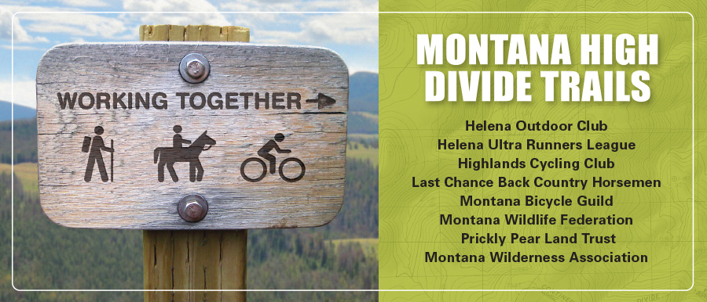

Objection Reviewing Officer

USDA Forest Service, Northern Region,

P.O. Box 7669,

Missoula, MT 59807

*July 20, 2020*

To: Supervisor Bill Avey and Regional Forester Leanne Martin

Subject: Objection to the Final Supplemental Environmental Impact Statement and Draft Record of Decision for the Helena-Lewis and Clark National Forest Management Plan.

**Statement of Interest**

On behalf of Montana High Divide Trails Collaborative Partnership, we thank you for this opportunity to submit collaborative objections with suggestions we feel can improve the success of the final Record of Decision and FEIS for the Helena-Lewis and Clark National Forest Plan.

Montana High Divide Trails is a collaborative partnership, formed thirteen years ago by southwest Montana organizations representing backcountry horsemen, mountain bikers, hikers and conservationists.

Following a year of dialogue, in 2007 these diverse groups came together to create Montana High Divide Trails, a collaborative vision connecting quiet trails and wild lands along the Continental Divide with people and communities.

This vision is a carefully balanced package of collaborative recommendations for the Continental Divide National Scenic Trail, future wilderness areas and additions, Non-Motorized Backcountry Conservation Areas, and quiet trails to link communities and improve diverse trail experiences.

The final Record of Decision and FEIS for the Helena-Lewis and Clark National Forest Plan is pivotal to the collaborative mission and goals of Montana High Divide Trails (MHDT).

MHDT submitted collaborative comments in scoping, on the wilderness inventory and the draft EIS for the revised forests plan. (attached) These collaborative comments form a foundation for MHDT objections and (proposed) solutions we seek included in the Final Plan.

**Upper Blackfoot Geographic Area**

MHDT member groups have worked collaboratively on the Helena and Lincoln Ranger Districts to help build and maintain trails, restore the Granite Butte Lookout and participate in community-based collaboration in Lincoln.

MHDT’s collaborative goals for future wilderness, conservation management areas and trails are now aligned with the collaborative goals of the Lincoln-based Prosperity Partnership.

Over the last 15 years, Lincoln has become a rare place where motorized and non-motorized recreationists, bicyclists, horsemen and women, loggers, anglers, hikers, business owners, first responders, snowmobilers, skiers, wilderness conservation and biologists have engaged in dialogue, years of outreach to affected parties to build a strong foundation for collaborative partnerships.

The solutions we offer are practical, linked and align with this remarkable community collaboration.

MHDT submits three linked objections to the draft ROD within the Upper Blackfoot Geographic Area seeking changes to RWA boundaries, ROS alignment and a connecting trails goal that would better align the final plan with the collaborative goals of the Prosperity Partnership endorsed by MHDT, Lincoln businesses and Lewis and Clark County Board of Commissioners. (attached)

**Objections**

**Recommended Wilderness Modifications**

We support recommended wilderness for Nevada Mountain and Scapegoat Wilderness Inclusions. We object to some boundary locations and submit three modifications as solutions. If accepted, these modest changes will have the beneficial effect of bringing the final plan into close alignment with the Lincoln (Upper Blackfoot) community collaborative plan.

Objection #1 – MHDT objects to the location of the Nevada Mountain RWA northern boundary.

Alt F moves the northern boundary of Nevada Mountain RWA south to Gould-Helmville Trail omitting @10,000 acres of equally excellent RWA quality wild lands with few conflicts. Alternatives B, C, and D placed the northern boundary of Nevada Mountain RWA on the roadless boundary, following the South Fork Poorman Creek Road.

Solution: MHDT offers the Lincoln collaborative boundary as a better solution. Place the northern boundary as shown on the attached map to protect the remote wild lands of northern Nevada Mountain in RWA yet leave a significant buffer near private and mining claims at lower elevations along the road corridor. Motorized use is not present in the area in any season.

Objection #2- MHDT objects to the location of the Silver King RWA (Scapegoat Wilderness Inclusion)

Alt F places the eastern boundary of the Silver King addition to the Scapegoat along the Alice Creek Road.

Solution: MHDT submits the modest boundary of the Lincoln Collaborative for RWA, with continued protection of Alice Creek as a National Historic Landscape, Conservation Area and under current travel without change.

Objection #3. MHDT objects to Alt F dropping Arrastra Creek from inclusion in the Scapegoat Wilderness.

Alternatives B, C, and D included Arrastra with boundaries that stretched from the Lolo Blackfoot-Monture RWA to Stonewall Creek. Alt F drops Arrastra from RWA entirely, an unwarranted extreme.

Solution: MHDT believes a better solution is the modest boundary of the Lincoln collaborative, which protects very high wilderness quality lands wedged between the Scapegoat Wilderness and large Blackfoot-Clearwater RWA, a key wilderness portal and habitat link, with no recreational conflicts.

**Recreation Opportunity Spectrum (ROS)**

**Modifications to Desired Conditions Map**

Objection #4: MHDT objects to specific elements in the displayed ROS summer map for the Upper Blackfoot and offer solutions consistent with our desired condition, the Lincoln collaborative proposal and current travel. [1]

Solution: Two summer ROS changes are offered as a desired solution on the modified ROS map attached.

1. Modest adjustments in summer ROS configuration are necessary to better reflect desired conditions that accommodate connecting trails between Stemple Pass and Lincoln supported by MHDT Collaborative.
2. The ROS map errs in codifying Nevada Mountain wild lands between Gould-Helmville and South Fork Poorman Creek as motorized.(SPM) This area is not currently open to motorized use. This should be corrected by classifying this area as summer ROS of Primitive to within one half mile of Poorman Creek Road.

**Objection #5 Desired Condition Omits Important Collaborative Goal**

Members of the Lincoln Collaborative and MHDT requested an important collaborative recreation goal be included in the Upper Blackfoot GA to foster trail connections sought by the community between Lincoln and Stemple Pass. This proposal, originally proposed in an IMBA Trail Solutions Report produced for the Lincoln Chamber of Commerce in 2009, merits inclusion as a desired condition. It is linked to RWA and ROD outcomes of the plan in this GA.

This future condition is broadly-supported, connects trails into a system and allows diverse interests to work together as a collaborative partner with the Lincoln Ranger District.

**Solution.** Include this desired condition in the Upper Blackfoot GA:

***Trails connect the community of Lincoln to the Continental Divide near Stemple Pass, with minimal impact to wildlife habitats and movement corridors.***

Thank you for incorporating collaborative recommendations from the Upper Blackfoot Working Group (UBWG) and Montana High Divide Trails (MHDT) Collaborative.

Sincerely,

Eric Grove and John Gatchell

Submitted by a full consensus ,

Montana High Divide Trails collaborative

1. NOTE: Alice Creek summer ROS: The Montana High Divide Trails collaborative (and Lincoln collaborative group) support forest plan and legislative proposals that continue existing travel management in Alice Creek. North of Lewis and Clark Pass, the CDNST and Trail#490 are managed for foot and stock, while south, the CDT is open to foot, stock and non-motorized bicycle travel. We wish to note here that the final summer ROS should support this clear outcome.