In regards to Scoping Summary : As a long time resident 22 yrs. In Navajo County .
Not only have I ridden horseback hundreds of miles on Black Mesa Ranger District but was for years an avid archery hunter.
The influx of off road vehicles is a major concern as the old logging roads that had been bermed up are now in constant use , total disregard for wildlife and their domain . The hunting pressure has had a negative effect on wildlife as now hunters have ready access that was not available years ago and are not kept in check by either FS or AZG&F.
Forest Service and certain groups have expressed their concern that the Wild Horses guard the water sources and compete with other wild life for forage ? When in fact the only animal competing for forage with wildlife including wild horses are the cattle .
Forest Service needs to take a good hard look at AUM for cattle if there is not sufficient forage for the wildlife then the cattle must be limited or not allowed at all.
I request that the Forest Service do a through environmental study to determine which species contributes negative impact on the range land . And that will encompass the 4 -6 month use by cattle . This environmental study needs to include the motorized vehicle impact on grass lands , water sheds, and erosion.
I coordinated the water hauling during the drought of 2018 at which time there were bands of horses found which were not able to access water sources due to cattle allotment fencing , gates are constantly either left open or shut I believe if those managing the cattle want the gates closed then it should be posted on that particular gate . There use to be metal signs on the gates that stated ‘ please close the gate “ what happened to those signs ?
Forest Service is severely lacking in enforcing any laws and especially those concerning the Protection of The Heber Wild Horses , off road vehicles , campers ect.
And the use of the forest in general , Last fall I turned in some campers that were camping at a water hole only to be told by F.S. Law Enforcement that there was no law pertaining to the distance from a water source where as being a hunter I knew better . 2 weeks later F.S. put up signs at every water source stating NO Camping ? By the way those campers left, camp fire smoldering and human feces behind the water hole .
FYI , Not only did the water we supplied save the wild horses but I have photos of the elk that would hear my truck and run in front of me to the troughs . In the photos attached it is quite clear that all the wildlife benefited by the water hauling effort . And even though water was at a premium all wildlife shared the troughs .

ELK and WILD HORSES enjoying the much needed water.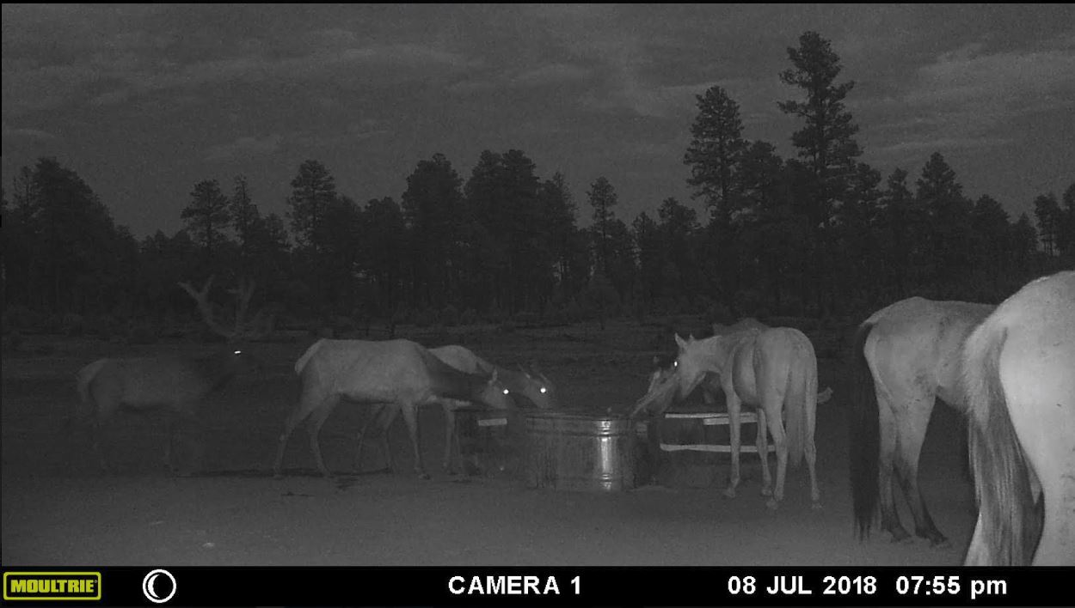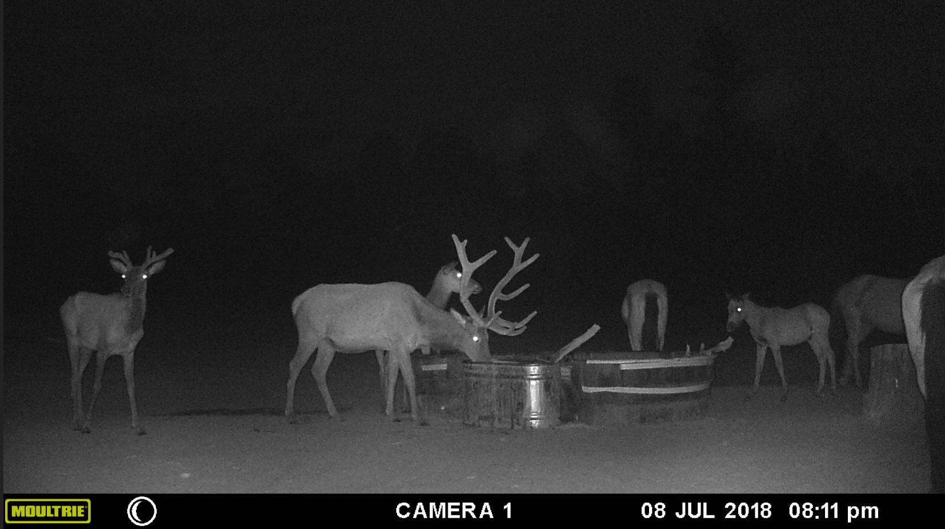EE