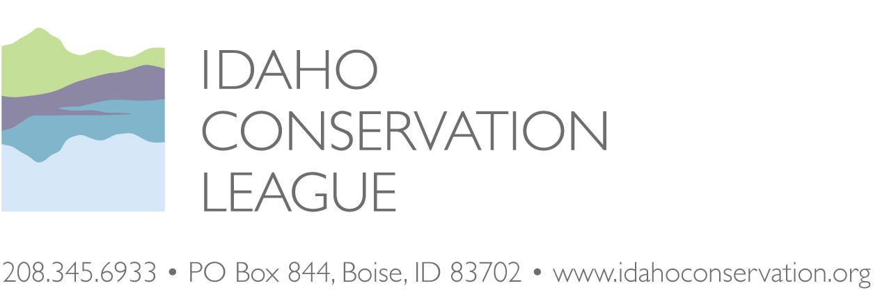

BEFORE THE REGIONAL FORESTER, INTERMOUNTAIN REGION, USDA FOREST SERVICE

BEFORE THE REGIONAL FORESTER, INTERMOUNTAIN REGION, USDA FOREST SERVICE

Idaho Conservation League
Objector
v.
Linda Jackson, Forest Supervisor
Responsible Official

Objection to the Huckleberry Landscape Restoration Project Draft Record of Decision, Council Ranger District, Payette National Forest

IDAHO CONSERVATION LEAGUE: John Robison, Lead Objector, Public Lands Director, P.O. Box 844, Boise, ID, 83701. Phone: (208) 345-6942 ext. 13, jrobison@idahoconservation.org

Certification of Filing
This objection was timely filed by electronic transmission to objections-intermtn-regional-office@fs.fed.us and submitted online ATTN: Objection Deciding Officer.
DATED this 13th day of April 2020.

Sincerely,
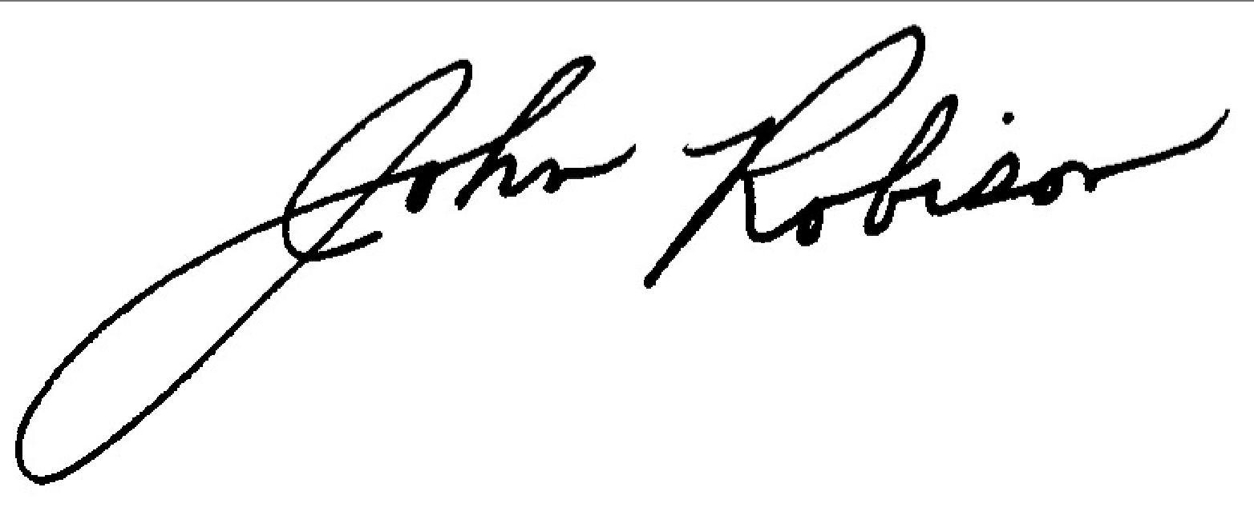
John Robison
Public Lands Director, Idaho Conservation League, Lead Objector
jrobison@idahoconservation.org
(208) 345-6942 x 13

Objector’s Notice, Statement of Reasons & Suggested Remedies
Objector’s Notice, Statement of Reasons

Notice of Objection
Pursuant to 36 CFR 218 Subpart B and § 218.5(a), the Idaho Conservation League is objects to the Huckleberry Landscape Restoration Project, proposed by Payette National Forest (PNF) Forest Supervisor Linda Jackson on the Council Ranger District. This is a supportive objection and we intend to use the objection process as a means to strengthen the project record, participate in any objection resolution discussions with other objectors, address any remaining issues of uncertainty, and update the adaptive management approach to better guide project implementation as needed.

Connection between prior specific comments
The Idaho Conservation League has been engaged in discussions and deliberations on this project since it was initially scoped. We have toured the project and also submitted comments in response to the Draft EIS as one of the members of the Payette Forest Coalition. In addition, ICL is a member of the Payette Forest Coalition. We have participated in numerous discussions about the project on several occasions at Payette Forest Coalition meetings.

The Payette Forest Coalition is a group of organizations and individuals which formed to work with the Payette National Forest on planning and executing large-scale forest landscape restoration projects. The goals of the PFC are to improve the forest’s resiliency to wildfires, enhance access for recreation, resource management and safety; improve watershed health and water quality, improve habitat for terrestrial and aquatic species, and bring economic benefits to surrounding communities. The PFC engaged in discussions and field trips regarding land restoration needs in the Huckleberry Project area starting in 2014. These discussions covered reducing fire risks in the Wildland Urban Interface, vegetation and landscape restoration, fuels management and fire mitigation, management of terrestrial and aquatic species of interest in the project area and management of roads and recreation in the project area. The PFC submitted consensus project design recommendations for restoration activities to the Forest Service in August 2016, scoping comments in November of 2016, and comments on the Draft Environmental Impact Statement (DEIS) in July of 2019.

Statement of Reasons
ICL has invested significant time and effort developing recommendations for the Huckleberry Landscape Restoration Project. We want to see the project successfully implemented in a timely manner and in such a way that projected benefits are realized and any negative effects are successfully avoided, minimized, and mitigated.

We support the project’s overall purpose and feel that the draft Record of Decision (ROD) will have a beneficial impact on this landscape’s forest health. As noted above, we have had extensive discussions on this project with the Payette National Forest, and we look forward to proceeding with this important landscape restoration.

We intend to use the objection process as a means to strengthen the project record, participate in any objection resolution discussions with other objectors, address any remaining issues of uncertainty, and update the adaptive management approach to better guide project implementation as needed.

Should other objectors raise additional concerns or bring additional information to the Forest Service’s attention, we hope to use the objection process to review this information and offer our perspective on any needed project modifications. We are concerned that if another party requests changes, the final outcome may not strike an appropriate balance between PFC’s restoration goals.

Regarding remedies, here are several suggestions for strengthening the Record of Decision and supporting documents:

- We note the Forest Service dropped 270 acres of commercial harvest because of lack of an easement across private lands. Even if the road easement could not be secured, we encourage the Forest Service to reach out to the landowners and see if there are other ways to coordinate forest restoration efforts across boundaries.

- The Record of Decision notes that analysis of LIDAR data may reveal additional routes and that the Forest Service will either retain or decommission these routes based on current and future management needs. The Forest Service should describe in more detail how it will make this determination.

- The Forest Service should describe if the 24.1 miles of new temporary road construction and 40.5 of temporary road construction on existing routes will be phased in and concurrently reclaimed, which could reduce the impacts of having all of these routes constructed and operating simultaneously.

- The Forest Service should clarify how the addition of 7.9 miles of new permanent roads is consistent with CFLR requirements of no new permanent road construction. Alternatively, the Forest Service should assess if these routes can be temporary.

- Regarding white headed woodpeckers, the Final Environmental Impact Statement (FEIS) p. 181 states that nest sites will be protected by following the Project Design Features outlined in Chapter 2, but this section has been omitted. The Forest Service should add the information and recommendations provided by the Rocky Mountain Research Station (RMRS).

If there are no other objections or no new relevant information is brought forward in the objection process, ICL would be willing to withdraw this objection. If the Forest Service selects a different alternative or combination of alternatives, we ask that the Forest Service work with the Idaho Conservation League, the Payette Forest Coalition, and any other objectors to craft an alternative that works for all parties.

