Comments on GMUG NF Draft Wild and Scenic Rivers Eligibility Report, March 15, 2019

Thanks for the opportunity to weigh in on the draft Wild and Scenic River eligibility criteria. I wholeheartedly support identifying all of the appropriate river segments on the forest.
I particularly wanted to focus comments on the streams arising on the Uncompahgre Plateau. The Plateau is an unusual landform, and streams have carved a number of long, unroaded valleys that cut down through the colorful sedimentary sandstone formations that overly the Plateau's ancient bedrock.
I strongly endorse the findings for Roubideau Creek and its tributaries, and Tabeguache Creek and the North Fork of Tabeguache Creek.
Roubideau is one of the truly undiscovered gems in the Rockies. In combination with the downstream reach on BLM lands, it forms one of the longest wilderness-quality river valleys in all of Colorado. The eligibility report appropriately notes its scenic, geologic, and vegetative ORVs. I most recently hiked into the middle reaches of Roubideau a couple of years ago, in a stretch dotted with large ponderosa pines, with encircling cliffs of red Wingate sandstone, and a gurgling stream plunging over falls and into pools carved into the black basement rock of the Uncompahgre Plateau. A photo is attached below that captures the scenic and geologic appeal of this reach of the stream. Roubideau's tributary streams are similarly appealing; one such tributary overlooked in the eligibility report is Potter Creek, which the BLM also found eligible. I encourage the GMUG to add its upstream reach of Potter Creek as an eligible wild segment with similar ORVs of scenic, geologic and vegetative ORVs.

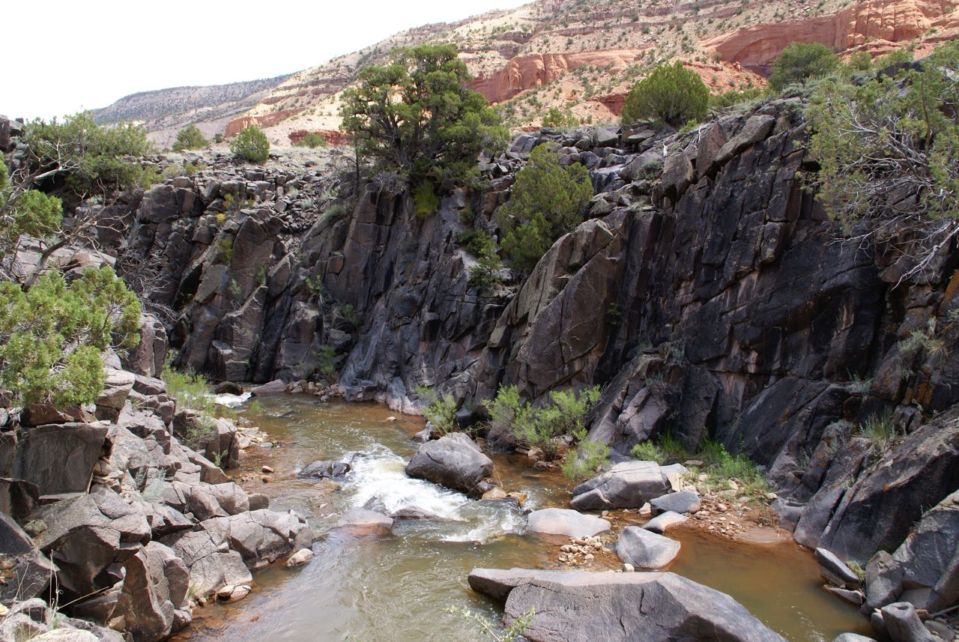

I've also hiked into Tabeguache in recent years, down the Indian Trail, and it offers perhaps even more impressive stands of old ponderosa pines along the creek's edge, in a narrower canyon than Roubideau, but also framed by soaring red sandstone walls. I concur that the reaches of Tabeguache are outstandingly scenic, but I'd also suggest that the stream creates conditions conducive to the abundant, large ponderosas and there are outstandingly remarkable vegetative values present as well.

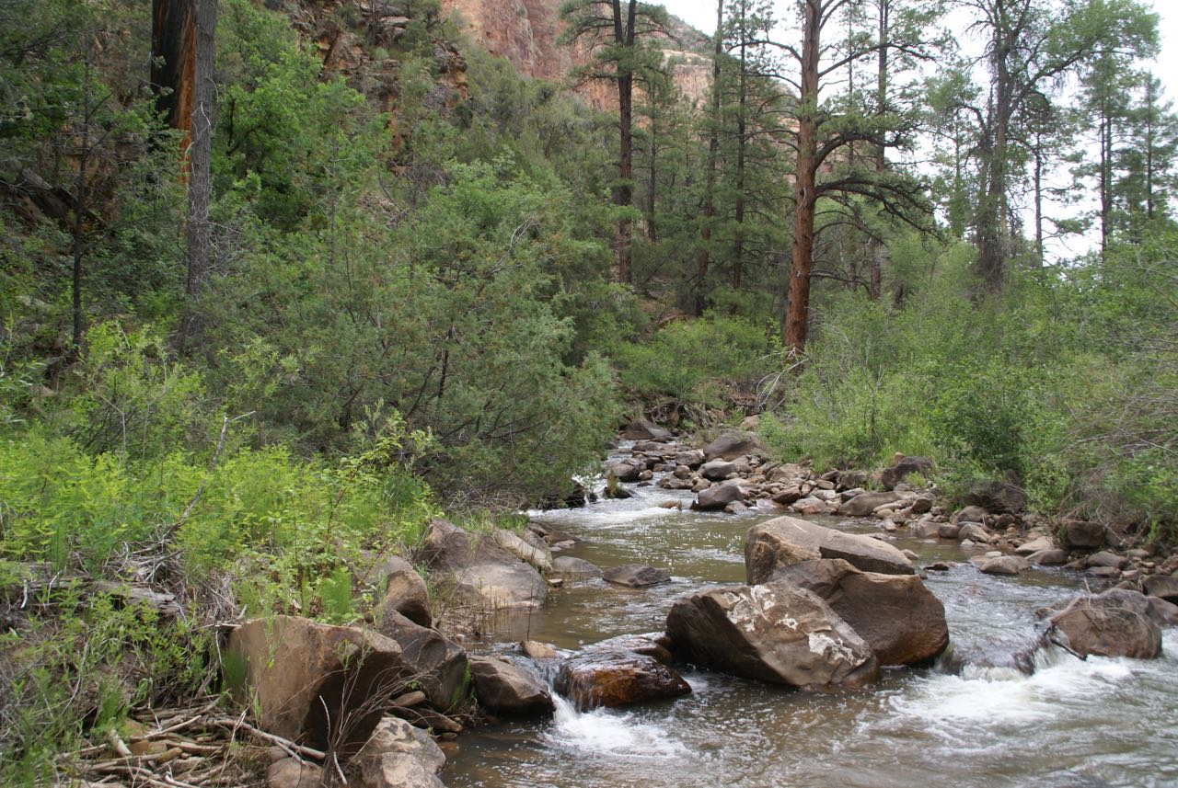

I am pleased to support the GMUG's finding that the North Fork of Escalante Creek and Kelso Creek are eligible. These are two additional wild river canyons of substantial length, a dozen miles each. I suggest they should also be found to possess outstandingly remarkable scenery values in addition to their fish values, for the same rationale that the report enumerates for Roubideau and Tabeguache. The North Fork of Escalante Creek and Kelso Creek have the same distinct scenic attractiveness as noted for Roubideau and Tabeguache as they also carve deep valleys as they descend from the higher reaches of the Plateau, creating deep canyons with high walls of Wingate sandstone amidst conifer forests of Doug fir and ponderosa, which is a striking scenic contrast. The streams descend through the sedimentary layers to the pre-Cambrian bedrock of the Uncompahgre Plateau. These kinds of stream corridors are exclusively limited to the Uncompahgre Plateau, and are uncommon and remarkable for that reason.
We live in a spectacular part of the world, and it's tempting to describe every single stream, creek, and river on the GMUG NF as outstandingly remarkable, but for the reasons listed above I sincerely believe that the streams on the Uncompahgre Plateau are exceedingly uncommon and outstanding.

Mark Pearson
560 Clearview Road
Durango, CO 81301
mudspringcreek@gmail.com

