Comments to the 2019 GMUG Draft Water and Scenic Rivers Eligibility Evaluation
Submitted on Feb. 22, 2019 by John Almy (jmalmy@gmail.com) of Delta, Colorado.

The process of identifying eligible stream reaches is primarily driven by the identification of outstanding remarkable values (ORV) in addition to the requirement of a free flowing nature to the stream reach. The ORVs are determined for a given stream in the context of comparing conditions/values with other streams in the same comparison region. It is not clear whether that analysis was conducted at the scale of the Ranger District, Geographic Area or Ecological Section. The document does not provide adequate information in identifying the context and scale for how the evaluated reaches were compared against other streams/rivers. No map was provided which displays the geographic boundaries of the comparative analysis. Assuming the map displayed in the 2006 Comprehensive Assessment Chapter 6 is the appropriate map it should be specifically referenced or better yet incorporated into this report. Certainly the findings should be reported and associated with the appropriate analysis scale.
A more important issue is how was the Forest able to comply with the intent of assigning ORVs based upon a comparative analysis requiring knowledge or information pertinent beyond the boundaries of the Ranger District or even the Forest. That is unless the scale was the Ranger District. As an example in the upper Gunnison Basin there is a surprising lack of streams identified as eligible given the aquatic resource values inherent to the area and the abundance of spectacular scenery along some of the corridors. One must assume that there are better examples of those values in other areas of the comparison region. It would be helpful to present on a map the eligibility determination outcomes for the entire stream network throughout the region of comparison. Without this link the evaluation could be construed as arbitrary and inconsistent. This process of identifying values is acknowledged in referenced documents as predicated on professional judgement and knowledge of resource conditions. In order to be judged credible the expertise and experience of team members should be identified.
I would like to make the case for two streams that were omitted from the list of eligible streams; the Taylor River and Spring Creek, which is a tributary to the North Fork of the Gunnison River. I find it ironic that the Forest chose the Upper Taylor River for its report cover photo and yet deemed it not eligible. The Taylor River is a true river and while some smaller streams deserve consideration the vast majority of designated reaches throughout the nation are larger streams and rivers. In the State of Colorado there are not many major stream reaches which are located within and administered by the National Forest System and this makes it special. I am disappointed the GMUG NF does share this perspective. Both the upper and lower segments of the Taylor River are very scenic, both in terms of the views from the river and the character of the river itself. The Upper Taylor River is a meandering channel located within a wide glacial valley and provides spectacular views of the Collegiate Peaks. The lower Taylor River cascades down a narrow canyon which has created many beautiful water features.
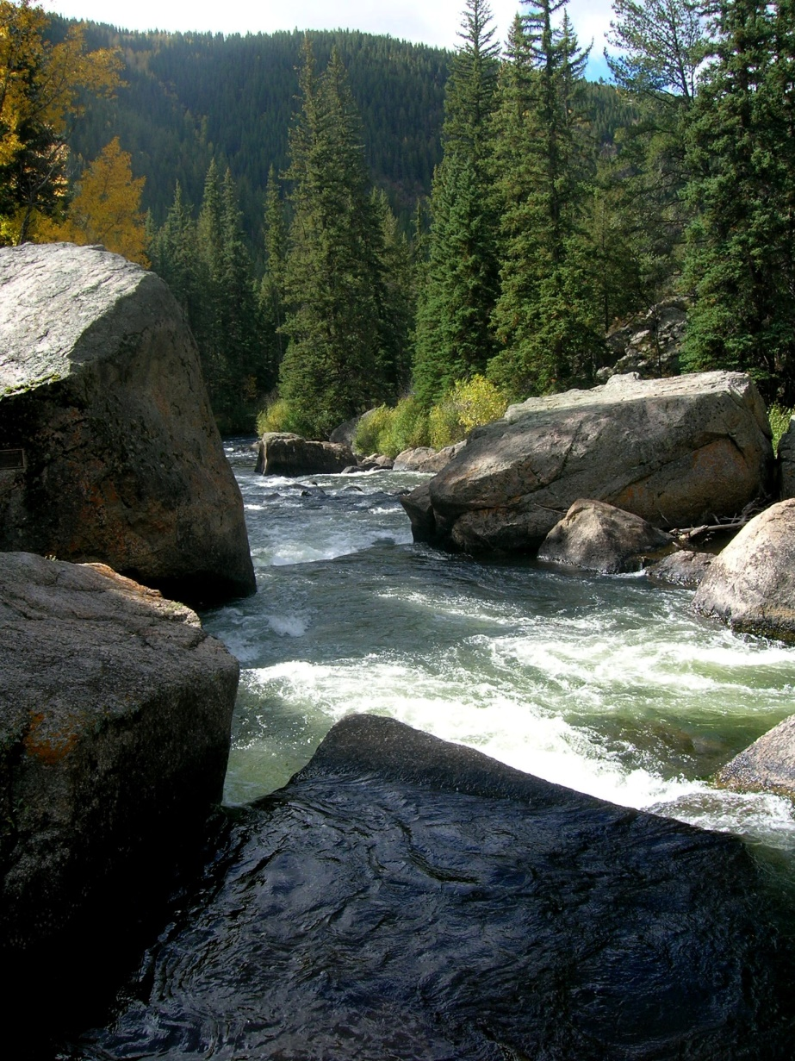
Image of Lower Taylor River

Both reaches of stream are crystal clear which add to their scenic attraction. Recreation use is high, which has its share of challenges, but there is little doubt that people travel from great distances to recreate on both segments. The Taylor River below the reservoir attracts fisherman from across the country to fish for the extremely large rainbow trout which occupy the river. White water rafting and kayaking is a major activity on the lower Taylor. I hope there is no confusion as to the lower Taylor River meeting the requirement of “free flowing”. Agency guidance clearly recognizes that reaches located between large impoundments may be eligible. Water release operations at Taylor Park Reservoir actually enhance several aspects of the reach that are germane to eligibility. While it is reasonable to conclude that neither reach fits the criteria of “Wild”, I believe both reaches meet the standards of either “Scenic” or “Recreation” classification. I suspect there would be broad public support for protection of this river, even by the traditional water use community who would prefer this water remain on the western slope. The lower Taylor River was identified as eligible in the 2006 report. What changed condition has occurred that changed its eligibility? Suitability is another question with a different set of considerations. But identifying the river as not eligible, because in the judgement of some, future designation would not be suitable, is a premature conclusion and violates the intent of the process.
The other stream reach mentioned that deserves listing as eligible is Spring Creek on the Paonia Ranger District. This stream only flows for a short distance on National Forest, but its origin is hydrologically unique. Two very large springs located at the base of the Ragged Mountains uplift discharge continuous flows of water sufficient to sustain well developed wetlands and also a resident cold water fisheries and other aquatic associate biota. This feature was being proposed as a Special Interest Area during the Plan revision efforts in 2006. The Forest Service was successful in convincing the Colorado Water Conservation Board to adopt a minimum instream flow on Spring Creek in large part because of this remarkable hydrologic feature. This hydrologic condition is a rarity in Colorado and certainly could be considered as an Outstanding Remarkable Value under either the scenic, geologic or other (scientific) categories. This stream should be re-examined. I believe it would be found to be eligible and classified as “Wild”.

