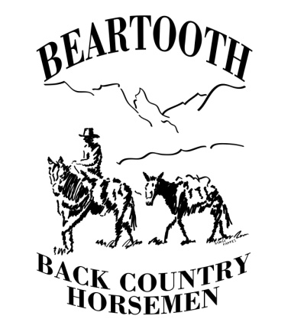
Beartooth Back Country Horsemen
P.O. Box 614
Absarokee, Mt 59001

To whom it may concern (Mary Erickson), CGNF

RE: East Crazy Mountain Land Swap #63115
also known as East Crazy Inspiration Divide Land Exchange

Recommendation: Proposal is concerning to the Beartooth BCH.
We recommend no action at this time, further information is needed for us to support or reject this proposal. Comments were mostly negative, some neutral.

I represent the Beartooth Chapter of the Back Country Horsemen of Montana based in Fishtail, Montana. (President, Jan 2021 to Dec 2022)

As you know we collaborate with the USFS on trails in the Custer -Gallatin. Our members do ride and recreate in the Crazy Mountains. We have in the past cooperated with trail work on public trails in that area. Our club provides a significant volunteer contribution to the USFS mission, as does the state organization, Back Country Horsemen of Montana. Crazy Mountain access has long been a contentious issue. Therefore, we feel we have a stake in this issue and should weigh in on it.

We have reviewed the proposal and discussed it at our general monthly meetings. We have shared the information in our monthly newsletters. I have been informed that you have already received comments from some of our individual members.

I wish to inform you that in our discussions we have reached no general consensus regarding this project. The comments were generally negative. I would like to share a few of the comments (below). However, the main primary reason we recommend no action at this time is because we feel we do not have enough information on the proposal’s effect on equine use in the Crazy Mountains. Therefore, we wish to await further details on it before recommending for or against. And I ask that we maintain our administrative status to comment in the future.

Negative Comments: The general comments from our chapter can be summarized into two categories. First is the potential negative effect on usable equine access; second, loss of recreation possibilities we access by equine use, but not directly related to the Back Country Horsemen mission statement. First, members stated that the prior land swap in the Crazies resulted in loss of trails suitable for equine use, being supplanted by trails that were “too steep for man or beast”. Viewing the map of the proposed loop trail around the Crazy Mountains, there is a concern this proposed swap will result in the loss of “reasonable” equine trails (accessible and lower elevation with recreational opportunity) being taken from Montana residents and the general public, and given to a few select local landowners and in – or out-of state commercial entities. This being exchanged for higher elevation poor quality access and recreational opportunity. Unrelated to our mission, but a direct corollary of it, since we use equines to access other recreational opportunities such as hunting, fishing or camping, some members supported the reasons given to reject the proposal expressed by sportsmen and environmental groups. Such as in the Billings Gazette Op Ed in mid November 2022 (Backcountry Hunters and Anglers, Friends of the Crazy Mountains and others). A few members who have researched the issue feel that the access loss of some trails Crazies is not legal. And that the USFS should pursue avenues to maintain the old means of access, as we are aware has been tried. Other, indirect consequences were concerning: commercial development with this land swap/ consolidation would harm the environment and change the nature of the ecosystem and equine recreational opportunities.

Neutral Comments: None
Positive Comments: None.

In summary, the Beartooth BCH has serious concerns about East Crazy Mountain Land Swap #63115. We recommend no action because our mission is to support, encourage and foster the responsible use of equines in the back country. At this time, with the details provided, we are unable to support this proposal since we feel there is a lack of details for us to comment on the effect on equine use in this area and on its trails. And we do have concerns about how the land exchange will affect our equine related recreational opportunities.

Respectfully

John K Jenkins MD, FACR

President, Beartooth Back Country Horsemen

