May 15, 2021

Roger A Nichols
5370 Bellaire Drive
Bellingham WA 98226
360 296-3511
roger.nichols@comcast.net

Jody Weil, Forest Supervisor
Mt. Baker-Snoqualmie National Forest
2930 Wetmore Ave, Suite 3A
Everett, WA 98201

Reference: Dead-horse Road Relocation Project # 57167 Dead-horse, Draft Decision
–Objection to the draft decision notice.

Dear Jody:

I have reviewed the Road Relocation Project Dead-horse EA and object to the proposed Draft Decision. The following are my issues with the draft decision:

Objections:

Moving Forest Service Road (FSR) 37, Dead-horse Road out of the North Fork Nooksack River channel migration zone (CMZ) of the North Fork Nooksack River has substantial merit. However I object to the draft decision after reviewing the EA Alternatives, Draft Decision Notice for alternative 3 and on the ground site conditions. It’s apparent that due diligence was not practiced by the Forest Service. The Alternatives are badly flawed and do not come close to meeting the main objective of moving the road location out of the CMZ and protect fish habitat.
No Channel migration zone (CMZ) was done, no geotechnical assessment was done and no fisheries evaluation was done; and the heritage report did not include any mention of Hoosier Mining Claim nor mention of the bathing site which was very important when the interpretive trail was built. If these items were done, they are certainly not mentioned or evident in the EA, nor apparent in the determination of the selected alternative.

No Ground marking of Alternatives was done.
The EA provided no road miles or ground flagging for the alternative routes identification. Photo measurements were used to tie the LIDAR based project alternatives to ground based measured FS Infra Road Inventory and the Stream catalog. The following narrative to Dead-horse road locations is tied to 2011 Dead-horse Road 37 Infra Inventory by Road Mile Post (MP), and 1975 Williams et al Stream catalog River Mile (RM) for on the ground refer.

Site locations and reference points
Following items MP’s are given for field location reference.
Alternatives tied to ground locations:
Alt # 3 starts at MP 2.92 red pin ends at MP 3.47 yellow pin
Alt # 2 starts at MP 3.05 green pin ends at MP 3.47 yellow pin
Alt # 1 starts at MP 3.12 purple pin ends at MP 3.47 yellow pin (east of Boyd Creek Culvert Crossing)

Boyd Cr crossing at MP 3.14, RM 62.1, and Stream ID #0490 labeled red text right
Channel migration at MP 3.69 (Meander Bend) within 75’ of the road blue pin right
Channel migration at MP 3.7 (Meander Bend) within 100’ of the road blue pin left
(Aerial Photos indicate the down- stream migration took place between 2006 and 2017)
Ditch Creek Waterfalls MP 3.9 blue line left
Junction with Bridge Camp entry (FSR 3722) MP 4.25, RM 63 labeled red text right
Cascade Creek MP 4.50, RM 63.3, Stream ID #0494 left of bridge camp
(Note: Cascade Creek location was misidentified in the EA.
Channel is actually West Fork of Boyd Creek. )

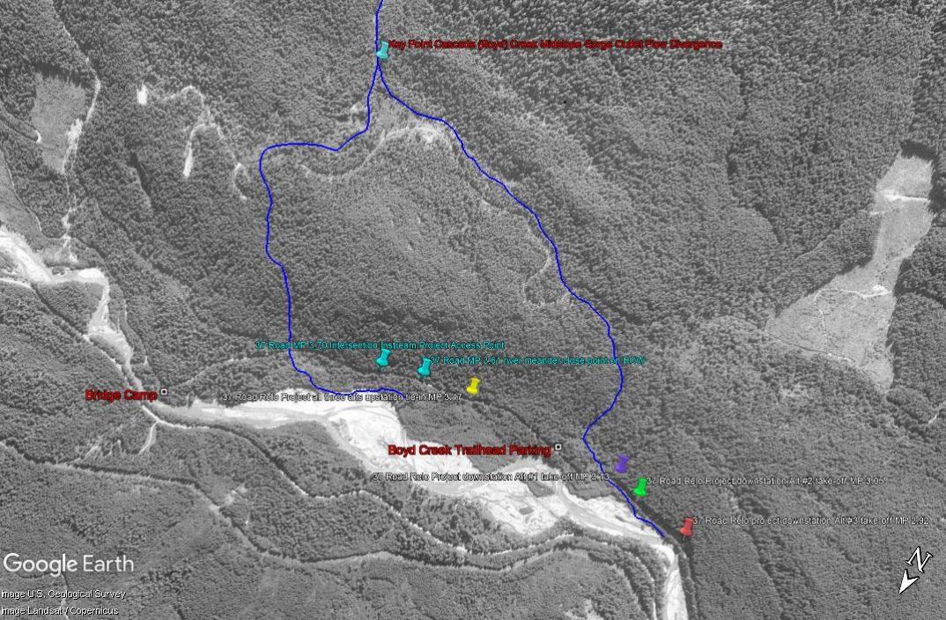
D Huddle 5/14/2021

No Channel Migration analysis of the CMZ was done.

Comparison of aerial photos between 2006 and 2017 shows the meander bend migration above Boyd Creek MP 3.14 is migrating downstream from below Ditch Creek MP 3.9 to Boyd Creek MP 3.12 and current migration rate in this section of road is in high risk category. None of the current alternatives address this high risk section of Dead-horse Road adequately by ending at MP 3.47. The section of the CMZ MP 3.47 to MP3.9 is not mentioned or addressed at all. This high risk road segment has a high potential for being removed by channel migration in the near future. As given in the comments to the draft EA: WA State Legal Requirements WAC 222-030-021. Any road location near a river needs to be outside of the CMZ, at a minimum, the core zone of the associated RMZ (see WAC 222-030-021). “Channel migration zone (CMZ)”- the area where the active channel of a stream is prone to move and this results in a potential near –term loss of riparian function and associated habitat adjacent to the stream, except as modified by a permanent levee or dike.” For this purpose, near-term means the time scale required to grow a mature forest. (See board manual section 2 for description and illustration of CMZ’s and delineation guidelines.) In this case 140 years’ time period has been established as the time period required reestablishing a mature forest stand. It becomes apparent that the chosen alternative to move the Dead-horse road out of the CMZ is flawed. An example of how RCM was done by the FS can be seen by reviewing 2010 determination road relocation setback across WA State land from the eroding river banks of the Suiattle River at ERFO location MP 6, Forest Service Road (FSR) 26.

The lack of details provided in the EA indicates specialists unlikely walked the routes. Example: the soils report does not describe the near surface rock and steep slope inclination that the route 2 and 3 would encounter. Just walking up Boyd Creek trail to the native American bathing site and looking upslope where the routes would likely have to cross is a 200’ plus exposure of approximately 60% rock slope that the waterfalls cascades down. Alt #2 and 3 would require considerable blasting to cross this slope which is not indicated in the soil report or properly described in the EA. There is really no Geo-Tec report on the effect of crossing this rock slope, four creek crossings or likely negative affect on the Boyd Creek, its waterfalls/ spiritual site, and its impact on the bathing site. Proper description and narrative is absent from the EA. There is no substantial information and a total lack of analysis to support the draft decision.

Alternative 3, the selected alternative would likely not maintain the existing scenic quality of the North Fork Nooksack, a nominated Wild and Scenic River with the amount of road clearing and blasting required. The EA clearly understates the likely affects. The site would also be highly visible from Church Mt Trail No 671, a popular use trail.

Not using WDFW stream surveys for fish stock utilization is problematic. WA Timber Fish and Wildlife utilize this information to prevent unjustified disturbance. It is extremely important to utilize related documents like North Fork Nooksack In-Channel Project (Nichols, R A. and M Maudlin. 2007) which surveyed this reach and documented relationships like number of rock pool to wood pools and the mobility of wood debris in the channel.

Documenting the movement and longevity of large wood pieces is important to understand the high likelihood of loss of spawning redds each year due to increased intensity and frequency of storms. It’s from documents like this that plans are usually formulated. Understanding the emergence of remnant buried forest in the form of stumps is the result of channel -bed scour due to increase in the frequency and magnitude of storm event.

Question the proposal to remove of the four rock groins in stream structures from the channel margin of the active channel would result in negative affect with the high probability of loss of Boyd Creek spawning area, loss of intermediate side channel pool formation, and wood collection. The design of these rock structures was done with the intent of mimicking natural bedrock features found elsewhere in the reach and increasing the channel roughness component. Since their installation in 1997, they have perform as intended and continue to collect wood and provide a component of the log jams longevity that form and dissipate though this reach. The rock groins and wood jam complex upstream of Boyd Creek Crossing has been documented to be utilized by juvenile Chinook utilizing the created upwelling of ground water. The combined rock deflectors and adjacent wood structures east of them have been documented to supported the holding and spawning of Riverine Sockeye and other species including threatened Chinook when river braids occupied the left bank of the North Fork Nooksack River. They also provide a bank stability element that works to protect the Boyd Creek Side-channel.

Proposing to install large wood structures in the active floodplain of the Nooksack River would require elevation and proper design. Most installed in-stream wood structures to date, do not meet their desired design intent in less than ten years.

Boyd Creek Crossing: There is a lack of detail for this crossing replacement which could involve the disturbance of spawning habitat areas for listed Chinook, Dolly Varden/Bull Trout and Steelhead trout, and Coho salmon. The disturbance of this stream reach above the culvert would likely have an adverse effect on listed species. Saying a few fish would be affected illustrated a total lack of understanding for this reach. Boyd Creek is a terrace bank channel and in this reach they are very limited in length and significantly important spawning habitat areas.

The ELJ wood projects downstream of this location, on the North Fork Nooksack have been installed and have resulted in increasing a single thread channel morphology and failed to create the desired braided /island habitat complex. This includes Warnick, Upper Boulder and possibly others installed on the Nooksack that have been installed in the last 10 years.

The decision based on the project EA to select alternative 3 is unsupported and does not meet the Purpose and Need for the Proposal. I have submitted comments to the Project Scoping and draft EA and am very disappointed by the lack of information that was brought forward to support the Purpose and Need for any of the alternatives currently being considered.

Thank you for the opportunity to comment on this very important U.S. Forest Service subject.

Sincerely,
Roger Nichols
Roger A. Nichols
Engineering Geologist PEG
Licensed WA and OR
Retired Forest Service

Reference

Huddle, Douglas. 2011. Dead-horse Road 37 Infra Inventory. Mount Baker –Snoqualmie National Forest Road 37. Mt. Baker Ranger District. Master Stationing List. Pages 28. Refer to as Dead-horse Road 37 Infra Inventory. Available at North Zone Engineering
MBS NF, Sedro Woolley WA.

Keller, Gordon and Ketcheson, Gary. 2015. Storm Damage Risk Reduction Guide for Low-volume Roads. Forest Service National Technology and Development Program 7700 Transportation Mgmt: 1277 1714-SDTDC

Forest Service. 1995. Watershed Analysis, North Fork Nooksack River. Mt Baker Ranger District. Mt Baker Snoqualmie National Forest. USDA. Pacific NW Region. Sedro Woolley WA.

Nichols, Roger A. and Michael Maudlin. 2007. North Fork Nooksack In-Channel Project. In J. E. Doyle, K. Meyers, S. Wegner, P. Fowler (eds.) Developing Monitoring Plans for Structure Placement in the Aquatic Environment. San Dimas Technology & Development Center Monitoring Project (2004-2004), San Dimas CA. (Ch. 3, Study 8) pp. 89-106.

Habitat monitoring has been done on this reach of the North Fork Nooksack for spawning and holding habitat. The above reference documents the loss of wood habitat though storm surges, and the lack of complex pools and stable spawning habitat.

Williams, R.W., R.M. Laramie, and J.J. Ames. 1975. A catalog of Washington streams and salmon utilization. Volume 1. Puget Sound Region. WRIA's 01-07. Nooksack Basin WRIA 01, Pages 1101-1304. Washington Department of Fisheries.

