Moeur, Melinda; Spies, Thomas A.; Hemstrom, Miles; Martin, Jon R.; Alegria, James; Browning, Julie; Cissel, John; Cohen, Warren B.; Demeo, Thomas E.; Healey, Sean; Warbington, Ralph. 2005. Northwest Forest Plan--the first 10 years (1994-2003): status and trend of late-successional and old-growth forest. Gen. Tech. Rep. PNW-GTR-646. Portland, OR: U.S. Department of Agriculture, Forest Service, Pacific Northwest Research Station. 142 p.
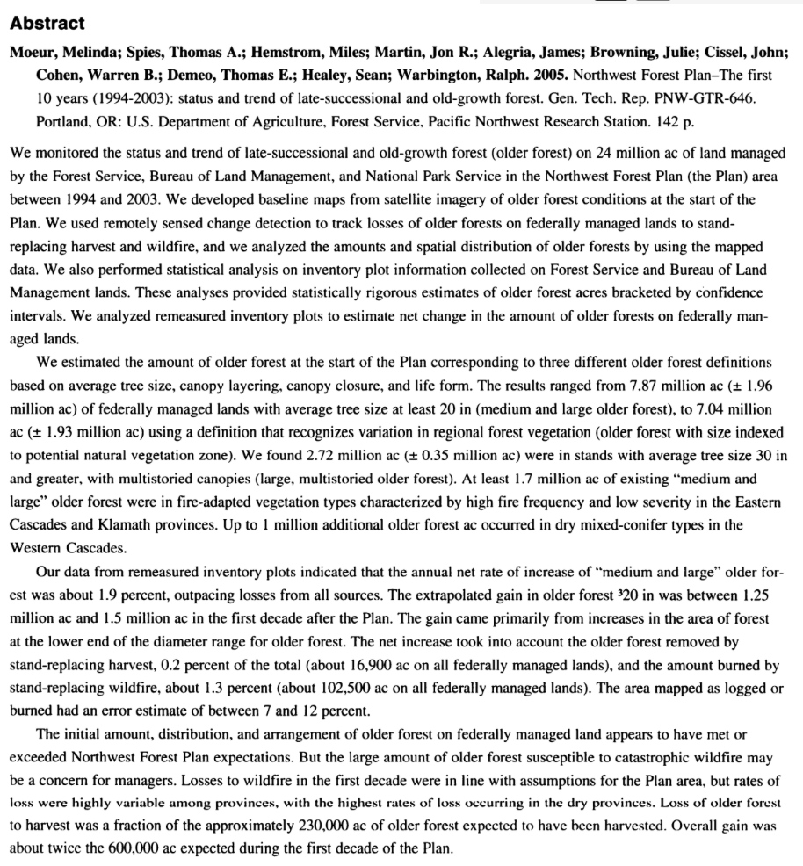

Ohmann, JL, M Moeur, M Hemstrom, T Burcsu, J Merzenich, MJ Gregory, HK May, EB Grossmann. 2008. Integrating forest inventory data, vegetation maps, and models of vegetation dynamics to support landscape analysis and planning: the IMAP story. Forest Inventory and Analysis Symposium: Park City, UT; October 2008.
https://lemma.forestry.oregonstate.edu/publications

Moeur, M.; Ohmann, J. L.; Kennedy, R. E.; Cohen, W. B.; Gregory, M. J.; Yang, Z.; Roberts, H. M.; Spies, T. A.; Fiorella, M. 2011. Northwest Forest Plan–the first 15 years (1994–2008): status and trends of late-successional and old-growth forests. Gen. Tech. Rep. PNW-GTR-853. Portland, OR: U.S. Department of Agriculture, Forest Service, Pacific Northwest Research Station. 48p.
https://www.treesearch.fs.fed.us/pubs/39632
