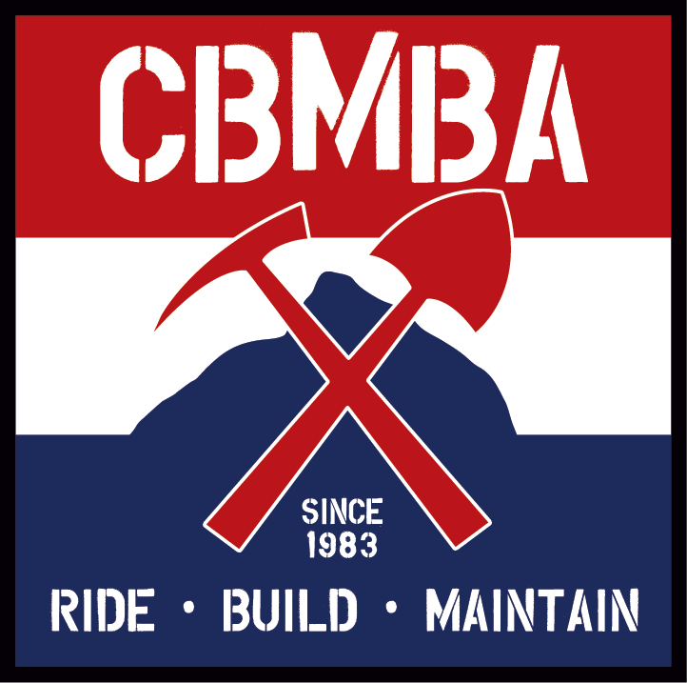

August 31, 2017

Grand Mesa, Uncompahgre and Gunnison National Forests
GMUG Plan Revision Team
2250 South Main Street
Delta, CO 81416

Re: GMUG Forest Plan Revision Assessment Comments

Thank you for initiating the Forest Plan Revision, the opportunity to comment, and for the outreach you very diligently pursued around the GMUG. We are excited to be a part of the planning process, and are grateful for your consideration of stakeholder assessments.

CBMBA is the oldest Mountain Bike Club in the world. Since 1983, CBMBA has been advocating for and maintaining sustainable and responsible trails in the Gunnison Valley. Recently, CBMBA has created the Crested Butte Conservation Corps (CBCC), in an effort to steward our backcountry and natural resources in response to the size of the area, increased impacts, and use. The CBCC’s focus is on all trails and impacted areas; Wilderness, non-motorized, motorized, hike/horse, dispersed camping, trailheads, and general access both public and private. We work alongside many stakeholders to partner and collaborate in our efforts. We are proud to work alongside the US Forest Service, and look to the Gunnison Ranger District for direction, support, and guidance.

Although amendments have been made to the current GMUG Forest Plan, the last three to four years have seen tremendous changes in impacts to parts of the GMUG, specifically on the Gunnison National Forest, of which we are specifically commenting upon.

The Gunnison National Forest is already managed heavily for recreation, however, population increase throughout Colorado and the American West, along with new technology and accessibility of recreational devices used on the Forest have significantly altered user experiences and have increased impacts. The shear size of recreationists have clogged roads and access, trailheads are bursting at the seams and without sanitation facilities, shuttling to trails has become more popular, vehicles can tow more and get further into the backcountry, and UTV/ATV traffic can create new routes around obstacles with ease.

With a recreation focus, we are hoping this Forest Plan Revision looks to the future of our pristine and very sensitive ecosystems. From sagebrush to wetlands, from dark timber to high alpine meadows, the Gunnison Valley sees a vast amount and variety of recreation, some of which do not combine for the best user experience. Connectivity and the ability to get users ‘off the roads’ should be of the utmost importance in planning, along with designated use, and infrastructure to support such use. Connecting safe, off-road access between our sister communities, trailheads, and popular recreation areas and destinations would complement a growing Gunnison Valley, and better mitigate user impacts, along with creating better user experiences.

CBMBA is also proud to be a part of the diverse working group of the Gunnison Public Lands Initiative (GPLI), and is in full support of the GPLI initial proposal. The proposal is consensus from many user groups in Gunnison County, and is a great tool for realizing the collaboration amongst the working group in regards to land protection, use, and management. We sincerely hope the GMUG Plan Revision Team utilizes the tool that the GPLI proposal is, and that is also helps facilitate the process with the consensus achieved.

Thank you for your consideration of our comments, and we look forward to the Draft Plan.

David Ochs – Executive Director
Crested Butte Mountain Bike Association
Since 1983
dave@cbmba.org
970.349.7324

