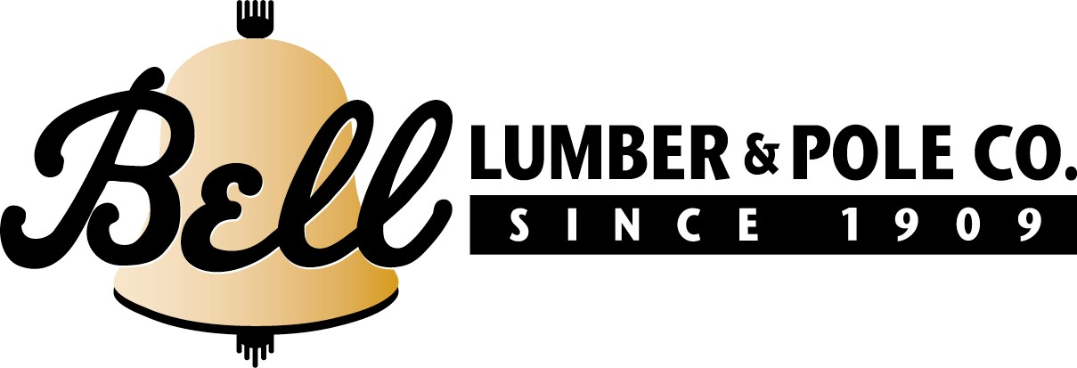
January 22, 2024

Bell Lumber and Pole Comments on December 20, 2023 Federal Register Vol. 88, No. 243 88042 – 88048
Director, Ecosystem Management Coordination, 201 14th Street SW, Mailstop 1108, Washington, DC 20250–1124.
Dear Sir or Madame
Thank you for accepting this comment regarding the Forest Service’s proposed amendment to 128 national forest land management plans to protect old growth. The Forest Service should take advantage of this opportunity to increase the pace and scale of active management to improve forest health on all its lands.
The Forest Service reconsidering the current proposal of amending 128 Land Management Plans through a single Environmental Impact Statement developed in less than a year does not seem reasonable. This type of approach risks undermining public trust and confidence in the agency managing forests. Major forest policy decisions should be accomplished through local engagement and public participation, not through a top-down directive from Washington, D.C. Our national forests require different approaches based on local conditions. The Forest Service, and the public, would be better served through individual plan revisions and amendments at the Regional and forest levels.
The Forest Service has determined that the most significant threat to old growth is wildfire, insects, and disease. Protecting old growth should focus on increasing science-based, active forest management to address our wildfire crisis, and to make our forests healthier and more resilient. No active management will not protect existing old growth stands from these threats. Protecting old growth forests requires action. We urge the Forest Service to describe and recommend, in detail, what specific actions it must take to achieve the agency’s stated goals.
Sincerely
Jim Parma
Jim Parma
Eastern Fiber Manager
Bell Lumber and Pole
Jim.parma@blpole.com

