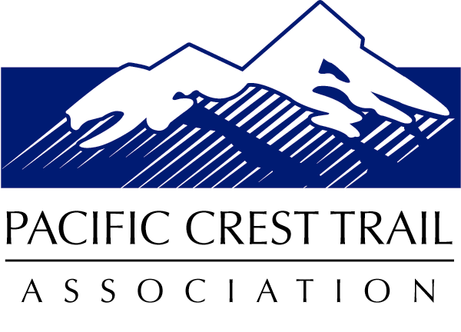

Big Bend Regional Trail Operations Office
Northern California/Southern Oregon
P.O. Box 458 ● Medford, OR 97504
541-778-3252 ● inelson@pcta.org

Heather McRae
USDA Forest Service
Shasta McCloud Management Unit
PO Box 1620
McCloud, CA 96057
April 18, 2016
Dear Ms McRae,

I am writing on behalf of the 11,500 member Pacific Crest Trail Association. The PCTA is the US Forest Service’s primary private partner in the management, maintenance, and protection of the Pacific Crest National Scenic Trail. I am writing today in regards to the Lower McCloud Fuels Management Project. We at PCTA support such fuels management projects on our public lands, and we have worked with our federal agency partners before to ensure the PCT and the experience of the trail user is protected through such a project area. However, I was disappointed that there are no PCT mitigation measures identified in the scoping document.
As the scoping document states, there are 11.8 miles of PCT within the project area boundary. And, I appreciate that the PCT is clearly represented on the project area map at the end of the document. According to the map, the PCT will cross through three 600’ wide fuel management zones at three different forest road crossings. And, it looks as though there is potential that the PCT could intersect one hand line and one dozer line. Lastly, there is one 300’ wide fuel management zone that the PCT will be close to between the AhDiNa campground and the Bald Mountain jeep road crossing. But, it is hard to tell from a map review the exact conditions on the ground. This is particularly true as it relates to the dozer line that appears to cross the trail at the upper reaches of Trough Creek in Section 30. I look forward to doing a field review of the PCT affected sections with Shasta-Trinity NF staff this upcoming field season.
As I stated earlier, we have worked closely with our federal agency partners (Plumas National Forest and the Bureau of Land Management’s Medford District are two examples) in the past on forest thinning projects that overlaid the PCT. We have found the following mitigation measures to be quite effective. And, they would only affect this project where the PCT passes through the fuel management zones. I respectfully request that you and your team on the Shasta-Trinity National Forest review the following PCT mitigation measures and consider them as the project’s planning process moves forward. The goal of the mitigation measures is to minimize the potential impacts to the PCT and the trail’s users while striving to mimic landscape-level patterns and features.
- Cut tree markings as opposed to leave tree markings should be utilized within 150’ of the PCT.
- Maximum stump height should be 6” or less within 150’ of the PCT.
- Utilize existing road crossings of PCT for machine crossings during operations.
- Burn piles should be located a minimum of 150’ from the PCT.
- Within the foreground viewshed as seen from the PCT, all project activities will meet a Visual Quality Objective (VQO) of Retention.
- Within the middleground viewshed, project activities should meet a VQO of at least Partial Retention.
- Warning signs will be placed on all trail access points and along the PCT where activities are occurring. Forest staff will communicate the timing of project activities with PCTA staff. PCTA will post project information on PCTA’s public information website to alert trail users to the project activities.
The mitigation measures above should be quite effective in minimizing the visual impacts on the PCT user as they pass through the three 600’ wide fuel management zones.
Specific to the prescribed fire portion of the project, we support introducing fire to the area and understand that the PCT will need to be temporarily closed. We also understand that the burning is subject to allowable conditions. That said, we ask that the length of the time the PCT is closed be kept to a minimum and the Forest staff work closely with PCTA staff to ensure that timely and accurate information gets to the public. Possible burning mitigation measures:
- Avoid using the PCT as a fire line.
- Burn outside the peak hiking season of late-April through early-October
- Post information at PCT access points regarding the reason for burning and inform PCTA of planned burn window
- Protect bridges and sign posts
- Prescribed fire intensity should be managed sufficiently to limit scorch of canopy vegetation and tree boles. The use of low intensity prescribed fire is a preferred method of fuels treatment and forest regeneration. Fire intensity should not be so high that canopy scorch occurs.
- Fire lines created for use of prescribed fire should not be straight lines, but should meander to follow topography or vegetation masses that remain. Lines should utilize natural breaks in topography and vegetation to delineate treatment edges. These lines should not be visible from the PCT.
- Following burning operations, fire lines should be restored by kicking, shoveling or raking dirt and duff back over the disturbed area. Cover cut stumps with dirt and duff.
  - If any lines are visible from the PCT, these lines must be restored.

We at the PCTA are proud of our role in the management of the PCT and the strong working partnerships we have with our federal agency partners. And, as the local regional representative I look forward to working closely with the Shasta-Trinity NF staff as this important project moves forward. I am confident we can work together to ensure that the PCT and the experience of the trail user is protected through the Lower McCloud Fuels Management Project area.
Sincerely,
S/Ian Nelson
Ian Nelson, Regional Representative
Northern California/Southern Oregon
Pacific Crest Trail Association

Cc: Beth Boyst, USFS Pacific Crest Trail Program Manager
Cc: Carolyn Napper, Shasta-McCloud Management Unit District Ranger
Cc: Becky Cooper, Shasta-McCloud Management Unit Recreation Officer

