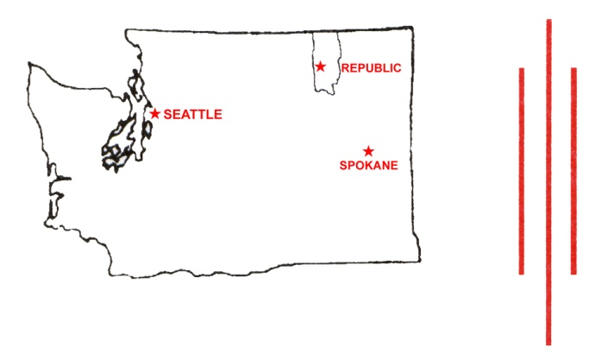
FERRY COUNTY
BOARD OF COMMISSIONERS

290 EAST TESSIE AVENUE
REPUBLIC, WASHINGTON 99166
TELEPHONE (509) 775-5225 ext. 2508 · FAX (509) 775-5230

JOHNNA EXNER, Curlew, District 1 Amanda L. Rowton, Clerk of the Board
NATHAN DAVIS, Republic, District 2 commissioners@co.ferry.wa.us
MIKE BLANKENSHIP, Boyds-District 3

Comment letter for Forest Plan Objection Period

October 31, 2018
To: Forest Plan Objection Period Comments
From: Johnna Exner
Ferry County Board of Commissioners

To Whom It May Concern;
Thank you for the opportunity to continue the process of the Forest Plan Revision period as we move into the Objection Period. The Colville National Forest makes up a large percentage of Ferry County connecting much of our economy, customs and cultures with forest use and forest products.
The Commissioners comment of July 5, 2016 questioned any wilderness recommendation.
The No Alternative Plan did not recommend any additional wilderness yet the other plans recommended from 6% to 20% increase. The Proposed Plan now recommends a 9% increase in wilderness (chart page 74). Ferry County objects to any recommendation. The Wilderness Act of 1964 allowed for wilderness recommendation within a 10 year period after enactment of the Act, additionally none of these areas fit the qualifications of Wilderness. Any Wilderness recommendation at this point is well beyond the time allowed within the Wilderness Act. We believe it would be negligent to support wilderness recommendation.
Wilderness recommendation would block effective management tools necessary for our first responders dealing with emergency situations as well as wildfire response. Both would endanger our citizens and could lead to additional devastation from fires. In accordance with our Wildfire Protection Plan the County states the need to “Prioritize the protection of people, structures, and unique ecosystems that contribute to our way of life and the sustainability of the local and regional economy.” (Ferry County Wild Fire Protection Plan Goal #2).
This recommendation would reduce economic activities in Ferry County and limit increasing recreational opportunities. Mountain biking and back country horsemen are both growing recreational interests within our Forest. We feel that the Forest Plan should address multi-use opportunities available within the Colville. Any recommendation of Wilderness eliminates that multi-use aspect and would have a negative economic impact on our local economy.
We would submit that any Wilderness Recommendation be removed from the proposed plan and that the Forest should instead recommend those areas as backcountry allowing for the increased multi-use activities. This would support retention of areas to allow for mechanical use to continue and accommodate a variety of recreational uses (Table B-2 page 936). With the growing demand for recreation we need support a plan that contains strategies to achieve multi-use for opportunities and good neighbor policies consistent with protecting county customs, culture and economic stability.
Thank you for the opportunity to continue to participate in helping developing a Forest Plan that promotes a healthy forest, expanded recreational opportunities and rebuild healthy economies within our counties.
Sincerely,
Johnna Exner, Chairman
Ferry County Board of County Commissioners
Objection Period Comment Submission
Ferry County Commissioners Office
290 East Tessie Avenue
Republic, WA 99166
509-775-5225 Ext.2102
509-775-5230 fax
commissioners@co.ferry.wa.us

