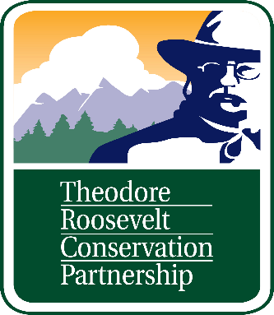

July 8, 2023

Amanda Milburn
Plan Revision Team Leader
Region 1 Ecosystem Planning
2880 Skyway Dr.
Helena, MT 59602

RE: Additional Assessment Comments for the Lolo national forest plan revision
The Theodore Roosevelt Conservation Partnership (TRCP) is a national conservation organization working to guarantee all Americans quality places to hunt and fish. The TRCP works with 63 formal partners and represents over 139,000 individual members nationally, including more than 3,500 throughout Montana. The conservation of fish and wildlife habitat and public access for outdoor recreation on our public lands are of great interest to us and our members. We appreciate the opportunity to submit additional draft assessment comments for the Lolo NF plan revision.
Elements of the 2012 Planning Rule Not Referenced

- 219.9: The Rule requires that plans maintain the diversity of plant and animal communities and the persistence of native species in the plan area (§ 219.9). When the USFS cannot provide the conditions to maintain a viable population of a species of conservation concern within a plan area, the Rule requires contributing to maintaining the species within its range, in coordination with managers of other lands relevant to that population (§ 219.9(b)(2)).
- 219.10: The Rule requires consideration of habitat conditions for species used by the public for hunting, fishing, trapping, gathering, observing, subsistence, and other activities (§ 219.10(a)(5)). The Rule directs the USFS to collaborate with federally recognized Tribes, Alaska Native Corporations, other federal agencies, and state and local governments when developing plan components to provide for habitat for species used and enjoyed by the public (§ 219.10(a)(5)).

- 219.7: The USFS is also directed in the Rule to consider the plan area’s role and contribution within a broader landscape (§ 219.7(f)(1(ii)), which is relevant for forests where migration corridors and seasonal habitats span multiple land ownerships and where the plan area plays an important role in the context of the broader landscape.

Landscape Pattern and Connectivity
We recommend a stronger acknowledgement and recognition of the new and best available science that demonstrates the scale of big game migration and movement corridors that exist on the Lolo NF. MTFWP and CSKT have acquired extensive migration data for elk, mule deer and big horn sheep in the lower Clark Fork, Upper Blackfoot and Mission Mountain portions of the Lolo NF. Listed below is an abbreviated list of federal and state policies that point to the importance and priority of migration conservation in land use planning.
-May 2021 Conserving and Restoring America the Beautiful Report, where the Biden-Harris Administration committed to “Expand Collaborative Conservation of Fish and Wildlife Habitats and Corridors,” and continuing with the implementation of SO 3362.
-Montana FWP has identified multiple migration corridors and other crucial seasonal habitats in their most recent SO 3362 State Action Plan. These migration routes were derived from FWP’s GPS collar data using a regular Brownian Bridge Movement Model which delineates low, medium, and high-use corridors to elucidate specific habitat types. Crucial stopover habitat for example is defined as the top 10 percent of the population utilization distribution. This new research indicates that stopovers play a key role in the migration strategy of mule deer by allowing individuals to migrate in concert with plant phenology and maximize energy intake rather than speed. Additional migratory habitats and winter range that have been observed anecdotally by agency biologists are also known and are prioritized for conservation.

-On June 23, 2022, Secretary of Agriculture Tom Vilsack issued Secretarial Memorandum 1077-044, directing the U.S. Forest Service to, among other things, develop policy recommendations to conserve wildlife migration corridors.
-Further, a letter signed by the USFS Deputy Chief Deputy Chief’s letter on August 19, 2022, specifically focused on big game migration. The letter directs Regions to consider “ecological connectivity and wildlife corridors during broad-scale planning associated with the land management planning process and implementation of land management plans through localized project planning and decision making.”
While there is mention of wildlife highway crossing opportunities west of St Regis and south of Lolo, there are additional opportunities on I-90 and Hwy 93 both north and south.
Cooperating Agencies
In the Executive Summary of the Draft Assessment there was a list of Cooperating Agencies. We recommend adding Missoula and Granite Counties to this list.
Public Engagement Events
We would like to commend the Lolo NF on its frequent efforts engage with the public during the early months of the plan revision that are outside of the traditional NEPA process. This level of engagement improves transparency and helps clarify the wide array of interests involved in the Lolo plan revision.

Sincerely,
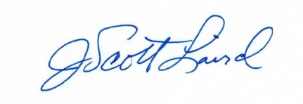
Scott Laird
Theodore Roosevelt Conservation Partnership

