October 9, 2018

Forest Supervisor
OSV Use Designation
19777 Greenley Road
Sonora, CA 95370

I am a cabin owner on the 5NO1 Eagle Meadow road between Haypress and Relief Reservoir. Our family has respected the environment and the surrounding area and has enjoyed both the summer and winter seasons at our cabin. Many cabin owners as well as our family who own private plots of land in this area have been snowmobiling in the area between Haypress, Relief Reservoir, and East Flange Rock each winter for over 40 years since the 1970’s. This area is adjacent to the vast Emigrant Wilderness, which we respect and do not ride. Our riding area around our cabins is approximately two miles long by one half mile wide. The area, next to the vast Emigrant Wilderness and the adjacent Yosemite National Park next to Emigrant Wilderness, is a very small and modest area in which we can ride. We wish to continue to ride the area that our family has enjoyed for decades and want our future generations to enjoy it as well. We respect the environment and have done nothing to destroy the natural habitat. In 40 years, I have never seen a Cross Country Skier in the Eagle Creek and Haypress area, with the exception of the bright orange tent at the top of the mountain next to the Three Chimneys on the border of Emigrant Wilderness.
Under the Forest Service Preferred Alternative Option 5, all of the property owners who own cabins on private property in the area between Haypress and Relief Reservoir on the 5NO1 Eagle Meadow road would be cut off and restricted from winter access to our cabins and private properties on a public road where many of us have been riding snowmobiles for over 40 years. In fact, the penalty for doing something that our family has done together for decades by accessing our property by public road via snowmobile is a $5,000 fine and/or six months jail time if this area is treated as Wilderness or a Forest Closure Order is issued. It seems unreasonable that cabin owners in the Eagle Valley and Long Valley would be granted OSV access to their cabins, but we cabin owners further along the 5NO1 Eagle Meadow road would not be granted OSV access to our private property, even on a maintained road that we pay our property taxes and green sticker money toward. The Eagle Valley and Long Valley cabin owners would also be granted designated areas of National Forest adjacent to their cabins in which to ride, where we would lose all of our traditional riding areas, even a mile radius around our property which we are accustomed to. Our two mile long by one half mile wide riding area should not be restricted and we should also continue to have access to ride Forest Road 20EV77 to Relief Reservoir and Forest Road 20EV79 to East Flange Rock at the edge of Emigrant Wilderness.
Forest Service’s Preferred Alternative 5 Map – purple is rideable, non-purple is restricted - NOT ACCEPTABLE – need to include the circled area as rideable for many riders for many years (not Wilderness) includes private property:
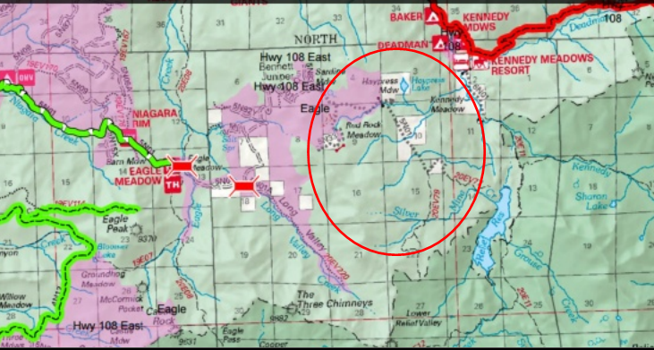

In the Stanislaus National Forest, there is a much larger percentage of Wilderness designated land than some of the other national forests and a much smaller percentage of privately owned land as well as land available for OSV use, so it does not seem reasonable to take the tiny portion of land directly around the privately owned land and heavily used by snowmobilers and cabin owners and treat that land as Wilderness.
The Forest Supervisor mentioned “Near Natural” areas that were noted in a Forest Plan in 1991 during the Sept 6th open house meeting. These areas are not currently designated as Wilderness, (or areas for non-motorized use), but are candidates for possible Wilderness designation in the future. I have never heard of these terms or have seen a map of the Stanislaus National Forest with the “Near Natural” areas on clearly marked on the map. Was this map ever released to the public? My understanding is that we property owners, since we are adjacent to the vast Emigrant Wilderness, know of only two areas, Wilderness as non-rideable, and National Forest which is rideable. The only change in designation of land use from motorized National Forest land to non-motorized Wilderness land that I am aware of is when President Clinton designated a small plot of land south and west of Relief Reservoir as Wilderness. I have never been aware of a public disclosure or of a Forest Service internal document that designates and labels some land as “Semi-Wilderness” or “Near Natural” and then declare that we cabin owners have been breaking rules by riding snowmobiles in these areas next to our property all of these years that we were never informed of, and that these areas should have been treated as Wilderness all along for decades that we were not aware of. I believe that only the President or Congress has the authority to designate National Forest areas as Wilderness. At this time, I am unable to locate any Forest Service maps with the “Semi-Wilderness” and “Near Natural” designations on them.
My questions are:
- Has the Forest Service released the maps to the public at any time in the past that show the “Semi-Wilderness” and “Near Natural” areas clearly marked?
- If these areas were candidates for Wilderness designation in 1991, why didn't President Clinton or any Presidents since his Presidency designate the areas as Wilderness as he was the only President to declare additional Wilderness area in the Stanislaus National Forest in the last 25 years?
- What decisions were made since 1991 regarding the designations or future designations of these areas?
- What correspondence has occurred between Congress members, the President of the United States, state, local, and federal representatives regarding any decisions about the designation of these areas? What was discussed and what were the major factors and decisions?
- Has there been any proof of damage to the natural environment from 40 years of OSV use in these areas?
- Finally, does the Forest Supervisor have the authority to designate areas as Wilderness when the authority lies with the President of the United States and/or Congress? Should there be a public release of these maps?
I can imagine that in 1991, while reviewing the winding down of the mining activities at the mine by the Bennett Juniper, Forest Service and/or other governmental authorities may have made a decision to limit the expansion of future mining activities in the area beyond the mine and may have been concerned about mine tailings and radiation potentially entering the water drainage into Relief Reservoir. There may have been a decision to designate this area as “Near Natural” in order to limit future mining activities and the building of any new roads in this area due to the protection of the watershed drainage system at Silver Mine Creek into Relief Reservoir, but not go as far as to designate it “Wilderness”. If this is the case, this “Near Natural” designation should only have applied to the decision to not allow future mining activities and new roads in this area in the summer and should not have had the intention of limiting winter OSV use, otherwise, this area would have been designated Wilderness at the time. This should not mean “no motors” but should mean “no mining” or no new roads. Certainly, none of us had been notified of any intention of the sort in the last 40 years.
I was unable to locate maps detailing the “Semi-Wilderness and “Near Natural” areas on the Forest Service website and was only able to locate the traditional publicly released maps from the last 25 years that clearly mark areas as Wilderness or National Forest. However, was able to I located a map on Winter Wildland’s website, that show “Near Natural” areas completely surrounding privately owned land between Haypress and Relief Reservoir and are located outside of the boundaries of Emigrant Wilderness inside National Forest land. These maps are not official Forest Service maps, so I am unaware who created these maps and if these are the 1991 Forest Plan internal discussion designations of land use. However, even using this map from the Winter Wildlands website, cabin owners should have a pretty good-sized shelf of land in which to travel to their properties between Haypress and Relief Reservoir. If these maps are accurate and are derived from the Forest Plan from 1991, we cabin owners are concerned that if this land is treated as Wilderness, this potential action would completely surround our private property, landlock us, and cut our access to our property. We have been unaware of these designations of this land as “Near Natural”. We are also concerned that even though we are located less than two miles away from Emigrant wilderness, if all of the land surrounding our privately owned land is designated or treated as Wilderness, what is the next step for the Forest Service to take? If our winter access is cut off, will our summer access be cut off as well?
I recommend Alternative 4. Even Snowlands website states that this alternative only gives a few small percentage points more of OSV access of the Stanislaus National Forest than their own plan Alternative 3. Whomever created the Alternative 4 map knows exactly where we snowmobilers have ridden in the last several decades. This map is not the “Gee I wish I could ride all of this extra area but will be ok if it is smaller” alternative, this is the real map of where we snowmobilers ride now and have ridden for 40 years since the 1970’s.
The best and only option – Alternative 4 Map - purple is rideable – non-purple is restricted (Wilderness Areas):
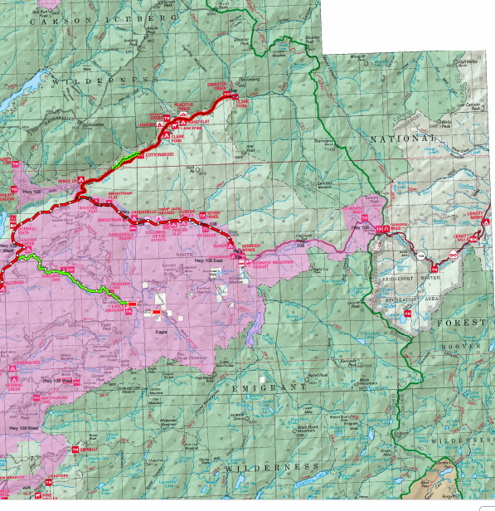
The Stanislaus National Forest is surrounded by several vast wilderness areas. If you were to stand at the edge of Emigrant Wilderness and look far into the distance into the interior of the wilderness, you would see mountain range past mountain range, and then if you could see farther than that, you would see into Yosemite National Park where you would see mountain range after mountain range. No snowmobiles. Our OSV access to the area that is two miles long and one half mile wide within a one mile radius of our cabins between Haypress, Relief Reservoir, and East Flange Rock as well as the entire Long and Eagle Valley areas where we and our families have ridden for over 40 years should not be restricted or curtailed, especially since we respect and maintain low impact to the natural environment, with no problems due to decades of historical use by cabin owners and snowmobilers.
If we had known about the “Near Natural” areas in 1991, we would have fought them at the time and would have continued to fight for our land since that time.
Attached are photos of our family’s snowmobile trips between the 1970’s and 1990’s in the National Forest areas listed above with landmarks such as the Three Chimneys, East Flange Rock, and Sonora Pass in the background. None of these photos were taken in Emigrant Wilderness or Carson-Iceberg Wilderness areas.
Our public lands do belong to the public, but we property owners and snowmobilers ARE the public, and we are the ones who love the area, know and respect the area, and use the area. Our views and right of access to private property should be respected as well!

Annie Clarke

