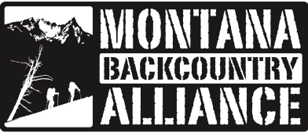
April 1, 2024
Amanda Milburn
Plan Revision Team Leader
Forest Service Northern Region Ecosystem Planning
2880 Skyway Dr.
Helena, MT 59602
Re: Lolo NF Plan Revision Comments from Montana Backcountry Alliance and Winter Wildlands Alliance
Submitted via CARA database

Dear Revision Team,
Montana Backcountry Alliance is a local group representing the backcountry ski and snowboard community in western Montana. Formed in 2005, our mission is " To preserve quality traditional human-powered winter recreation experiences, improve access, and reduce conflict among backcountry users.” We strive to build community among like-minded backcountry enthusiasts to serve our mission. Our work is conducted by a volunteer board and is amplified by 700+ emails and 650+ Facebook members. The recent and dramatic increase in backcountry ski/snowboarders in Montana has made our mission more pressing.

Winter Wildlands Alliance is the national non-profit working to inspire and empower people to protect America’s wild snowscapes. Our alliance includes 37 grassroots groups in 15 states, including Montana Backcountry Alliance, and has a collective membership exceeding 130,000. Winter Wildlands Alliance has been actively involved in commenting and stakeholder collaboration on the first cohort of winter travel plans under the 2015 OSV Rule in California, as well as on recent winter travel management planning efforts and forest plan revisions on national forest units in Colorado, Idaho, Wyoming and Montana.

Backcountry skiing/snowboarding in Montana occurs primarily on Forest Service lands due to the relatively high elevation and large amounts of snowfall. However, Forest roads are often impassible to cars and trucks in the winter and combined with the laborious nature of winter backcountry travel, the opportunities for safe, backcountry skiing daytrips for most users are often limited to areas near plowed parking areas. Snowmobiles on the other hand have much more recreational opportunity due to the long distances that they can travel. In fact, approximately 1,541,000 acres (71%) of the Lolo National Forest is open to snowmobiles, while approximately 643,000 acres is closed to motorized recreation (includes Wilderness and other areas that are inaccessible to skiers/riders in the winter). Additionally, new technologies (such as timber sleds, tracked UTVs, etc.) allow more extensive access to more complex terrain than in the past. Dangerous conflicts arise when over-snow vehicles (OSVs) travel at high speeds in the same areas as backcountry skiers, or when OSVs “high-mark” on slopes where skiers are present, increasing the chances of avalanches or collisions.

The backcountry skiing and snowboarding community recognizes and values the multiple-uses and mixed recreation opportunities on the Lolo National Forest. We see this forest plan revision process as an important step in creating intentional, safe, non-motorized backcountry skiing and riding opportunities and minimizing conflict among user groups. The select locations described below represent the most popular and accessible locations that our community currently uses in the Lolo National Forest (Appendix A). We recognize that the Forest Service will not be making travel management decisions in the forest plan revision, however, the winter Recreation Opportunity Spectrum (ROS) map will set the stage for future winter travel planning under Subpart C of the Travel Management Rule.

Given the importance of these areas for the non-motorized winter recreation community, we believe the areas described below, and depicted on the attached maps, should be classified as Semi-Primitive Non-Motorized or Primitive in winter. These areas we are requesting to be non-motorized total less than 10,000 acres – only 0.6% of lands available to motorized users. In the case of the Morrell Mountain Lookout Road (FR 4365), we feel it’s appropriate also to include a Semi-Primitive Non-Motorized setting, narrowly buffering the road. Our comments are organized by Geographic Area and just focus on the Wintertime Recreation Opportunity Spectrum (ROS).

Lolo Creek: Lolo Pass
Lolo pass is the most popular backcountry ski and snowboard destination close to Missoula. The pass is also a destination for snowmobilers, creating a potential use conflict. Backcountry skiers/riders access a variety of terrain from several plowed pullouts along Hwy 12, and from the parking area at the pass. While the vast majority of snowmobile use is on the Idaho side of the pass on the Nez Perce-Clearwater National Forests, motorized use is currently permitted in the places where people ski/ride at the pass creating the potential for use conflict and significant safety concerns.
We support the proposed desired Winter ROS for the area as a Semi-Primitive Non-Motorized setting for Crystal Theater, The Spot, and Montana sign (Figure 1). This ROS for the area aligns with current use of the area by non-motorized users and will eliminate the potential for future use conflict in the area. Motorized use is rare in all of these areas, and this designation would prevent any future potential for conflict.
We strongly oppose the proposed desired winter ROS for the FS 16675 road as a Semi-Primitive Motorized setting. The road is used by backcountry skiers/riders to access Crystal Theater, as well as by cross country skiers from Lolo Pass. This is a very popular backcountry ski/riding area, and there is currently no motorized use behind this gated road. Allowing snowmobiles on the road would introduce conflict on the road and provide an opportunity for motorized trespass into the Semi-Primitive Non-Motorized setting area. Please consider a desired winter ROS setting for the FS 16675 road as a Semi-Primitive Non-Motorized setting.
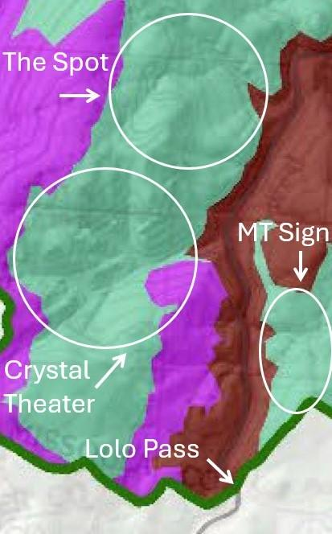
Figure 1: The desired Winter ROS setting for the Lolo Pass Area. Green is Semi-Primitive Non-Motorized, Purple is Semi-Primitive Motorized, and red is Primitive ROS setting.
Saint Regis: Saint Regis Basin
Saint Regis Basin is to the south of Lookout Pass along the crest of the Bitterroot Divide. This basin has some of the best backcountry skiing/snowboarding in western Montana with a deep inland northwest snowpack. Saint Regis Basin is the only basin that is feasibly accessible by non-motorized backcountry skiers/snowboarders on Lookout Pass for day trips, while extensive snowmobile opportunities are available in adjacent basins.

Much of Saint Regis Basin is also an Inventoried Roadless Area (IRA) as well as non-inventoried roadless area. There is significant use conflict in the basin. Prior attempts to collaborate with local snowmobile clubs (including collaborative signage) have proved ineffective, and current use policies create significant use conflict and safety concerns. The area is also used by cross-country skiers and snowshoers.

We support the proposed desired Winter ROS for the basin as a Semi-Primitive Non-Motorized setting. This setting would minimize use conflict and safety concerns in the basin.

We strongly oppose the proposed desired winter ROS for the FS 18591 as a Semi-Primitive Motorized setting (Figure 2). Allowing snowmobiles on the road would introduce use conflict not only on the road but would also provide an opportunity for motorized trespass into the Semi-Primitive Non-Motorized setting area. Please consider a desired winter ROS for the FS 18591 road as a Semi-Primitive Non-Motorized setting.
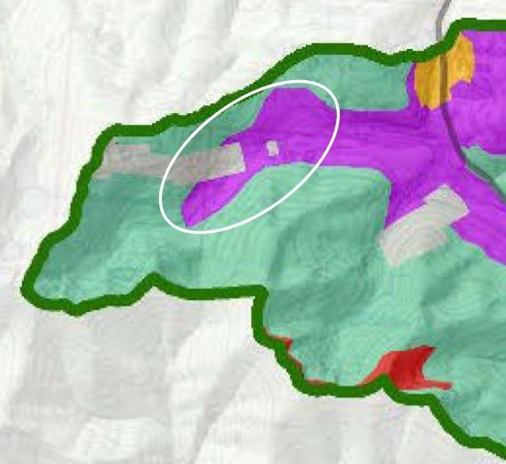
Figure 2: The desired Winter ROS setting for the Saint Regis Basin area. Green is Semi-Primitive Non-Motorized, Purple is Semi-Primitive Motorized, and red is Primitive ROS setting. Circle depicts motorized area referenced in text. Allowing motorized access in this area would increase use conflict and trespass.

Clearwater Upper Blackfoot: Morrell Mountain
Morrell Mountain in the southern Swan Mountains is a popular backcountry ski/snowboard destination. This area sees >1000 non-motorized user days per year through two yurts run by Montana Backcountry Yurts (Figure 1). One yurt is located just east of the Morrell Mountain Lookout (6,800 ft.), and one yurt is located lower to the south of the lookout (6,400 ft.). This area has been an area of contention between the snowmobile and backcountry ski/snowboard communities since the Revised Travel Plan was put in effect in 2002. Most important to the backcountry ski community is the watershed to the south of Morrell Mountain in Cottonwood Creek watershed (Section 26). This area provides the best skiing opportunities at a reasonable level of access.
We support the desired Winter ROS setting for Cottonwood Creek watershed to the south of Morrell Mountain as a Semi-Primitive Non-Motorized setting (Figure 3). This is the area where most backcountry skiers use, and where conflict with snowmobiles has been most pronounced.
We understand the need for the road to the Morrell Mountain Lookout Road (FR 4365) to remain open to snowmobiles. However, because the road switchbacks as it climbs the mountain, the entire area appears to be open to snowmobiles (Figure 3). One of the Montana Backcountry Yurts’ yurts is located in what appears to be entirely motorized to the south of the lookout. This area is safe from avalanches and is used by beginner/intermediate backcountry skiers/riders who stay at the yurt. With such a large buffer of the road, snowmobiles will use the whole area and conflict will continue. Please consider reducing the size of the road buffer to ensure that motorized traffic remains on the road to the lookout.

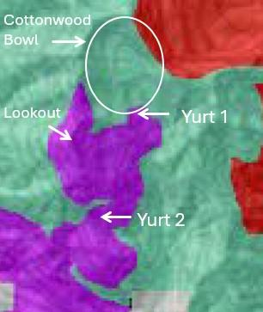
Figure 3: The desired Winter ROS setting for the area around Morrell Mountain. Green is Semi-Primitive Non-Motorized, Purple is Semi-Primitive Motorized, and red is Primitive ROS setting.
Middle Clark Fork: Hoodoo Pass
Hoodoo Pass is a popular early season backcountry ski/riding location. While much of the area is non-motorized, MBA members have reported several violations by snowmobiles in non-motorized areas, specifically the Great Burn Recommended Wilderness area, which can be accessed from Hoodoo Pass.

We support the proposed desired Winter ROS for the area as Semi-Primitive Non-Motorized and Primitive settings. This setting would limit use conflict in the area and reduce motorized trespass into the Great Burn Recommended Wilderness area.

We do not support the inclusion of small isolated areas as a Semi-Primitive Motorized setting (Figure 4). Possibly these are just GIS errors, but we support removing these small areas for practical reasons that they would not be accessible by snowmobiles in the winter. Please consider changing the small isolated areas as Semi-Primitive Non-Motorized or Primitive settings.

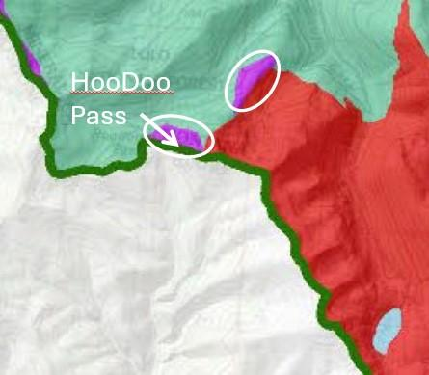
Figure 4: The desired Winter ROS setting for the HooDoo Pass area. Green is Semi-Primitive Non-Motorized, Purple is Semi-Primitive Motorized, and red is Primitive ROS setting. Circles depict motorized areas referenced in text.

Greater Missoula: Marshall Mountain and Wisherd Ridge

Marshall Mountain
Marshall Mountain is a former ski resort located just 10 minutes from Missoula. While the base and some of the ski terrain is being purchased by the City of Missoula, much of the area above the former ski area lies on Forest Service land regularly skied by backcountry skiers/riders. It is not uncommon to see a nearly full parking (80+cars) lot full of backcountry skiers/riders. Snowmobile use is rare in the area, but is currently allowed. We feel motorized use is incompatible with the extensive non-motorized use and the City’s vision for Marshall Mountain Park and has the potential to create safety concerns.

We support the proposed desired Winter ROS for the area as a Semi-Primitive Non-Motorized and Primitive setting. This ROS for the area aligns with current use and will prevent future user conflict in the area.

Wisherd Ridge:
Wisherd Ridge has traditionally been the most popular backcountry ski/riding area near Missoula. The area has easy access from Missoula, deep snowpack, and some of the best terrain in the region including steep bowls and glades. However, over time and with improvements in OSV technology, snowmobiles have begun high-marking in the bowls, creating use conflict. This recent increase in use has largely displaced backcountry skiers/riders in that area. The noise, tracks, and risk posed from the snowmobiles restricted skiing to the lower areas that had too many trees for snowmobiling. Today most skiers use the forested area to the south of Wisherd Ridge at Lockwood Point, but some skiing/riding and conflict continues in the Wisherd Ridge bowls.

We support the proposed desired Winter ROS for the area as Semi-Primitive Non-Motorized and Primitive setting. This ROS for the area aligns with traditional use of the area by non-motorized users, and will eliminate current use conflict in the area.

Thank you for your consideration of our scoping comments. We look forward to continuing to work collaboratively with the Lolo National Forest and other relevant agencies and stakeholders to help develop balanced winter recreation management scenarios that minimize conflict between different recreation uses and yet provide equitable and quality access and opportunities for all. Please do not hesitate to contact us if you have any questions.

Sincerely,

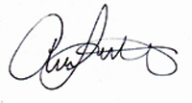
Adam Switalski
Board President
Montana Backcountry Alliance
PO Box 8691
Missoula, MT 59801

David Page
Executive Director
Winter Wildlands Alliance
901 Main St.
Suite 235
Boise, ID 83702

Appendix A: Approximate Locations of Focal Backcountry Ski/Riding Areas
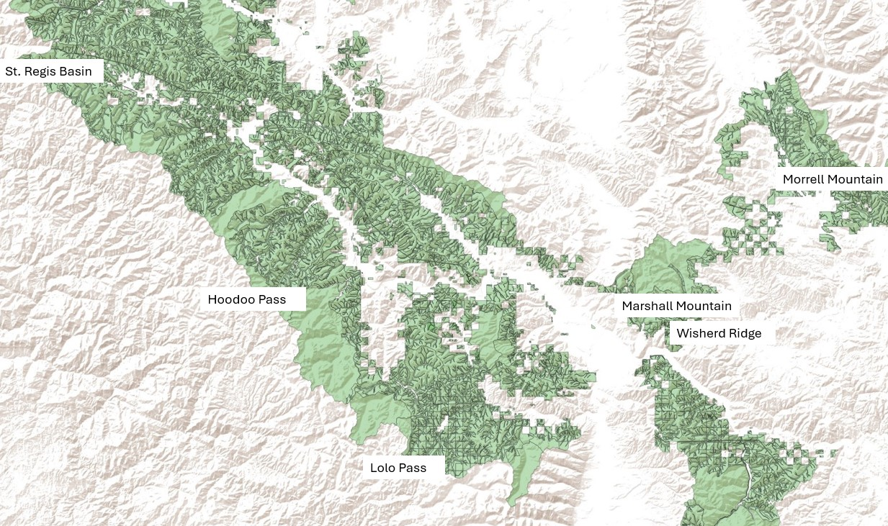

Eisen, H. 2015. Winter Recreation on National Forest Lands. A Comprehensive Analysis of Motorized and Non-Motorized Opportunity and Access. Winter Wildlands Alliance, Boise, ID. 37p.

