November XX, 2017

Grand Mesa, Uncompahgre and Gunnison National Forests
Attn: Plan Revision Team
2250 South Main Street
Delta, CO 81416

Re: Draft assessment comment extension request

Dear Plan Revision Team,

In light of the importance of the Assessment phase of the Forest Plan revision for developing the informational base for the planning effort, as well as the holiday schedule and the unusually large number of stakeholders interested in and affected by the GMUG Forest Plan revision, we are writing to request a 45-day extension of the deadline for submitting comments on the draft Assessment. We appreciate the planning team’s efforts to move briskly through the planning process, but believe that those efforts must not come at the expense of public engagement.

The Assessment phase of planning under the 2012 Planning Rule is exceptionally important because it develops the information that will undergird the entirety of the planning effort. We view this phase as an essential investment in the ultimate success of the planning process. It is especially important that the Assessment incorporate robust public feedback with regard to outdoor recreation because the recreation community will often, if not always, be the best source of information regarding where people go on the Forests, what they do there, and the values that drive those decisions.

Public input on the Assessment is especially important for the GMUG Forests because they are such highly valued resources for outdoor recreation, with substantial population centers within close proximity and a high volume of quality recreational resources. Our organizations are keen to assist in facilitating outreach to the recreation community, and we believe that additional time—particularly given that Thanksgiving week falls in the middle of the current comment period, as well as the upcoming holidays—will help allow for more substantive public engagement.

Thank you for considering this request for an extension of the comment period.

Best Regards,

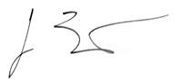 | 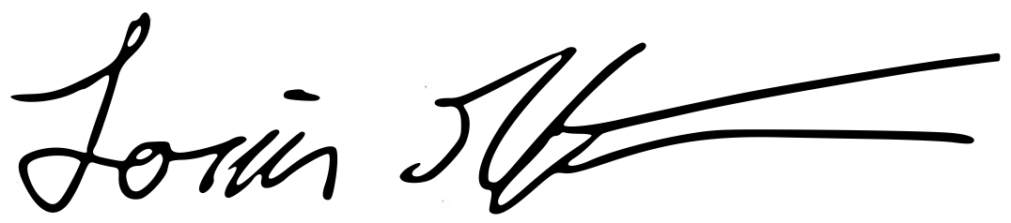
Jason Bertolacci  Founding Member  Outdoor Alliance Colorado | Louis Geltman  Policy Director  Outdoor Alliance

cc: Adam Cramer, Executive Director, Outdoor Alliance
Nathan Fey, Colorado River Program Director, American Whitewater
J.B. Haab, FRCS Field Manager, Access Fund
Julie Mach, Conservation Manager, Colorado Mountain Club
John McCauley, Regional Organizer, Outdoor Alliance
Maria Millard Povec, Policy & Advocacy Director, American Alpine Club
Gary Moore, Executive Director, Colorado Mountain Bike Association

