Comment re Impact of Cattle on Water Sources and Ground Trampling (with Examples #2 and #3)

Throughout the Heber Wild Horse Territory Draft Management Plan and its associated documents, much concern is expressed over any damage the horses may possibly cause to water quality and sources and to the overall health of the forest. Concern for damage caused by cattle cannot be found anywhere in Forest Service Plan documents. According to the Heber Allotment Management Plan, cattle just don’t cause damage.

Throughout Forest Service documents, there is a clear bias in favor of domestic livestock and a clear bias against our federally protected Heber Wild Horses, which are to be considered a self-sustaining and natural component of our public lands. There is so much bias in favor of the cattle that you would actually think the cattle are the protected animals.

I have been unable to locate a Black Canyon Allotment Plan, which is strange, since the Heber Wild Horse Territory overlaps the Black Canyon Allotment. The entire Black Canyon Allotment area needs to be assessed, not just the portion of that Allotment that overlaps the Territory, and the assessment of both Allotments (Heber and Black Canyon) in regards to cattle grazing needs to be fair and unbiased.

Cattle have an alarming impact on water availability and water quality. And, cattle badly trample areas around water sources. Attached is an example of just one water source where the water was completely depleted by cattle in very short order. Additional photos and video of this and other water sources are available. Especially concerning is the impact of cattle on the Black Canyon Lake water quality, considering the fishing, camping and other family recreational activities in the area during the summer months and the fact that cattle stand around water sources for days on end and freely urinate and defecate into the water.

Below are Examples #2 and #3 of three separate examples of the negative impact of cattle, which is never considered in any of the Forest Service’s planning documents.

Dirt water tank on Forest Road 124, east of the 146. Photo Taken June 9, 2019:
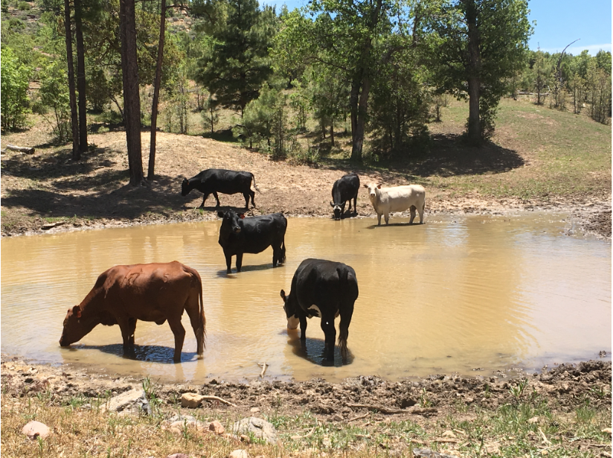
Same water tank – Photo Taken July 24, 2019:
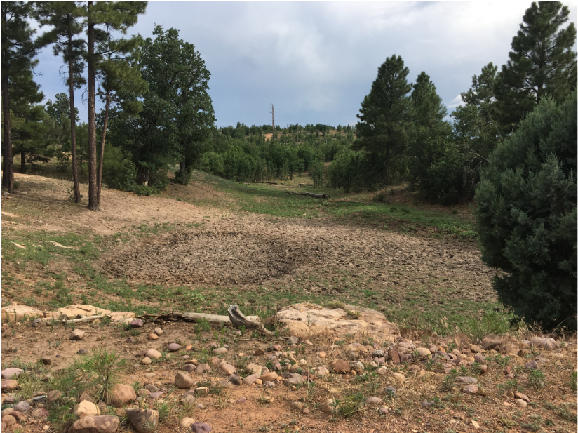
Note: I have video of a very large number of tadpoles that died in this water tank after cattle urinated and defecated in the water and finally left the hole bone dry.

Two photos of cattle defecation in and around the waters’ edge:
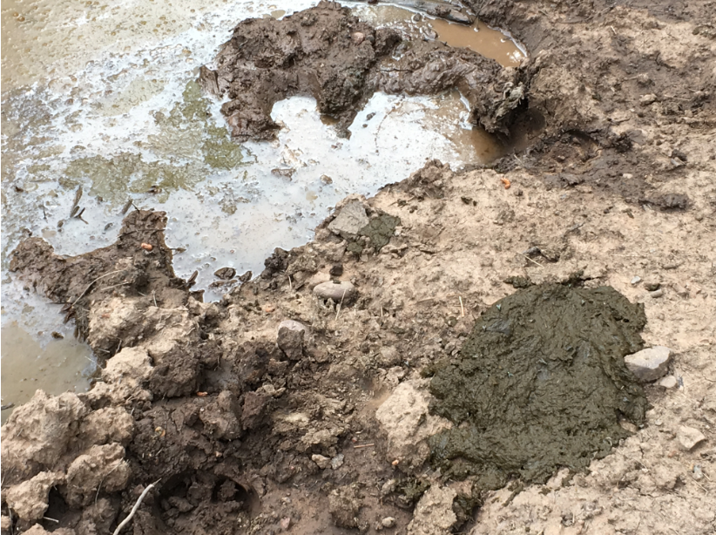
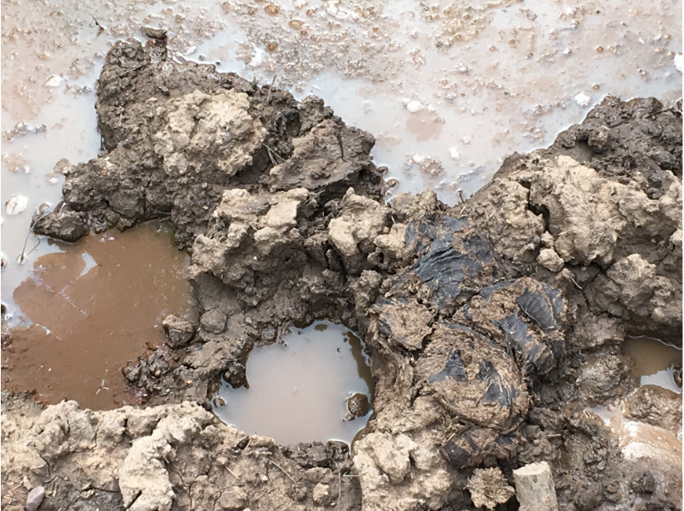

Old Buck’s water tank on Forest Road 124, east of the 51. You can see a good amount of water in the tank. Two photos taken June 19, 2019:
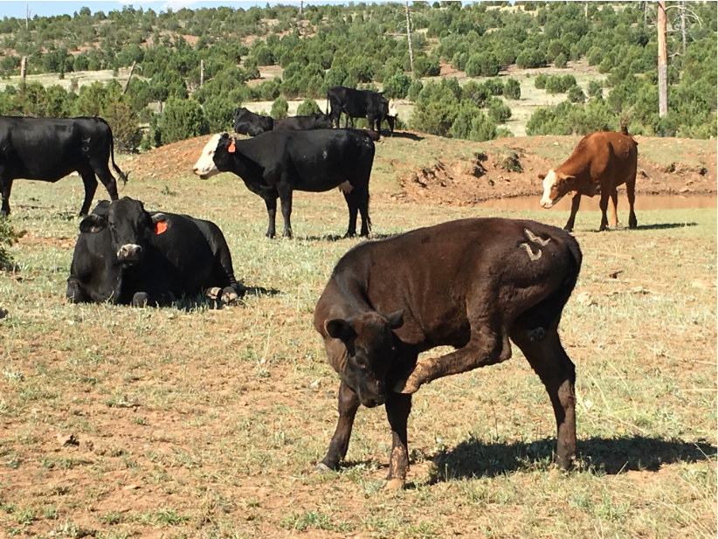
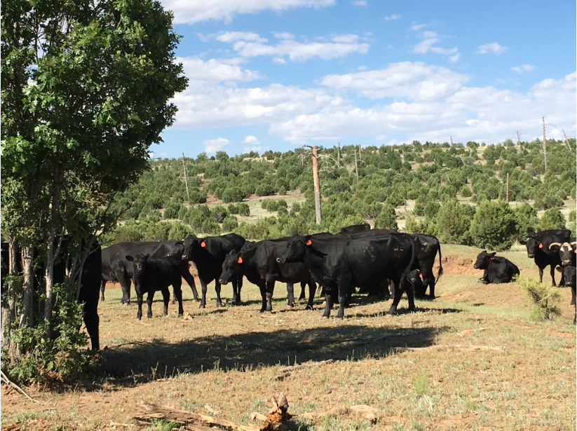

Same water tank, nothing more than mud and muck with cattle feces all around. Two photos taken on July 21, 2019:
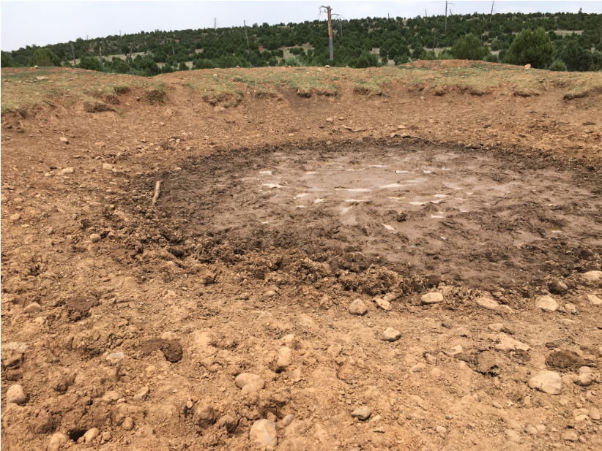
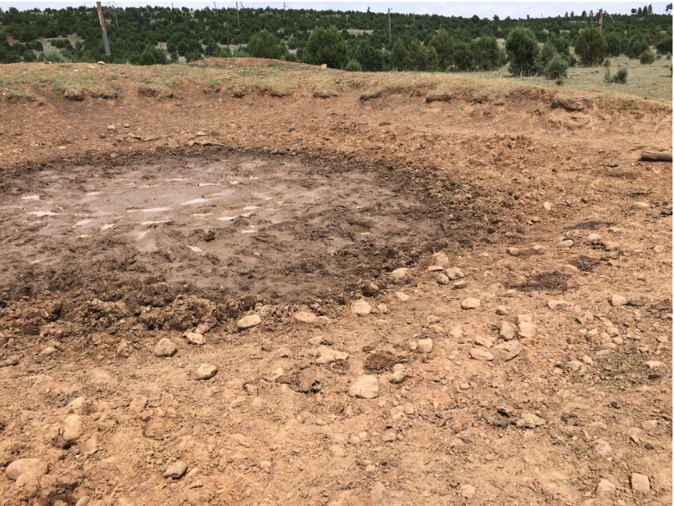

The area in and around the water tank is badly trampled by cattle, with cattle feces all around. Three photos taken July 21, 2019:
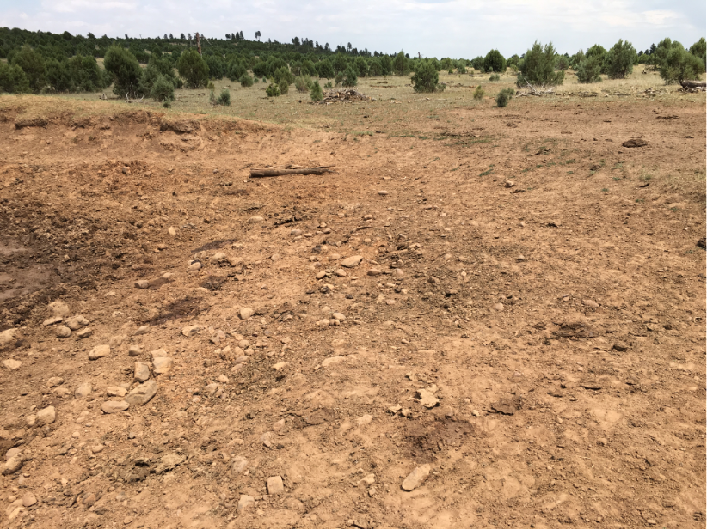
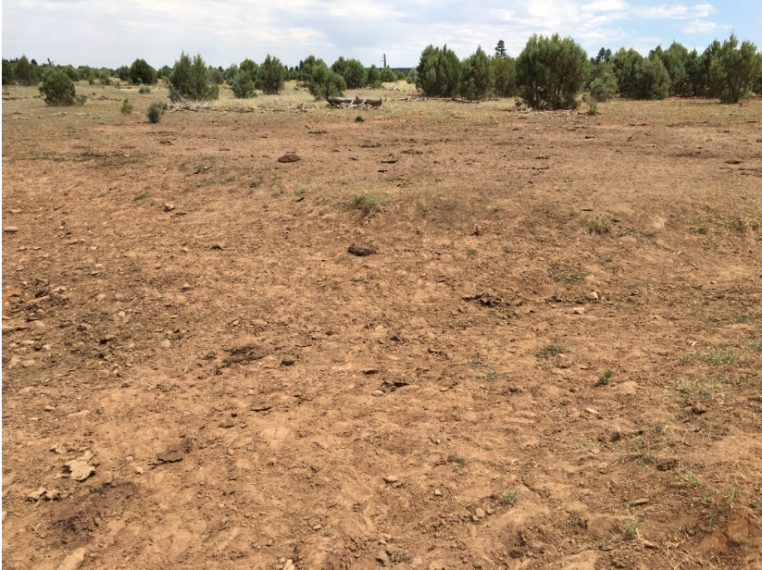
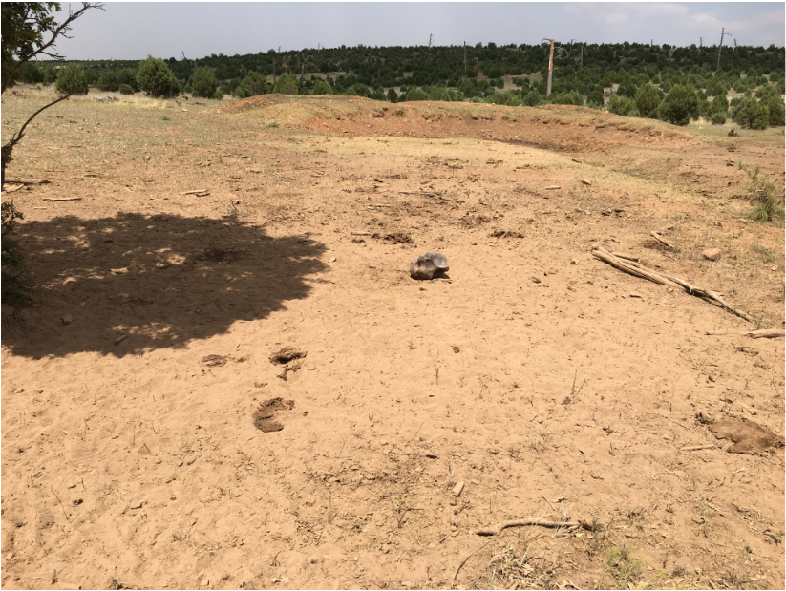

Same tank. Two photos taken July 29, 2019 shows the area is badly trampled by cattle and covered with cattle feces:
