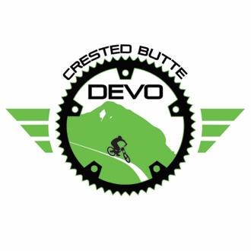
January 29, 2022

United States Forest Service
Rocky Mountain Region
216 N. Colorado
Gunnison, CO 81230

To Whom It May Concern:

On behalf of the Crested Butte Development Team Board of Directors, I formally submit these comments on the North Valley Trails Project for your consideration. This letter has been approved via email and will be included in the February 17, 2022 Crested Butte Development Team Board of Directors Meeting documents.

Thank you so much for inviting the Crested Butte Development Team to participate in this process. As a non-profit youth mountain bike program, our partnership with CBMBA is extremely important to us. As a 20+ year resident of Crested Butte, I personally am very familiar with CBMBA’s efforts since 2009 when they first started developing a long-term trail construction plan. Fast forward 13 years, outdoor recreation tourism in the north end of the Gunnison Valley has exploded and thankfully, CBMBA was already in a position to tackle this growth head-on.

For over a decade CBMBA has been collaborating and reaching out to stakeholders, including STOR, to find consensus and a plan that was agreed upon. They have gone through extensive scoping on their own and it is our opinion that nobody in Gunnison County puts as much passion into our trail system as CBMBA. We support all of CBMBA’s efforts to bring forth a recreation experience that is safe, responsible, and sustainable. While the eight trails that are included in this plan are incredible, I am left to wonder what happened to the other trails that were originally in this plan? The Snodgrass connector to the Rendezvous camping area would have been another great opportunity to get riders off the road, as well as provided a much-needed beginner trail.

We recognize that the USFS, as a nonpartisan government agency, must balance the interests of all citizens. In that spirit, it is unclear to us how the USFS weighs the interests of the ranching community and opportunities for enhanced recreational land use. Historically, the balance of USFS rulings in our district have appeared to favor ranching interests over recreational enhancement. It would be beneficial to all community members, and much appreciated, if the USFS would help us understand how these competing interests have been weighed and considered. Time and again, the people of Gunnison County have expressed an overwhelming desire for more trails, especially additional beginner and intermediate trails which would have been hugely beneficial for CB Devo programming.

This plan makes logical sense as these additional trails will complete a better network while not fragmenting existing trail locations. Ultimately, the North Valley Trails Project will keep users much safer by getting “Riders off the Road”. As a youth organization, we are especially appreciative of CBMBA’s vision to supplement our existing trail system with easier, safer trails for young riders. It is clear to us that CBMBA has done their due diligence, has shown beyond doubt, that all of these proposed trails serve a purpose and need that have been thoroughly vetted. By providing non-motorized users an alternative to busy roads, such as the Irwin Parallel trail, this plan will reduce congestion thus making access to recreation less stressful on everyone by lessening user conflict.

Thank you for your time and consideration of the North Valley Trails Project. We look forward to further supporting the goals and objectives of CBMBA’s “Riders off the Road” initiative as we unequivocally believe that there is an imminent need for robust management action.

Sincerely,

Amy Nolan
Executive Director, Crested Butte Development Team &
The Crested Butte Development Team Board of Directors

