February 15, 2020

To: Ms Shelly Grail
Recreation Manager
White River National Forest
Re: Comments for USFS NEPA review of the Redstone to McClure Pass trail

Dear Ms. Grail:

This letter contains my comments about the NEPA evaluation for the Crystal Trail from Redstone to the top of McClure Pass. I strongly support the exact trail alignment recommended by the Pitkin County Open Space and Trails for the Crystal Trail. Additionally, it is vitally important to include the trail segment up the old McClure Pass roadbed from Placita to the top of McClure Pass in the Crystal Trail alignment. This segment has been used extensively by locals and visitors since it was decommissioned as a vehicle road in the 60’s, and continues year round today.

Having attended many community meetings about the Crystal Trail, I am very aware that some are promoting a trail completely within the ROW of Hwy 133. This is a very bad idea for the reasons outlined below.

Here are my two points to consider in support of my recommendation to preserve the old McClure Pass alignment. First, most that live in and visit the Crystal Valley do so to recreate and enjoy the marvels of nature in the Crystal Valley. Bicycling or hiking side-by-side with the noise and speed of passing car and truck traffic on Hwy 133 would fail to provide any contact with nature. Hence the user experience of a trail in the highway ROW would seriously discourage most from using it.

Secondly, claims have been made at various community meetings that the area around the old McClure Pass road is an elk sanctuary and including it as part of the proposed Crystal Trail would have major impacts on the elk population. Elk wintering and calving are frequently mentioned to support this claim. This is then the basis for the recommendation to locate the Crystal Trail completely within the Hwy 133 ROW. I am a frequent four-season user of the old McClure Pass roadbed trail and over the years have seen little factual evidence to support any of these claims. The Placita area is not a major wintering or calving area as claimed. Some elk winter in the Placita area on the east side of the Crystal River where human presence is quite small, but rarely on the west side around the old McClure Pass trail alignment.

Thanks for listening,
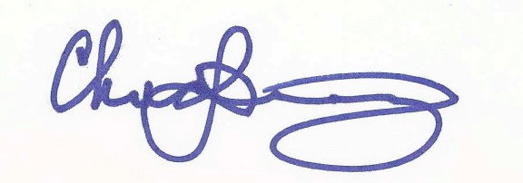
Chuck Downey

