TABLE OF CONTENTS

Project Introduction 1
Area Description 1
Background 1
Project Location Map 2
DESCRIPTION OF PROPOSED ACTION 3
Purpose and Need 3
Proposed Action 3
Project Design Features 3
SPECIES CONSIDERED AND EVALUATED 4
Listed and Sensitive Species 4
Consultation History 4
CHINOOK SALMON, STEELHEAD, and BULL TROUT 5
Environmental Baseline 5
Section 7 Watershed Summary 5
Analysis Area Summary 5
Species Status Overview 7
Effects Analysis 20
Direct Effects 23
Indirect Effects 24
Summary Effects to Bull Trout Critical Habitat PCEs 27
Cumulative Effects (State and Private) 27
Determination 28
Rationale 28
LITERATURE CITED 30

Table of Figures

Figure 1. Project vicinity located within Profile Creek 6th HU Analysis Area 2

Figure 2. Analysis Area, South Fork Salmon River Section 7 Watershed. 6

Figure 3. Habitat Designations. 10

Figure 4. Map of proposed site. 22

Figure 5. Ford 1.. 26

Figure 6. Ford 2. 26

Figure 7. Parking/turn around area, End of SUA. 27

Table of Tables

Table 1. Federally listed species determination summary 4

Table 2. Appendix B Baseline. 11

Table 3. Bull Trout DCH Crosswalk 19

Table 4. Effects to Watershed Condition Indicators. 20

Table 5. Species and life stages potentially affected by fording. 24

Project Introduction
This Biological Assessment (BA) evaluates and discloses the effects to threatened, endangered, or proposed fish species from the project located on the Krassel Ranger District, Payette National Forest (PNF), in Valley County, Idaho. This BA is in accordance with Forest Service Manual Direction (FSM 2672.4) to review all planned, funded, executed, or permitted programs and activities for possible effects on endangered, threatened, or proposed species. No effect determinations were documented for lynx and North Idaho Ground Squirrel.

Area Description
The project is located on the Krassel Ranger District. The road is described as starting in Township 20 North, Range 9 East, section 30 and continuing through Township 20 North, Range 8 East, section 25; Boise Meridian, Valley County, Idaho. See project map (Figure 1).

Motorized access would be authorized on unauthorized road 503408900 (aka Red Metal Mine Road) from the Profile Gap road 50340 to a parking/turn around area as shown on the attached map ( Figure 4). From the parking area, access to the furthest private property is via user created non-motorized trail to Crater Lake.

Background
The PNF is proposing to allow motorized access to personal property owners on road 503408900 (aka Red Metal Mine Road). Personal, motorized access would be limited to approximately <40 trips per year (Vita, personal communication). The existing road is not open for motorized use to the public under the current Forest Travel Plan; therefore, authorization is needed for motorized use on this route. The Vita’s have used the route to access their property for many years. In 2008, they submitted a special use application requesting authorization for motorized use of the road for access to private property. From 2012 through 2015, a temporary permit has been issued to the Vita’s for motorized access on the road. The Vita’s have seen increased use of the road by the public over the past several years. Even though the road is closed under the travel plan, there are no signs or barriers to prevent use. The Vita’s have committed to installing a gate on the road at the junction with the Profile Gap Road as part of their special use authorization (SUA). There is additional private property and mining claims that would be accessible via this road, but currently no other SUA’s have been requested or issued. For the purposes of this SUA, “baseline” is considered to mean that the road is closed to public use, but continues to experience unauthorized traffic.

Project Location Map
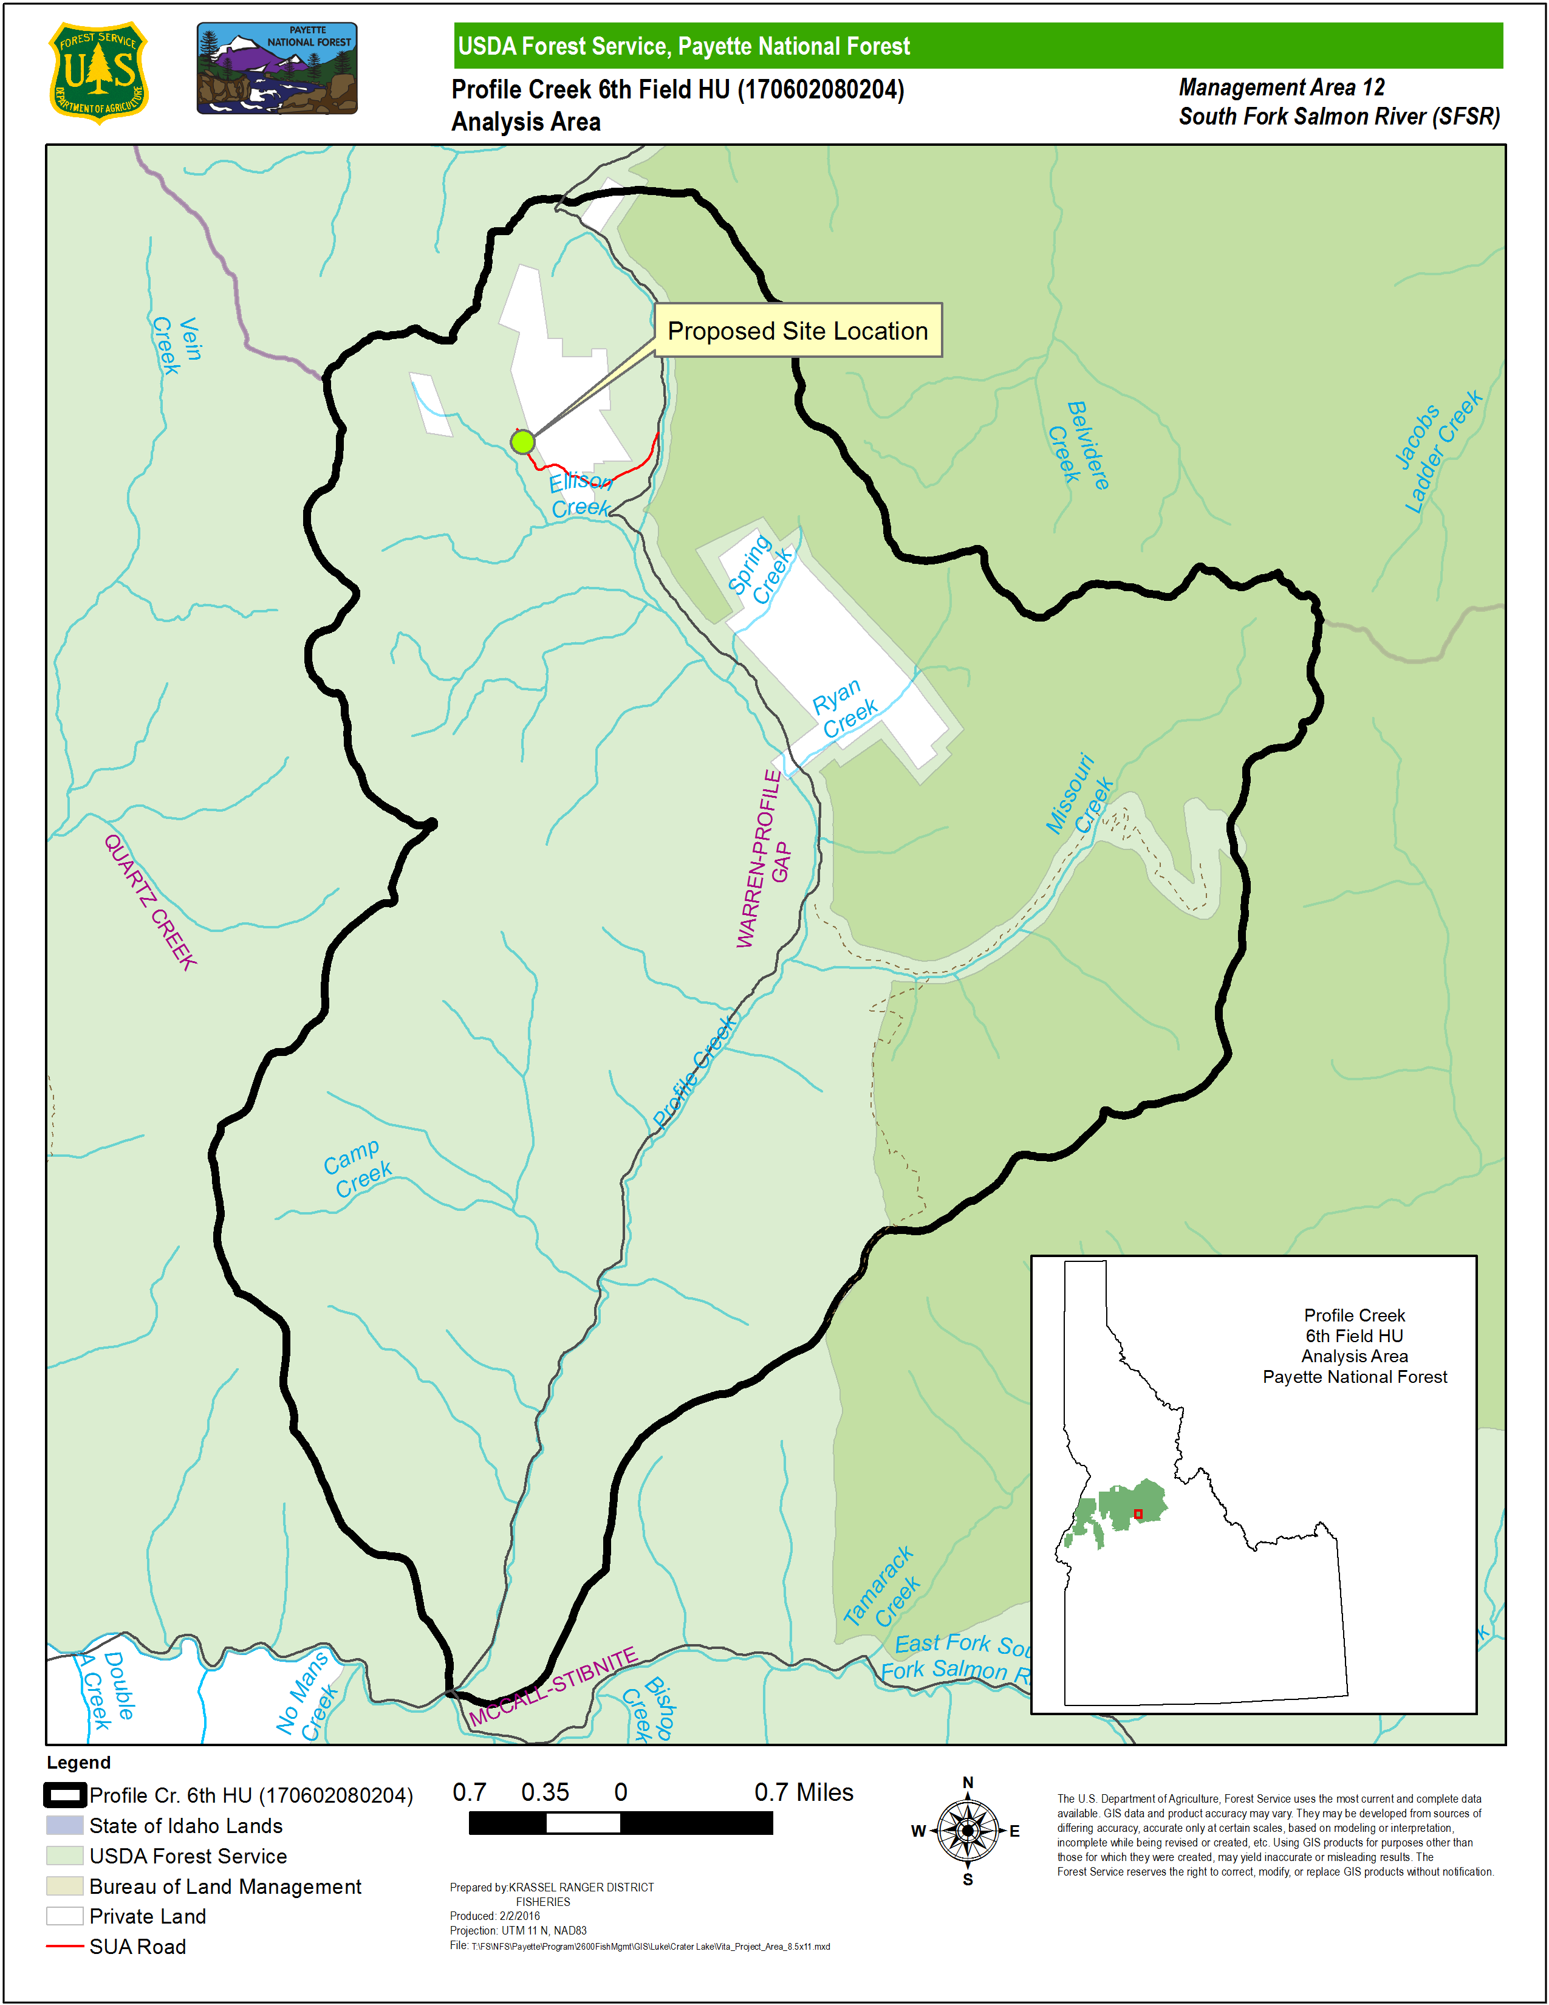
Figure 1. Project vicinity is located within Profile Creek 6th HU Analysis Area and is denoted on map.

DESCRIPTION OF PROPOSED ACTION

Purpose and Need
The purpose of this project is to authorize motorized use and maintenance of an unauthorized road crossing the PNF through the issuance of an SUA.

The need for this project is to respond to a request from the Vita’s for motorized access to a parking area that is near their private property. The Vita’s own a 20 acre parcel that includes Crater Lake. The parcel is surrounded by National Forest land and the Vita’s have built a small cabin near the lake. The project provides motorized access on a short segment of road that leads to private property (20 acres) at Crater Lake.

Proposed Action
The proposed action would issue an SUA to private landowners for use and maintenance of an access road crossing PNF land to private land. The road is approximately ½ mile long. A parking and turn around area would also be included in the authorization.

The road is accessed from the Profile Gap road #50340, crosses PNF land to non-federal property (Mineral Survey #2041), and back onto PNF land to a parking and turn around area where the Vita’s park and hike to their Crater Lake property. Motorized access would be authorized on the portion of the road crossing PNF land for landowner ingress and egress purposes. The road also crosses private property and the Vita’s have attained permission for use of the road through the non-federal property (On file PNF).

There are two perennial stream fords along the road. Both of these ford locations have predicted sediment delivery through Geomorphic Road Analysis and Inventory Package (GRAIP) models ( Figure 4). These points will be hereafter referred to as Ford 1 (Figure 5) and Ford 2 (Figure 6).

Project Design Features
- Rolling dips will be placed at FS-approved locations and at GRAIP modeled delivery points. Material used to create rolling dips will be sourced from a pit approved as weed free by an individual certified by the State, County, or Forest Service.
- All equipment used to ford streams will be regularly inspected by the Holder to ensure there are no leaks.
- Maintenance will occur as needed to ensure sediment generation and subsequent deliver is minimized.
- Barriers such as large rock will be installed in the parking area at the end of the road to prevent future expansion of the disturbed area. A Forest Service representative will approve barrier placement.
- Tributary ford approaches will be armored at FS-approved locations. Aggregate used to armor ford will be sourced from a pit approved as weed free by an individual certified by the State, County, or Forest Service.
Ford maintenance and improvement will ensure that no material will be placed in the stream, and that aggregate will be simply placed on top of the existing surface in lieu of excavation.

SPECIES CONSIDERED AND EVALUATED

Listed and Sensitive Species
The species included in this Biological Assessment (BA) were based on the forest-wide species lists prepared by United States Fish and Wildlife Service (USFWS) for the PNF (Table 1). This BA evaluates potential effects on Essential Fish Habitat (EFH), pursuant to section 305(b) of the Magnuson-Stevens Act and its implementing regulations, 50 CFR Part 600.920. This document also includes a Biological Evaluation (BE) of the effects of Federal actions on Westslope Cutthroat Trout O. clarki lewisi. Biological Evaluations for sensitive species are prepared by direction of the Forest Service manual (FSM 2670).

Table 1. Federally listed species determination summary
Species | Scientific Name | Status | Determination
Bull Trout | Salvelinus confluentus | Threatened  Designated Critical Habitat | NLAA
Spring/Summer Chinook Salmon | Oncorhynchus tshawytscha | Threatened  Designated Critical Habitat | NLAA
Steelhead | Oncorhynchus mykiss | Threatened
 |  | Designated Critical Habitat | NLAA
Westslope Cutthroat Trout | Oncorhynchus lewisi | Sensitive PNF Species | NLLL

Consultation History

The project was introduced to the Level 1 on February 11, 2016.

CHINOOK SALMON, STEELHEAD, and BULL TROUT

Environmental Baseline

Section 7 Watershed Summary
The South Fork Salmon River (SFSR) watershed covers 721,926 acres in the Payette (594,432 acres) and Boise (104,427 acres) National Forests (Figure 2). State and private lands make up less than four percent of the watershed’s land base. Designated wilderness areas total 69,100 acres. A variety of land uses occur on public and private land, including, but not limited to, livestock grazing, mining, recreation, road maintenance and reconstruction, road use and timber harvest.

Analysis Area Summary
The Analysis Area is the Profile Creek 6th HU (170602080204) (Figure 2). Measurable effects to Forest Plan Appendix B Watershed Condition Indicators (WCIs) (
Table 2) are not expected downstream of the Analysis Area.
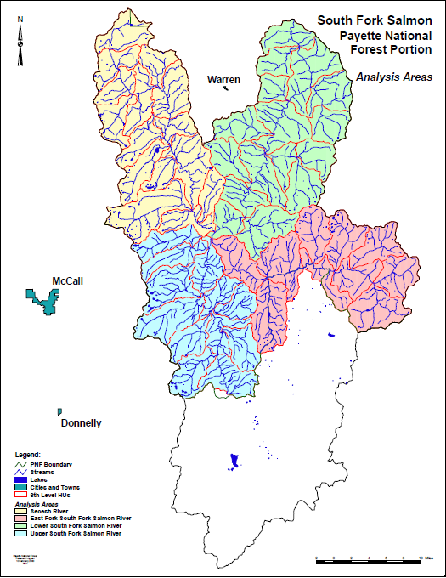
Figure 2. Analysis Area is the Profile Creek 6th Field HU.
Profile Creek 6th Field HU

Species Status Overview
The fish species listed under the Endangered Species Act (ESA) of 1973, as amended (16 USC 1531 et seq.), occur widely throughout the SFSR Section 7 Watershed. These ESA listed fish species are Snake River spring/summer Chinook Salmon, Snake River Basin steelhead, and Columbia River Bull Trout. Westslope Cutthroat Trout are designated by the Regional Forester (Region 04) as a “Sensitive” species.

Snake River Spring, Summer Chinook Salmon
Snake River spring/summer Chinook Salmon (hereafter referred to as “Chinook Salmon”) were listed as threatened on April 22, 1992 by the National Marine Fisheries Service (NMFS) (57FR14653). Critical habitat for Chinook Salmon was established December 28, 1993 (58FR68543). Designated critical habitat (DCH) for Snake River spring/summer Chinook Salmon consists of river reaches of the Columbia, Snake, and Salmon Rivers, and all tributaries of the Snake and Salmon Rivers (except for the Clearwater River), and adjacent riparian zones (i.e., 300 feet on either side of the normal high water line [50 CFR 226.205]), presently or historically accessible to Snake River spring/summer Chinook, except reaches above impassible natural falls and Hells Canyon Dam.

Snake River spring/summer Chinook Salmon exhibit a stream-type life history, which means they rear in freshwater for an extended period of time (NMFS 2011). Adults (mostly 3 and 4 year old fish) begin their upstream migration in the Columbia River in late February and early March. In high elevation areas, mature fish hold in cool, deep pools until late summer and early fall, when they return to their native streams to begin spawning. Eggs incubate through the fall and winter and emergence begins in the late winter and early spring. Most juvenile fish mature in fresh water for 1 year before they migrate to the ocean in the spring of their second year, and may be present in the Action Area year-round.

The Analysis Area occurs within the EFSFSR Chinook Salmon Population, a historically large population, consisting of historic spawning areas in the EFSFSR mainstem and in Johnson Creek (NMFS 2011). Chinook Salmon in the upper EFSFSR (upstream from the Yellow Pine Pit) were extirpated by sediment and pollutants from mining operations early in the 1940s, and most current spawning occurs in Johnson Creek, approximately 20 kilometers (km) downstream from the project area. Recently however, the IDFG planted Chinook Salmon above Yellow Pine Pit Falls, a highly suspected upstream fish barrier, which have spawned successfully (Nez Perce Tribe (NPT) 2010, 2011). The SFSR is supplemented with artificially produced Chinook Salmon from the McCall hatchery, and the Idaho Department of Fish and Game (IDFG) conducts an annual sport fishery for hatchery fish when returns exceed the number needed for supplementation purposes.

Chinook Salmon DCH occurs within the Analysis Area (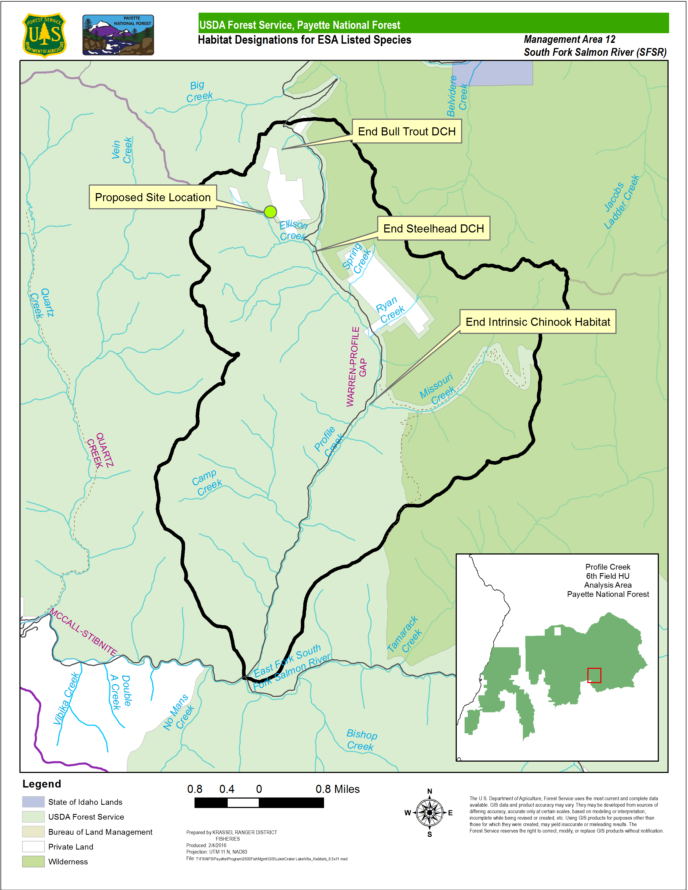Figure 3). Spawning and rearing also occurs within the Analysis Area, and surveys have detected the species in both the EFSFSR and Profile Creek. Habitat modeled as intrinsic potential for spawning and rearing occurs approximately 4.95 stream km downstream from the project area (Figure 3).

Essential Fish Habitat
EFH is established pursuant to the Magnuson-Stevens Fishery Conservation and Management Act (MSA, 50 CFR 600) and is considered synonymous with designated critical habitat in this area (PFMC 2014).

Snake River Steelhead
Snake River steelhead (hereafter referred to as “steelhead”) were listed as threatened August 18, 1997 by the National Marine Fisheries Service (NMFS) (62FR43937). The final rule designating critical habitat for steelhead was published by NMFS on September 2, 2005, and took effect on January 2, 2006 (70FR52630). In the case of steelhead, critical habitat includes only the water column and streambed, not adjacent riparian areas (70FR52630). Figure 3 depicts steelhead DCH within the Activity Area (50 CFR 226.212).

Less is known about wild steelhead than about Chinook Salmon. All Snake River steelhead are subspecies O. m. gairdneri and distinct from the coastal O. m. irideus and are placed into the same geographic grouping by Brannon et al. (2004) and are placed by NMFS as belonging to the Snake River Evolutionarily Significant Unit (ESU) (NMFS 2005). The common name for O. m. gairdneri is Redband Trout, but the anadromous form is typically referred to as a steelhead. Benhke (2002) refers to the anadromous redband as a redband steelhead and the stream resident form as Redband Trout. In the SFSR, these are the steelhead that return after 2 to 4 years in the ocean, and are referred to as “B-run fish”.

Steelhead rearing occurs throughout the Activity Area. Although not listed with steelhead, resident Redband Trout (aka rainbow trout) undoubtedly play a role in the population dynamics of steelhead because steelhead are merely the anadromous form of Redband Trout. Miller et al. (2014) report the approximate spawning, incubation, and emergence period for steelhead from February 1 to August 15th, with both spawning and emergence occurring on the later end of the spectrum in higher elevation and smaller streams such as Upper EFSFSR and its tributaries. Steelhead in the SFSR begin spawning about mid-April in the same traditional spawning areas as Chinook Salmon, but likely also use other suitable locations (Thurow 1987).

Within the Analysis Area, steelhead or Redband Trout occur throughout the EFSFSR and into Profile Creek. Steelhead DCH occurs throughout the Analysis Area and into Profile Creek, terminating approximately 1.3 stream km below the project area, at the confluence of Profile Creek and Ellison Creek (Figure 3).

It should be noted that Westslope Cutthroat Trout have additionally been documented in the watershed, which can be very difficult to distinguish from redband when the two species are less than approximately 200 mm in length (Ferguson and Zurstadt 2014). There is no recreational fishery for steelhead in the SFSR, nor is the population supplemented with hatchery-produced fish.

Columbia River Bull Trout
Columbia River Bull Trout Salvelinus confluentus were listed in 1998, (70 FR 56211) and were designated a Management Indicator Species (MIS) in the PNF Land and Resource Management Plan (LRMP; USFS 2003). As with steelhead, Bull Trout critical habitat includes only the water column and streambed, not adjacent riparian areas (75FR63898). The Bull Trout populations on the SFSR watershed are part of the Upper Snake Recovery Unit which has been subdivided for recovery planning into “core areas” with the proposed Action Area in the South Fork Salmon River core area (USFWS 2015a). The SFSR, is additionally comprised of 27 local populations and is regarded by the USFWS as one of the most robust, least threatened of the core areas (USFWS 2015b). Burns et al. (2005) summarized the assessment of Bull Trout viability (the PAF’s designated Management Indicator Species (MIS)) across the Forest and indicate high viability in the EFSFSR Analysis Area because of high connectivity, suitable habitat, and the presence of fluvial and adfluvial migrants.

Bull Trout distribution and abundance appear to be directly tied to specific habitat requirements. They need cold water to survive, so they are seldom found in waters where temperatures exceed 59°F to 64°F (15°C to 18°C). They also prefer stable stream channels, clean spawning and rearing gravel, complex and diverse cover, and unblocked migratory corridors. Bull Trout exhibit two forms: resident and migratory. Resident Bull Trout spend their entire lives in the same stream/creek. Migratory Bull Trout move to larger bodies of water to overwinter and then migrate back to smaller waters to reproduce. Resident and juvenile Bull Trout prey on invertebrates and small fish. Adult migratory Bull Trout are primarily piscivorous.

Bull Trout reach sexual maturity at between four and seven years of age and are known to live as long as 12 years. They spawn in the fall after temperatures drop below 48°F (9°C), in streams with cold, unpolluted water, clean gravel and cobble substrate, and gentle stream slopes (USFWS 2015). Many spawning areas are associated with cold water springs or areas where stream flow is influenced by groundwater (USFWS 2015). Bull Trout eggs require a long incubation period compared to other salmon and trout (100-145 days depending on water temperature), hatching in late winter to early spring (USFWS 2015). Fry remain in the stream bed for up to three weeks before emerging. Juvenile fish are often found at or near the stream bottom.

All life history stages of Bull Trout are present in the Upper EFSFSR (Hogen and Scarnecchia 2006). Migrants stage at the mouths of presumptive spawning tributaries including Profile Creek from mid-July to mid-August, move into tributaries to spawn from mid-August to mid-September, and quickly outmigrate as far as the main Salmon River (Hogen and Scarnecchia 2006). Migrations from overwintering habitat to spawning grounds can exceed 100 km (Hogen and Scarnecchia 2006) which indicate a particular importance of the habitat of the upper EFSFSR to other distant Bull Trout populations.

Profile Creek is a known spawning tributary of Bull Trout (Hogen and Scarnecchia 2006) and has temperatures that satisfy the extreme thermal requirements for various life history stages of Bull Trout (Unpublished data on file PNF). Bull Trout DCH is coincident with the entirety of Profile Creek and occurs approximately 1.3 km downstream of the project area at the confluence of Profile and Ellison Creeks. Figure 3 depicts the termination point of bull trout DCH within the Activity Area.

Westslope Cutthroat Trout
Westslope Cutthroat Trout were petitioned for listing (63 FR 31691) but were determined by the USFWS to not be warranted in 2000 (65 FR 20120). Westslope Cutthroat Trout are widely distributed in the SFSR watershed. No abundance and trends exist because population-level fish data is not regularly collected. It is commonly believed that the range of Westslope Cutthroat Trout is shrinking due to habitat degradation, loss of connectivity, harvest, and introductions of exotic species (Shepard et al. 2005), and are thought to currently occupy somewhat more than 80 percent of their historic range. Thurow (1987) surveyed the mainstem and most important tributaries to the SFSR and reported that cutthroat trout were “uncommon” in both and comprised no more than 3 percent of the angler harvest in 1984 and 1985; this low abundance has led to catch-and-release angling regulations in the SFSR. Within the project area Westslope Cutthroat Trout occur throughout the EFSFSR and in Profile Creek.

Figure 3. Termination points for Designated Critical Habitat Designations for steelhead and Bull Trout and Intrinsic Potential Habitat for Chinook Salmon in the Analysis Area.

Table 2. Appendix B Baseline
Profile Creek 6th Field Subwatershed Analysis Area
Agency/Unit: | PNF Krassel Ranger Districts |  | HU Code & Name: |  |  | 170602080204 Profile Creek 6th HU
Fish Species Present: | Chinook Salmon, steelhead, Bull Trout, cutthroat |  | Spatial Scale of Matrix: |  |  | 6th Hydrologic Unit
(Anadromous. Sp.) Population: | South Fork Salmon River |  | Subpopulation: |  |  | East Fork South Fork Salmon River
(Bull Trout) Core Area: | South Fork Salmon River |  | Local Population: |  |  | South Fork Salmon River
Management Action(s): | Crater Lake Road Special Use Authorization
Pathway Indicators | Population and Environmental Baseline
 | Desired Condition | Baseline |  | Discussion of Baseline –Current Condition
Subpopulation Character (Bull Trout Only)
Subpopulation Size | Bull Trout - Mean total local population size or local habitat capacity more than several thousand individuals. Adults in local population > 500. All life stages are represented within the local population. | FR  PJ |  | Population size unknown. Thurow (1987) reported that Bull Trout populations are viable; however the status of discrete populations is unknown. A tagging study of Bull Trout in the EFSFSR found the fish dispersed throughout the main river as well as in several tributaries, primarily Profile, Tamarack, and Sugar Creeks (Hogen 2002). Bull Trout also moved further up into smaller tributaries of these three systems. Thurow (1987) documented fish densities for the mainstem and tributaries ranging from 0.26 to 0.51 fish per 100 m². Spawning and rearing habitat for Bull Trout occur throughout the river and its tributaries; adfluvial Bull Trout use the Yellow Pine Pit in the Stibnite area (Hogen 2002)”...
Growth and Survival | Bull Trout - Local population has the resilience to recover from temporary or short-term disturbances (e.g., catastrophic events, etc.) or local population declines within 1 to 2 generations (5-10 years). The local population is characterized as increasing or stable. At least 10 years of data support this estimate. | FR  PJ |  | Spawning occurred over a short, definite time period, from September 1 –15 with all spawning completed by September 20. Overwintering of fish tagged in the EFSFSR occurred in the EFSFSR and the main South Fork Salmon River, and extended into the main Salmon River as well (personal communication D.Hogen, former Council District fish biologist) (Burns et al. 2005). Tributaries function as spawning and rearing areas for fluvial and resident stocks, and the mainstem SFSR serves as a migration corridor and overwintering area for both emigrating juveniles and adult fish.
Life History Diversity and Isolation | Bull Trout - The migratory form is present and the local populations are in close proximity to each other. Migratory corridors and rearing habitat (lake or larger river) are in good to excellent condition for the species. Neighboring local populations are large with high likelihood of producing surplus individuals or straying adults that will mix with other local populations. | FR  PJ |  | Spawning and rearing habitat for Bull Trout occur throughout the EFSFSR and its tributaries; Quartz Creek, Profile Creek, and Tamarack Creek are particularly important streams for spawning by fluvial Bull Trout (Hogen 2002).”…  All three life histories are present in the SFSR. Fluvial individuals have been documented in the EFSFSR, some of which make extensive migrations, (Hogen 2002) and Secesh River (Watry and Scarnecchia 2008); in addition, Hogen (2002) and Watry and Scarnecchia (2008) documented adfluvial Bull Trout in the EFSFSR and Secesh River, respectively.
Persistence and Genetic Integrity | Bull Trout - Connectivity is high among multiple (5 or more) local populations with at least several thousand fish each. Each of the relevant local populations has a low risk of extinction. The probability of hybridization or displacement by competitive species is low to nonexistent | FR  PJ  (see above) |  | Burns et al 2005: “All Bull Trout life history strategies are present in the SFSR watershed, which contributes to long term population viability. There are very few human caused or natural barriers that fragment occupied or suitable Bull Trout habitat. Therefore, the populations of Bull Trout in the drainage are well connected, which enhances long term viability. There are data from the SFSR drainage showing areas of Bull Trout and brook trout overlap, and in these areas hybridization is likely, and, indeed, we have observed probable hybrids in some; viability is undoubtedly reduced in these areas.”  (USFWS 2015- “Bull Trout of the South Fork of the Salmon River are of the “most robust, least threatened core areas”.  Spawning Bull Trout of the EFSFSR, including Profile Creek, have been documented migrating over 100 km downstream to overwintering areas (Hogen and Scarnecchia 2006).
Temperature | 7-day average. maximum, °C  Bull Trout:  Incubation (Sept-Mar): 2-5°C  Rearing (year-round): 4-12°C  Spawning (Sept): 4-9°C  Migration (June-Sept): NTE 15°C | FA  SR, PJ |  | Temperature data collected from three sites on Profile Creek in 2009 displayed 7-day average maximums found below:  Site MWMT (°C)  Mouth 13.42  Upper 11.59  Missouri Creek 10.87  (Data on file PNF)  Median temperatures do not exceed the 15 degree (C) criterion for classification as “Functioning Appropriately” for Bull Trout migration. Temperature values for incubation and rearing however, classify as “Functioning at Risk” (Nelson and Burns 2006).  These data are considered to reflect a natural temperature regime in most of the SFSR drainage because there is little evidence of management effects in these watersheds that would contribute to elevated temperatures. Given the stream elevation, topography, aspect, and riparian vegetation characteristics, this data likely reflects the natural range of variability, except along the mainstem roads, where shading is compromised.
Temperature | 7 day average maximum, ºC  Chinook/steelhead: Spawning, rearing, & migration: 10-13.9 ºC. As directed by the NMFS BO on the LRMP (NMFS 2003), these default WCI values are being revised to appropriate values for this subbasin based on the best available data on functioning habitat conditions for ESA-listed fish within the subbasin. | FA  SR |  | See above
Intragravel Quality (Sediment) | LRMP definition:  <12% fines (<0.85mm) in gravel.  Surface fines( < 6mm) < 20% | See Interstitial Sediment WCI |  | NA
Chemical Contaminants/Nutrients | Low levels of chemical contamination from agricultural, industrial, and other sources; no excess nutrients, no 303 (d) water quality limited water bodies. | FA  SR |  | Low levels of known chemical contamination. No known excess nutrients. No 303(d) water quality limits.
Habitat Access
Physical Barriers | Any man-made barriers present in watershed allow upstream and downstream fish passage at all flows. | FR  SR, PJ |  | Several culverts within tributaries of Profile Creek may impede fish movement and limit interaction of metapopulations within the 6th HU of Profile Creek.
Habitat Elements
Interstitial Sediment Deposition  (Substrate Embeddedness) | Non-granitic single mean cobble embeddedness value of ≤ 14% OR a 5 year mean cobble embeddedness level of ≤ 19%. | FA  SR, PJ |  |  | Cobble Embeddedness Data:  Stream Name 5-year mean Rating  Profile Cr. 11.5 FA  Tamarack Cr. 21.3 FUR*  (Zurstadt 2016) *Less than 5 years of data.  Free Matrix Data:  Stream Name 5-year mean Rating  Profile Cr. 55.2 FA  Tamarack Cr. 54.3 FA  (Zurstadt 2016)  Non-granitic thresholds used for embeddedness data.
Large Woody Debris | >20 pieces per mile, >12 in. in diameter, >35 feet in length, and adequate sources of large woody debris for both long and short-term recruitment. | FUR  SR, PJ |  |  | Unpublished data on file at PNF: 0 pieces of LWD during habitat survey (FID on file at PNF 2014).  High gradient streams such as Profile Creek may inherently hold low quantities of LWD due their dynamic nature during high flow.  Wood has also been removed by PNF from Profile Creek due to infringement onto road (C. Zurstadt, personal communication 2015)
Pool Frequency | Bull Trout:  Wetted No.  Width (ft) Pools/Mile  0-5 39  5-10 60  10-15 48  15-20 39  20-30 23  30-35 18  35-40 10  40-65 9  65-100 4  Chinook/steelhead:  Wetted No.  Width (ft) Pools/Mile  0-5 184  5-10 96  10-15 70  15-20 56  25-50 26  50-75 23  75-100 18 | FA  SR, PJ |  |  | Stream Width Pools/mi Condition  Profile Cr. 23.2 ft 24.1 BT-FR CHK/STD-FUR  (FID on file at PNF 2014)
Pool Quality | Each reach has many large pools >3.28 feet (1 meter) deep. Pools have good cover and cool water, and only minor reduction of pool volume by sediment. | FR  SR, PJ |  |  | MWH habitat data shows no pools ≥ 1 meter in their survey of Profile Creek (FID on file at PNF 2014).  Reaches have few large pools or inadequate cover/temperature (see temperature and RCA WCIs) (Kuzis 1997).
Off-Channel Habitat | Watershed has many ponds, oxbows, backwaters, and other off-channel areas with cover; side channels are low energy areas. | FR  PJ |  |  | Upper EFSFSR has experienced continual rerouting and diversions.  Roaded RCAs, such as Profile Creek, have confined off-channel habitats. Profile Creek and its tributaries also exhibit high gradient profiles which can limit off-channel habitat.
Refugia | Bull Trout - Habitats capable of supporting strong and significant local populations are protected and are well distributed and connected for all life stages and forms of the species.  Chinook/steelhead - Habitat refugia exist and are adequately buffered (e.g., by intact RCAs); existing refugia are sufficient in size, number, and connectivity to maintain viable populations. | FR  PJ |  |  | Roads have substantially affected RCAs along Profile Creek, however, migration corridors into systems such as the EFSFSR, the SF Salmon River and the main stem Salmon River appear to be open and navigable for all life stages and forms of the species.
Channel Condition and Dynamics
Avg Width/Maximum Depth Ratios in scour pools | ≤ 10 | FR  SR, PJ |  | Profile Creek: 4.71 (2014) (This data may include dam pools, on file PNF).
Streambank Condition | >90% of any stream reach has stable banks relative to the percent of inherent stable streambanks associated with a similar unmanaged stream system. | FR  SR, PJ |  | Profile Creek habitat Survey (FID on file at PNF 2014): Streambank Stability: 100%
Floodplain Connectivity | Within RCAs, floodplains and wetlands are hydrologically linked to the main channel; overbank flows occur and maintain wetland/floodplain functions; and riparian vegetation succession. | FUR  PJ |  | Profile Creek roads lie close to the stream and have likely affected links to floodplains or wetlands.
Flow\Hydrology
Change in Peak/Base Flows | Watershed hydrograph indicates peak flow, base flow, and flow timing characteristics comparable to an undisturbed watershed of a similar size, geomorphology and climatology. | FR  SR, PJ |  | Roads have most likely affected flow timing in Profile Creek and its tributaries but few other anthropogenic causes of imperviousness exist in the Analysis Area.
Drainage Network Increase | Zero or minimum change in active channel length correlated with human caused disturbance. | FUR  SR, PJ |  | A high percentage of roads within RCAs have changed channel lengths on Profile Creek and its tributaries.
Watershed Condition
Road Density and Location | Total road density <0.7 miles/square mile of subwatershed, no road within RCAs. | FR  SR, PJ |  | Total road density of Profile Cr. 6th HU = 0.72 mi/sq.mi. RCA road density=3.5 mi/sq mi.  (WARS data on file PNF)  Profile Gap Road follows Profile Creek RCA for most of its duration.
Disturbance History | <15% ECA (entire watershed) with no concentration of disturbance in areas with landslide or landslide prone areas, and/or refugia, and/or RCAs. | FUR  SR, PJ |  | ECA approximately 25%  Disturbance is concentrated in RCAs (roads, mining) in upper watershed, including Profile Creek and its tributaries.
Riparian Conservation Areas | The riparian conservation areas within the subwatershed(s) have historic and occupied refugia for listed, sensitive or native/desired nonnative fish species which are present and provide: adequate shade, large woody debris recruitment, sediment buffering, connectivity, and habitat protection and connectivity to adequately minimize adverse effects from land management activities (>80% intact).  All vegetative components are within desired conditions identified in Appendix A of the Forest Plan. RCA functions and processes are intact, providing resiliency from adverse effects associated with land management activities. | FUR  SR, PJ |  | Roads along Profile Creek have affected RCA function.  See Disturbance History and Road Density and Location.
Disturbance Regime | Disturbance resulting from land management activities are negligible or temporary. Streamflow regimes are appropriate to the local geomorphology, potential vegetation and climatology resulting in appropriate high quality habitat and watershed complexity that provide refugia and rearing space for all life stages or multiple life-history forms. Ecological processes are within historical ranges. Resiliency of habitat to recover from land management disturbances is high. | FR  PJ |  | See above  Adjacent road has affected Profile Creek’s resiliency.  Disturbance from land management actions such as mining and roads (riparian) is not insignificant or temporary. Resiliency of habitat to recover from land management disturbances is moderate throughout most of the Analysis Area.
Integration of Species and Habitat Conditions | Bull Trout - Habitat quality and connectivity among subpopulations is high. Disturbance has not altered channel equilibrium. Fine sediments and other habitat characteristics influencing survival and growth are consistent with the desired conditions for the habitat. The subpopulation has the resilience to recover from short-term disturbance within one to two generations (5-10 years). The subpopulation is fluctuating around an equilibrium or is growing. | FR  SR, PJ |  | Road disturbance has altered channel equilibrium.  Connectivity between Profile Creek and larger systems downstream is satisfactory.  See above WCI baseline discussions.

Table 3. Relationships of Bull Trout Designated Critical Habitat Primary Constituent Elements and Watershed Condition Indices in Baseline and Effects Matrices.
Bull Trout DCH PCE |  | Related WCIs
PCE No. | Description
1 | Springs, seeps, groundwater sources, and subsurface water connectivity (hyporheic flows) to contribute to water quality and quantity and provide thermal refugia. | Floodplain Connectivity, Change in Peak/Base Flows, Increase in Drainage Network, Riparian Conservation Areas, Chemical Contamination/Nutrients.
2 | Migration habitats with minimal physical, biological, or water quality impediments between spawning, rearing, overwintering, and freshwater and marine foraging habitats, including but not limited to permanent, partial, intermittent, or seasonal barriers. | Life History Diversity and Isolation, Persistence and Genetic Integrity,  Temperature, Chemical Contamination/Nutrients, Physical Barriers, Average Wetted Width/Maximum Depth Ratio in Scour Pools in a Stream Reach, Change in Peak/Base Flows, Refugia.
3 | An abundant food base, including terrestrial organisms of riparian origin, aquatic macroinvertebrates, and forage fish. | Growth and Survival, Life History Diversity and Isolation, Riparian Conservation Areas, Floodplain Connectivity.
4 | Complex river, stream, lake, reservoir, and marine shoreline aquatic environments, and processes that environments, with features such as large wood, side channels, pools, undercut banks and unembedded substrates, to provide a variety of depths, gradients, velocities, and structure. | Large Woody Debris, Pool Frequency and Quality, Large Pools, Off Channel Habitat, Refugia, Average Wetted Width/Maximum Depth Ratio in Scour Pools in a Stream Reach, Streambank Condition, Floodplain Connectivity, Riparian Conservation Areas.
5 | Water temperatures ranging from 2 to 15 °C (36 to 59 °F), with adequate thermal refugia available for temperatures that exceed the upper end of this range. Specific temperatures within this range will depend on Bull Trout life-history stage and form; geography; elevation; diurnal and seasonal variation; shading, such as that provided by riparian habitat; streamflow; and local groundwater influence. | Temperature, Refugia, Average Wetted Width/Maximum Depth Ratio in Scour Pools in a Stream Reach, Streambank Condition, Change in Peak/Base Flows, Riparian Conservation Areas, Floodplain Connectivity.
6 | In spawning and rearing areas, substrate of sufficient amount, size, and composition to ensure success of egg and embryo overwinter survival, fry emergence, and young-of-the-year and juvenile survival. A minimal amount of fine sediment, generally ranging in size from silt to coarse sand, embedded in larger substrates, is characteristic of these conditions. The size and amounts of fine sediment suitable to Bull Trout will likely vary from system to system. | Sediment, Substrate Embeddedness, Intragravel Quality (Nelson and Burns 2005), Interstitial Sediment (Nelson and Burns 2005), Large Woody Debris, Pool Frequency and Quality.
7 | A natural hydrograph, including peak, high, low, and base flows within historic and seasonal ranges or, if flows are controlled, minimal flow departure from a natural hydrograph. | Change in Peak/Base Flow, Increase in Drainage Network, Disturbance History, Disturbance Regime.
8 | Sufficient water quality and quantity such that normal reproduction, growth, and survival are not inhibited. | Sediment, Substrate Embeddedness, Intragravel Quality (Nelson and Burns 2005), Interstitial Sediment (Nelson and Burns 2005), Chemical Contamination/Nutrients, Change in Peak/Base Flows.
9 | Sufficiently low levels of occurrence of nonnnative predatory (e.g., lake trout, walleye, northern pike, smallmouth bass); interbreeding (e.g., brook trout); or competing (e.g., brown trout) species that, if present, are adequately temporally and spatially isolated from Bull Trout. | Persistence and Genetic Integrity, Physical Barriers.

Effects Analysis

The following discussion describes the effects of the proposed action on the WCIs with potential mechanisms of effect. The discussions of effects are summarized in Table 4, and where there are potential mechanisms of effect, the WCI is discussed in more detail. Temporary, short, and long-term are defined as 0-3 years, 3-15 years, and greater than 15 years. The baseline condition and project effects to these WCIs are discussed in more detail than other WCIs which are listed in
Table 2.

Table 4. Effects to Watershed Condition Indicators.
Pathways Indicators ^{a, d} | Effects of the Management Action
 | Effects ^{b, c} | Temporary  trend/effect | Short-term  trend/effect | Long-term  trend/effect | Discussion of Effects
Subpopulation Character
Local Population Size | NI | none | none | none | No influence to Bull Trout at ford. See discussion in Direct Effects section.
Growth and Survival | NI | none | none | none
Life History Diversity and Isolation | NI | none | none | none
Persistence and Genetic Integrity | NI | none | none | none
Water Quality
Temperature | NI | none | none | none | No influence on stream temperature is expected.
Sediment/Turbidity | M | +* | +* | +* | Minor temporary inputs from fording, minimized by improvements of ford approaches and reduction of unauthorized traffic. Slight long term improvements due to mitigation actions explained above. See discussion in Direct Effects section.
Chemical Contaminants/Nutrients | M | +* | +* | +* | Minor inputs from fording with negligible effects. Long term improvements possible due to reduction of unauthorized traffic from gate installation. See discussion in Direct Effects section.
Habitat Access
Physical Barriers | NI | none | none | none | No influence. Project activities do not address current or create new barriers.
Habitat Elements
Substrate embeddedness | M | +* | +* | +* | Minor temporary impacts from fording, minimized by improvements of ford approaches and reduction of unauthorized traffic. Slight long term improvements due to mitigation actions explained above. See discussion in Direct Effects section.
Large Woody Debris | NI | none | none | none | No influence.
Pool Frequency | NI | none | none | none | No influence.
Pool Quality | NI | none | none | none | No influence.
Off-Channel Habitat | NI | none | none | none | No influence.
Refugia | NI | none | none | none | No influence.
Channel Condition and Dynamics
Width/Depth Ratio | M | +* | +* | +* | Extremely minor impacts on width/depth ratio due to fording, mitigated by armoring ford and long term reduction of unauthorized traffic.
Streambank Condition | M | +* | +* | +* | Extremely minor impacts on streambank condition due to fording, mitigated by armoring ford and long term reduction of unauthorized traffic. See discussion in Direct Effects section.
Floodplain Connectivity | NI | none | none | none | No influence.
Flow/Hydrology
Change in Peak/Base Flows | NI | none | none | none | No influence.
Drainage Network Increase | M | +* | +* | +* | Slight improvement due to construction of rolling dips.
Watershed Conditions
Road Density and Location | NI | none | none | none | No change to road density or location.
Disturbance History | M | +* | +* | +* | Reduction of unauthorized traffic should reduce long term impacts.
Riparian Conservation Areas | NI | none | none | none | No influence.
Disturbance Regime | NI | none | none | none | No influence.
Integration of Species and Habitat Conditions | NI | none | none | none | No influence.
a. Matrix checklist adapted from USFWS and NMFS 1998.
b. This displays the potential effects of the action on habitats or individuals, and not on the status of the entire local population watersheds. I = Improve, M = Maintain, D = Degrade, N = No Influence
c. Effects that “Maintain” or “Improve” indicators are compliant with Pacfish and Infish objectives (see USFWS 1998 for crosswalk).
d. Evaluated against local criteria where appropriate and available
* Effect cannot be meaningfully detected, measured, or evaluated. In many situations it is used to identify a potential effect.

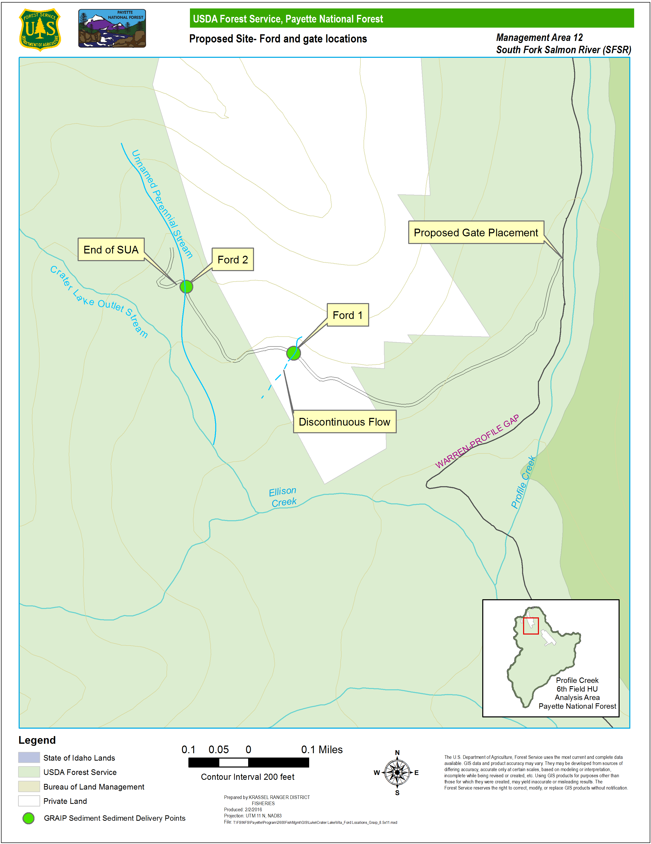 Figure 4. Map of proposed site showing ford locations and gate placement. Ford locations are also noted as being GRAIP modeled sediment delivery sites.

Direct Effects

Chinook Salmon, Steelhead, Bull Trout (Subpopulation Character WCIs)

Direct Effects to Fish at the Unnamed Ellison Creek Tributary Ford

Direct effects are those effects that would impact individuals or populations directly through the acts described above, and authorized through this action.

The perennial stream at Ford 1 ( Figure 4) goes subsurface shortly after the road crossing and is not fish bearing (Zurstadt, personal communication, 2016). Because of this streams ephemeral flow, it is very unlikely that it is fish bearing; therefore no direct effects are expected at this ford.

On October 14, 2015 PNF fish biologists obtained an environmental DNA (eDNA) sample from Ford 2 (Figure 6). The sample was evaluated for the presence of DNA from steelhead, Bull Trout and Westslope Cutthroat Trout. No fish DNA was detected at the ford (unpublished data on file at PNF 2015). The probability of detection and the distance of detection of current eDNA sampling protocols varies but is suggested to range from 20-≥99% within 240 meters (m) (Jane et al. 2014, Wilcox et al. 2016). Additionally, due to the steep gradient (≈15-20%) and limited size of the tributary, it is doubtful that this stream contains suitable habitat for fish species (Zurstadt, personal communication 2016) at or immediately above Ford 2. Ford locations are also outside of modeled habitat for Chinook, steelhead and Bull Trout.

Crater Lake is actively stocked by with fish Idaho Department of Fish and Game (IDFG) (http://fishandgame.idaho.gov/public/fish/stocking/stockingDataDisplay.cfm). The outlet stream of Crater Lake joins with the stream forded at Ford 2 approximately .5 km downstream of the ford and before flowing into Ellison Creek ( Figure 4). It is possible that hatchery cutthroat trout could be present downstream of the ford however, due to the gradient and other features (e.g., size, flow) of this stream, it is unlikely that they occur at the ford. Because the stream at Ford 2 appears to be non-fish bearing, direct effects of fording this tributary on Chinook, steelhead, Bull Trout or Westslope Cutthroat Trout are not expected.

Table 5. Species and life stages potentially affected by fording.
Action | Effect | Chinook | Steelhead | Bull Trout | Cutthroat Trout
Stream fording with motorized vehicle. | Direct disturbance to fish from vehicle fording. | Juvenile and adult Chinook not likely to be present at ford. | Juvenile and adult steelhead not likely be present at ford. | Adults and juveniles not likely to be present at ford. | Adults and juveniles not likely to be present at ford.

Indirect Effects

Potential indirect effects on Chinook Salmon, steelhead, Bull Trout and Westslope Cutthroat Trout could occur due to the fording of streams that would be permitted in this special use authorization. Indirect effects may include, but are not limited to; contamination of water from petroleum based or other contaminants from vehicles actively fording, increased turbidity and sediment deposition and the disruption of streambank stability located within the area of fording.

Sediment/Turbidity
High levels of fine sediment can cause an overall loss of productivity and diversity within a stream (Bjornn et al. 1977, Suttle 2004). Road stream crossings can be a major point of sediment delivery from roads (Gucinski et al. 2001; Taylor et al. 1999; Furniss et al. 1991). Fording can increase sediment delivery in three ways: Wave action from fording vehicles eroding streambanks, tire rutting concentrating surface runoff on approaches, and water draining off vehicles and eroding approaches (Brown 1994). Fording streams can also temporarily increase turbidity by mobilizing fine material in the substrate of the ford.

Fording will cause minor temporary pulses of turbidity and some minor sediment delivery from wave action on the streambanks, and water draining off of vehicles as they climb out of the ford, although armoring of the ford approaches and installation of rolling dips will help reduce erosion from the road surface (Burroughs and King 1989). Additionally, the proposed elimination of unauthorized vehicles should reduce temporary to long term sediment delivery due to the overall minimization of traffic. The perennial stream with Ford 1 does not have continuous surface connection to Ellison Creek, therefore any increase will not be seen downstream in Ellison or Profile Creeks. A commonly used threshold for distance of effects from stream crossing projects is 600 feet (Scaife and Hoefer 2011). Ford 2 is approximately 1500 feet from likely ESA listed fish bearing water. While Ford 2 does have continuous perennial flow, limited sediment delivery is expected to Ellison or Profile Creeks due to the distance (1,500 ft), the limited annual traffic at the ford (Bilby et al. 1989) and the required hardening of the ford approaches. For these reasons, increases in sediment delivery and turbidity over background from authorized use are expected to be negligible and temporary. Even with GRAIP modeled sediment delivery to the channel, the likelihood of measurable delivery to downstream channels is discountable. Installation of a gate will reduce unauthorized traffic and result in a net reduction in turbidity pulses and sediment delivery in the temporary to long–term time frames.

Chemical Contamination
Fuels and other petroleum products (e.g., fuel, oil, hydraulic fluid) that leak or are spilled can directly poison salmonids and their aquatic invertebrate food source. Free oil and emulsions can adhere to gills and interfere with respiration, and heavy concentrations of oil can suffocate fish. Evaporation, sedimentation, microbial degradation, and hydrology act to determine the fate of fuels entering fresh water (Mason 1991).

Authorizing the property owners to install a gate will preclude unauthorized traffic from further use of the ford and limit additional potential contamination of the water body. Minor amounts of fuel or other contaminants may wash off authorized vehicles at the fords, but these quantities should be negligible and temporary due to the limited use of the ford by authorized users. While this special use authorization would continue to permit fording by those owning personal property accessed by this road, that access would be limited to approximately <40 trips per year (Vita, personal communication), and could be considered insignificant in terms of potential contamination. Negligible benefits should occur due to the elimination of unauthorized traffic in the temporary, short, and long-term.

Streambank Stability
Streambank stability is an often used indicator of the type and quantity of streambank vegetation as well as the potential erosive qualities of a stream (Sweeney and Newbold 2014). Streambank stability is used in standardized fish habitat analysis in order to determine potential changes in channel morphology (Archer and Meredith 2015; Kershner et al. 2004). Bank condition can also be important in regards to fish habitat as bank structure is often used by fish as cover.

Streambank degradation can cause unnatural channelization and inhibit the natural processes of stream migration and meandering. This can reduce stream complexity and limit available fish habitat.

Fording streams in a vehicle can decrease bank stability and exacerbate erosion of streambanks causing elevated levels of sediment delivery to streams (Taylor et al.1999). Passenger vehicles, as well as ATV’s and OHV’s, can damage streambanks and their associated vegetation and limit the regeneration of vegetative anchoring with continued use. Vehicle fording may also cause destruction of undercut banks, a staple component of fish habitat.

The streambank present at the current fording locations are low and undefined due to the limited flow of water and the long term prior use as a vehicle ford, and would not be further impacted by continued limited use ( Figure 4, Figure 5). Mitigation practices such as armoring approaches would limit further streambank degradation. Additionally, the restriction of unauthorized motorists through gating of the road would help to reduce further impacts to streambank condition in the temporary, short, and long-term.

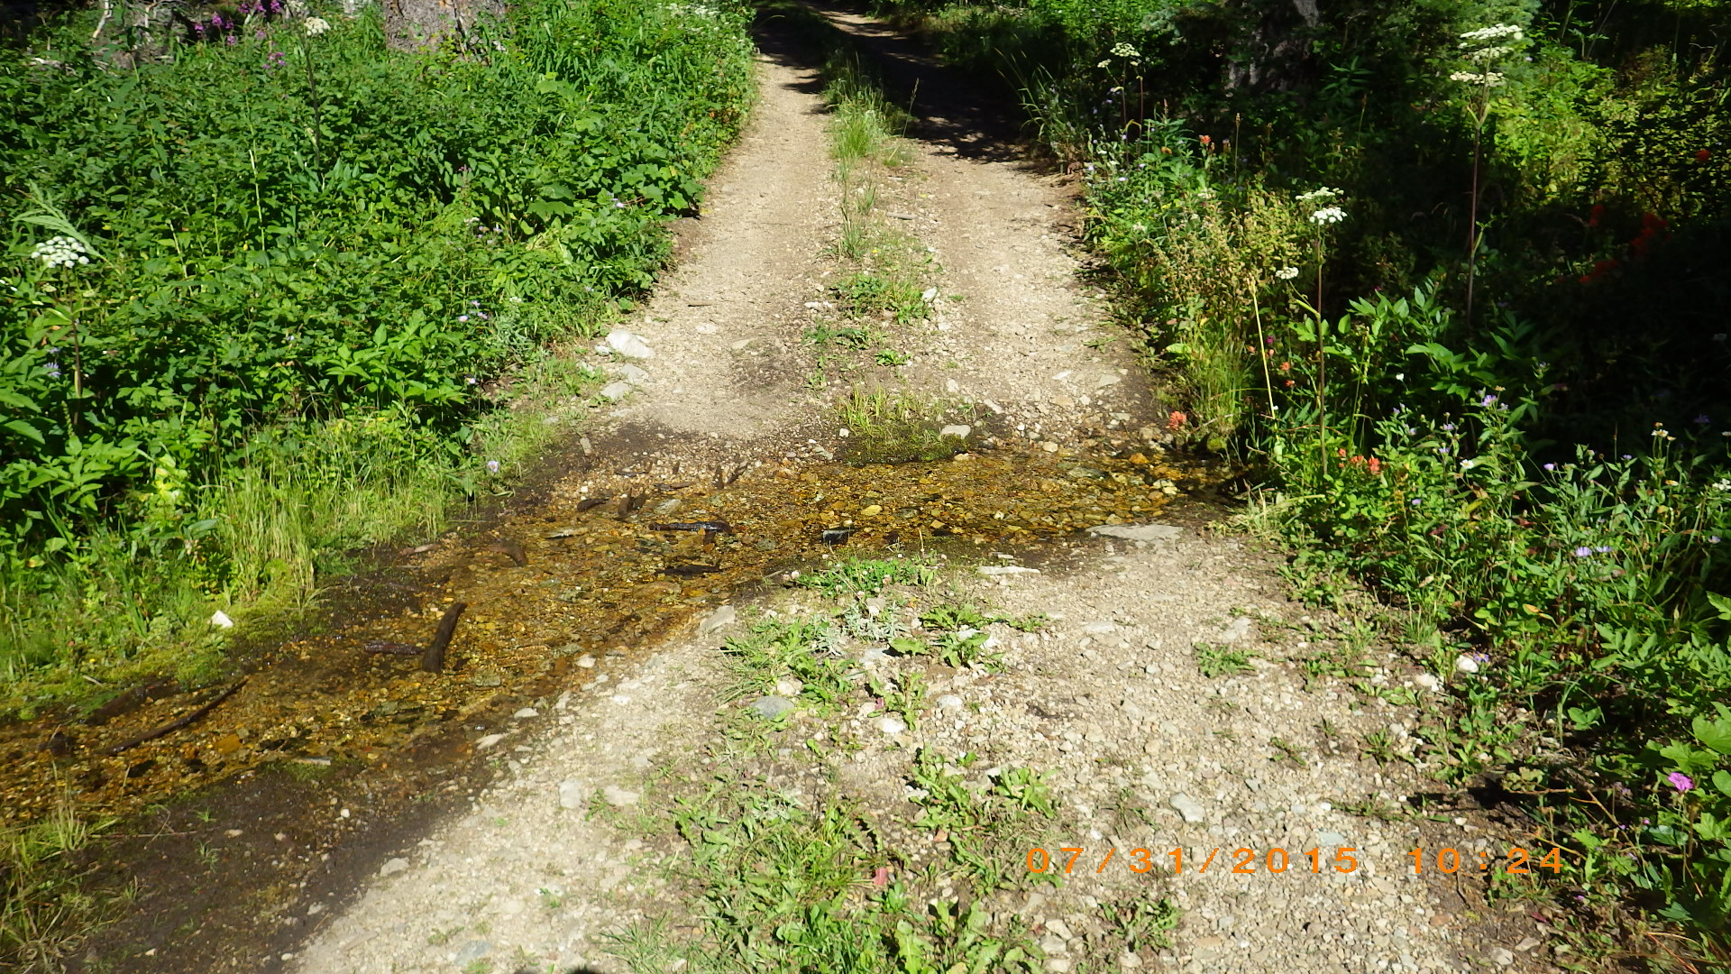
Figure 5. Ford 1. First of two perennial stream fords. Flow goes subsurface before reaching another downstream channel. Ford location is on private ground and is modeled as GRAIP sediment delivery point.

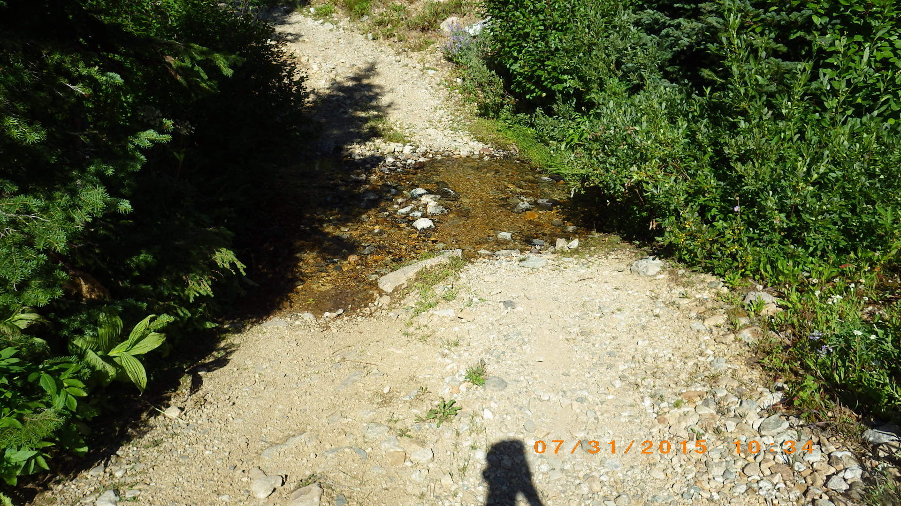
Figure 6. Ford 2. Second of two perennial stream fords. Ford location is on PNF ground and is modeled as a GRAIP sediment delivery point. The approaches would be armored.
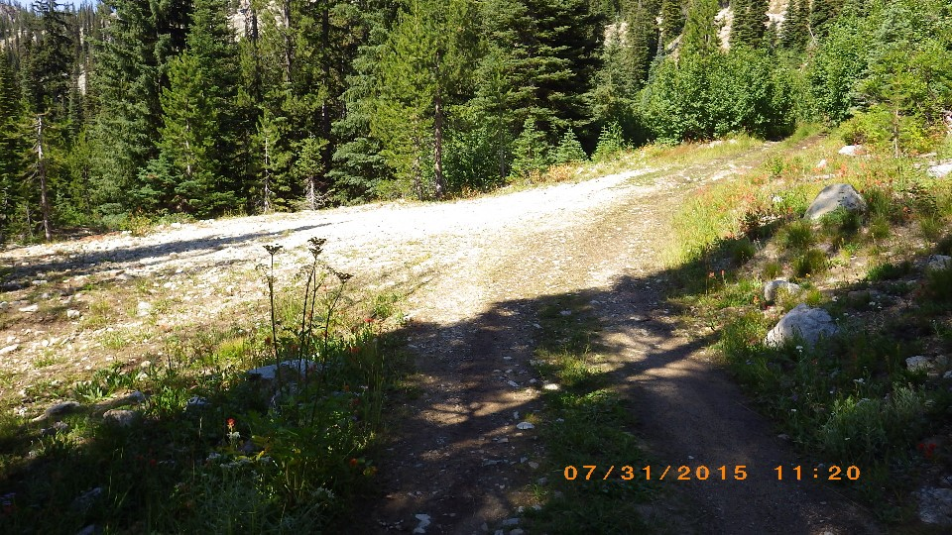Figure 7. Parking area on left side of photo that will be lined with rock barriers. Signifies end of SUA.

Summary Effects to Bull Trout Critical Habitat PCEs

Table 2 identifies a crosswalk of the Forest Plan WCIs and Bull Trout PCEs. Many of the PCEs related to multiple WCIs in one aspect or another.

Based on the analysis of effects to WCIs (Table 4) for sediment/turbidity, chemical contaminants/nutrients, and streambank stability, there exists potential to have negligible effects to corresponding PCE’s 1, 2, 4, 5, 6, 7, and 8, and no effects to PCE’s 3 and 9. The beneficial effects noted in Table 4 will be insignificant at the subwatershed scale.

Cumulative Effects (State and Private)
Cumulative effects (50 CFR 402.02) are the effects of future state or private activities that are reasonably certain to occur in the project area where the federal actions occur. Future actions on non-Federal land could result in local, site-specific impacts to some habitat indicators especially with mining or other private land development. The SUA road that is the subject of this BA also accesses additional private property including mining claims. Future actions regarding this area are unknown but could occur, including the possibility of further development by the Vitas on their private land. The actions suggested in this BA (e.g., rolling dips and armoring of ford approaches) aim to additionally protect for the possibility of these occurrences.

Determination

Bull Trout and Designated Critical Habitat:

No Effect
May Affect, Not Likely to Adversely Affect
May Affect, Likely to Adversely Affect

Chinook Salmon, Designated Critical Habitat, and Essential Fish Habitat:

No Effect
May Affect, Not Likely to Adversely Affect
May Affect, Likely to Adversely Affect

Steelhead and Designated Critical Habitat:

No Effect
May Affect, Not Likely to Adversely Affect
May Affect, Likely to Adversely Affect

Westslope Cutthroat Trout:

No Effect
May Affect, Not Likely to Lead to Listing
May Affect, Not Likely to Lead to Listing

Rationale

- Direct effects to Chinook Salmon, Bull Trout, steelhead and Westslope Cutthroat Trout are discountable because they are not likely to be present at the fording locations based on surveys, gradient, and stream sizes. This rationale is based on eDNA surveys taken at the ford site as well as gradient and size of the tributary.

- Sediment delivery to Bull Trout, Chinook Salmon, and steelhead DCH is unlikely due to the ephemeral flow (Ford 1) and distance (Ford 2), as well as the limited authorized fording traffic. The elimination of unauthorized traffic in addition to the armoring of ford approaches and installation of rolling dips will cause negligible future benefits.

- At Ford 1, sediment delivery to Bull Trout, Chinook Salmon, and steelhead DCH is discountable due to the ephemeral flow downstream of the ford.

- At Ford 2, sediment delivery to Bull Trout, Chinook Salmon, and steelhead DCH is insignificant due to the distance of the ford from DCH, and the limited use of the ford.

- The elimination of unauthorized traffic in addition to the armoring of ford approaches and installation of rolling dips will cause negligible future benefits.

- Chemical contamination potential is insignificant due to the elimination of unauthorized traffic and limited authorized fording traffic. The overall reduction of fording traffic will cause future benefits.

- Impacts to bank stability are not expected to be detrimental because of the current character of the streambank at the fording locations, the limited fording that will occur, and the requirement to harden the ford approaches.

LITERATURE CITED

Archer E., and C. Meredith. 2015. Habitat condition for sites in the Payette National Forest: PACFISH/INFISH Biological Opinion (PIBO) effectiveness monitoring program. Unpublished Report. USDA Forest Service, Logan UT. 83p.

Behnke, R.J. 2002. Pages 81-86 in Trout and salmon of North America. The Free Press a division of Simon and Schuster Inc. New York, NY. 359p.

Bilby R.E., K. Sullivan, and S.H. Duncan. 1989. The generation and fate of road-surface sediment in forested watersheds in Southwestern Washington. Forest Science. 35(2) 453-468.

Bjornn, T.C., M.A. Brusven, M.P. Molnau, J.H. Milligan, R.A. Klamt, E. Chacho, and C. Schaye. 1977. Transport of granitic sediment in streams and its effects on insects and fish. Bulletin No. 17. College of Forestry, Wildlife and Range Sciences, University of Idaho, Moscow, Idaho, USA.

Brannon, E.L., M.S. Powell, T.P. Quinn, and A. Talbot. 2004. Population structure of Columbia River Basin Chinook Salmon and steelhead trout. Reviews in Fisheries Science 12:99-232.

Brown, K. J. 1994. River-bed sedimentation caused by off-road vehicles at river fords in the victorian highlands, Australia. JAWRA Journal of the American Water Resources Association, 30: 239–250. doi: 10.1111/j.1752-1688.

Burns, D.C., M. Faurot, D. Hogen, M. McGee, R. Nelson, D. Olson, L. Wagoner, and C. Zurstadt. 2005. Bull Trout populations on the Payette National Forest. USDA Forest Service, Payette National Forest, McCall, Idaho, USA. Pages 97p.

Burroughs Jr., E.R. and J.G. King. 1989. Reduction of soil erosion on forest roads. USDA Forest Service General Technical Report INT-264. Intermountain Forest and Range Experiment Station. Ogden, UT.

Ferguson, L., and C. Zurstadt. 2014. Relative reliability of phenotypic identifiers for juvenile Westslope Cutthroat Trout and Redband Trout in tributaries to Big Creek, Idaho: an aid to identification for field crews. Unpublished Report. Payette National Forest, McCall, Idaho. 15p.

Furniss, M.J., T.D. Roelofs, and C.S. Yee. 1991. Road construction and maintenance. Pages 297-301 in W.R. Meehan, editor. 1991. Influences of Forest and Rangeland Management on Salmonid Fisheries and their Habitat. Special Publication 19. American Fisheries Society.

Gucinski, H., M.J., Furniss, R.R. Ziemer, and M.H. Brookes. 2001. Forest roads: a synthesis of scientific information. Gen. Tech. Rep. PNWGTR-509. Portland, OR: U.S. Department of Agriculture, Forest Service, Pacific Northwest Research Station. 103 p.

Hogen, D.M. 2002. Spatial and temporal distribution of Bull Trout, Salvelinus confuentus, in the upper East Fork South Fork Salmon River watershed, Idaho. Master’s Thesis, University of Idaho.

Hogen, D.M.; Scarnecchia, D.L. 2006. Distinct fluvial and adfluvial migration patterns of a relict charr, Salvelinus confluentus, stock in a mountainous watershed, Idaho, USA. Ecology of Freshwater Fish 15:376–387.

Idaho Department of Environmental Quality (IDEQ). 2011. Idaho’s 2010 integrated report. Available at: http://www.deq.idaho.gov/media/725927-2010-integrated-report.pdf. Accessed 29 January 2016.

Idaho Department of Fish and Game (IDFG). http://fishandgame.idaho.gov/public/fish/stocking/stockingDataDisplay.cfm. Accessed 20 January 2016.

Jane, S.F., Wilcox, T.M., Mckelvey,K.S., Young, M.K., Schwartz, M.K., Lowe, W.H., Letcher, B.H., Whiteley, A.R., 2014. Distance, flow, and PCR inhibition: eDNA dynamics in two headwater streams. Mol. Ecol. Resour. 15:216-227.

Kershner, J.L., E.K. Archer, M.C. Ritchie, E.R. Cowley, R.C. Henderson, K. Kratz, C.M. Quimby, D.L. Turner, L.C. Ulmer, M.R. Vinson. 2004. Guide to effective monitoring of aquatic and riparian resources. Gen.Tech. Rep. RMRS-GTR-121. Fort Collins, CO: U.S. Department of Agriculture, Forest Service, Rocky Mountain Research Station.

Kuzis. K. 1997. Watershed Analyses of the Upper East Fork of the South Fork of the Salmon River, Idaho. Payette National Forest.

Mason, C.F. 1991. Biology of Freshwater Pollution. 2nd addition. John Wiley & Sons, Inc. New York.

Nelson, R.L. 2004a. East Fork South Fork Salmon River steelhead observations. Unpublished file memorandum EF.04.0027. McCall, ID: USDA Forest Service, Payette National Forest. 4p.

Nelson, R.L. 2004b. East Fork South Fork Salmon River steelhead observations. Unpublished file memorandum EF.16.0066. McCall, ID: USDA Forest Service, Payette National Forest. 3p.

Nelson, R.L. 2011. Bull Trout Designated Critical Habitat PCE – Baseline and Effects Matrix Crosswalk and Consultation Issues. Unpublished File Memorandum EF.01.0041. McCall, ID: U.S. Department of Agriculture, Forest Service, Payette National Forest, Fisheries Program. 6p.

Newcomb, C.P., and J.T. Jensen. 1996. Channel suspended sediment and fisheries: a synthesis for quantitative assessment of risk and impact. North American Journal of Fisheries Management. 16:693-727.

Nez Perce Tribe (NPT). 2010. Nez Perce Tribe Nacó’x (Chinook Salmon) and Héeyey (steelhead) adult escapement and spawning ground survey 2009 summary report. Department of Fisheries Resources Management, Fisheries Research Division. Lapwai, ID.

Nez Perce Tribe (NPT). 2011. Nez Perce Tribe Nacó’x (Chinook Salmon) and Héeyey (steelhead) adult escapement and spawning ground survey 2010 summary report. Department of Fisheries Resources Management, Fisheries Research Division. Lapwai, ID.

NMFS. 2005. Final Assessment of NOAA Fisheries’ Critical Habitat Analytical Review Teams for 12 Evolutionarily Significant Units of West Coast Salmon and Steelhead. Portland, OR.

NMFS. 2011. Endangered Species Act Section 7 Formal Consultation and Magnuson-Stevens Fishery Conservation and Management Act Essential Fish Habitat Consultation for the Johnson Creek Airport Bridge Replacement, 170602080501 – Johnson Creek; Valley County, Idaho.

Scaife D. and S. Hoefer. 2011. Biological Assessment for restoration activities at stream crossings affecting the habitat of ESA-listed fish species on National Forests and Bureau of Land Management public lands in Idaho. USDA Forest Service, Idaho Panhandle National Forests, USDI Fish and Wildlife Service Bureau of Land Management, Idaho, USDI Fish and Wildlife Service Snake River Fish and Wildlife Office, Boise, Idaho, National Marine Fisheries Service, Idaho State Habitat Office, Boise, Idaho, and US Army Corps of Engineers, Walla Walla District. 112p.

Shepard, B.B.; May, B.E.; Urie, W. 2005. Status and Conservation of Westslope Cutthroat Trout within the Western United States. North American Journal of Fisheries Management 25:1426–1440.

Suttle, K.B., M.E. Power, J.M. Levine, and C. McNeely. 2004. How fine sediment in riverbeds impairs growth and survival of juvenile salmonids. Ecological Applications 14:969-974.

Sweeney, B.W. and D.J. Newbold. 2014. Streamside forest buffer width needed to protect stream water quality, habitat and organisms: A literature review. Journal of the American Water Resources Association 50(3):550-584.

Taylor, S.E., B. Rummer, K.H. Yoo, R.A. Welch, and J.D. Thompson. 1999. What we know and don’t know about water quality at stream crossings. Journal of Forestry. 97(8):12-17.

Thurow, R.F. 1987. Completion Report. Evaluation of the South Fork Salmon River. Steelhead Trout Fishery Restoration Program. Lower Snake River Fish and Wildlife Compensation Plan Contract No. 14-16-0001-86505. Boise, ID: Idaho Department of Fish and Game. 155p.

USDA Forest Service (USFS). 2003. Payette National Forest Land and Resource Management Plan. USDA Forest Service, Payette National Forest, McCall, Idaho, USA.

U.S. Fish and Wildlife Service (USFWS). 2015a. Recovery Plan for the Coterminous United States Population of Bull Trout (Salvelinus confluentus). Portland, OR: U.S. Department of the Interior, Fish and Wildlife Service. 179p.

U.S. Fish and Wildlife Service (USFWS). 2015b. Upper Snake Recovery Unit Implementation Plan for Bull Trout (Salvelinus confluentus). Boise, ID: U.S. Department of the Interior, Fish and Wildlife Service. 113p.

Wagoner, L. and D.C. Burns. 2001. Biological Assessment for the Potential Effects of Managing the Payette National Forest in the South Fork Salmon River Section 7 Watershed on Snake River spring/summer and fall Chinook Salmon, Snake River steelhead, and Columbia River Bull Trout and Biological Evaluation for Westslope Cutthroat Trout. Volume 24: Ongoing and new actions.

Waters, T.F. 1995. Sediment in Streams. Sources, Biological Effects and Control. American Fisheries Society Monograph 7. Bethesda, MD: American Fisheries Society Monograph 7. 251p. PAF Fisheries Program Library Reference BH.02.0001.

Watry, C.B.; Scarnecchia, D.L. 2008. Adfluvial and Fluvial Life History Variations and Migratory Patterns of a Relict Charr, Salvelinus confluentus, Stock in West-Central Idaho, USA. Ecology of Freshwater Fish. 17:231–243.

Wilcox, T.M., McKelvey, K.S., Young, M.K., Sepulveda, A.J., Shepard, B.B., Jane, S.F., Whiteley, A.R., Winsor, H.L., Schwartz, M.K. 2016. Understanding environmental DNA detection probabilities: A case study using a stream-dwelling char Salvelinus fontinalis. Biological Conservation. 194:209-216.

Zurstadt, C. 2016. Deposition of fine sediment in the South Fork Salmon River watershed, Payette and Boise National Forests, Idaho; Statistical summary of intragravel monitoring 1977-2015, etc. Draft Report. Payette National Forest, McCall, Idaho. 26 p.

LAA = Likely to Adversely Affect, NLAA = May Affect, Not Likely to Adversely Affect, NLLL = Not Likely to Lead to Listing NE = No Effect

